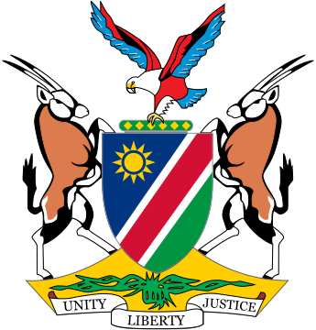

Statement by ***Gladice Pickering – Ministry of Justice and Office of the Attorney-General,*** 4th session of the WG on Transnational Corporations and Human Rights, Geneva, 15 October 2018

Mr. Chair-rapporteur,

Namibia would like to take this opportunity to congratulate you, Ambassador, on your election as chairperson-rapporteur.

Namibia aligns itself to the statement delivered on behalf of the African group.

Mr. Chair,

From the outset, we would like to commend the WG for the dedication and persistence in making its work an ongoing reality and thank Ecuador for the draft instrument and draft optional protocol thereto. The achievements reached by this Working Group have surpassed many expectations.

Mr. Chair,

We concur with the position that States are gatekeepers in the promotion of trade and for providing a conducive trade environment, including monitoring the compliance with human rights due diligence by all business entities, both national and transnational. Such due diligence should not be seen as a barrier to trade opportunities, but instead, it should serve as motivation to businesses to become leaders in this field.

Mr. Chair,

Namibia remains acutely aware of our responsibility, as State, to put effective national mechanisms in place even in the absence of a legally binding instrument – including a legislative framework and national action plans that address the issues comprehensively. We are consulting with all stakeholders at a national level in this regard. The existing UN Guiding Principles provide a good basis in this regard and has, in our opinion, formed the basis for this draft treaty. However, effective operationalization of ETOs under human rights law is critical to closing existing gaps of protection with regard to corporate accountability for human rights abuses. The articulation of ETOs in an internationally legally binding instrument on TNCs and other business enterprises with respect to human rights also aims to confront the structural imbalance apparent in the international legal order which privileges business interests above human rights protections.

We are now provided with a golden opportunity to discuss issues of concern and to modify and improve this draft in order to reach consensus. We look forward to the discussions on this point and will make reference to other legally binding instruments, which deals with this.

We wish the WG all the best of success with its work and look forward to remain engaged in its work.

I thank you.