UN TREATY PROCESS ON BUSINESS AND HUMAN RIGHTS
Further considerations by the international business community on a way forward

First Submission

The international business community’s engagement to date

Human rights are a high priority for the international business community. BIAC, ICC, IOE, and WBCSD and their millions of member companies around the world have been engaged in this subject for many years. Each of these representative organizations have endorsed the UN Guiding Principles on Business and Human Rights and continue to be active in promoting and disseminating the UN Guiding Principles and related implementation guidance among their membership and associated networks.

As part of this ongoing activity, BIAC, ICC, IOE, and WBCSD and their members have constructively participated in the work of the Intergovernmental Working Group (IWG). After submitting initial written observations on the UN treaty process in June 2015, the groups actively participated in the IWG’s first meeting in July 2015 and have since then proactively engaged in the process.

Observations on the occasion of the 2nd Meeting of the IWG

BIAC, ICC, IOE, and WBCSD are concerned that certain parameters of the IWG’s early discussions, if reflected in an initial draft treaty text, would severely constrain the effectiveness of any eventual proposed treaty on business and human rights that may emerge from the IWG’s deliberations. The IWG process and the broader debate its work has engendered offer a unique opportunity to advance understanding and galvanise action by States, business and civil society to enhance the protection, respect and fulfilment of human rights in practice. The trajectory of the IWG’s discussions to date, however, risks narrowing that vital discussion and failing to address, in any draft legal instrument, the majority of human rights impacts associated with the activities of businesses. In particular, the scope of the instrument, as currently proposed, would not cover the majority of the businesses operating in the world today, including purely domestic companies, and state-owned enterprises operating domestically. BIAC, ICC, IOE and WBCSD are also concerned that the present focus of some treaty proponents on transnational accountability mechanisms is misplaced and, if pursued to the exclusion of identifying mechanisms to strengthen nationally-based accountability for business-related human rights impacts, a tremendous opportunity will have been wasted.

- The treaty should strengthen the implementation of the UN Guiding Principles on Business and Human Rights.

The proposed instrument could require ratifying States to develop and implement National Action Plans (NAPs) and thereby encourage States to use the guidance provided by the UN Working Group on Business and Human Rights.

The IWG should also consider measures to increase peer pressure between States to strengthen implementation of the UN Guiding Principles, such as explicitly requiring States to report on their implementation of the UN Guiding Principles and NAPs to the appropriate UN supervisory mechanisms, such as the Universal Periodic Review.

These and other ideas could be facilitated by closer involvement of the UN Working Group on Business and Human Rights in the IWG’s work, which would allow the IWG to benefit from the experience of the UN Working Group in the promotion of the UN Guiding Principles as well as to ensure policy coherence at across the UN.

- To be effective, the treaty’s jurisdictional scope must include all business enterprises.

A truly victim-centred approach to business and human rights requires motivating all actors to prevent, mitigate and, where necessary, remedy adverse human rights impacts; victims of business-related human rights impacts do not care whether their suffering resulted from the action of a domestic company or a multinational one, a privately-held entity, one that is publicly-traded or one whose shareholders include sovereigns or which are financed by sovereign assets – the key issue is that the negative impact of the company`s conduct is mitigated and remedied.

In light of this victim-centred approach, the current deliberations on the treaty are worrying, as the first IWG’s meeting decided that the mandate of the IWG established in Human Rights Council Resolution 26/9 could not be understood to include purely domestic enterprises and, furthermore, that it was outside the IWG’s mandate to modify its own mandate as stated in the text of the Resolution. The views taken in the first session of the IWG can of course inform the second session, but it remains within the IWG’s power to reassess the conclusions reached last year. In revisiting the scope of the proposed instrument, we wish to offer the following observations:

- State-owned enterprises of a transnational character or with transnational operations are clearly within the scope of the IWG’s work. It is the view of the undersigned business organizations that State-owned enterprises (SOEs) that are by structure “transnational corporations” or which “have a transnational character in their operational activities” are clearly already included within the scope of the IWG’s mandate and therefore within the potential jurisdictional scope of any binding instrument.

This is an important clarification because SOEs are significant economic actors in the global economy: the proportion of SOEs among Fortune Global 500 companies has grown from 9.8% in 2005 to 22.8% in 2014, with US$389.3 billion of profit and US$28.4 trillion in assets. A similar growth was seen in the broader Fortune 2000, with SOEs comprising 14 percent of the Fortune 2000 in 2014, with the value of their sales, both domestic and international, being equivalent to approximately 19 percent of the value of global cross-border trade in goods and services. Indeed, in many of the most impactful industries, SOEs comprise anywhere from 13-43% of the top 10 firms in each industry, according to the OECD (see Figure 1).

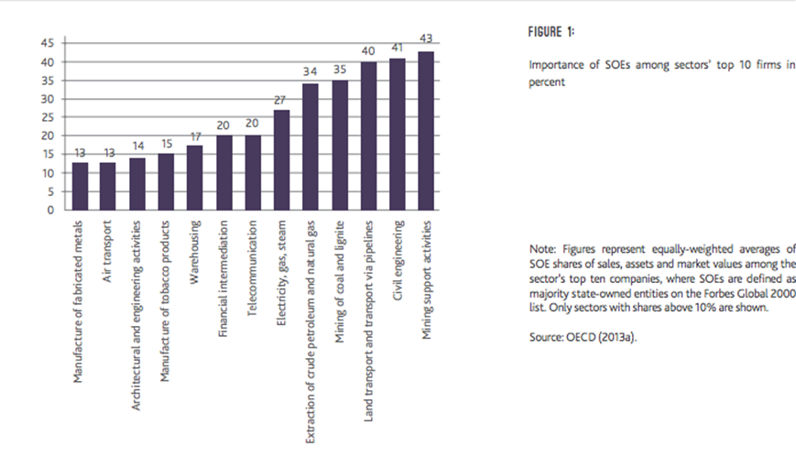
The E15 Task Force for Investment Policy, Think Piece: Governments as Competitors in the Global Marketplace: Options for Ensuring a Level Playing Field (OECD, February 2016) (joint effort of International Centre for Trade and Sustainable Development and World Economic Forum).

More pertinent to the IWG’s mandate, however, is the fact that most of the world’s economies with a particularly high share of SOEs among their largest enterprises are important players in international trade in goods and services. Moreover, those segments of the raw materials, manufacturing and services sectors that have the strongest SOE presence account for significant shares of world trade, with these sectors known to play important upstream and downstream roles in international supply chains. There are also signs that in recent years, the transnational nature of SOE activity has been on a rapid rise, out-pacing the same activity by private companies (see Figure 2). In fact, there has also been a rise of M&A activity by SOEs within purely domestic markets, confirming the overall trend of their ascendance as major economic players. Thus, to ignore SOEs would dramatically limit the relevance and effectiveness of a future instrument from the very beginning.

- Excluding domestic enterprises would render the focus on transnational corporations ineffective and would likely fail to cover the vast majority of business-related adverse human rights impacts. Margaret Jungk, former member of the UN Working Group on Business and Human Rights, pointed out in an article in the Huffington Post that “the vast majority of economic activity is carried out by small-scale companies, ones you've never heard of, mostly in the informal sector. Their goods don't travel across borders, and when they exploit their workers or harm communities, you don't hear about it”. Indeed, according to the ILO World Employment Social Outlook 2015, only 20.6 per cent of the global workforce is linked to Global Supply Chains (ILO WESO, page 132).

Thus, a treaty which proceeds along the lines suggested during the IWG’s first session would exclude the vast majority of companies from its ambit as well as the majority of the world’s workforce. Moreover, as stressed in the business organization’s submission last year, to the extent that transnational corporations do cause or contribute to adverse human rights impacts or are directly linked to such impacts, in many cases, this is a direct result of those multinational companies’ engagement with smaller, domestic suppliers and other business partners.

Accordingly, multinational companies’ efforts to respect human rights in accordance with a proposed treaty or otherwise would not have the same impact if their business partners were left outside the scope of the instrument, because those actors would feel they could act with impunity. Human rights and decent working conditions have to be ensured for all workers and all people – not only for the minority of the global workforce that are linked to MNEs. Thus, the IWG should revise the scope of the proposed instrument accordingly. Alternatively, this question can be referred back to the Human Rights Council for consideration as it looks to possibly renew the mandate of the IWG in 2017.

In response to the suggestion that domestic enterprises should be covered under the term “other business enterprises,” it was argued at the last meeting of the IWG that domestic companies are already covered under domestic laws and therefore do not need to be within the mandate of the IWG’s work. But this creates a false distinction which does not hold-up under even a cursory examination: the simple truth is that transnational companies are also covered by the existing laws and regulations in every jurisdiction in which they operate. There is accordingly no regulatory gap to be bridged at the international level for transnational corporations any more than there is for domestic ones. Rather, the challenge with respect to both is to ensure better implementation and enforcement of regulation at national level.

*****

Resolution 26/9’s preamble refers to “all the work undertaken by the Commission on Human Rights and the Human Rights Council on the question of the responsibilities of transnational corporations and other business enterprises with respect to human rights,” and in a footnote, defines “Other business enterprises” as “denote[] all business enterprises that have a transnational character in their operational activities, and does not apply to local businesses registered in terms of relevant domestic law.”
The E15 Task Force for Investment Policy, Think Piece: Governments as Competitors in the Global Marketplace: Options for Ensuring a Level Playing Field (OECD, February 2016) (joint effort of International Centre for Trade and Sustainable Development and World Economic Forum).
Available at http://e15initiative.org/wp-content/uploads/2015/09/E15-Investment-OECD-FINAL.pdf
Available at http://e15initiative.org/wp-content/uploads/2015/09/E15-Investment-OECD-FINAL.pdf

