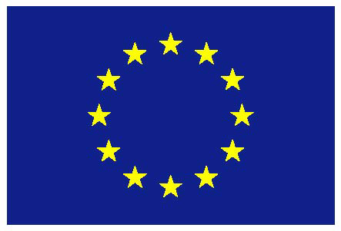

European Union

Fourth Session of the open-ended intergovernmental working group on United Nations declaration on the rights of peasants and other people working in rural areas
(18-19 May 2017)

EU general statement

Madam Chair, distinguished delegates, dear colleagues,

I have the honour to speak on behalf of the EU for the duration of the fourth session of this working group. We congratulate you for your election as Chair-Rapporteur of this Working Group. Please be assured of the EU’s support for you in your work.

Madam Chair,

As we have stated on previous occasions, the EU attaches great importance to the situation and the human rights of persons living and working in rural areas. Such persons receive important support from EU policies and often make an important contribution to the protection of the environment. The EU remains deeply concerned by the fact that there are still significant inequalities with regard to the full realisation of all human rights, in particular economic, social and cultural rights, between persons living in rural and persons living in urban areas.

It is the obligation of every State to ensure the promotion and protection of all human rights without discrimination. To this end, the EU contributes significantly to national efforts through development assistance, seeking to improve the situation of persons living in rural areas. The EU recognises that challenges faced by people living and working in rural areas around the world need to be addressed, and we consider this Working Group an important opportunity to discuss how to improve the promotion and effective implementation of the rights of those living and working in rural areas.

Madam Chair,

We would like to thank you for circulating the revised draft declaration in advance of this session. We thank you for shortening the declaration and taking on board some of our proposals. However, we note that problems in the text remain, especially with regard to notions of extra-territoriality, new rights to seeds, land, means of production, food sovereignty, biological diversity and a safe, clean and healthy environment. The creation of new rights, which would only be applicable to persons living and working in rural areas, would undermine universality of human rights. The EU, notwithstanding our procedural concerns with this initiative, has constructively engaged in the first three sessions of the Working Group. While such concerns remain, we are ready to continue our constructive engagement in the session before us.

The EU believes that the existing normative human rights framework can and needs to be better implemented. We should also bear in mind that we are negotiating a declaration which, by definition, will not constitute a legally binding document and thus, cannot create new rights.

Madam Chair,

We believe it is important to reiterate once more for the record that divergent views on this declaration remain. We would therefore not be in a position to support the current draft without substantial revisions. The text would need to be brought into line with existing instruments dealing with women’s rights, occupational health and safety, social security, access to land, seeds and the right to food. The EU will make specific suggestions to reflect these points during the Working Group, as we have done in previous meetings. While, for the reasons outlined above, the EU will need to reserve its position on the paragraphs where we are making proposals, we are, in the spirit of constructive engagement, ready to participate in the discussions this week and raise some general and some specific comments on the draft text, without prejudice to our overall position.

In closing, Madam Chair, let me reiterate the EU’s support for you in your work and express the EU’s hope that this Working Group will be able to make progress this week towards the goal of an improvement in the human rights situation of persons living and working in rural areas.

Thank you.

