 | Human Rights Council
Seventh session
Geneva, 3 – 28 March 2008

Order of the Day
Wednesday, 5 March 2008
Plenary meetings
 | 6th meeting | 10.00 a.m. - 12.00 noon | Assembly Hall
 | 7th meeting | 12.00 noon - 3.00 p.m. | Assembly Hall
 | 8th meeting | 3.00 p.m. – 6.00 p.m. | Assembly Hall
1. High-level segment
10.00 a.m. | H.E. Mr. Henri Eyebe Ayissi, Minister of Foreign Affairs of Cameroon
10.10 a.m. | H.E. Mr. Mark Malloch-Brown, Minister for Africa, Asia and the United Nations of the United Kingdom of Great Britain and Northern Ireland
10.20 a.m. | H.E. Mr. Phandu T.C. Skelemani, Minister of Defence, Security and Human Rights of Botswana
Notes: | - All speakers scheduled to take the floor should provide the Secretariat beforehand with 25  copies of their statements. For general distribution, 250 copies are needed.
 | - The Secretariat is pleased to inform all delegations that all statements delivered during the high-level segment are available on the webpage of the Human Rights Council.
 | - The full text of statements, as well as the audio files may be accessed at http://www.ohchr.org/english/bodies/hrcouncil
 | - Deadline to table draft proposals for action: Wednesday, 19 March 2008, noon.
 | - Identity photo-badges valid for the session may be obtained by all delegations, if needed, from the UNOG Security and Safety Section at the “Pregny Gate”(Palais des Nations, 8-14 avenue de la Paix) from 8.00 a.m. to 5.00 p.m. upon presentation of a copy of their letter of accreditation and an identity document.
_______________
A/HRC/7/OD.3
GE.08-11069 /…
(Cont’d)
10.30 a.m. | H.E. Mr. Frank Belfrage, State Secretary for Foreign Affairs of Sweden
10.40 a.m. | H.E. Mr. Per Stig Moeller, Minister for Foreign Affairs of Denmark
10.50 a.m. | H.E. Mr. Oskaras Jusys, Under-Secretary for Foreign Affairs of Lithuania
11.00 a.m. | H.E. Mr. Günter Nooke, Vice-Minister and Commissioner of the Federal Government  for Human Rights and Humanitarian Aid of Germany
11.10 a.m. | H.E. Mr. Zaid bin Abdul Muhsin Al-Hussain, Vice-Minister for Human Rights of  Saudi Arabia
11.20 a.m. | H.E. Mr. Gianni Vernetti, Under-Secretary for Foreign Affairs of Italy
11.30 a.m. | H.E. Mr. Bernardino Leon Gross, Secretary of State for Foreign Affairs of Spain
11.40 a.m. | H.E. Mr. Aniceto Ebiaka Mohete, Vice-Prime Minister in charge of Human Rights of Equatorial Guinea
11.50 a.m. | H.E. Mr. Patrick Anthony Chinamasa, Minister of Justice, Legal and Parliamentary Affairs of Zimbabwe
2. Panel on human rights voluntary goals (please refer to annex)
3. General Segment
- Member States of the Human Rights Council
- Observer States and other observers (including a representative of NHRIs
and four representatives of civil society)
/…

Annex
PANEL ON HUMAN RIGHTS VOLUNTARY GOALS
5 MARCH 2008
1200H TO 1500H

Modalities: Presentations of the panelists up to 10 minutes, adding up to one hour, followed by an Interactive dialogue (two hours) with Member states and observers of the HRC, civil society and special procedures.
Panel chaired by the HRC President (Ambassador Doru Costea, Romania)
Panelists:
1. Switzerland: Introductory remarks by Mr. Andrew Clapham, Director of International Law and International Humanitarian Law and Human Rights, The Graduate Institute of International Studies of Geneva.
2. Brazil: Mr. Paulo Vannuchi, Minister-Chief of the Special Secretariat of Human Rights of the Presidency of the Republic.
3. Italy: Mr. Gianni Vernetti, Vice-Minister of Foreign Affairs (National Authority for Human Rights issues).
4. Morocco: Mr. Abdelwahed Radi, Minister of Justice.
5. Sri Lanka: Mr. Mahinda Samarasinghe, Minister of Disaster Management and Human Rights.
/…

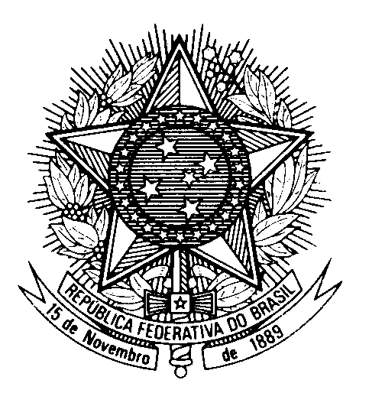
Permanent Mission of Brazil in Geneva
71, avenue Louis Casaï - Case Postale 165
1216 Cointrin Geneva - Switzerland

Non Paper
Human Rights Council
Geneva, February 2008

Common Position of Co-sponsors of Resolution A/HRC/6/26
regarding the Panel on Human Rights Voluntary Goals
at the 7th Session of the Human Rights Council in March 2008

Co-sponsors of Resolution A/HRC/6/26: Algeria, Angola, Argentina, Bolivia, Brazil, Chile, Colombia, Cyprus, Ecuador, Greece, Haiti, Honduras, Italy, Mali, Morocco, Nicaragua, Panamá, Paraguay, Peru, Slovenia, Spain, Sri Lanka, Switzerland, Thailand, Timor-Leste and Uruguay.

Taking into account OP 1 and OP2 (a) of A/HRC/6/26, resolution approved by consensus on 14 December 2007, under item 3 of the Agenda of the Human Rights Council, at the Second Part of the 6th Session of the HRC, the group of co-sponsors agree, on a consensual basis, on the following modalities regarding the Panel on Human Rights Voluntary Goals:
- Title: “Panel on Human Rights Voluntary Goals and the 60th Anniversary of the Universal Declaration of Human Rights;
- Timing: 5 March (in order to guarantee visibility to the event, attendance and participation of the greatest number of Dignitaries who will take part in the High Level Segment);
- Duration: Three hours, from 12:00 to 15:00;
- Representation: Balanced geographic regional representation. At least one representative from each region (ideally up to two participants from each region);
- Composition: Government and Experts (mixed composition).

-----

