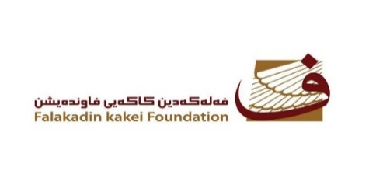
Falakadin Kakei Foundation
Address: 1335 Italy2 / Erbil / Kurdistan Region / Iraq
Mobile: +9647504850673
Email: Falakadin.kf@gmail.com
10th session – United Nation Forum on Minority issues
Geneva, 30th November - 1st December
Statement by Liza Saber
I’m from Kurdistan of Iraq. I belong to the Kakei minority’s. And I’m representing Falakadin Kakei Foundation that work on Cultural and Tolerance issues.

The volatile political and social situation in with the genocides and mass killings committed by different actors in the last few decades makes impossible the establishment of an efficient education system for young people. Recently, the situation worsened for young people from Yezidis, Kaka'is, Christians and other minorities due to the displacement caused by Young people from the minorities is also aggravated by the displacement caused both by ISIS and by the most recent military confrontation between the Iraqi government and the KRG forces.
Education is at the core of any transitional justice process and it is an indispensable tool in order to build a more just and tolerant society. Our intervention wants to call on the Iraqi Government and international community, in particular the European Union and the United States for the establishment of educational program for young people from minorities. Most of our young people are prevented from completing their education and the provision of scholarships with the opportunity to study abroad would grant them the opportunity to contribute, when back, to the development of their own country.

Thank you for your attention.

Liza kakei
Writer and Activist, and Head of Falakadin Kakei foundation affairs cultural and tolerance issues.

