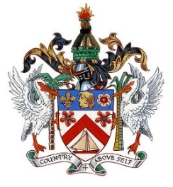

**THE FEDERATION OF SAINT KITTS AND NEVIS**

**42nd Session of the Human Rights Council**

**Statement by Sheldon Henry**

**Representative of St. Kitts and Nevis**

**on behalf of**

***St. Kitts and Nevis, St. Lucia and Grenada***

**Annual Panel Discussion**

**Integration of a Gender Perspective (HRC res. 6/30)**

23 **September, 2019**

Mr. President,

I am pleased to speak on behalf of St. Kitts and Nevis, Grenada and St. Lucia.

We are pleased that the Council agreed back in 2007 to integrate an annual discussion

following its adoption of Resolution 6/30 entitled “Integrating the human rights of women throughout the United Nations system.” Complimentary, the 2030 Agenda for Sustainable Development advocates for an inclusive process and equal participation of all.

Gender integration has been established as the process of assessing the implications for women and men of any planned action, including legislation, policies or programmes, in all areas and at all levels.

Our respective countries have all made significant strides in mainstreaming a gender

perspective in various ways and at different levels. We continue to realise, through

Implementation, that gender equality and the empowerment of both women and men

allows significant progress across all the Sustainable Development Goals and targets. We have also seen that gender mainstreaming is not just about meeting our international legal obligations but when genuinely integrated it can help to alleviate poverty and increase

output exponentially.

We continue to advocate for this annual discussions and pledge our full support for the continued implementation of this important area.