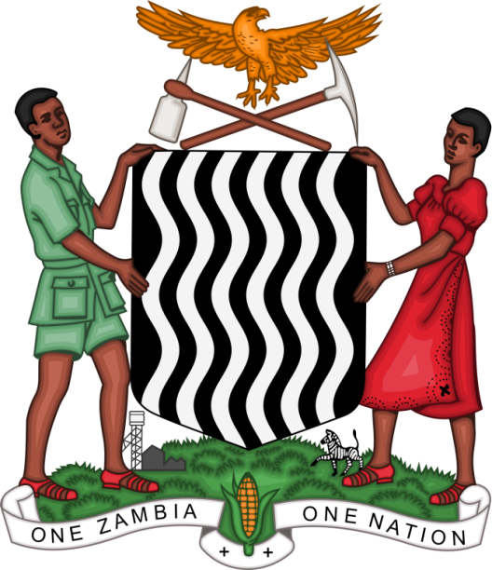

Joint Statement Delivered
By
LOIS KAPEZA
COUNSEL – INTERNATIONAL LAW AND AGREEMENTS
REPUBLIC OF ZAMBIA

On behalf of the
African beneficiary delegates of the LDCs/SIDS Trust Fund at the HRC 42nd Session namely Angola, Benin, Malawi, Tanzania, Uganda and Zambia

on

Annual Discussion on Integration of a Gender Perspective

Geneva, Switzerland
23rd September, 2019

MR. VICE PRESIDENT

I am honoured to deliver this statement on behalf of the African beneficiaries of the LCDs/SIDS Trust Fund namely; the Republic of Angola, Benin, Malawi, Tanzania, Uganda and Zambia respectively.

MR VICE PRESIDENT

We fully align ourselves with the statement of the African Group. We, further appreciate the efforts of the donor countries to the Trust Fund that enabled the participation of 11 delegates, 6 of whom are women, in the HRC 42nd Session. This demonstrates that the Council is determined in ensuring gender integration in its activities.

MR. VICE PRESIDENT

As we all know, women play a vital role in promoting peace, security and social economic policies at the national, regional, continental and international fora. We acknowledge the positive attitude and response of our countries towards the recommendations of the UPR and special rapporteur to integrate women at all stages and sectors of work including; formulation of policies, implementation and decision making since the passing of Resolution 6/30.

However, more needs to be done in the Human Rights Council and its subsidiary bodies. Necessary measures should be taken to guarantee the full participation of women at medium and high level ranks and nominating more women candidates for election and appointment to the Human Rights Council and its Subsidiary Bodies.

MR. VICE PRESIDENT

As a way forward, what are the practical ways of integrating a gender perspective and the human rights of women into all United Nations activities?

I Thank you.

