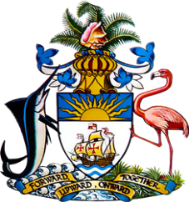

Joint Statement on behalf of the Commonwealth of The Bahamas and
the Commonwealth of Dominica
delivered by Ms. Angelika Hillebrandt
during the General Debate of Agenda Item 10 (Technical Assistance and International Cooperation)
41st Session of the Human Rights Council
10 July, 2019

Thank you, Mr. President,

I have the honor to deliver this statement on behalf of Dominica and my own country, The Bahamas.

Allow me to express our deep appreciation to the OHCHR, Human Rights Council, and donor States for the continued support accorded to the Voluntary Technical Assistance Trust Fund to Support the Participation of Least Developed Countries and Small Island Developing States in the work of the Human Rights Council, which exposes underrepresented countries to the work of the Council, but more importantly, enables them to meaningfully contribute to the promotion and protection of human rights.

Despite the resource challenges of Small Island Developing States, we remain fully committed to the promotion and protection of human rights. The Trust Fund offers a unique space for Member States to reap, in real time, the benefits of technical assistance. Through this experience, we have been encouraged to network and exchange best practices with delegations, UN experts and officials, as well as a wide cross-section of NGOs and members of civil society. In this regard, the Human Rights Council provides an important platform for engagement with civil society, which serves to provide guidance and to foster partnerships for future engagement. As one capital and one New York based delegate, our participation in this Session has both brought the UN “home” and helped to bridge the New York Geneva divide. With this new understanding of human rights mechanisms and processes in Geneva, we are now equipped, not only with the valuable lessons learned during the session, but with the ability to teach others in our countries about the Council and the critical work it does to ensure that human rights are at the centre of what we do at the national level.

Mr. President,

We reiterate our thanks to Member States for supporting the Trust Fund, and, call for the continued, active support of Member States to the Fund, to achieve universal participation at the Human Rights Council.

I thank you.

