(Check Against Delivery)

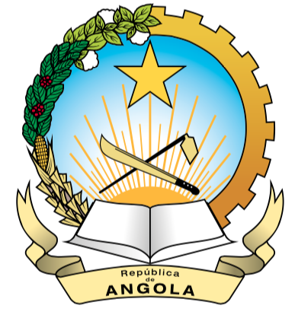
Mission Permanente
De la Republic d´Angola
In Genebra

42nd SESSION OF THE HUMAN RIGHTS COUNCIL
ITEM 10
JOINT STATEMENT MADE ON BEHALF OF
Angola, Benin, Grenada, Malawi, Marshall Islands, Saint Kitts and Nevis,
Saint Lucia, Suriname, Tanzania, Uganda and Zambia
25/09/2019

Mr. President,

On behalf of the 11 beneficiaries present at the 42nd Session of the HRC Angola, Benin, Grenada, Malawi, Marshall Islands, St. Kitts and Nevis, St. Lucia, Tanzania, Uganda and Zambia.- We would like to thank the HRC and the OHCHR for supporting our participation.

Mr. President,

As beneficiaries of this LDCs/SIDS Trust Fund, we would like to acknowledge the importance of this Fund as it ensures and reinforces the direct universality participation of all countries at the work of the HRC. This has empowered our countries, especially those Small Countries without a Permanent Mission, to strengthen their capacities and express their country’s views directly to this Council.

Mr. President,

As countries who are all committed to our human rights obligations, we have maximized the use of this situation and have actively participated throughout the work of the Council; from engaging in informal meetings to lending our voices to General debates and Special procedures. This is evident by so far (41) national statements that were delivered throughout the 42nd Session. Additionally the beneficiaries have been able to actively participate in discussions that their respective countries are directly involved in or follow.

In light of this, we call for continued support of this Fund as it allows the LDCs-SIDS and Low Lying Coastal States to develop their national capacities to promote the effective implementation of their human rights and allows them to competently follow the issues.

Mr. President,

As Developing Countries we would like to call your attention to all countries affected by natural disasters especially those located in the path of recurring hurricanes, land sliding, desertification and earthquake. We kindly urge developed countries to continue to provide assistance and means for capacity building as this would help mitigate the effects of climate change.

We urge the country donors and other stakeholders to continue their financial support in this area while also taking this moment to encourage other countries who have not yet supported this Trust Fund to do so, because our participation was only possible with through the generous contributions of donor countries to the LDCs/SIDS Trust Fund.

I Thank You Mr. President

