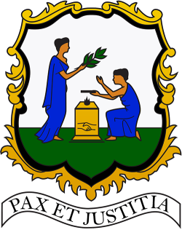
Saint Vincent and the Grenadines

United Nations Human Rights Council
(37th Session)

Joint Statement delivered
by
Westford S. Joseph
Saint Vincent and the Grenadines

On behalf of the Caribbean beneficiary delegates of the LCDs/SIDS Trust Fund; Antigua and Barbuda, The Bahamas, Haiti and Saint Vincent and the Grenadines
on
ITEM 3 - The Report of the Special Rapporteur on Human Rights and the Environment

Geneva, 5 March, 2018

Chairperson,
I am honoured to deliver this statement on behalf of the following Caribbean beneficiary delegates of the LCDs/SIDS Trust Fund; Antigua and Barbuda, The Bahamas, Haiti and Saint Vincent and the Grenadines.
We thank the Special Rapporteur on Human Rights and the Environment for the presentation and report on human rights obligations relating to the enjoyment of a safe, clean, healthy and sustainable environment.
The theme of the environment is very important to the islands of the Caribbean, particularly because the dangers of environmental degradation and climate change threaten our very survivability. Our economies are largely tourism and agricultural; dependent on the natural surroundings. We are keenly aware that the right to life, adequate standard of living, health, food and education, among others, are linked to health of the environment.
It is, as a consequence, priority for us to ensure that our environment is protected and preserved through sustainable practices. To this effect, our countries are continuously investing in the areas of climate change resilience, recycling, renewable energy, smart technologies and the creation of green cities and islands.
Chairperson,
In the words of the President of Haiti, His Excellency Jovenel Moïse, “the absolute necessity to create a climate-smart region is a clear given the effects of climate change which have brought us droughts, mega hurricanes, and heavy floods, all of which adversely affect our development”.
We can all agree that a truly global response is needed to address environmental concerns. Our countries are pleased with the adoption of recent internationally agreed upon commitments, which seek to put us all on a path of sustainable development and environmental security, in particular the United Nations Paris Climate Agreement. We express our appreciation for the goodwill and pledges from international partners who have stood by us, particularly following the devastating 2017 Hurricane season. We are resolved to work diligently to create safe, clean, and healthy environments where people can enjoy sustainable livelihoods, security and their human rights.
Thank you for your attention.

