**Human Rights Council - Guidelines on the online submission of NGO written statements**

**(updated in May 2023)**

|  |
| --- |
| NGOs in consultative status with ECOSOC (General, Special or Roster status) may submit written statements to the Human Rights Council ahead of a session of the Council.  Each NGO may submit **up to five written statements** per session. NGOs may submit only **one written statement per debate**.   * NGOs in general consultative status may submit written statements of up to **2,000** **words** (including endnotes). * NGOs in special consultative status or on the roster may submit written statements of up to **1,500** **words** (including endnotes).   **The submitting NGO assumes full responsibility for the content of the statement.**  **Admissibility:**   * Statements must relate to the Programme of Work of the session to which they are submitted. NGOs are reminded that General Debates **only** occur during the March and September regular sessions. Failure to link properly the content of the statement to the relevant debate in the Programme of Work, will result in the reassignment of the statement to another debate or the inability to process it. * Statements should fully uphold UN standards and strictly follow UN terminology (including the titles of UN human rights mechanisms, commissions, Special Procedures mandate holders, States and territories). To view Member States’ names and correct UN terminology, please refer to the UNTERM database: <http://unterm.un.org>. * Statements containing abusive language, including personal attacks against individuals, including Special Procedures mandate holders or officials from the United Nations, are not admissible.[1] * Statements containing names or images of minors are not admissible.[2] * Do not use hyperlinks in the body of the statement or in the endnotes.   **Written statements are issued, unedited, in the language(s) as received (English, French and/or Spanish).**   * Spell and grammar check should be used before submission. * Statements should be written in a clear manner. Abbreviations should be avoided. * No names of individual authors should be indicated in the statement. The first-person singular should be avoided. * Statements should not address the President of the Human Rights Council or any other UN official or thank the reader at the end of the statement. * References to websites, articles and previous statements may be used only in the endnotes, without hyperlinks. * Endnotes are reproduced as received. They should be clearly indicated in the body of the statement and numbered in consecutive order.   For any questions or clarifications, please contact the Civil Society Team of the OHCHR’s Human Rights Council and Treaty Mechanisms Division at: [OHCHR-hrcngo@un.org](mailto:OHCHR-hrcngo@un.org). |

**Technical requirements**

**Step-by-step description of the online submission procedure**

1. First step: creating a Username and Password (only necessary once per session)

2. Second step: submitting your written statement(s)

**Please ensure that you follow the indicated steps until the formal submission of your statement/s. The status of your document should be marked as ‘submitted’. Only submitted statement/s will be processed.**

**STEP 1. Register and create your NGO’s Username (#1) and Password (#2)**

The NGO registration system uses the same platform for submitting written statements as is used for requests for oral statements. Your NGO will need to register once for each new session of the Human Rights Council. **NOTE**: The same NGO Username (#1) and Password (#2) should be used for both written and oral statements throughout the entire session!

You can access the registration page from the HRC information page for NGOs:

<http://www.ohchr.org/EN/HRBodies/HRC/Pages/NgoParticipation.aspx>

The direct link is: <https://ngoreg.ohchr.org/WrittenStatementRegistration/Home>

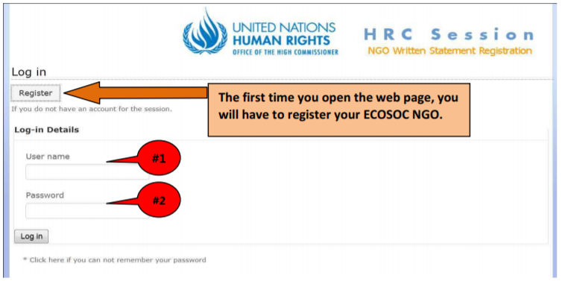

When you register your NGO for the first time into the system, you will register with your NGO’s official ECOSOC name, **identical to the name registered in the ECOSOC database**: <http://csonet.org/>

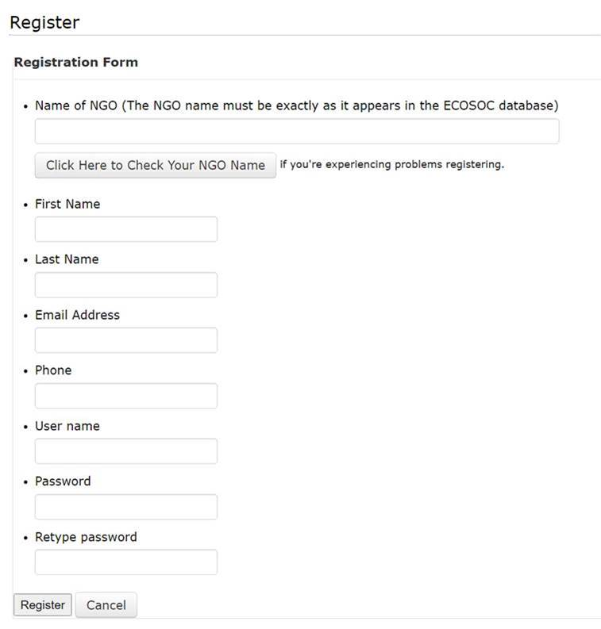

You will then choose a User Name (1) (which can be your name, for example) and then a Password (2) which should become the credentials for your NGO throughout the entire session.

**Attention**: Passwords are case-sensitive! Once you have registered, these last two items (User Name and Password) (1 & 2) will be used after that to log in to the system where your written statements are kept for each session of the Human Rights Council automatically under your NGO’s name. Do not register again, but log in instead.

I M P O R T A N T: If several persons are going to submit statements for the same NGO, coordinate together and use the same #1) User Name and #2) Password so that you can verify, among other things, what has already been submitted by others.

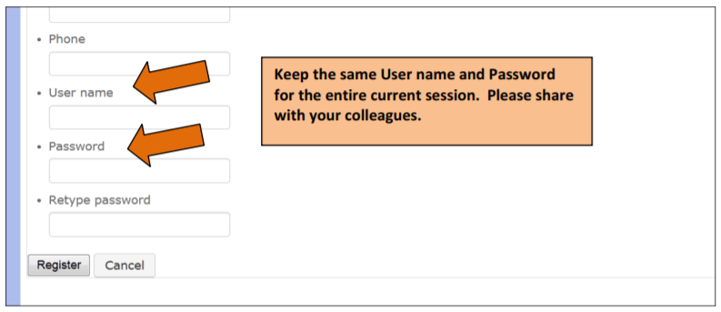

Click on the **Register** button.

**STEP 2. Submitting your written statement(s)**

After Registration, you should now be on the Home Page, where you should access the NGO Written Statement Registration section. You will find the “Register New Document” button:

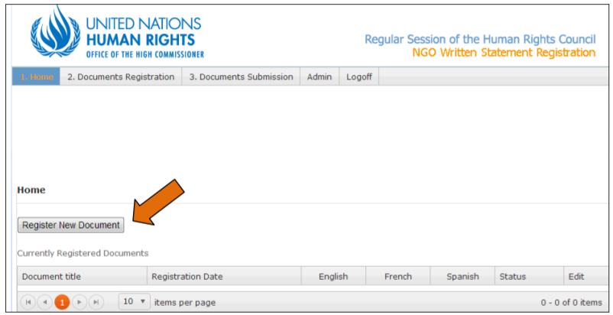

**IMPORTANT**: If you wish to submit a document in several languages, please submit **all** linguistic versions at the same time and not separately. Please see below for more detailed guidance.

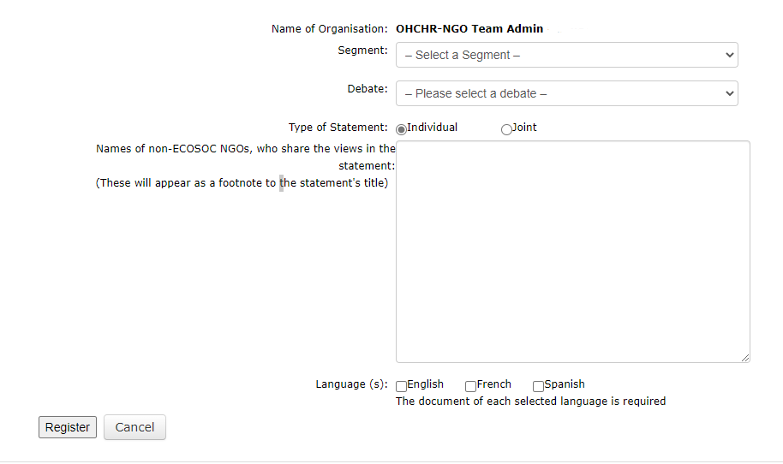

To register a new statement, you must first insert your organisation’s name and then select the **Segment** and **Debate** from the session’s Programme of Work relevant to your statement from the drop-down list on the platform.

If it is a **joint** statement, you will have to add the **other ECOSOC NGOs** co-submitting the statement from a drop-down list from the ECOSOC database. For **NGOs without consultative ECOSOC status** who share the views in an individual or joint statement, this can be added in the **next** **box** below. They will appear as a footnote at the end of the statement. It is your responsibility to enter the name correctly.

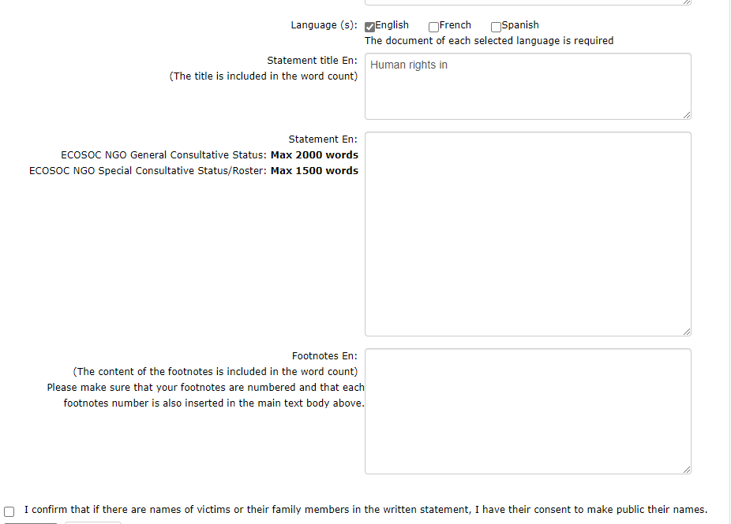

You must select the language of your statement (English, French and/or Spanish). If you are submitting your statement in more than one language, you must select at this stage all the relevant languages. Each language selection will generate three boxes.

1. In the first box, you must enter the title of your statement.
2. In the second box, you must paste the text of your statement.
3. In the third box, you must enter the endnotes of your statement, if any.

**Please note that both the title and endnotes are included in the word count.**

Please do not enter HTML tags into the title, body, and endnotes; otherwise, the system will reject the document, and an error will appear on the screen.

Please tick the box if you used the names of victims or their family members in the written statement and have their consent to make public their names.

**IMPORTANT – USE OF ENDNOTES:**

The NGO submission platform does not allow to submit text with embedded endnotes (superscript). For this reason, you are invited to indicate references as follows, which will appear as endnotes in the published version:

1. When you copy/paste the body of your statement into the second box, please manually insert a number at the end of each sentence to which an endnote should refer.

Examples:

… protesters began using message codes rather than verbally chanting during the assembly. (1)

… protesters began using message codes rather than verbally chanting during the assembly.1

… protesters began using message codes1 rather than verbally chanting during the assembly

… protesters began using message codes rather than verbally chanting during the assembly,1

1. In the third box, please copy/paste your endnotes, reproducing the numbers you used in the body of your statement.

Example:

1 Link to webpage/Reference or

2 Link to webpage/Reference or

OR

(1) Link to webpage/ Reference

(2) Link to webpage/ Reference

(…)

Please ensure that all endnotes are numbered in consecutive order and are indicated in the body of the statement.

**IMPORTANT – GUIDANCE ON SUBTITLES:**

When you submit the text and want to make sure that your subtitles will be in bold in the published written statement, you can use the sign “**” to mark it properly. For example:

* Recommendations*

After you have filled in the three boxes, then you must click Register and then on the next page you must click **Continue,** as shown in this example:

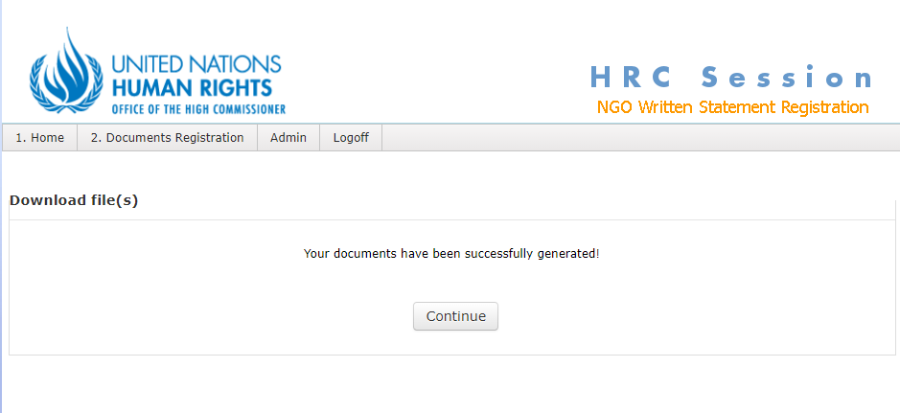

After you click **Continue**, you will see your statement/s listed on the next page. The next page will display the statement that you have generated in the Word Document template in English, French and/or Spanish. You can click on the Word file/s to download a copy of your statement/s for your reference or to review it before submission. Click **Edit** if you still want to make changes to your statement/s, or click **Submit** to submit your statement/s. Please make sure you check your statement before clicking **Submit**.

**WARNING**: If you do not click on **Submit**, your statement will not be registered as “Submitted” and hence will not be processed. Please note that it does not suffice only to register and/or generate your document; it must be formally submitted to be processed by OHCHR for publication on the HRC web page.

Once you click on **Submit**, **no further changes can be made to the text.** Please therefore ensure that you checked and/or edited your document before and are submitting the final version.

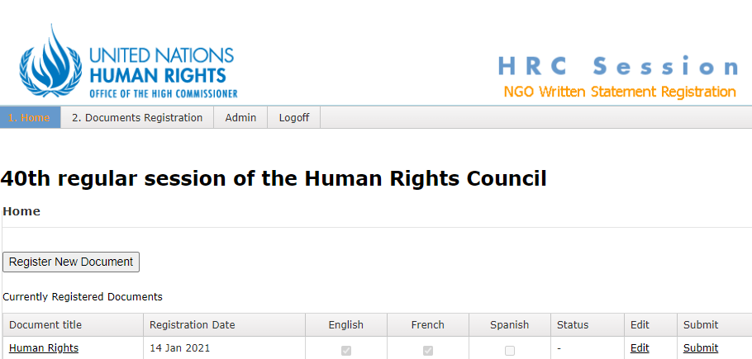

After you click **Submit**, you will see the status of your statement/s marked as “Submitted” on the next page. If you wish to submit another statement/s, click **Register New Document** as in this example:

Remember, **after submitting your documents, please check that the “Status” of your statement indicates that it has been “Submitted”, otherwise the Secretariat will not be able to process your statement.**

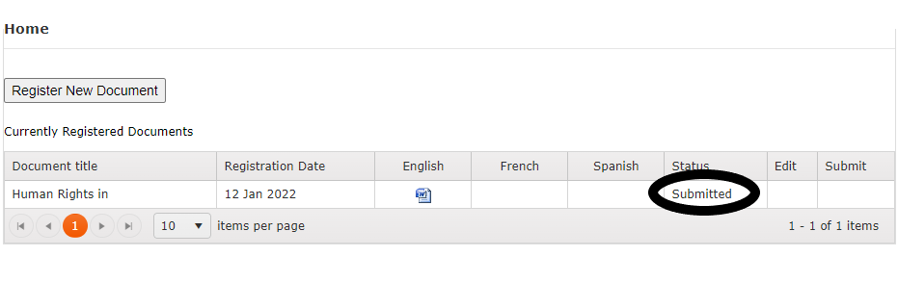

1. Ruling by the President of the HRC during the 1st meeting of the 50th session on 13 June 2022.
2. Ruling by the President of the HRC during the 32nd meeting of the 48th session on 1 October 2021.