|  |  |  |  |
| --- | --- | --- | --- |
|  | United Nations | A/HRC/48/70 | |
| United Nations logo | **General Assembly** | | Distr.: General  13 August 2021  Original: English |

**Human Rights Council**

**Forty-eighth session**

13 September–1 October 2021

Agenda item 4

**Human rights situations that require the Council’s attention**

Report of the Independent International Commission of Inquiry on the Syrian Arab Republic[1]*, [2]**

|  |
| --- |
| *Summary* |
| In the present report, submitted to the Human Rights Council pursuant to its resolution 46/22, the Independent International Commission of Inquiry on the Syrian Arab Republic presents the findings it has drawn from investigations into incidents occurring between 1 July 2020 and 30 June 2021 in government-controlled areas; Idlib and western Aleppo; northern Aleppo and Ra’s al-Ayn; and the north-east of the Syrian Arab Republic. |
|  |

I. Mandate and methodology

1. In preparing the present report, pursuant to its established methodology and guided by standard practices of commissions of inquiry and human rights investigations, the Independent International Commission of Inquiry on the Syrian Arab Republic[3] relied primarily on 538 interviews, conducted in person, in the region and from Geneva.[4] Documents, reports, photographs, videos and satellite imagery from multiple sources were collected and analysed.[5] The Commission also requested, in writing and during meetings, information on incidents, events and developments from the Government, parties to the conflict and States Members of the United Nations.[6] The standard of proof was considered met when the Commission had reasonable grounds to believe that incidents occurred as described, and, where possible, that violations were committed by the warring party identified.

2. The Commission’s investigations remain curtailed by the denial of access to the country and protection concerns in relation to interviewees. In all cases, the Commission remained guided by the principle of “do no harm”.

3. The Commission thanks all who provided information, in particular victims and witnesses.

II. Political and military developments

4. The 5 March 2020 ceasefire led to a significant decrease in hostilities in the north-west, but the situation in the Syrian Arab Republic remained volatile.[7] The economic situation continued to deteriorate, and the COVID-19 pandemic further strained the country’s war-torn health system. The Secretary-General’s appeal in March 2020 for a nationwide ceasefire and for Group of 20 members to waive sanctions in order to ensure access to food and essential health supplies, including COVID-19 support, remained unheeded.

5. Daily life presented mounting challenges for civilians. Fuel shortages placed many in a desperate situation when, in early January, the Syrian Ministry of Oil and Mineral Resources announced that it would reduce fuel distribution – for some types of fuel, by almost a quarter – due to supply chain delays, which it blamed on the impact of sanctions.[8] On 15 April 2021, the Central Bank again devalued the Syrian pound, from LS 1,250/US$ 1 to LS 2,500/US$ 1,[9] leading to further increases in the price of goods and medication.

6. The World Food Programme found that 12.4 million Syrians (nearly 60 per cent of the population) were food insecure – the highest number ever reported – while 43 per cent reported poor food consumption, which is double the figure reported last year.[10] Meanwhile, lagging testing capacity, an acute shortage of oxygen supplies and slow delivery of vaccines under COVAX, the vaccines pillar of the Access to COVID-19 Tools (ACT) Accelerator, impaired responses amid widespread community COVID-19 transmission.[11]

7. Of the estimated 13.4 million Syrians needing humanitarian assistance as of March 2021 – a 21 per cent increase from 2020 – 4.9 million reside in the north-west of the country.[12] In its resolution 2585 (2021), adopted unanimously on 9 July, the Security Council renewed the cross-border aid delivery mechanism, albeit mandating the Bab al-Hawa border crossing as the sole entry point for United Nations humanitarian goods.

8. Meanwhile, conflict endured and military tensions remained high, with government forces, non-State armed groups, United Nations-designated terrorist groups, and five foreign armies[13] operating in close proximity, although front lines remained static during the period (see annex II). Forces of the Russian Federation conducted at least 82 air strikes in support of the Government of the Syrian Arab Republic, while the international counter-Da’esh coalition, led by the United States of America, carried out at least 56 air strikes in the Syrian Arab Republic.[14] Reportedly, the United States conducted at least four additional air strikes, two in August 2020 near Qamishli and two further air strikes in February and June 2021 against non-State armed groups near the Iraqi border.[15] The Commission tracked at least 19 incidents of reported air strikes by Israeli forces on territory of the Syrian Arab Republic, including a particularly deadly one on 13 January against pro-government forces.[16]

9. Idlib and the surrounding governorates remained the epicentre of violence, including attacks on joint Russian-Turkish patrols in the de-escalation zone. Aerial and ground attacks intensified in early 2021, affecting deconflicted hospitals and gas facilities (see sect. IV below).

10. In the Afrin and Ra’s al-Ayn regions, detonations of improvised explosive devices became a near weekly occurrence for civilians. The Commission documented seven such incidents, which killed and maimed at least 243 women, men and children and damaged civilian infrastructure (see sect. V below).

11. In the north-east, economic hardship, a precarious security situation and unpopular “regulations” by the self-administration[17] triggered widespread demonstrations in Hasakah and Aleppo Governorates (see sect. VI below). The presence of Da’esh remnants continued to pose a threat to security in the region, and – as Da’esh attacks increased – amplified public discontent.

12. Presidential elections in the Syrian Arab Republic were announced on 18 April and took place on 26 May. The President, Bashar al-Assad, who has led the Syrian Arab Republic since 2000, was re-elected with 95 per cent of the vote. Voting was restricted to government-controlled areas and among parts of the diaspora abroad, and the credibility of the elections, which were not monitored by the United Nations, was questioned.[18]

13. Ahead of the elections, on 2 May, the President granted pardons to people who had been found guilty of crimes such as smuggling, drug abuse and foreign currency trading. Reportedly, a limited number of prisoners was subsequently released.

14. Three rounds of meetings of the constitutional committee that will draft a new constitution in line with Security Council resolution 2254 (2015) were held during the reporting period. The Special Envoy of the Secretary-General for Syria, Geir O. Pedersen, informed the Security Council in late 2020 that substantial differences, including at the general level, persisted, impeding tangible progress in advancing a political solution.

15. The foreign ministers of Qatar, the Russian Federation and Turkey met in Doha on 11 March to discuss the Syrian Arab Republic. After the meeting, the Minister for Foreign Affairs of Turkey announced that the three countries had launched a new trilateral consultation process to contribute to a lasting political solution in the Syrian Arab Republic, but pointed out that the process was not intended to undermine the Astana talks.

16. The Secretary-General announced the establishment of the three-person Independent Senior Advisory Panel on Humanitarian Deconfliction in the Syrian Arab Republic on 21 January 2021, tasked with advising the Secretary-General on how to strengthen the deconfliction mechanism.

17. The issue of the use of chemical weapons in the Syrian Arab Republic remained high on the agendas of both the Security Council and the Organisation for the Prohibition of Chemical Weapons during the period under review. On 12 April, the latter’s Investigation and Identification Team published its second report, concluding that there were reasonable grounds to believe that, on 4 February 2018, a Syrian Air Force helicopter had dropped at least one cylinder of chlorine in the area of Saraqib, affecting at least 12 individuals.[19] On 22 April, the Conference of the States Parties to the Convention on the Prohibition of the Development, Production, Stockpiling and Use of Chemical Weapons and on Their Destruction adopted a decision to suspend certain rights and privileges of the Syrian Arab Republic under the Convention.[20]

18. On accountability, the first verdict in relation to State torture in the Syrian Arab Republic was delivered on 24 February in Koblenz, Germany. Separately, the Netherlands, and later Canada, announced their intention to hold the Government of the Syrian Arab Republic responsible for gross human rights violations and torture under article 30 of the Convention against Torture and Other Cruel, Inhuman or Degrading Treatment or Punishment.[21]

III. Government-controlled areas

A. Conduct of hostilities

19. The southern area of the Syrian Arab Republic, in particular Dar’a Governorate, saw increasing insecurity during the reporting period, including targeted killings and clashes between armed individuals and State security services. Some clashes were followed by demands from government forces for certain individuals to be expelled to areas controlled by armed groups. Siege-like tactics were used on several occasions to put pressure on the local community to acquiesce.

20. Tensions in Kanakir, rural Damascus, continued between government forces and residents throughout September 2020. On 20 September, officials at an ad hoc Air Force Intelligence Directorate checkpoint at Taybeh bridge, between the Kiswah and Dannoun regions, arrested three women and one 3-year-old girl, sparking protests in the town the following day. Government forces demanded that relatives of the women surrender in exchange for their release. On 22 September, as people gathered at the same checkpoint waiting for the handover, members of the military security forces arrested one of the victims’ male relatives. Another man was arrested in the following days. Confrontations between some of the armed men and government security forces turned lethal, resulting in one death and two injuries to officials from Branch 220 of the military security forces. Following this, government forces encircled Kanakir, preventing movement and denying the entry of food, fuel and non-food items for at least 12 days, to the detriment of approximately 30,000 residents.

21. A few weeks later, on 8 November 2020, unidentified armed men attacked an Air Force Intelligence Directorate checkpoint in eastern Karak in Dar’a Governorate, resulting in the death of five government officials and the injury of two others. Subsequently, pro-government forces surrounded the town, imposing a blockade and preventing freedom of movement for an estimated 30,000 people. Access to services, including health care, as well as food and non-food items, was severely limited. Government forces demanded the surrender of a number of men, their transfer to areas beyond government control with their families, and the handover of weapons, including those allegedly taken during the checkpoint confrontation. Civilians reported that they had to pay bribes of over $100 to pass checkpoints and that they feared arrest, particularly if they were related to the wanted men. Five days later, government security forces searched the houses of the wanted men in the presence of the Russian forces-backed Eighth Brigade. One interviewee recalled that, during the searches, Government security forces had taken his phone and camera. None of the wanted men allegedly surrendered to government forces, but one was shot dead, along with his child, in front of his house on 7 December 2020 by unidentified perpetrators.

22. In the village of Umm Batinah, Qunaytirah Governate, following tensions around the detention of two residents, on 1 May 2021 unknown armed elements attacked a military security forces checkpoint. In response, government security forces surrounded the village of approximately 5,000 inhabitants, and demanded the surrender of a number of residents, or their displacement to northern Syrian Arab Republic. As the individuals did not surrender, government forces launched mortar attacks on the town. Five women and their children were arrested at a checkpoint as they were trying to flee. To avoid a full-scale ground attack against Umm Batinah, approximately 100 individuals, including women and children, were transported under escort and arrived in Bab on 23 May 2021.

23. Starting on 24 June, pro-government forces closed most access to and from the southern neighbourhood of Dar’a al-Balad, hindering civilians’ access to water, food and medicine for several weeks. Reportedly, pro-government forces demanded that local factions give up light personal weapons, a demand they refused to comply with. Investigations are ongoing.

24. Targeted killings,[22] or attempts thereof, also increased in Dar’a; several instances appeared to be retaliatory acts by locally based armed actors. The Commission sought to investigate 18 such incidents occurring between July 2020 and February 2021, and received reports of hundreds more.

25. While some killings may have been murders occurring in the context of general insecurity, others followed a pattern of conflict actors targeting specific individuals. Victims included local political leaders with different political leanings, as well as judges, medical workers and former members of armed groups, some of whom had previously “reconciled”[23] with the Government.

26. In one incident, Ahmed Fayez al-Hasheesh, from the town of Tall Shihab, Dar’a Governorate, was killed at around midday on 22 April 2021. Armed men riding motorcycles shot the victim dead in his car, in front of his children. He was a well-known former field paramedic during the period when armed groups controlled Dar’a. He had reportedly resisted “reconciliation”. In another case, a former judge and a member of the reconciliation committee was shot dead on 10 September by unknown armed men in front of his house.

27. In other incidents, on 31 October 2020, Maria al-Zou’bi, the government-supporting mayor of Taybeh town, Dar’a Governorate, was reportedly shot at, but not hit, while outside her house by unknown gunmen on motorcycles. Two months earlier, she had reportedly survived another attempt on her life, when explosives were thrown at her house. In the evening of 7 January 2021, unknown armed men shot the mayor of Jasim, Dar’a Governorate, near the village of Tibnah in the presence of his family. The mayor later died of his injuries.

Findings

28. The use of the described siege-like tactics by pro-government forces (see paras. 20–22 above) violates the rights of people living in those areas, including their rights to freedom of movement, to food and to health, and may amount to the war crime of collective punishment. There are also reasonable grounds to believe that government forces also resorted to hostage-taking, which would constitute a war crime.

29. The targeted killings described above, when carried out by parties to the conflict, violate the prohibition of direct attacks against civilians and amount to the war crime of murder. There is no indication that the Government launched any investigation into these killings.[24]

B. Arrests and detention

30. In March 2021, the Commission submitted to the Human Rights Council a report covering 10 years of detention practices in the Syrian Arab Republic.[25] Violations identified during the reporting period further add to the considerable evidence underpinning the conclusions contained in the report.

31. Incidents of deaths in detention continued to be documented, with 13 reports received during the reporting period from Dar’a and Rif Damascus alone. In one example, a man from Jasim who had “reconciled” was arrested by military security forces following the recapture by government forces of the area in 2018. In May 2021, the family was informed through informal government contacts that he had died in detention in July 2020. No body or death certificate was received.

32. Survivor detainees reported hundreds of deaths in government security branches and Saydnaya Military Prison as well as dozens of detainee deaths following transfer to Tishrin Military Hospital. In Saydnaya they reported continuing deaths in custody caused by torture and inhumane and degrading treatment of prisoners, with hunger and tuberculosis being widespread.[26]

33. Several interviewees explained how the spectre of arbitrary arrests remained omnipresent notwithstanding any “reconciliation” status, impeding their freedom of movement.[27] For example, a young man from Homs described how he had returned to the Syrian Arab Republic in December 2019 under a government-sponsored “reconciliation” process. He had submitted a request to return to the Syrian security apparatus, and, as he had crossed into the country, he had “reconciled” with the authorities at the border. He was subsequently requested to present himself to the Political Security Directorate branch in Homs. He went alone – and was arrested and detained for three and a half months and held in more than five different detention facilities before being released following the payment of bribes by his family. He described being tortured throughout his detention by various officials, as well as by the medical staff at Branch 235 of the Military Intelligence Directorate in Damascus.

34. Cases of incommunicado detention and enforced disappearance remained pervasive. As previously documented, government forces and officials continued to conceal the fate and whereabouts of those detained, and to extort large sums of money in exchange for releasing information to families.

35. To illustrate, one detainee was released in 2020 as part of a presidential amnesty, although only after paying a bribe. He reported that during his nine years of detention he had been held in Military Intelligence Directorate Branches 291 and 248 in squalid conditions, and tortured in Saydnaya military prison. He only learned of the verdict rendered against him four months before he was transferred to a prison in Suwayda’ Governorate.

36. In another case, a media activist was arrested at an Air Force Intelligence Directorate checkpoint in Aleppo on 18 September 2019, and transferred to three other military intelligence branches (office of the Fourth Division, Branch 215 and then Branch 235, also known as the Palestine Branch), before being held incommunicado at Saydnaya Military Prison. He said that in each of those facilities he had been tortured and subjected to sexual violence. He also reported that, while detained in the military intelligence branches, he had been held alongside minors aged between 12 and 17 years, including in the Palestine Branch. He was released on 11 December 2020.

Findings

37. The cases of arbitrary detention described above add to the considerable evidence already described in the Commission’s March 2021 report on detention,[28] in which the Commission documented continuing patterns of crimes against humanity and war crimes. Tens of thousands of people remain in incommunicado arbitrary detention or forcibly disappeared by government forces. Regarding the above-mentioned cases of death in detention, the Commission is not aware of any investigations having been launched.

C. Housing, land and property rights

38. The confiscation of property and land through public auctions in areas retaken by government forces in the north-west of the Syrian Arab Republic, particularly in Aleppo, Hama and Idlib Governorates, continued to inhibit the return of internally displaced persons. Affected areas included arable land with high value crops, such as pistachio and olive trees. Some of this land was burned or destroyed after being retaken, while other areas were tilled by pro-government forces to generate profit for the authorities and specific individuals.

39. In October 2020, the local authorities in Aleppo, Hama and Idlib Governorates started auctioning annual leases, purportedly to allow individuals to work the land while the owners remained displaced. The Ministry of Agriculture and Agrarian Reform announced on 24 November that the goal of the auctions in those governorates was to cultivate all idle agricultural lands capable of growing wheat. However, interviewees alleged that the auctions were often just a facade to formalize the already existing appropriation and exploitation by various pro-government forces of land belonging to displaced owners, pointing to the unchanged usage of the land before and after the auctions.

40. In Hama Governorate, administrative orders established by the Security and Military Committee contained announcements for about 19 public auctions, including auctions for agricultural lands, between October and November 2020. A farmer from Hama reported that large parts of his land had been put up for public auction, while in other parts, trees had been uprooted and sold by local militias as firewood.

41. An October announcement in Idlib further stated that public auctions were being held for land owned by debtors of the Agricultural Bank. However, affected interviewees consistently denied that they had debts with the agricultural bank, and expressed a fear that the auctions were a pretext and a first step in an effort to permanently seize the land from its owners.

42. Meanwhile, the Government of the Syrian Arab Republic continues to confiscate civilian properties pursuant to the counter-terrorism law (No. 19/2012).[29] Additionally, individuals – and their family members – have also had their assets frozen following decisions by the Ministry of Finance based on recent amendments to article 97 of the military conscription law (No. 30/2007). Investigations are ongoing.

Findings

43. The acts of confiscation of private property described above, in particular those that are likely to generate personal gain, may amount to pillage, which is strictly prohibited under international humanitarian law and amounts to a war crime. The property rights of displaced persons are also specifically protected as a customary norm of international humanitarian law, and must be respected by all parties. Private property is also protected under international human rights law, as no one is to be arbitrarily deprived of their property.

IV. Idlib and western Aleppo

44. A decrease in violence in the north-west of the country since the 5 March 2020 ceasefire initially led to the return of many displaced civilians.[30] Hostilities however increased in early 2021, involving aerial and ground offensives. Sustained attacks devastated civilian infrastructure, including markets and hospitals. Additionally, gas facilities and vital economic supply routes were further affected by attacks in March, crippling the provision of vital resources and access to aid distribution (see paras. 59–63 below). Several such attacks resembled patterns previously documented during the offensive on Idlib and western Aleppo between November 2019 and March 2020.[31]

45. Most recently, a devastating offensive focusing on the Jabal al-Zawiyah region, Idlib Governorate, resulted in the displacement of more than 11,000 people by mid-June.[32] Investigations are ongoing.

46. Alongside the attacks carried out by government forces, and compounding the suffering of civilians throughout the Idlib and western Aleppo regions, members of armed groups intensified ground attacks on government-controlled areas, affecting primarily residential areas and causing civilian casualties. Beyond hostilities, members of Hay’at Tahrir al-Sham[33] also continued targeting journalists and activists in Idlib Governorate, systematically curtailing freedom of expression in areas under its control. The group’s “salvation government” also imposed “regulations” restricting the ability of media workers to travel and perform basic journalistic functions.

A. Pro-government forces

Idlib Governorate

47. Between November 2019 and March 2020, government forces and opposition groups battled for control over Idlib Governorate and the western area of Aleppo Governorate, forcing many residents in strategic locations near active front lines to flee their homes.

48. After attempting to recapture Ariha in late 2019, government forces resumed their efforts towards that end in July 2020. For instance, on 14 July 2020, at approximately 2 p.m., pro-government forces carried out a ground-to-ground attack comprising at least eight rockets, reportedly originating from Kafr Battikh village, Saraqib Subdistrict. The attack struck a residential area in eastern Ariha, damaging at least two civilian houses, a school and a water plant, which had reportedly been used to distribute potable water to more than half of the town’s inhabitants. One man and a 12-year-old boy were killed, and five others were injured, including four children. Interviewees reported that munitions had also triggered fires that had destroyed crops.

49. Images of remnants and impact analysed by the Commission showed that pro-government forces had used Grad rockets, likely fired from a multibarrel rocket launcher. Witnesses expressed belief that the attack could have been in response to a vehicle-borne improvised explosive device attack carried out earlier on the same day, which had struck a Russian-Turkish convoy patrolling the M4 highway.

50. Efforts to recapture Ariha accelerated towards October and November. On 28 October, pro-government forces, reportedly positioned in Saraqib, shelled the town between 9 a.m. and 1 p.m. The attacks killed at least two men and one boy, and wounded another eight civilians, including one boy, one girl and one woman. At least five munitions hit the entrance of Hawl market, damaging several shops and the Sado’ school nearby. One of the victims, a 15-year-old boy, was killed while working inside a mechanical shop in the market.

51. On 4 November, between 7.30 and 8 a.m., pro-government forces launched another ground attack on Ariha, killing four civilians, including two relief workers and one 10-year-old girl, and injuring five more, including one woman. Interviewees described how some 35 munitions hit residential areas in the eastern and northern parts of the city, causing distinct craters on the street and in the Sado’ schoolyard, as well as damage to civilian houses and a humanitarian vehicle.

52. Similarly, on 6 March 2021, at around 3.45 p.m. and over a span of 20 minutes, pro-government forces fired at least 12 munitions that struck multiple locations in the eastern neighbourhoods of Ariha, including – for a second time – Hawl market and adjacent residential areas. One man was killed and at least five other civilians injured, including three girls and one boy. One of the munitions struck the area near the offices of local rescuers and destroyed a civilian house situated nearby. In none of the above-mentioned attacks documented by the Commission did interviewees note the presence of a military objective near the affected sites.[34]

53. One month later, on 8 April, a moving vehicle was hit directly in Najeya village, Jisr al-Shugur District, located near Ariha, close to active front lines and to military observation points. The Commission notes that a guided munition was likely used in this attack, which killed two men, two women and three children and injured at least three children.

Western Aleppo

54. In parallel to the above-mentioned attacks on Ariha, government forces renewed their efforts to recapture Atarib town. To illustrate, on 21 March 2021, at around 8.30 a.m., at least six rockets were launched over a span of 20 minutes towards a “deconflicted” cave hospital in Atarib, three of which directly hit the facility.[35] At least 8 civilian patients, including 1 woman and 2 boys, were killed, and 13 others injured, including 5 medical workers. The attack further damaged vital medical equipment and one generator, and nearly destroyed the entrance to the orthopaedic clinic and underground-floor waiting rooms.

55. The facility, which was subsequently rendered out of service, had been operating as a surgical and paediatric hospital following the damage done to the Atarib maternity and children’s hospital,[36] and had reportedly been providing approximately 3,650 out-patient medical services per month, and more than 170 general, orthopaedic, surgical, emergency and obstetrics services per month.[37]

56. Interviewees noted that the hospital was in a rural area, approximately two kilometres away from Atarib, close to civilian houses and without known military objectives nearby. The facility was built about seven metres into a cave, with two underground floors.

57. Witnesses described seeing patients, including children and medical staff, lying on the ground, bearing visible shrapnel injuries and extensive burns.One interviewee recounted how the pressure of the blast had caused the entrance door to lock, forcing patients and medical staff to use the emergency exit, which had been struck by another rocket minutes later. The successive explosions had obstructed any potential exit points, leaving victims trapped inside as the facility was being destroyed.

58. Consistent with witness testimonies, the videos and photographs of remnants analysed by the Commission indicated the use of a sophisticated guided missile by pro-government forces. Interviewees, moreover, reported standard artillery rounds during the attack, reportedly from government-controlled areas.

B. Attacks disrupting economic activity in buffer zones

59. Amid chronic fuel shortages and a severe economic crisis, pro-government forces launched several attacks that affected resource provision, access to goods and fuel supplies for large parts of the population.

60. On 5 March 2021, between 7 and 7.30 p.m., a ground-to-ground attack, consisting of cluster munitions, hit a parking area and damaged rudimentary oil refineries in rural Hamran, near the town of Jarabulus, Aleppo Governorate. Interviewees described the area as a “buffer zone” where crude oil was being loaded and transported from Hasakah and Dayr al-Zawr Governorates into the northern part of the Syrian Arab Republic, through a crossing point in Hamran. At least 4 people were killed and 27 others injured; numerous oil containers and trucks were destroyed completely.

61. Approximately one hour later, as rescuers rushed to assist the victims, pro-government forces carried out a second attack hitting rudimentary oil refiners near Tarhin village in Bab, close to Jarabulus. The resulting explosion killed at least one rescuer and injured four other civilians, while damaging the surrounding facilities and oil tanks. Consistent with witness testimonies, the photographs of remnants and damage analysed by the Commission indicated the use of rocket-launched cluster munitions. The Commission received reports of additional attacks in the same area on or around 15 March. Investigations into these attacks are ongoing.

62. On 21 March 2021, hours after the bombardment of the hospital in Atarib (see paras. 54–58 above), pro-government forces carried out two attacks on the Bab al-Hawa/Sarmada axis. At around 4.30 p.m. a rocket attack hit an oil company close to Sarmada, causing material damage, although no casualties. Approximately 30 minutes later, repeated air strikes hit a gas facility and destroyed around 18 trailers parked near the Bab al-Hawa crossing point. At least three munitions struck the area, killing one man and injuring three others. The blasts of the explosions set aflame 15 trucks and damaged 30 others that were stationed in an adjacent parking area, along with three nearby humanitarian logistic centres, forcing non-governmental organizations to temporarily suspend their operations. Aside from containing the last open border-crossing for aid delivery,[38] the area is a major economic and supply route for the region and a humanitarian hub, hosting numerous non-governmental organization logistics facilities and camps for displaced persons. The attacks further disrupted the flow of goods, and resulted in increased fuel prices, compounding an already dire humanitarian situation.

63. Information obtained by the Commission, including flight spotters’ reports, indicated the presence of at least one Russian fixed-wing aircraft and one drone en route to the affected site and circling in the area during the above-mentioned events. The Commission received no information indicating that any Syrian aircraft had been present in the vicinity of the affected area at the time of the attack.

Findings

64. Based on the facts described above, the Commission has reasonable grounds to believe that pro-government forces have violated the international humanitarian law principle of distinction in launching indiscriminate attacks damaging civilian infrastructure, including hospitals and schools, and impeding access to objects indispensable to the survival of the population, such as fuel and humanitarian supplies, including through the use of cluster munitions. Furthermore, the indiscriminate attacks resulting in death or injury to civilians described above may amount to war crimes. Moreover, in the case of the attack on the cave hospital in Atarib (see paras. 54–58 above), the Commission has reasonable grounds to believe, based on the absence of a known military objective in the vicinity, the use of guided munitions and patterns previously observed,[39] that pro-government forces may have committed the war crime of directing an attack against a medical facility.

C. Hay’at Tahrir al-Sham and other non-State armed groups

Conduct of hostilities

65. With the March ceasefire agreement repeatedly violated,[40] civilians residing in areas under government control continued to suffer attacks by armed groups. They expressed fears for their safety and feelings of anxiety as to when the next attack would come. For example, following the attacks on 21 March (see paras. 54–58 and 62–63 above), at around 3 p.m., armed groups launched a ground attack on eastern Aleppo, striking several residential neighbourhoods under government control. Interviewees described how munitions struck Salihin neighbourhood, damaging a market and the local cemetery. Minutes later, another munition, reportedly originating from the Atarib area, hit a civilian house near a market and a mosque in Firdaws neighbourhood. At least 2 civilians were killed, and 15 others injured, including 3 women and 2 children.

66. On 20 June, armed groups launched another attack on Jurin town, located some 90 kilometres from Hama, in the strategically important Ghab plain area. Interviewees told the Commission that a government military camp was located on the outskirts of Jurin. One interviewee recalled how, at around noon, munition had hit his cousin’s house and, as the cousin had rushed to his children outside, his 2-year-old daughter had been hit in the head by shrapnel. The girl died, while her father and 4-year-old brother sustained injuries. Information received indicated that attacks on Jurin had continued late into June. Investigations into the latter attacks are ongoing.

Deprivation of liberty

67. Hay’at Tahrir al-Sham continued to curtail freedom of expression, including media activities, as part of a previously documented effort to stifle political dissent.[41] The Commission documented eight cases of detention of media activists and journalists.

68. Detainees reported being held incommunicado, not being informed of the reasons of their arrest, and never being brought before any regularly constituted court during their incarceration.

69. For example, one journalist recalled how, on 2 October, he had been summoned by the Hay’at Tahrir al-Sham “prosecutor’s office” to appear on allegations of defamation after criticizing online marriage registration procedures at Idlib city’s civil registry office. Upon arrival, he had been forced to put his thumbprint on a document containing a confession, blindfolded and transferred to an underground facility where he had spent the night. He had been transferred to a third location the following day, and released three days later following mounting public discontent.

70. As previously documented,[42] women media workers and activists have been doubly victimized, including for exercising their freedom of expression, such as speaking out against the rule of Hay’at Tahrir al-Sham. In one emblematic example, an activist was held incommunicado by Hay’at Tahrir al-Sham members for at least three months until her release in January 2021. In another case, on 8 March, Hay’at Tahrir al-Sham members stormed the premises of an education organization in Idlib following a gathering where women were being urged to refuse polygamous marriages. Hay’at Tahrir al-Sham members confiscated the keys of the premises and engaged in altercations with staff before shutting down the offices.

71. Meanwhile, the “salvation government” imposed new rules, including mandatory accreditation for journalists. Those affected described to the Commission how the imposition of the latest measures may have been a way for Hay’at Tahrir al-Sham to prevent free journalistic work. Journalists also recalled that such regulations further complicated their reporting ability, citing, for example, checkpoints throughout the governorate. Others feared harassment and intimidation, as registration was done in person by members of Hay’at Tahrir al-Sham, at premises run by Hay’at Tahrir al-Sham.

Findings

72. The Commission concludes that there are reasonable grounds to believe that members of non-State armed groups have continued to violate the principle of distinction in launching indiscriminate attacks that hit populated areas and causing civilian casualties and damage. This may amount to the war crime of launching indiscriminate attacks resulting in death or injury to civilians.

73. There are also reasonable grounds to believe that Hay’at Tahrir al-Sham members have continued[43] to unlawfully and arbitrarily deprive civilians of their liberty, including journalists and women activists, who have been detained for exercising their fundamental freedoms, without respect for judicial guarantees. The right to freedom of expression has further been curtailed by Hay’at Tahrir al-Sham measures that have an impact on the media.

V. Northern Aleppo and Ra’s al-Ayn regions

74. During the period under review, civilians in the Afrin and Ra’s al-Ayn regions suffered increased levels of violence, including numerous car bombs and artillery shelling that killed and injured scores of men, women and children and damaged civilian infrastructure. Compounding the fragile security situation, civilians continued to endure international human rights violations at the hands of forces operating under the umbrella of the opposition Syrian National Army.[44]

A. Conduct of hostilities

75. During the period under review, at least 59 incidents, causing approximately 641 casualties involving the use of explosive devices, reportedly occurred in Afrin and Ra’s al-Ayn.[45] The Commission documented seven such explosions in crowded zones that resulted in at least 243 casualties in areas controlled by the Syrian National Army. On 14 September 2020, at around 6 p.m., a vehicle-borne improvised explosive device exploded near the Kawa roundabout in Afrin city, killing 10 civilians, including 1 boy, and injuring 31 others, including 3 women and 7 children. One interviewee described removing the burned bodies of 4 civilians from a vehicle hit by the explosion.

76. Two weeks later, at least 21 people, including 4 children, were killed and 60 others injured, including 3 humanitarian workers, when a truck bearing an improvised explosive device detonated around 1 p.m. on 6 October in Bab town, Aleppo Governorate. Witnesses described the area as civilian in nature, with numerous shops and restaurants, in addition to a busy roundabout and a bus stop. One month later, on 24 November, another explosion detonated in a commercial area on the outskirts of Bab town, killing 5 civilians and injuring 16 others.

77. Later, on 30 January 2021, at least 6 civilians, including 3 boys, were killed and 29 others injured, including 3 women and 8 children, when a vehicle-borne improvised explosive device exploded in the Sina’a commercial area in Afrin. The next day, on 31 January, another such device exploded in a market area in I’zaz, killing 6 civilians, including 1 woman and 2 girls, and wounded 25 others, including 2 boys and 1 girl.

78. Attacks involving the use of vehicle-borne improvised explosive device were also documented in the Ra’s al-Ayn region. For example, on 26 September 2020, at around 5.30 p.m., such a device exploded in a commercial area in southern Ra’s al-Ayn, killing 7 civilians, including 2 children and injuring 11 others, including at least 1 child. At least 4 others were killed, including 2 children, and 12 others injured when a vehicle-borne improvised explosive device placed in a van detonated in a similar commercial area near a market in Ra’s al-Ayn on 25 February.

79. In a particularly egregious attack on 12 June, rocket and artillery shelling struck multiple locations in Afrin city, killing at least 16 people and injuring 20 others, including children and medical and rescue staff. Witnesses described how, at around 6 p.m., munitions hit agricultural lands near the main road to Jindayris and several civilian houses near Ibn Sina Hospital. Minutes later, at least eight munitions were fired into a residential area in central Afrin, killing at least three people, including one Syrian National Army fighter. Between 6.30 and 7 p.m., as residents rushed victims to the nearby al-Shifa hospital, some two kilometres away, another eight munitions directly struck the eastern side of the hospital, destroying the emergency section where victims had been just taken. The obstetric and children’s unit was also damaged. Following the attacks, Turkey and opposition armed groups accused the Kurdish Peoples’ Protection Units and the Kurdistan Workers’ Party (PKK) of deliberately targeting the hospital, while the Syrian Democratic Forces, which includes the Kurdish Peoples’ Protection Units,[46] condemned the attack. Investigations are ongoing.

B. Deprivation of liberty

80. Civilians – primarily of Kurdish origin – continued to be unlawfully deprived of their liberty by members of various Syrian National Army brigades, including from Division 22 (the Hamza Brigade); Division 14 (the 141st Brigade) and Division 13 (the Muhammad al-Fatih Brigade), and Faylaq al-Sham.[47] While detained, victims were often brought to makeshift facilities run by Syrian National Army brigades at the subdistrict level. The same brigades continued, as previously documented,[48] to loot and appropriate civilian property along with detaining individuals, including agricultural land belonging to members of the Yazidi minority group.

81. Former detainees described being beaten and tortured by Syrian National Army members, including during initial interrogations, in an effort to extract confessions or other potentially incriminating information. Interviewees were not informed of the reasons of their arrest and were subsequently denied legal representation and contact with their families. Once confessions had been coerced, Syrian National Army members transferred individuals from makeshift detention centres to centralized prisons, often first to al-Rai and then Maratah prison in Afrin. Such transfers also occurred when detainees paid bribes to the Syrian National Army members guarding them.

82. Released detainees recalled how they had been registered, and permitted access to a lawyer and contact with their relatives, only once they had been transferred to centralized prisons. At the time of writing, many were yet to appear before a court. Others were brought to military courts in the Afrin region. Some related how they had been denied access to a lawyer, and how confessions and other information extracted through torture or ill-treatment was considered as the main source of evidence in subsequent criminal proceedings.

83. Village raids by various brigades emerged as a trend during the period under review. For example, between 4 and 7 December 2020, members of Faylaq al-Sham raided the Yazidi-populated Dai, Basufan, Burj Haydar and Kabashin villages in the Shrawa Subdistrict of the Afrin District, allegedly in response to the assassination of a senior Syrian National Army brigade leader. One witness described how, on or about 5 December at 10 p.m., five Syrian National Army members stormed her house, arrested and detained her brother, and stole money and personal belongings. As they beat her, members of Falaq al-Sham shouted “Why are you still here?”. An unknown number of men were allegedly arrested, and released some 10 days later. Basufan village was raided repeatedly throughout February by the Hamza Brigade and, as control shifted, by the Faylaq al-Sham brigade.

84. The following month, on 27 January, between 3 and 3.30 a.m., members of Division 14, Brigade 142 (the Suleiman Shah Brigade) raided several houses in al-Yahour village, near Ma’batli town (Afrin region).To restrict civilian movement, they encircled the vicinity and imposed a curfew during the raid. At least 18 men and reportedly 1 boy were arrested, blindfolded and brought to the Suleiman Shah Brigade’s headquarters, where they were severely beaten and tortured. One interviewee described seeing the marks of beatings on some of the victims after their release some 24 hours later.

85. In exchanges with the Commission, the Syrian National Army leadership stated that it was committed to applying international and domestic laws related to improving the conditions of detainees, respecting human rights in places of detention and providing fair trial guarantees, and that its military judicial system was investigating Syrian National Army elements involved in violations, with a view to holding them accountable.[49]

C. Sexual and gender-based violence

86. Detention practices in the Syrian Arab Republic have consistently displayed a heavily gendered dimension.[50] During the reporting period, the Commission continued to document gender-based violations, including of a sexual nature.[51]

87. As in the case of male detainees, throughout their detention, female detainees were transferred between detention facilities run by different Syrian National Army brigades at the subdistrict level in the Afrin region (see para. 81 above). Women and girls were commonly detained either at the same time as their male relatives or following the detention of their spouses, suspected of having links with the self-administration.

88. Female former detainees described being subjected to multiple rapes, beatings and torture by members of the Syrian National Army forces guarding them, and regularly denied food. Others were threatened with rape during interrogation sessions, assaulted and harassed, including while being held in solitary confinement, which amplified fears and the intimidation.[52] On occasion, victims were harassed in front of male detainees, while male relatives were forced to listen to their screams as the women were beaten or assaulted.

89. In two cases, the Commission documented how women had been held separately in a civilian house in the Afrin region, where they were brought by a senior Syrian National Army commander in exchange for gifts he received from the owner of the house. At least one of the women was allegedly subjected to rape and sexual violence during her detention.

Findings

90. With regard to the use of vehicle-borne improvised explosive device (see paras. 75–78 above), no party has claimed responsibility for the attacks. There are, however, significant indications that all seven of the attacks launched on and in the region of Afrin and Ra’s al-Ayn were carried out by armed group factions or fighters, as opposed to members of State forces. There are reasonable grounds to believe that the seven attacks, through the use of improvised explosive devices with wide-area effects in populated civilian areas, may amount to the war crime of launching indiscriminate attacks resulting in death or injury to civilians. Investigations are ongoing.

91. Although investigations to identify perpetrators are ongoing, the Commission has reasonable grounds to believe that the war crime of launching indiscriminate attacks resulting in death or injury to civilians may have been committed also in relation to the shelling of civilian areas described above, including in relation to the attack impacting al-Shifa hospital (see para. 79 above). Medical facilities benefit from special protection under international humanitarian law in all circumstances.

92. Based on the described instances of arrest and detention of minority groups’ members during raids by Syrian National Army brigades, including from Division 22 (the Hamza Brigade), Division 14 (the 141st Brigade 141) and Division 13 (the Muhammad al-Fatih Brigade), and Faylaq al-Sham, the Commission has reasonable grounds to believe that individuals have been unlawfully and arbitrarily deprived of their liberty, most likely on discriminatory grounds. There are also reasonable grounds to believe that Syrian National Army elements committed torture, cruel treatment and outrages upon personal dignity, including rape and other forms of sexual violence, which constitute war crimes.[53]

93. Finally, in areas under effective Turkish control, Turkey has a responsibility to, as far as possible, ensure public order and safety, and to afford special protection to women and children. Turkey remains bound by its human rights obligations vis-à-vis all individuals present in such territories.[54]

VI. North-east Syrian Arab Republic

94. During the period under review, the security situation in certain areas controlled by the Syrian Democratic Forces deteriorated. Violent attacks by Da’esh remnants increased. Meanwhile, the families of missing persons, who had been disappeared by Da’esh, were still waiting to know the fate and whereabouts of their loved ones more than two years after the territorial defeat of Da’esh in 2019.[55]

95. To restore security, the Syrian Democratic Forces accelerated arrest campaigns and launched large-scale operations to “deter terrorism” as of summer 2020[56] in, among others, the towns of al-Shuhail and Busayrah and, later into 2021, in Kasra and Kubar towns. At least 140 individuals were arrested and detained by the Syrian Democratic Forces, some in facilities also holding Da’esh suspects. Violence meanwhile also increased in Hawl camp, where nearly 60,000 men, women, and children have been detained for more than two years, without access to due process (see paras. 110–112 below).

96. Moreover, insufficient service provision, poverty, corruption and detention-related violations committed by the Syrian Democratic Forces fuelled discontent, particularly among the Arab population in certain areas.

A. Protests and demonstrations

97. In Dayr al-Zawr Governorate for instance, tensions markedly increased between July and August 2020, particularly following the killings of influential leaders from prominent tribes. At least 10 such tribal sheikhs were killed between July 2020 and May 2021, including Sheikh Mutashar al-Hafl, often by masked men on motorcycles. These and other killings, some claimed by Da’esh, triggered protests calling on the Syrian Democratic Forces and self-administration to restore security.

98. Moreover, the announcement of numerous “regulations” on, for example, military conscription, taxes and education,[57] further escalated resentment among the population in some regions. In response, civilians held demonstrations between July and August, which largely coincided with fuel scarcities and growing allegations of corruption.

99. More recently, on 18 May, civilians across rural areas in the south of Hasakah Governorate gathered to protest a decision issued by the self-administration that tripled the price of fuel. As protesters gradually grew in number, Syrian Democratic Forces members attempted to disperse the crowd and opened fire, killing at least seven people.

100. Two weeks later, on 31 May, demonstrations erupted in Manbij town, in the north-east of Aleppo Governorate, to protest a decision, dated 29 May, mandating the conscription of men aged between 18 and 21 years. Demonstrations rapidly spread across the wider Manbij area to include several major town squares near al-Hekma hospital, and on the outskirts of the city. Members of the Syrian Democratic Forces attempted to disperse the crowd by opening fire, killing at least one man. Later, as more people gathered, members of the Syrian Democratic Forces shot dead at least 5 civilians and injured more than 30. To further limit the rapidly spreading protests in the area, the self-administration imposed a curfew and erected checkpoints restricting civilian movement across Manbij town, and on 2 June, revoked the conscription decision following negotiations with local tribal leaders.

101. The Syrian Democratic Forces stated that during both demonstrations held in Manbij and Hasakah, some of the individuals present on site had allegedly engaged in armed violence and had also attacked military positions of the Syrian Democratic Forces.[58] Investigations into these events are ongoing.

B. Deprivation of liberty

102. During the period under review, Syrian Democratic Forces members arrested civilian men, including media personnel, in the context of large-scale anti-terrorism operations initiated in summer 2020. Interviewees described how, with warplanes overhead, anti-terror units of the Syrian Democratic Forces carried out night raids on several homes, including of activists. One victim recalled that, following a critical post on social media, he was arrested at his home, handcuffed, blindfolded and transferred to a detention facility along with six neighbours. While in detention, he was accused of having links to Da’esh. At no point was he brought before a court or offered a lawyer. He was released approximately one month later, then detained again for a shorter period.

103. Another man was arrested in a similar raid in August 2020, purportedly for being linked to Da’esh sleeper cells, and brought to a United States-coalition military base in Dayr al-Zawr. After being interrogated by personnel from the United States, he was transferred to Kasra prison and held incommunicado for at least 20 days. During his interrogation at Kasra by members of Asayish, he was beaten with a hose and deprived of medical treatment for wounds he suffered from the beatings. He further recalled hearing other detainees, including children, being tortured and seeing some 25 boys between 14 and 16 years of age held in the same facility. He was not brought before a court nor given access to a lawyer.

104. In another incident, on 5 March, at around 11 p.m., members of the Syrian Democratic Forces stormed a surgical hospital in Dayr al-Zawr following an earlier attack reportedly by Da’esh sleeper cells.[59] About 30 fighters entered the building while shooting, and 7 others moved towards the operation rooms where medical staff had gathered to hide. Witnesses reported that Syrian Democratic Forces fighters had threatened them, called them “terrorists”, beat staff with rifle butts and metal pipes and attacked one patient. Members of the Syrian Democratic Forces also destroyed medical equipment and stole money and personal belongings. At least 12 civilians were arrested, including 8 members of the medical staff. They were dragged out of the building and transported to the al-Umar detention facility, run by the Syrian Democratic Forces, in the Umar oil fields. There, detainees were forced to undress and crouch while members of the Syrian Democratic Forces beat them with metal chains. Detainees were released at around 2.30 a.m., allegedly following the intervention of senior leaders of the Syrian Democratic Forces. On 17 March, in response to another wave of protests, the Syrian Democratic Forces publicly apologized for the incident and subsequently renewed their commitment to protect hospitals and medical facilities in areas under their control.[60] The Syrian Democratic Forces indicated that it had provided compensation for the damage caused and the items stolen by its members. Those who were part of the raid were also reportedly subjected to an internal investigation, and brought before a military court.[61]

105. Arrests also took place alleging anti-corruption charges, some involving former employees of the self-administration in Hasakah and Manbij. One interviewee described how, following the disappearance of his brother (accused of corruption) in late 2020 in Hasakah, his parents and three brothers, including one child, were arrested as part of anti-corruption campaigns carried out in January 2021. No information on their whereabouts has been provided to date, and the interviewee had been threatened after speaking publicly about the disappearance of his family.

106. Further arrests were documented in the context of access to education. For example, on 19 January, Asayish detained six teachers in Darbasiya, Hasakah Governorate, for tutoring students enrolled in university exams on the government curriculum. The following day, on 20 January, their arrest triggered a demonstration demanding their release. Some of the protesters were physically assaulted, while others were brought to a detention facility in the town. Two protesters who were teachers were detained, as well as eight students between the ages of 13 and 18. The teachers were forced to sign a pledge that they would no longer tutor students per the government curriculum; they were all released over the following three days. Another eight teachers were detained for similar reasons in Amuda, Hasakah Governorate, on 6 February.

107. The Commission continues to receive reports concerning individuals, including members of the Kurdistan Democratic Party, who were arrested and detained before 2018 in areas controlled by the Syrian Democratic Forces. Most families have still not been able to locate their relatives, while the family of one detainee was informed of his death in the second quarter of 2021.

108. Beyond these operations, the Syrian Democratic Forces have continued to detain individuals with alleged links to Da’esh – more than 10,000, since at least 2019 – in prison facilities across the eastern part of the Syrian Arab Republic.[62] Among them are around 750 boys, held in at least 10 prison facilities. Boys have continuously been held along with men in overcrowded prison facilities with limited access to food and medical care. Additionally, at least 100 boys, including some as young as 10 years of age, who were transferred from Hawl camp, are being held in Houri “juvenile rehabilitation” centre in Hasakah Governorate.

109. While approximately 8,650 Syrians had faced trial by mid-2020, some 4,000 foreigners from over 50 countries, including around 500 boys, remain in a legal limbo, in which they are not being prosecuted for association with Da’esh, nor repatriated, thereby facing indefinite detention.[63]

C. Hawl and Rawj camps

110. Insecurity also increased in Hawl camp, where nearly 60,000 people, including 55,000 women and children, have been held since the 2019 Baghuz offensive in dire camp conditions.[64] Around 50,000 camp residents are nationals of the Syrian Arab Republic or Iraq. As the COVID-19 pandemic continued to spread, the camps’ already limited access to education and health care became skeletal, with persistent challenges in obtaining medication, particularly oxygen support.[65] In August 2020 alone, at least eight children reportedly perished; the causes of death included health complications caused by malnutrition; heart failure; and internal bleeding.[66] Child labour has reportedly become common, rendering young boys, especially those who are unaccompanied, particularly vulnerable to exploitation and abuse.

111. In 2021 alone, some 60 residents were reportedly killed in the camp, including two boys.[67] In response, Asayish – security forces of the Syrian Democratic Forces – carried out a security operation between 28 March and 2 April to eliminate the influence of Da’esh inside the camp’s main subsections, where Syrians and Iraqis reside.[68] Interviewees described how, in the early morning hours on 28 March, Asayish forces had entered the camp and raided tents as they had searched for weapons and mobile telephones, as residents were ushered to the camp registration area, where Asayish collected their personal and biometric data. At least 150 people,[69] including Da’esh leaders but also women, were arrested.

112. Rising security concerns in Hawl camp also resulted in chaotically organized transfers by the Syrian Democratic Forces of at least 400 families from Hawl camp to the expanded Rawj camp. Some 2,700 individuals, mainly foreigners, now reside in Rawj camp, including over 1,500 children.[70] Approximately 400 are Syrian or Iraqi nationals. While living conditions were better than in Hawl camp, interviewees in Rawj camp also described having limited access to lawyers, education and medical care, including mental health care. One interviewee recalled how her daughter-in-law had not been able to procure enough of her asthma spray, and how her grandchildren were constantly sick in the camp.

D. Releases and repatriations

113. The Commission welcomes reports of ongoing releases of Syrian families from Hawl camp to Syrian Democratic Forces-controlled areas under tribal sponsorship agreements, including most recently in June 2021. Reportedly, since mid-2019, 8,548 Syrians have been released, including 4,677 children. However, more than 20,000 Syrians remain in Hawl camp.[71]

114. While some 380 Iraqi nationals were repatriated in the second quarter of 2021 (the first since 2018), over 30,000 Iraqi nationals, including 19,000 children, remained in the camps.

115. As for repatriations to other States, at least 322 children and 56 women from 13 different countries were repatriated between September 2020 and June 2021, while four additional countries repatriated orphaned children. Dozens of other States, however, continued to refuse to repatriate their nationals (see annex III), including young children who remain at risk of statelessness, trafficking and indefinite detention. As of June 2021, more than 7,800 children from nearly 60 countries other than the Syrian Arab Republic and Iraq were held in the camps.

Findings

116. The conditions in the camps strongly suggest that the most basic human rights of those confined there, such as the rights to health and to food, are being violated. The Commission has reasonable grounds to believe that the conditions in Hawl camp in particular may amount to cruel or inhuman treatment, which is a war crime.[72]

117. To hold 27,000 children, 33 per cent of whom are under 5 years of age, in these camps for years without any legal recourse not only contravenes the prohibition of unlawful or arbitrary deprivation of liberty of these children, whose detention must only be a measure of last resort, but also runs against the most fundamental guarantees afforded to children by international law.

118. Outside the context of the camps, the Syrian Democratic Forces curtailed freedom of expression through the arbitrary and unlawful deprivation of liberty of dissenting individuals, including possible acts tantamount to enforced disappearance (see para. 107 above). In addition, the Commission has reasonable grounds to believe that the Syrian Democratic Forces’ treatment of detainees may amount to the war crime of cruel treatment and ill-treatment of those deprived of liberty.

119. The Commission is currently examining whether members of the Syrian Democratic Forces have used excessive force against protesters (see paras. 99–101 above), and thereby committed unlawful killings, which in the context of the ongoing conflict may amount to a war crime.

120. Referring to the above-mentioned killings of prominent tribal leaders (see para. 97 above), the Commission reiterates that, if committed by a party to the conflict, targeted killings violate the prohibition of direct attacks against civilians and may amount to the war crime of murder.

VII. Recommendations

121. **Over the past year, the deepening economic crisis, the pandemic and the violations described in the present report – through shelling, air strikes, improvised explosive devices, targeted killings, arbitrary and incommunicado detention and torture – combined to worsen the human rights situation for many Syrians. The Syrian Arab Republic does not yet offer a safe and stable environment for sustainable and dignified returns of refugees, nor for the 6.7 million displaced persons inside the country.**

122. **Tens of thousands of Syrians are still desperately awaiting news from missing and disappeared loved ones, while tens of thousands of men, women and children remain unlawfully deprived of their liberty in the Syrian Arab Republic. Some have been held incommunicado by the Government for more than a decade. Their fate is in the hands of the Government and other parties to this protracted conflict. Those parties, and the international actors that have supported them, have to date failed to leverage the fragile and partial ceasefire to further respect for the most basic human rights or engage meaningfully to end the conflict.**

123. **It is long overdue that the Government and other parties to the conflict cease attacks on civilians and civilian objects and:**

(a) **Ensure and facilitate unimpeded access for independent humanitarian, protection and human rights organizations in every part of the country, including to places of confinement or detention;**

(b) **Immediately cease torture and other cruel, inhuman or degrading treatment or punishment, including sexual and gender-based violence, in places of detention; cease all forms of incommunicado detention and release the infirm, those with disabilities, older persons, women, children and those who were arbitrarily detained; and take all feasible measures, in line with Security Council resolution 2474 (2019), to search for and reveal the fates of those who were detained and/or disappeared, and further establish an effective channel of communication with families to ensure that their legal, economic and psychological needs are addressed adequately;**

(c) **Pursue a long-lasting, nationwide ceasefire, in line with Security Council resolution 2254 (2015), that allows Syrians to focus on tackling the COVID-19 pandemic and creates the conditions for meaningful peace talks, building on the relative reduction in the level of violence in the Syrian Arab Republic since the onset of the pandemic.**

124. **Furthermore, the Commission recommends that States Members of the United Nations:**

(a) **Facilitate the creation of an independent mechanism with an international mandate to coordinate and consolidate claims regarding missing persons, including persons subjected to enforced disappearance;**[73]

(b) **Repatriate their nationals residing in the Syrian Arab Republic who are allegedly associated with Da’esh, in particular children with their mothers, in accordance with the best interests of the child, and also in light of the dire camp conditions. Repatriations should not happen where individuals risk arbitrary detention or physical harm, including the death penalty;**

(c) **Continue seeking accountability, including by ensuring and investing in effective legislative, investigative, judicial and prosecutorial infrastructure. The Commission reiterates its readiness to continue to assist in this endeavour, in close cooperation with the International, Impartial and Independent Mechanism to Assist in the Investigation and Prosecution of Persons Responsible for the Most Serious Crimes under International Law Committed in the Syrian Arab Republic since March 2011;**

(d) **In light of the economic crisis, food insecurity and the COVID-19 pandemic, remove all obstacles to humanitarian aid, including those unintentionally caused by sanctions that have overly cumbersome humanitarian exemption procedures.**

Annex I

Map of the Syrian Arab Republic[74]

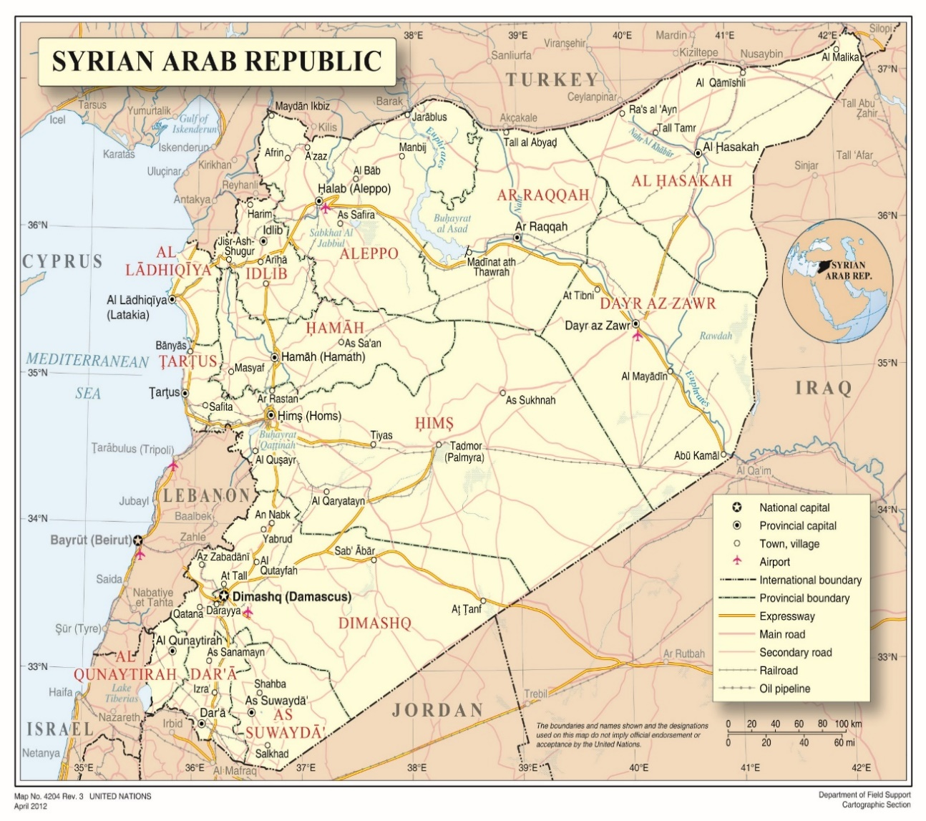

Annex II Estimated areas of influence – July 2021[75]

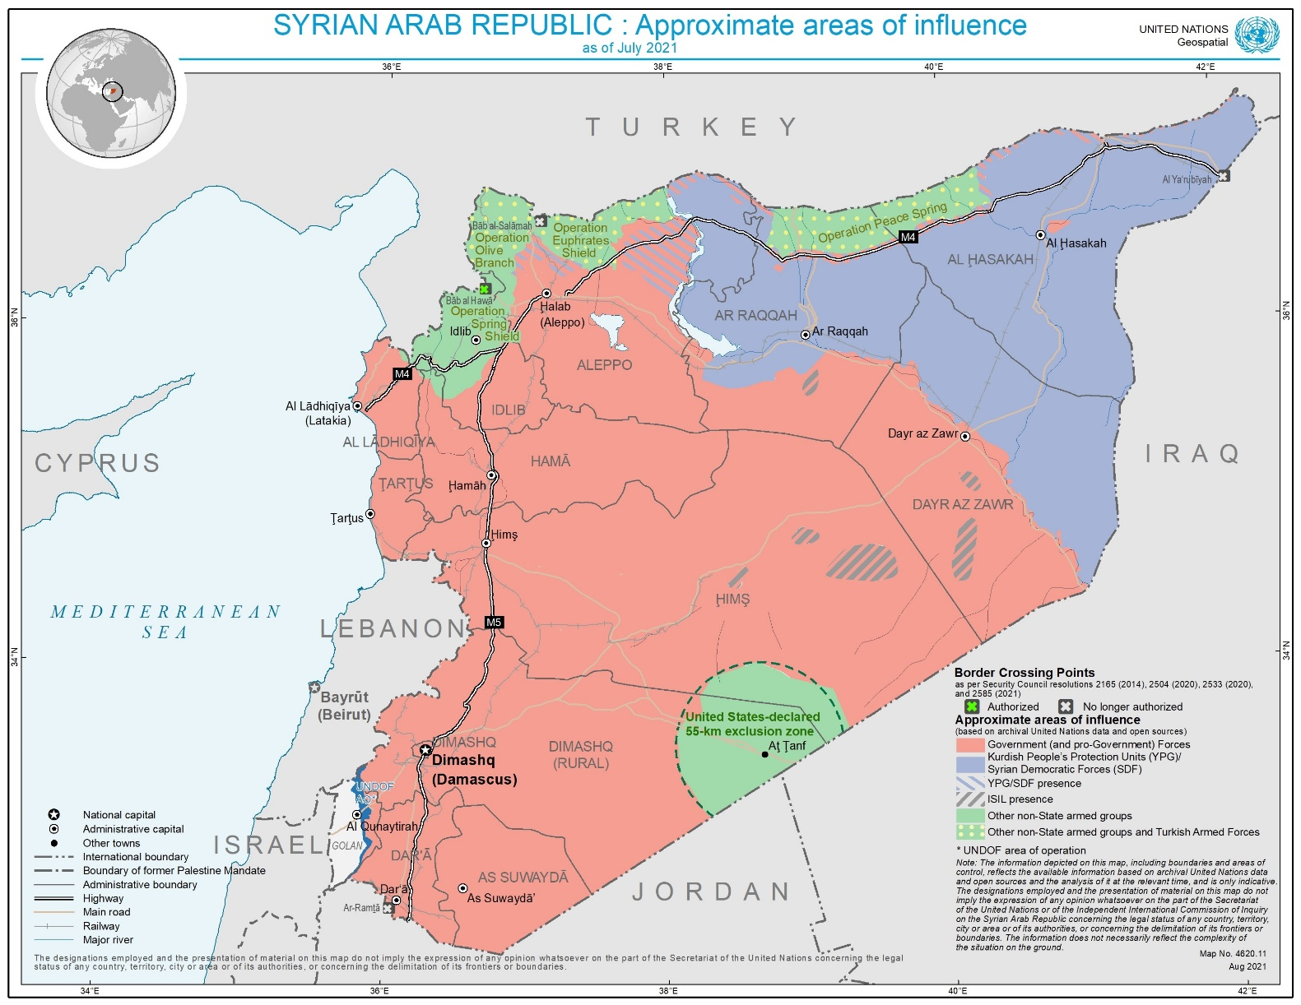

Annex III

Table of repatriations of foreign children and women

Repatriation of foreign children and women from SDF-run camps in North-eastern Syria (as of June 2021)[76]

| *Countries and areas* | *Repatriated Children (range)a* | *Countries and areas* | *Repatriated Women (range)a* |
| --- | --- | --- | --- |
|
| Kazakhstan, Uzbekistan*d* | 201-500 | *N/A* | 201-500 |
| Russian Federation*d* | 101-200 | Kazakhstan, Uzbekistan | 101-200 |
| Kosovo[77] | 51-100 | *N/A* | 51-100 |
| France | 26-50 | *N/A* | 26-50 |
| Germany | 16-25 | *N/A* | 16-25 |
| Australia, Belgium*g*, Bosnia and Herzegovina, Finland*d*, Norway, Sudan*d*, Sweden, United States of America*d*, Ukraine | 6-15 | Russian Federation | 6-15 |
| Albania, Austria, Canada, Denmark, Italy, Netherlands, Nigeria, Trinidad and Tobago, United Kingdom of Great Britain and Northern Ireland | 1-5 | Afghanistan, Albania, Finland*d*, Germany, Netherlands, Norway, Sudan, United States of America, Ukraine | 1-5 |
| Indonesia, Morocco*e*, Tajikistan | TBD*b* | Morocco*e* | TBD*b* |
| Afghanistan, Algeria*f*, Azerbaijan, Bangladesh, China, Egypt, Estonia*f*, Georgia, India, Iran, Kyrgyzstan, Lebanon, Libya, Malaysia, Maldives, North Macedonia*g*, Pakistan, Philippines, Poland, Portugal, Romania*f*, Saudi Arabia*f*, Senegal, Serbia, Somalia, South Africa, Switzerland, Tunisia, Turkey, Viet Nam*f*, Yemen, State of Palestine | None*c* | Algeria*f*, Australia, Austria, Azerbaijan, Bangladesh, Belgium*g*, Bosnia and Herzegovina, Canada, China, Denmark, Egypt, Estonia*f*, France, Georgia, India, Indonesia, Iran, Italy, Kyrgyzstan, Lebanon, Libya, Malaysia, Maldives, Nigeria, North Macedonia*g*, Pakistan, Philippines, Poland, Portugal, Romania*f*, Saudi Arabia*f*, Senegal, Serbia, Somalia, South Africa, Sweden, Switzerland, Tajikistan, Trinidad and Tobago, Tunisia, Turkey, United Kingdom of Great Britain and Northern Ireland, Viet Nam*f*, Yemen, State of Palestine, Kosovo | None*c* |

*a* Figures are based on information submitted by States in response to communications by United Nations Special Procedures (https://spcommreports.ohchr.org/Tmsearch/TMDocuments), submissions to the Commission (see footnote 4), and a compilation of open source data by the United Nations (until 30 June 2021).

*b* Repatriations have reportedly occurred, without indication of the number of individuals.

*c* The countries listed here are those for which the Commission received information that citizens were held and for whom there is no indication of any repatriation.

*d* Based on an average value due to differing information between sources.

*e* Eight individuals were reportedly repatriated, without specification as to the number of children and women.

*f* According to information submitted by States in response to communications by United Nations Special Procedures (https://spcommreports.ohchr.org/Tmsearch/TMDocuments), the national authorities have no indication as to the presence of citizens in Northeast Syria.

*g* Media reports outside the reporting period indicated recent repatriations (July 2021) from this country that have not been taken into account in the chart and would change the related classification.

Annex IV

Correspondence with the Government of the Syrian Arab Republic

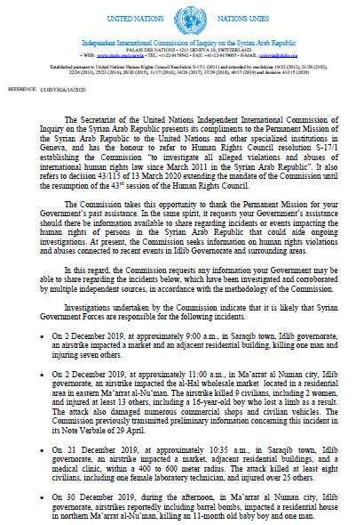

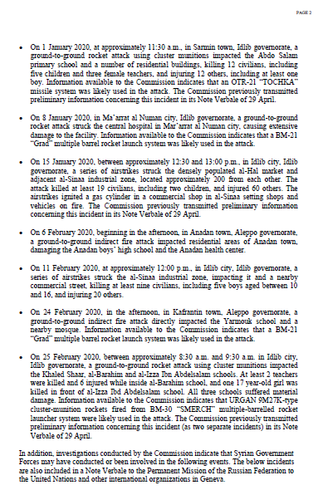

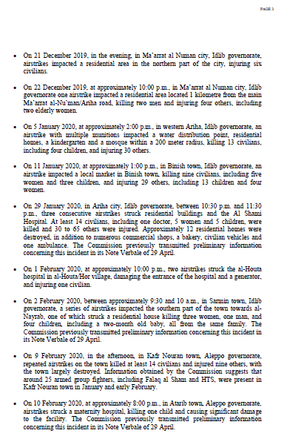

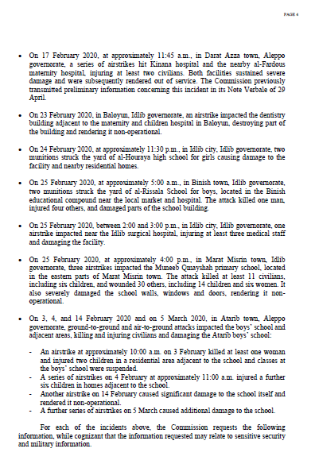

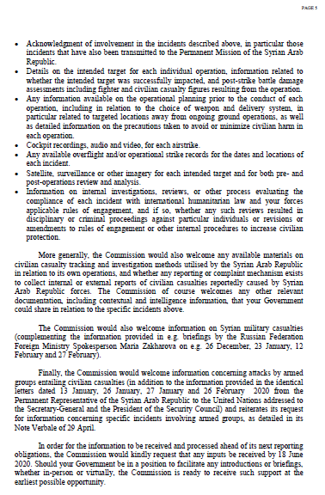

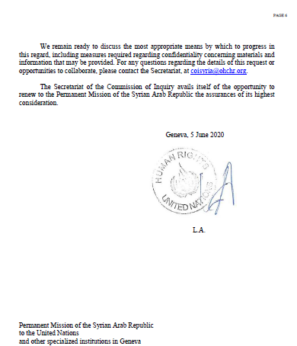

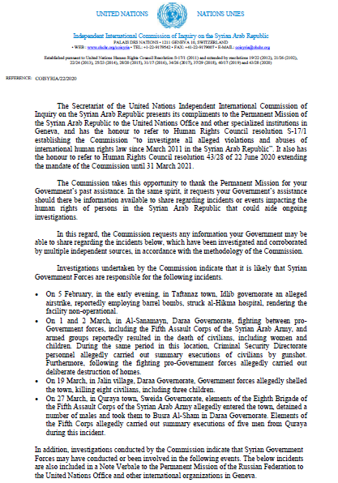

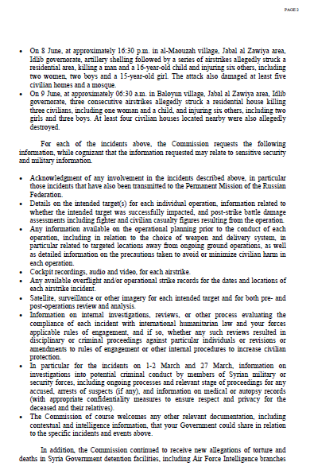

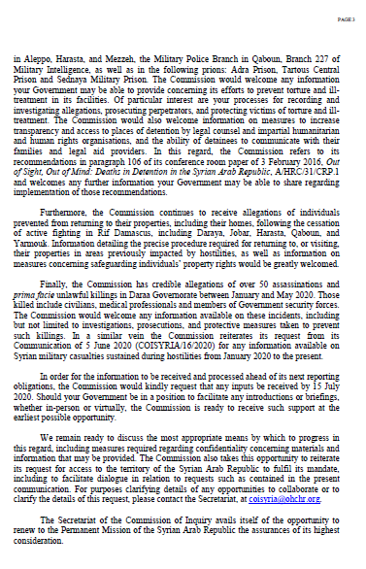

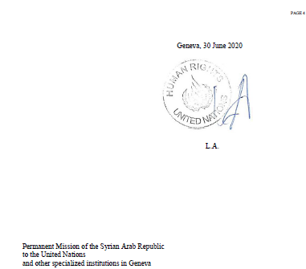

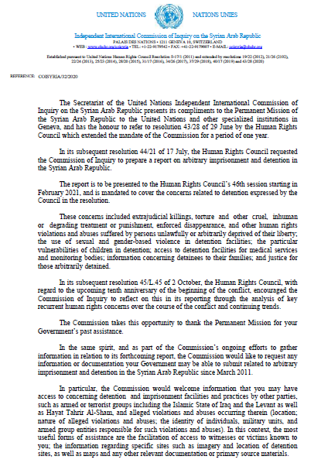

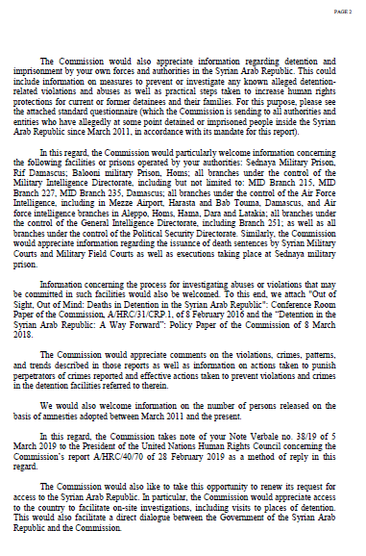

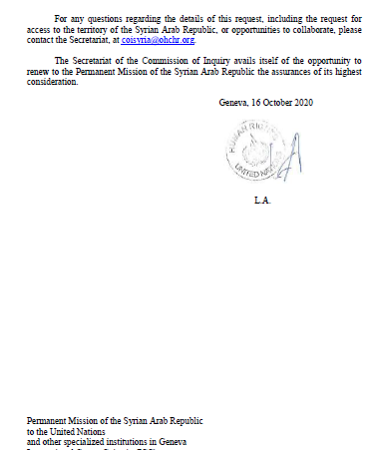

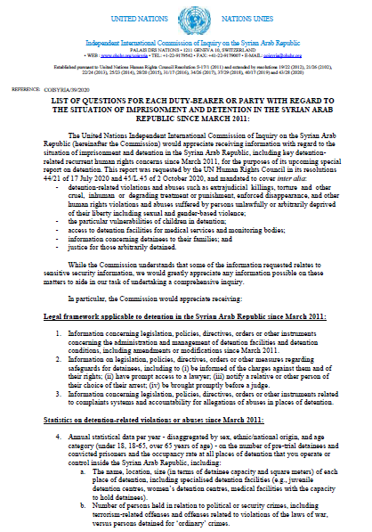

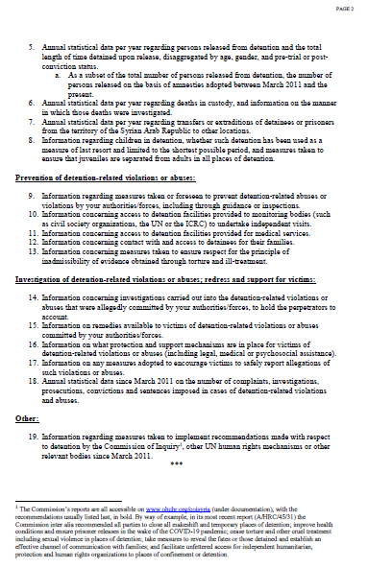

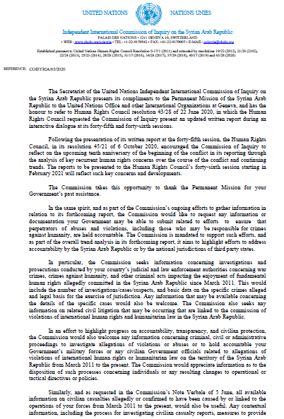

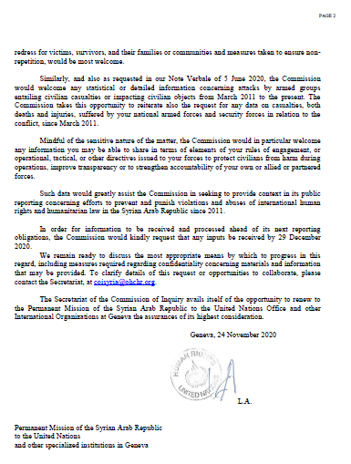

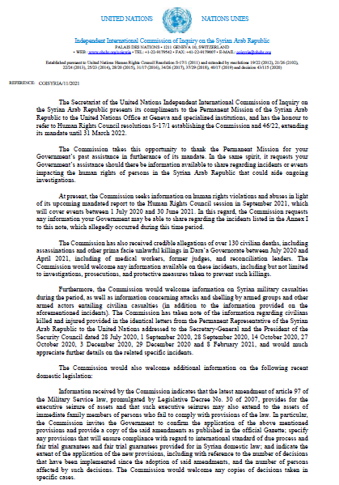

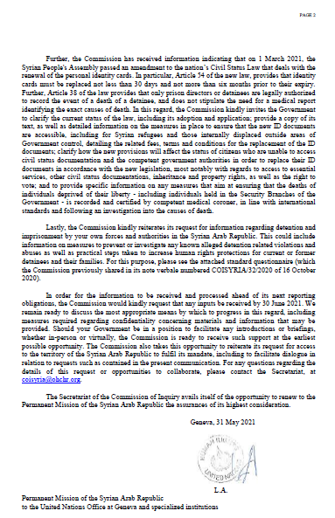

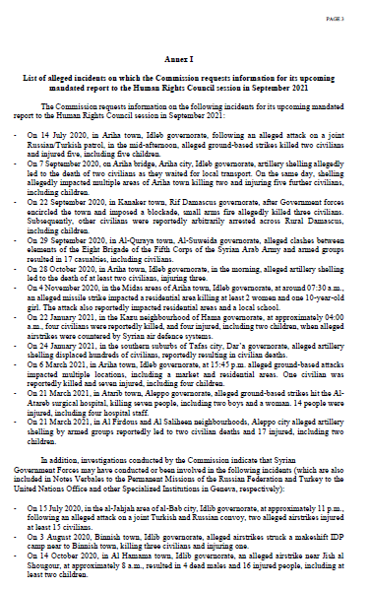

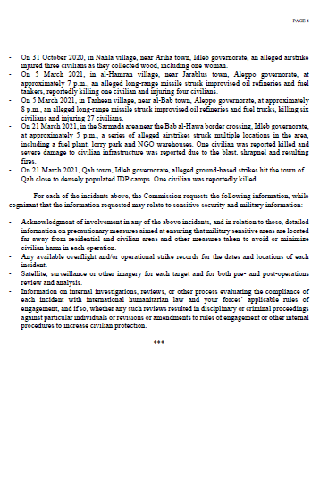

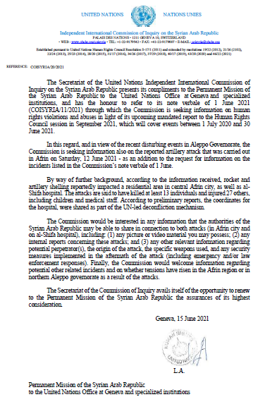

1. * Agreement was reached to publish the present report after the standard publication date owing to circumstances beyond the submitter’s control.
2. ** The annexes to the present report are circulated as received, in the language of submission only.
3. The commissioners are Paulo Sérgio Pinheiro (Chair), Karen Koning AbuZayd and Hanny Megally.
4. Owing to the travel limitations related to the coronavirus disease (COVID-19) pandemic, the majority of the interviews were undertaken remotely. During the reporting period, the Commission’s work was also affected by the United Nations regular budget liquidity crisis and related budget cuts, which forced the Commission to operate for most of the period with less than 40 per cent of the staff expected, significantly limiting the scope of its investigations.
5. The Government of the Syrian Arab Republic periodically addresses identical letters to the Secretary-General, the President of the Security Council and others in relation to situations of concern. The Commission analysed 68 such letters submitted by the Government between 1 July 2020 and 30 June 2021.
6. In communications dated 5 June, 30 June, 16 October and 24 November 2020 and 31 May and 15 June 2021, the Commission sought information from the Government of the Syrian Arab Republic on issues and incidents (see annex IV), but received no reply. During the same period, the Commission addressed 59 information requests to other parties to the conflict and other States members of the United Nations, and is thankful for the ensuing responses and exchanges.
7. For a map of the Syrian Arab Republic, see annex I.
8. See www.sana.sy/?p=1292868 (in Arabic).
9. World Food Programme, “Syria Country Office Market Price Watch Bulletin”, issue 77, April 2021.
10. See https://news.un.org/en/story/2021/06/1094782 and <https://reliefweb.int/sites/reliefweb.int/files/resources/2021%2004%20WFP%20Syria%20External%20Situation%20Report%2004%20-%20April%202021.pdf>.
11. See www.emro.who.int/syria/news/update-on-covid-19-vaccination-in-syria.html and https://reliefweb.int/sites/reliefweb.int/files/resources/Syrian%20Arab%20Republic%20-%20COVID-19%20Humanitarian%20Update%20No.%2026%20As%20of%2010%20June%202021.pdf.
12. See https://reliefweb.int/sites/reliefweb.int/files/resources/syria_2021_humanitarian_needs_overview.pdf.
13. Iran (Islamic Republic of), Israel, the Russian Federation, Turkey and the United States of America.
14. Data on record with the Commission. See also www.inherentresolve.mil/Releases/Strike-Releases.
15. See www.defense.gov/Explore/News/Article/Article/2516530/us-conducts-defensive-airstrikes-against-iranian-backed-militia-in-syria/ and www.defense.gov/Newsroom/Releases/Release/Article/2672875/statement-by-the-department-of-defense.
16. Data on record with the Commission. See also the identical letters submitted by the Government of the Syrian Arab Republic to the Secretary-General, the President of the Security Council and others between 1 July 2020 and 30 June 2021, in particular S/2021/46. For the definition of pro-government forces, see A/HRC/46/54, para. 19, footnote 27.
17. A/HRC/45/31, para. 12.
18. See, e.g., S/PV.8805 and www.un.org/press/en/2021/db210525.doc.htm.
19. See also A/HRC/39/65, para. 55.
20. See www.opcw.org/media-centre/news/2021/04/conference-states-parties-adopts-decision-suspend-certain-rights-and.
21. A/HRC/46/55, para. 99.
22. A/HRC/45/31, para. 17.
23. A/HRC/46/54, para. 16.
24. The Commission sought but did not receive such information from the Government of the Syrian Arab Republic.
25. A/HRC/46/55.
26. See also A/HRC/46/55, para. 24.
27. See also A/HRC/36/55, paras. 20–22.
28. A/HRC/46/55.
29. A/HRC/40/70, paras. 80–82.
30. See <https://reliefweb.int/sites/reliefweb.int/files/resources/syria_2021_humanitarian_needs_overview.pdf>, p. 16.
31. See generally A/HRC/44/61.
32. See https://reliefweb.int/report/syrian-arab-republic/syria-mvam-bulletin-56-june-2021.
33. Notwithstanding its change in name from “Jabhat al-Nusra” to “Jabhat Fatah al-Sham” in July 2016 and to “Hay’at Tahrir al-Sham” by early 2017, the Commission continues to regard the group as a terrorist entity as designated by Security Council resolution 2170 (2014), with links to Al-Qaida globally (see e.g. A/HRC/46/54, para. 7).
34. The Commission sought such information from the Government of the Syrian Arab Republic and from the Government of the Russian Federation, but did not receive any reply.
35. See also A/HRC/44/61, paras. 43–45, 56 and 75–76.
36. A/HRC/44/61, para. 45.
37. See https://reliefweb.int/report/syrian-arab-republic/five-sams-medical-staff-injured-airstrikes-al-atareb-surgical-hospital.
38. See https://cdn.logcluster.org/public/logistics_cluster_syria_cross-border_operations_2020.pdf and https://reliefweb.int/sites/reliefweb.int/files/resources/20210326_sitrep_26_final.pdf.
39. A/HRC/37/72, paras. 73–74.
40. See, for example, regular information bulletins issued during the reporting period by the Ministry of Defence of the Russian Federation regarding the status of implementation of the memorandum on the creation of de-escalation areas.
41. A/HRC/40/70, paras. 54–57.
42. A/HRC/44/61, paras. 103–104.
43. A/HRC/46/55, sects. VI.A. and VIII.
44. A/HRC/46/54, para. 18.
45. Confidential submission.
46. A/HRC/46/54, para. 12.
47. See also A/HRC/45/31, paras. 46 and 52–56.
48. Ibid., paras. 46–51.
49. Confidential submission.
50. See “‘I lost my dignity’: sexual and gender-based violence in the Syrian Arab Republic”. Available from www.ohchr.org/EN/HRBodies/HRC/IICISyria/Pages/Documentation.aspx.
51. A/HRC/45/31, paras. 59–60.
52. A/66/268, paras. 62–65.
53. See also A/HRC/45/31, para. 66.
54. Ibid., para. 67.
55. On the obligations relating to missing persons, see A/HRC/AC/6/2, paras. 21–22.
56. The beginning of a second phase of the “deterrence of terrorism” operation.
57. “Regulations” imposing a Kurdish curriculum have been announced by the self-administration, effectively preventing students from accessing education in government institutions. This has triggered protests that, in turn, have led the self-administration to revoke such decisions.
58. Confidential submission.
59. Ibid.
60. See www.hawarnews.com/en/haber/sdf-releases-military-instructions-on-health-care-h23521.html.
61. Confidential submission.
62. Ibid.
63. A/HRC/45/31, para. 77, and confidential submission.
64. See https://news.un.org/en/story/2021/02/1085982.
65. See https://www.msf.org/covid-19-has-devastating-knock-effect-northeast-syria.
66. See https://www.unicef.org/press-releases/eight-children-die-al-hol-camp-northeastern-syria-less-week.
67. See https://www.unicef.org/press-releases/two-children-killed-al-hol-camp-syria.
68. See https://asayish.org/?p=1915 (in Arabic).
69. Confidential submission.
70. United Nations data and confidential submission.
71. See https://m-syria-d.com/en/?p=2795. Information was also drawn from a confidential submission.
72. See also A/HRC/40/70, para. 92.
73. As previously recommended in A/HRC/46/55, para. 113.
74. The boundaries and names shown and the designations used on this map do not imply official endorsement or acceptance by the United Nations.
75. The representation of approximate areas of influence is limited to data relevant for the human rights situation in the Syrian Arab Republic and in relation to the mandate and findings of the Commission of Inquiry on the Syrian Arab Republic.
76. This table does not reflect the repatriation of Iraqi nationals, who form the largest group of foreigners in North-eastern Syria.
77. References to Kosovo shall be understood to be in the context of Security Council resolution 1244 (1999).