COMMITTEE ON THE RIGHTS OF PERSONS WITH DISABILITIES

Submission by:

ADF International
Chemin du Petit-Saconnex 28
1209 Geneva, Switzerland

Web: www.ADFinternational.org
Email: RNavarro@ADFinternational.org

ECOSOC Special Consultative Status (2010)

General Comment No. 6 on Article 5 of the CRPD – Equality and Non-discrimination
30 November 2017
Geneva, Switzerland

Introduction
- ADF International is a global alliance-building legal organization that advocates for religious freedom, life, and marriage and family before national and international institutions. As well as having ECOSOC consultative status with the United Nations (registered name “Alliance Defending Freedom”), ADF International has accreditation with the European Commission and Parliament, the Organization for Security and Co-operation in Europe, and the Organization of American States, and is a participant in the FRA Fundamental Rights Platform.
- ADF International welcomes the opportunity to provide comments to the Committee on the Rights of Persons with Disabilities regarding Draft General Comment on Equality and Non-discrimination, article 5 of the Convention on the Rights of Persons with Disabilities. This submission first covers the situation of unborn persons with disabilities, who are increasingly targeted for abortion through Non-Invasive Prenatal Testing (NIPT) and other screening and diagnostic tools. The submission demonstrates how the Committee has already acknowledged that article 5 applies to unborn persons with disabilities, and accordingly how article 10 on the right to life should also apply to them. ADF International calls on the Committee to consistently protect unborn persons with disabilities by recommending the prohibition of abortion on the grounds of disability and further to protect the right to life of all unborn persons. Next, the submission discusses the Draft General Comment’s introduction of “intersectional discrimination” into the Convention, highlighting that the term does not appear in the text and inappropriately extends States Parties’ obligation to prohibit all discrimination on the basis of disability. Finally, the submission points out that the Committee has become the arbiter of what is discrimination and that States Parties should have deference in this area.
- Accordingly, ADF International makes the following recommendations to the Committee:
- Explicitly acknowledge the challenges faced by unborn persons with disabilities;
- Recognize, drawing from the Committee’s previous comments and observations, that article 5 applies to unborn persons with disabilities, and that they therefore deserve equal protection of the law and protection from discrimination;
- Add a subsection to Section VII (Relationship with other specific articles of the Convention) recognizing that article 10 on the right to life applies to unborn persons with disabilities;
- Call on States Parties in Section VIII (Implementation at the national level) to abolish abortion provisions on the grounds of fetal disability, and further to protect the right to life of all unborn persons with disabilities by prohibiting abortion, in order to prevent continued discrimination against such persons under the cover of general abortion laws;
- Eliminate “intersectional discrimination” language in paragraphs 3, 10, 20e), 22, 33, 38, 41, 42, 44, 62a), and 76d, l & m) and focus solely on discrimination on the grounds of disability; and
- Eliminate the list of possible grounds of discrimination in paragraph 22.

Equal protection for and non-discrimination against unborn persons with disabilities

Background
- The targeted elimination of persons with disabilities is occurring at an increasing rate today through abortion.
- For example, abortion rates for prenatal diagnoses of Down Syndrome, the most common chromosomal abnormality, are high: nearly 100 percent in Iceland, 77 percent in France, 98 percent in Denmark, 80-90 percent in Norway, and 90 percent in the United Kingdom. In the United States, it is 67 percent.
- One major reason for such high numbers is the introduction of non-invasive prenatal testing (NIPT) in 2011. NIPT is a blood test used to screen for certain chromosomal abnormalities: Down Syndrome (Trisomy 21), Patau Syndrome (Trisomy 13), and Edwards Syndrome (Trisomy 18). Because it is noninvasive, unlike the diagnostic tests chorionic villus sampling (CVS) and amniocentesis, NIPT is a popular option for pregnant women. Women can undergo NIPT screening as early as ten weeks pregnant. The test is considered 99 percent accurate with respect to identifying when the fetus has an abnormality, but it also has false positives, where the fetus does not have an abnormality but the test identifies one.
- Countries like Iceland require that all pregnant women learn they have the option of NIPT, and 80 to 85 percent of pregnant women in Iceland do undergo the screening; presumably, many women who do not undergo the screening have no risk factors for having a fetus with one of the screened-for chromosomal abnormalities. The predominant trend in countries where women have access to NIPT is the abortion of fetuses with abnormalities. This means that in countries that have a policy of recommending NIPT to all pregnant women—and offering it to them for free—fetuses with these abnormalities will be aborted at high rates.
- There are other screening tools, such as blood screens and ultrasounds, for chromosomal abnormalities, heart defects, and other disabilities. Diagnostic tools—which go beyond screening and actually diagnose a wide range of abnormalities—include CVS, amniocentesis, and high-resolution ultrasound. With the availability of all these tools, an increasing number of people are choosing to abort fetuses with disabilities.

Protecting unborn persons with disabilities
- Laudably, the Draft General Comment acknowledges the discrimination against unborn persons with disabilities through policies that emphasize screening for disabilities. Paragraph 44 of the Draft General Comment states, “States parties should address stigmatization through modern forms of discrimination, such as a disability-selective antenatal screening policy that go against the recognition of the equal worth of every person.”
- The Committee’s previous comments also highlight the discrimination faced by unborn persons with disabilities. In comments to the Human Rights Committee on its draft of the General Comment No. 36 on article 6 (the right to life) of the International Covenant on Civil and Political Rights, the Committee explicitly stated that provisions allowing for abortion on the grounds of disability violate article 5 of the Convention:
Laws which explicitly allow for abortion on grounds of impairment violate the Convention on the Rights of Persons with Disabilities (Art,. 4,5,8). Even if the condition is considered fatal, there is still a decision made on the basis of impairment. Often it cannot be said if an impairment is fatal. Experience shows that assessments on impairment conditions are often false. Even if it is not false, the assessment perpetuates notions of stereotyping disability as incompatible with a good life.
- In its concluding observations, the Committee has recommended that countries with provisions allowing abortion in the case of fetal disability abolish any distinctions between how these countries treat abortions on the grounds of disability and how they treat abortions on other grounds, specifically with respect to the timeframe. The Committee has made such recommendations to Spain, Hungary, Austria, and the United Kingdom. In each case except Spain, the Committee based its recommendations on article 5. Notably, the Committee did not tell these countries to abolish provisions allowing abortion on the grounds of fetal disability, only the disparate treatment. For these recommendations to be in line with its comments to the Human Rights Committee, it would have had to recommend that these countries abolish disability provisions altogether.
- The Committee’s concluding observations, comments to the Human Rights Committee, and draft paragraph 44 indicate that the Committee rightly believes article 5 applies to unborn persons. What follows is that unborn persons with disabilities are entitled to equal protection of the laws and States Parties must prohibit discrimination against unborn persons with disabilities.
- Because the Committee recognizes that “persons” under the Convention includes unborn persons, it must also interpret article 10 as applying to the unborn. Article 10 states, “States Parties reaffirm that every human being has the inherent right to life and shall take all necessary measures to ensure its effective enjoyment by persons with disabilities on an equal basis with others.”
- The Draft General Comment has rightly identified antenatal screening policies as potentially discriminatory against unborn persons with disabilities. Policies that even subtly encourage people to abort fetuses with positive abnormality test results clearly discriminate against those unborn persons. Awareness-raising should include state-sponsored campaigns promoting the dignity of persons with disabilities, their enjoyment of their lives, and how their families value them.
- A model example of a private campaign that could be adopted by States is that created by the Fondation Jérôme Lejeune and other European organizations to celebrate World Down Syndrome Day in 2014. An advertisement called “Dear Future Mom” depicts young people with Down Syndrome telling a woman pregnant with a baby diagnosed with Down Syndrome that she and her child could have happy lives, even if at times difficult. Unfortunately, instead of supporting the campaign, France’s Council of State banned the video because it could “disturb the conscience of women who, in accordance with the law, have made personal life choices.” The country would not allow the portrayal of persons with disabilities leading lives of dignity and value.
- States can promote NIPT and other screening and diagnostic tools as means to help mother and baby go as safely as possible through pregnancy and childbirth, and to prepare the parents for possible medical interventions and other decisions after the birth of the child. States should not promote these tests as a pathway to abortion in the event of a test result indicating a likely abnormality.
- However, the Draft General Comment must go beyond merely calling for awareness-raising, as awareness-raising is only a small tool in combating discrimination. First, it must call on States to provide real help to parents who receive prenatal diagnoses of disabilities or abnormalities, such as connecting them to appropriate medical care, counselors, support groups of families with children with similar diagnoses, and even perinatal palliative care and support in the case of children expected to live only a short time.
- The Draft General Comment must also emphasize that to comply with article 5(1) on equal protection of the law—to “refrain from any discrimination against persons with disabilities when enacting laws and policies” (paragraph 18)—States Parties must not have provisions allowing abortion of unborn persons with disabilities. Going further, in order to meet their obligations to “prohibit all discrimination on the basis of disability” (article 5(2), paragraph 19), States Parties must specifically prohibit abortion on the grounds of disability.
- Despite its negative view toward specific provisions on abortion on the grounds of fetal disability, the Committee supports “[w]omen’s rights to reproductive and sexual autonomy,” even though nowhere in international human rights treaties is abortion mentioned. This is essentially support for laws that allow abortion generally, provided that fetal disability is not listed as a permissible ground, and so long as a fetus with a disability cannot be aborted further along in pregnancy than a fetus without a disability.
- Laws that allow abortion generally or on any ground violate States’ obligation to “prohibit all discrimination on the basis of disability” because they still allow the abortion of fetuses with disabilities. Such laws do not serve as a deterrent or as a way for encouraging people to consider the value of the lives of persons with disabilities. They simply give people the option to abort on the grounds of disability without having to provide the reason to the State.
- This means that the only law that prevents the targeted abortion of unborn persons with disabilities and that is consistent with recognizing their inherent dignity is one that recognizes and protects the right to life of all unborn persons. Any law permitting abortion opens the door to the targeting of unborn persons with disabilities through abortion, and therefore States Parties should prohibit abortion.
Recommendations: (1) Explicitly acknowledge the challenges faced by unborn persons with disabilities. (2) Add a subsection to Section VII (Relationship with other specific articles of the Convention) recognizing that article 10 on the right to life applies to unborn persons with disabilities. (3) Recognize, drawing from the Committee’s previous comments and observations, that article 5 applies to unborn persons with disabilities, and that they therefore deserve equal protection of the law and protection from discrimination. (4) Call on States Parties in Section VIII (Implementation at the national level) to abolish abortion provisions on the grounds of fetal disability, and further to protect the right to life of all unborn persons with disabilities by prohibiting abortion, in order to prevent continued discrimination against such persons under the cover of general abortion laws.

DISCRIMINATION

Obligation to “prohibit all discrimination on the basis of disability”
- The Committee is tasked with monitoring States’ implementation of the Convention on the Rights of Persons with Disabilities. The Convention is obviously focused on protecting persons with disabilities. Therefore, the Draft General Comment on article 5, on equality and non-discrimination, must focus on equality and non-discrimination for persons with disabilities. However, the Draft General Comment goes beyond this task and introduces a new concept, intersectional discrimination, to the Convention, which States Parties did not agree to when they ratified the Convention.
- The Committee states in paragraph 10 that “the Convention is the first human rights treaty to acknowledge explicitly intersectional discrimination.” As support for this claim, it cites article 6, on women with disabilities, which “recognize[s] that women and girls with disabilities are subject to multiple discrimination [ . . . ].” It also cites preamble (p), the non-operative section of the treaty, which lists types of discrimination faced by some persons with disabilities: “race, colour, sex, language, religion, political or other opinion, national, ethnic, indigenous or social origin, property, birth, age or other status[.]”
- However, while the Convention does state in article 6 that “women and girls are subject to multiple discrimination,” nowhere does it recognize intersectional discrimination. The Committee itself emphasizes the difference between multiple discrimination and intersectional discrimination in paragraph 22, acknowledging that they are not the same. The Committee’s Draft General Comment therefore broadens the scope of how the Convention addresses discrimination.
- The Committee then states in paragraph 20, “The duty to prohibit ‘all discrimination’ includes all forms of discrimination.” The forms of discrimination it then identifies are a) direct discrimination, b) indirect discrimination, c) denial of reasonable accommodation, d) harassment, and e) intersectional discrimination.
- First, it must be clear that the “all discrimination” the Committee emphasizes must be prohibited is specifically stated in the Convention in article 5(2) as “all discrimination on the basis of disability.” In article 2, the Convention defines the specific term “discrimination on the basis of disability,” not discrimination in general.
- Second, it is important to consider what “intersectional discrimination” is. The Committee defines “intersectional discrimination” in paragraph 20e) as “when a person having a status or a characteristic associated with one or more prohibited grounds is discriminated on several prohibited grounds or statuses” and in paragraph 22 as “refer[ring] to a situation where several grounds operate and interact with each other at the same time in such a way that they are inseparable.”
- From these definitions it is impossible to determine how a State Party should deal with so-called “intersectional” discrimination any differently than other discrimination. However, the definitions indicate intersectional discrimination includes discrimination that goes beyond “on the basis of disability,” given that it includes other grounds. States Parties have obligated themselves to prohibit “all discrimination on the basis of disability,” not whatever notion of intersectional discrimination the Committee has developed.
- Further, the concept of “intersectional discrimination” or “intersectionality” is polarizing among persons with disabilities and their advocates, as not all agree on its merit. It unnecessarily distracts from core issues of discrimination and marginalizes those who disagree.
Recommendations: Eliminate “intersectional discrimination” language in paragraphs 3, 10, 20e), 22, 33, 38, 41, 42, 44, 62a), and 76d, l & m) and focus solely on discrimination on the grounds of disability.
Obligation to “guarantee to persons with disabilities equal and effective legal protection against discrimination on all grounds”
- The Committee then discusses States Parties’ obligation to guarantee to persons with disabilities equal and effective legal protection against discrimination on all grounds. Paragraph 22 states that “all possible grounds of discrimination and their intersections have to be taken into account” with respect to States. The Committee then enumerates over 25 different grounds of discrimination:
race, colour, descent, sex, pregnancy and maternity, civil, family or carer status, gender identity, sexual orientation, language, religion, political or other opinion, national, ethnic, indigenous or social origin, migrant, refugee or asylum status, association with a national minority member, economic status or property, health status, genetic or other predisposition towards illness, birth, and age, or a combination of any of these grounds, or characteristics associated with any of these grounds.
- Paragraph 22 is a non-exhaustive list of types of “discrimination and their intersections” the Committee wants States Parties to target. The means by which States will then guarantee to persons with disabilities equal and effective legal protection is “[e]xplicit prohibition of disability-based and other discrimination against persons with disabilities in legislation [ . . . ]” (paragraph 23).
- First, the list is just a list and does not provide meaningful guidance. What is meant by discrimination in each of these categories, and, more specifically, why is that discrimination impermissible? This list gives the impression that a wide swath of laws and actions would be impermissible.
- Second, the Committee’s focus should not be to determine what types of discrimination are impermissible, beyond discrimination on the basis of disability. Otherwise, that would make the Committee the arbiter of all discrimination, when the Convention deals with discrimination on the basis of disability.
- Third, the States Parties to the Convention must have deference to determine what “discrimination on all grounds” entails. Whatever grounds a State Party identifies as impermissible, States Parties must provide equal and effective legal protection for persons without disabilities.
Recommendations: Eliminate the list of possible grounds of discrimination in paragraph 22.

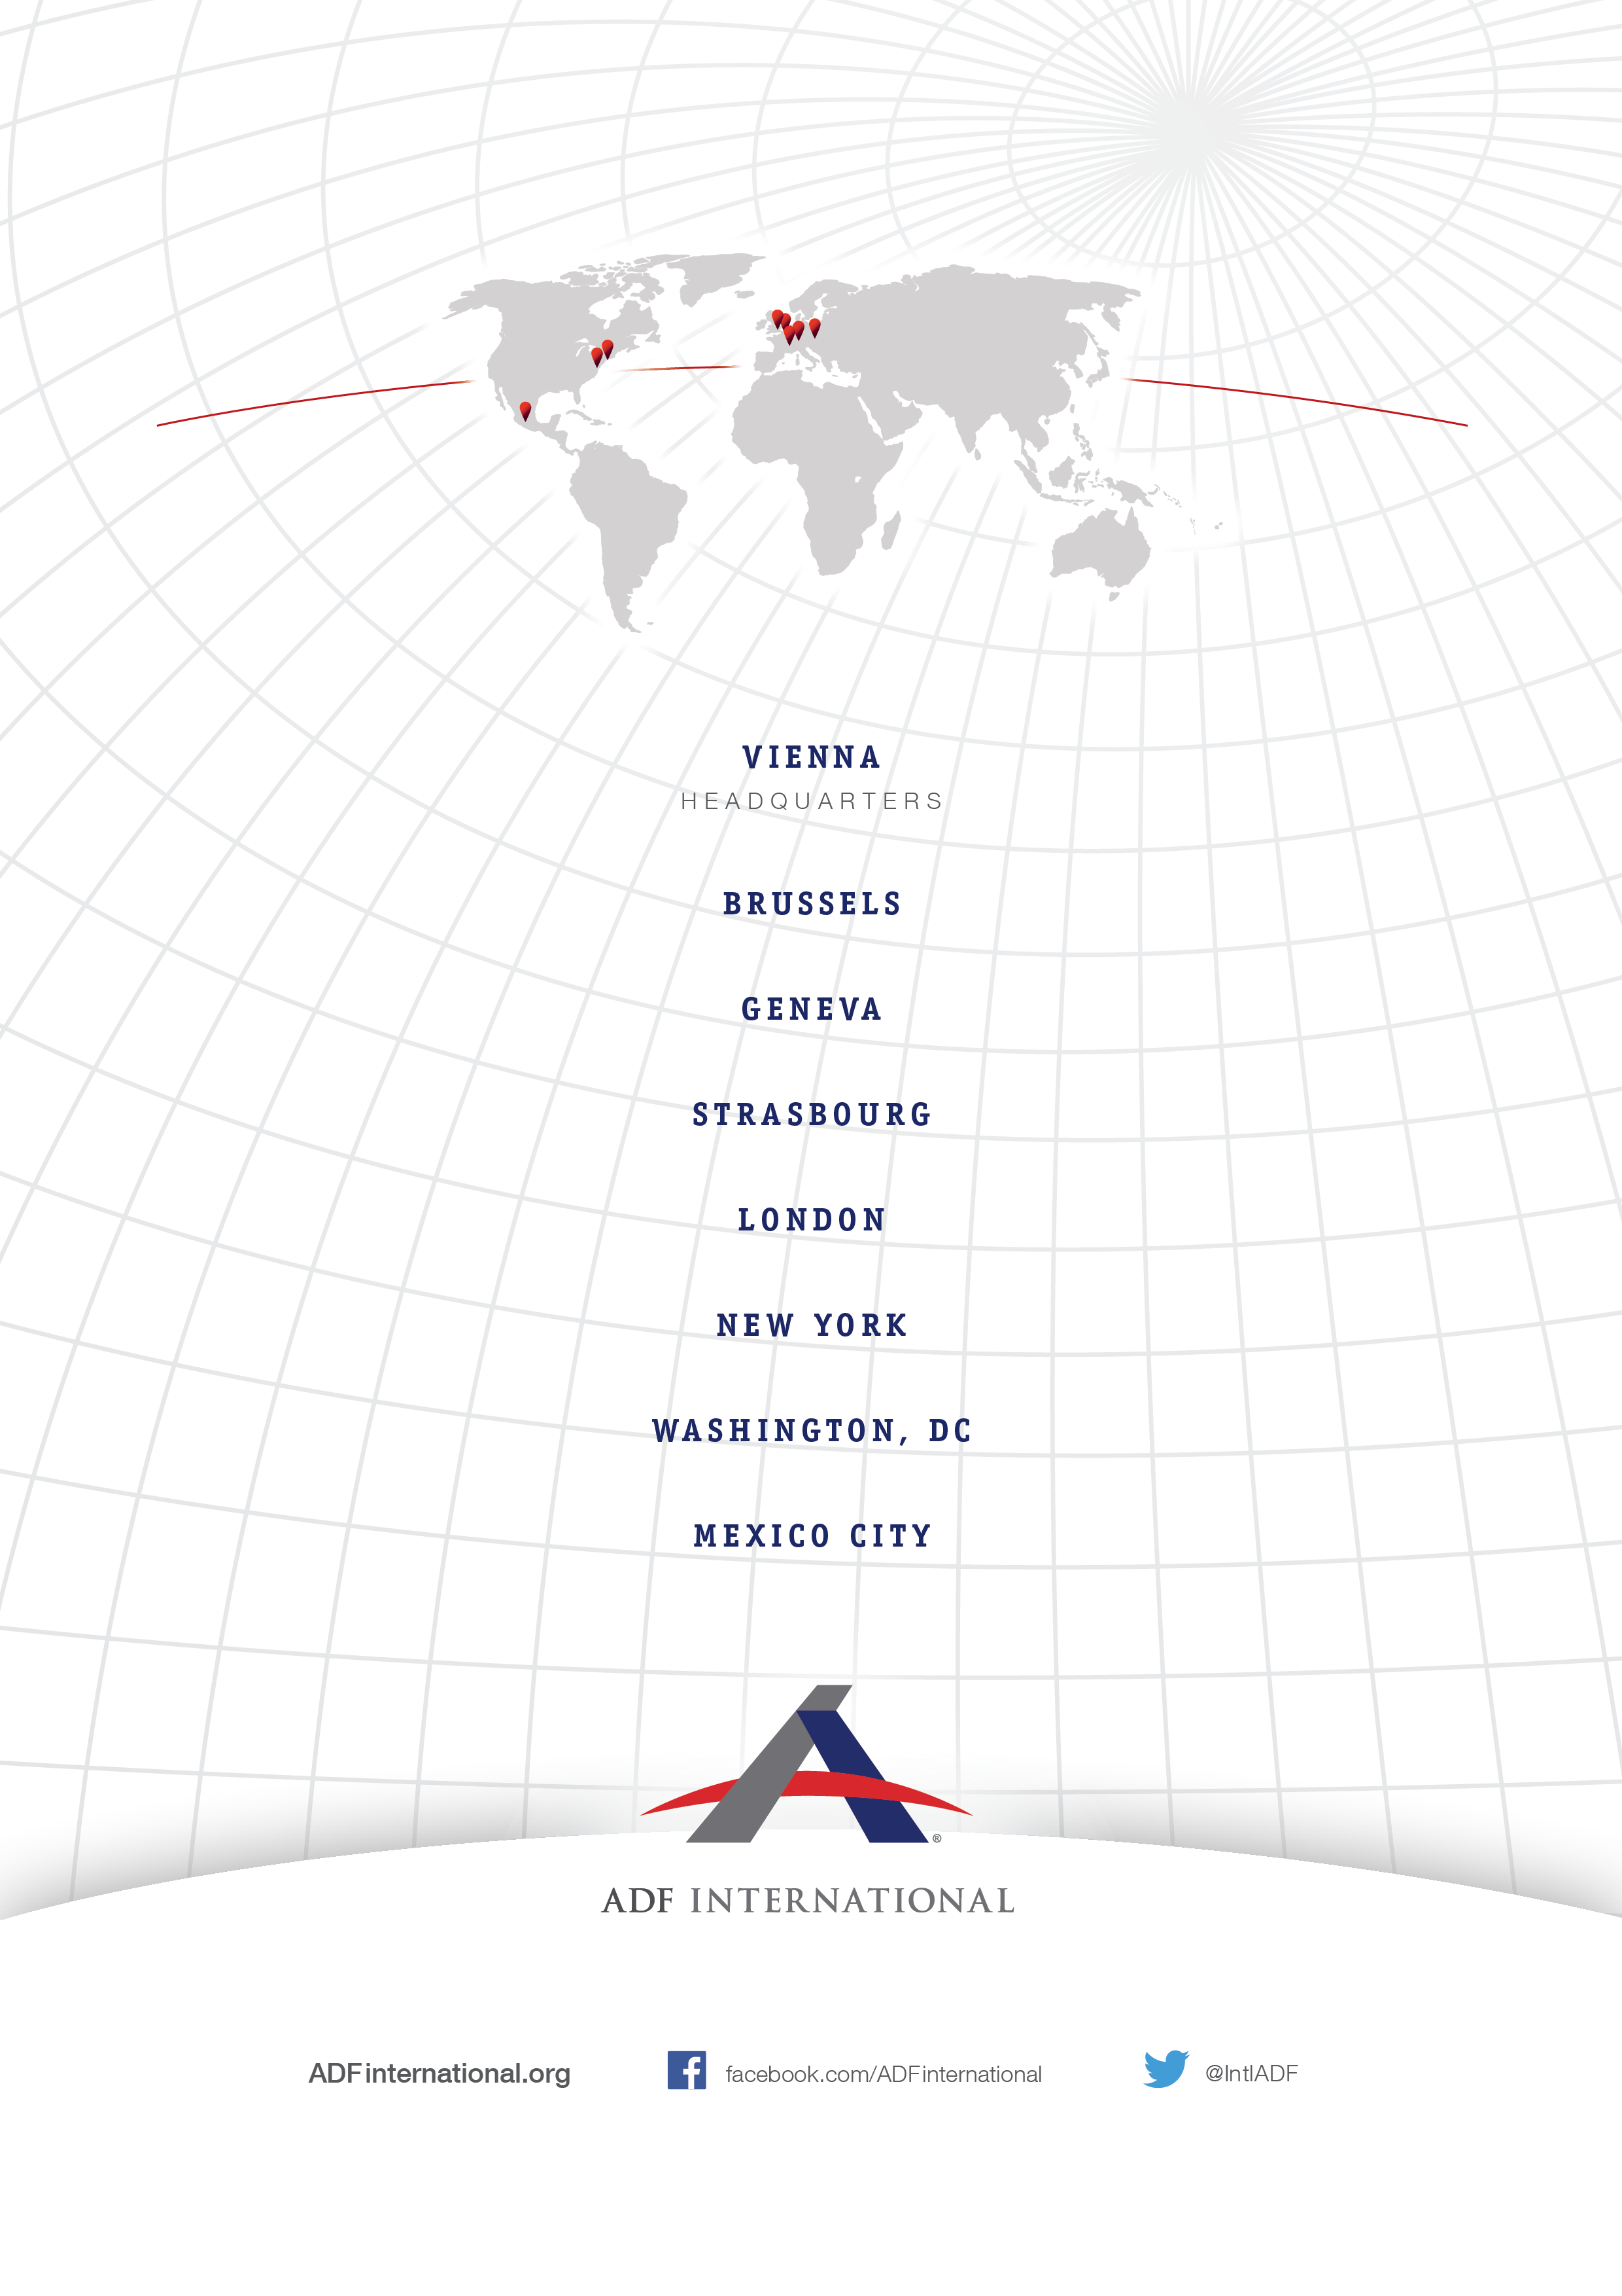
© 2017

Julian Quinones & Arijeta Lajka, “What kind of society do you want to live in?”: Inside the country where Down syndrome is disappearing, CBS News (Aug. 15, 2017), https://www.cbsnews.com/ news/down-syndrome-iceland/.
Christian W., Down Syndrome heading for extinction in Denmark, CPH Post (Oct. 20, 2015), http://cphpost.dk/news/down-syndrome-heading-for-extinction-in-denmark.html.
Nine out of Ten Mothers in Norway Choose Abortion for Down Diagnosis, Nordic Page (Mar. 4, 2014), https://www.tnp.no/norway/panorama/4366-nine-out-of-ten-mothers-in-norway-choose-abortion-for-down-diagnosis.
Alison Gee, A world without Down’s syndrome?, BBC News Mag. (Sept. 29, 2016), http://www.bbc.com/news/magazine-37500189.
J.L. Natoli et al., Prenatal diagnosis of Down syndrome: a systematic review of termination rates (1995-2011), 32 Prenatal Diagnosis 142, https://www.ncbi.nlm.nih.gov/pubmed/22418958.
See Am. Coll. Obstetricians & Gynecologists (ACOG), Committee Opinion 640, Cell-free DNA Screening for Fetal Aneuploidy (Sept. 2015), https://www.acog.org/Resources-And-Publications/ Committee-Opinions/Committee-on-Genetics/Cell-free-DNA-Screening-for-Fetal-Aneuploidy.
Prenatal Tests Have High Failure Rate, Triggering Abortions, NBC News (Dec. 14, 2014), https://www.nbcnews.com/health/womens-health/prenatal-tests-have-high-failure-rate-triggering-abortions-n267301.
Ctrs. for Disease Control, Birth Defects: Diagnosis, https://www.cdc.gov/ncbddd/birthdefects/ diagnosis.html (last visited Nov. 28, 2017).
Id.
Comm. on the Rights of Persons with Disabilities (CRPD), Comments on the draft General Comment No36 of the Human Rights Committee on article 6 of the International Covenant on Civil and Political Rights, http://www.ohchr.org/EN/HRBodies/CCPR/Pages/GC36-Article6Righttolife.aspx.
CRPD, Concluding observations on the initial report of Spain, 17-18, U.N. Doc. CRPD/C/GBR/CO/1 (Oct. 19, 2011).
CRPD, Concluding observations on the initial periodic report of Hungary, 17-18, U.N. Doc. CRPD/C/HUN/CO/1 (Oct. 22, 2012).
CRPD, Concluding observations on the initial report of Austria, 14-15, U.N. Doc. CRPD/C/AUT/CO/1 (Sept. 13, 2013).
CRPD, Concluding observations on the initial report of the United Kingdom of Great Britain and Northern Ireland, 12-13, U.N. Doc. CRPD/C/GBR/CO/1 (Oct. 3, 2017).
Fondation Jérôme Lejeune, A campaign, Dear Future Mom, is being launched on internet and social networks for the World Down Syndrome Day on the 21st of March 2014 (Mar. 17, 2014), https://www.fondationlejeune.org/en/a-campaign-dear-future-mom-is-being-launched-on-internet-and-social-networks-for-the-world-down-syndrome-day-on-the-21st-of-march-2014/.
French TV bans advert with smiling Down’s syndrome children as it might ‘DISTURB’ women who have had an abortion, Mirror (Nov. 26, 2016), http://www.mirror.co.uk/news/world-news/french-tv-bans-advert-smiling-9340336.
CRPD, Concluding observations on the initial report of the United Kingdom of Great Britain and Northern Ireland, 13.
Emphasis added.
Emphasis added.

