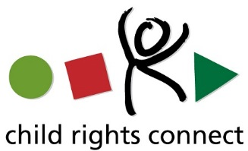
Oral Statement by Child Rights Connect for the CRPD’s Consultation on its draft General Comment n°7
27 August 2018

Thank you Chair,
Child Rights Connect would like to thank the CRPD Committee for providing the opportunity to share inputs and recommendations on its draft General Comment n°7. Appreciating the CRPD Secretariat’s support for reading out this statement, we would like to seize this opportunity to raise few key recommendations from our written submission.
The General Comment should recognize children with disabilities as a specific group that has its own challenges in order to call for tailored policies and measures to tackle barriers for their empowerment. Children with disabilities are particularly vulnerable to discrimination and experience what is called “double jeopardy”: they suffer violations of their rights on the grounds of age, like other children, as well as on the grounds of their disability.
The General Comment should reflect the CRC standards on children’s right to freedom of association and expression as well as children’s right to be heard, by including “child-led organisations and initiatives” as an additional type of “representative organisations” to both acknowledge children’s role in channelling the views of their constituency and in promoting their development and advocacy.
The General Comment should also recognise that children with disabilities need specific participation processes and should elaborate on the measures that need to be taken to provide disability and age-appropriate assistance as well as on capacity building activities to family members, teachers, disability workers, etc. to have a right based perspective on participation and for them to provide appropriate support to children with disabilities.
Finally, we call for the CRPD Committee to engage in two on-going processes that are relevant for the topic of the General Comment and key opportunities to advance the standards and practices on child participation: 1) the Day of General Discussion of the CRC Committee on the “protection and empowerment of children as human rights defenders” that will take place on 28 September in Palais des Nations; 2) the 2019 Resolution and Day of the Rights of the Child of the Human Rights Council which will focus on the “empowerment of children with disabilities, for the enjoyment of their rights, including through inclusive education”.

I thank you.

