Submission to the

Committee on the Rights of Persons with Disabilities

Day of General Discussion on the right to education for persons with disabilities

15th April 2015

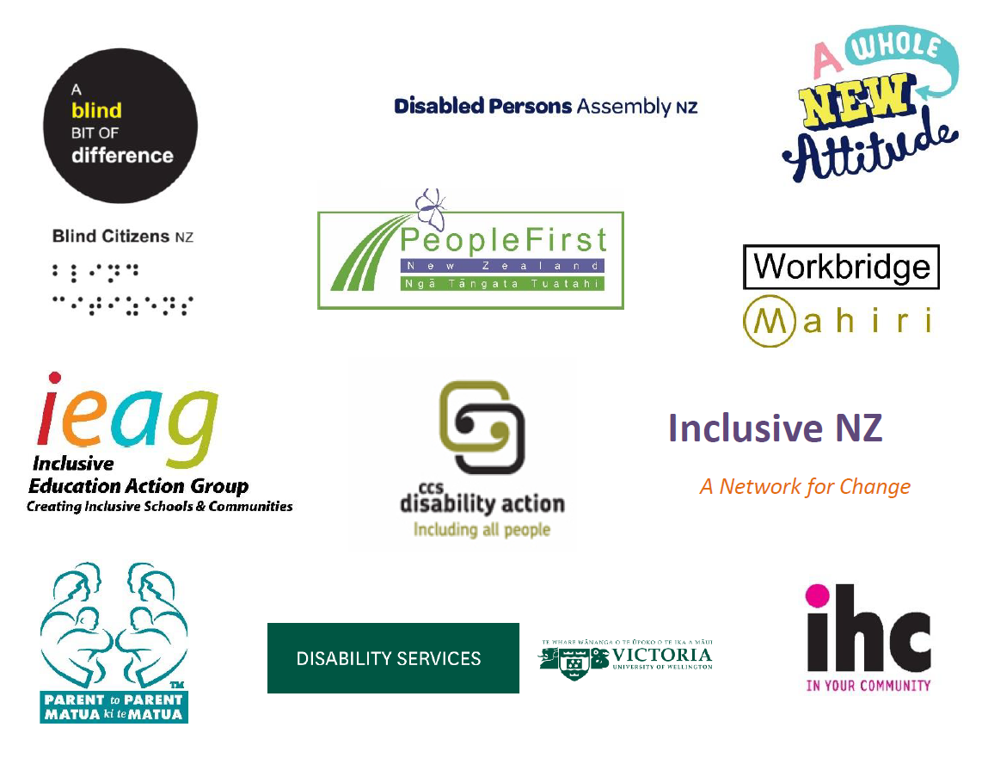

From a network of Disabled Persons Organisations and disability NGO organisations

Summary
- New Zealand has made efforts to improve aspects of its education system to better meet the needs of disabled students since the ratification of the Convention on the Rights of Persons with Disabilities (CPRD) however evidence shows that tweaking at the edges does not work. New Zealand needs a whole-scale shift to an inclusive education framework underpinned by a robust legislative and policy framework.
- Guidance from the CRPD Committee on this framework and on what it looks like in practice will go some way in helping New Zealand make this necessary shift.
- Guidance in the areas of definitions of inclusive education, reasonable accommodation and requirements for an enforceable right to education would be particularly useful.

The right to education on an equal basis with others
- Article 24 of CRPD affirms that disabled children have the right to education on an equal basis with others.
- In New Zealand the Education Act, the Human Rights Act, the New Zealand Disability Strategy and CRPD all provide for disabled children’s right to attend their local, regular school. Despite this many disabled children are unable to realise this right and many schools struggle to respond to their rights, needs and interests.
- IHC, a leading disability advocacy and service organisation which represents the voice of disabled people and families, is progressing legal proceedings against the Ministry of Education in New Zealand claiming special education policies are discriminatory. This complaint, initiated in 2008, is in response to the high number of complaints and concerns about disabled children being treated differently to non-disabled children in enrolling at their local school, participating in school life and accessing the curriculum. Information collected from families and education professionals as evidence for the complaint highlight strong levels of agreement about the barriers to discrimination free and inclusive education being a lack of teacher capacity, access to specialist and financial support, difficulties with policy implementation and legal provisions and a lack of accountability and transparency about disabled children’s rights to education
- CRPD recognises that the right to education is a cross cutting provision to the realisation of other rights within CPRD. Therefore failures in implementation of Article 24 in New Zealand are inextricably linked to reduced experiences of citizenship and other quality of life indicators.

Guidance on defining inclusive education
- The Independent Monitoring Mechanism for the CRPD noted in 2012 and 2014 the lack of a plan to take New Zealand from a mixed segregated-inclusive education system to a fully inclusive education system.
- Recent Government reports and media statements about special education have highlighted the Government’s continued confusion over the definition of Inclusive Education and a lack of a human rights focus in education for disabled students.
- As a modern democratic society, people in New Zealand often hold different views on how to ensure the best education for disabled children. We do not always agree with each other. Some people view a special school or unit is the best choice for their child. It is important to respect and understand choice. For choice to be real, however, there must be universal access to a fully inclusive education in local early childhood, compulsory primary and secondary and tertiary settings and equity of funding. If families are choosing special schools/units because their regular school was unwelcoming, this is not a real choice. If resources are locked up unfairly in special schools and units and not transferable to regular schools then this is also not a real choice. In addition if considerable funding is locked up in the property and administration of special schools this is not equitable funding for disabled students across the education system. And, if achievement levels are significantly lower when disabled children attend special schools/units this is not a real choice.
- The Ministry of Education identifies specific gaps in service provision for disabled students such as progress reports from Professional Learning and Development providers have identified that facilitators are “less confident about promoting inclusive practices that contribute to raising the achievement of learners with special education needs” (Ministry of Education, 203, p.3). Furthermore in terms of addressing the indicators of student achievement, that there is a need to design a framework for recognising the progress and achievement of learners with special learning needs including those with the most significant special education needs (Ministry of Education,2013) so that progress is recorded alongside requirements for all typical student learning.
- CCS Disability Action, a national community advocacy and service organisation carried out research in 2011 on families with disabled children. This research found that nearly half of the 217 respondents felt they had not always had a real choice between schools. Almost a quarter of those who had not been able to enrol their children in the school of their choice reported an unwelcoming atmosphere, lack of special services and poor equipment and physical access as barriers to their child’s participation in regular settings.
- New Zealand Sign Language (NZSL) is an official language in New Zealand. However, there is no right to access education in NZSL. Realising language rights depends on the provision of environments that bring together a critical mass of users of that language, including fluent users. In New Zealand we have Kura Kaupapa schools for Māori children and their families. Māori children cannot acquire Māori language (an official language in New Zealand) and culture in a classroom where they are the only Māori person. These arguments similarly apply to deaf children. And, Deaf schools and Deaf units have a role in sign language maintenance and transmission of the language between generations.
- There are similar views expressed for the provision of education for blind and visually impaired students, where particular learning resources and strategies can be shared.
- Guidance on inclusive education with particular reference to the extent to which State parties should provide a legally enforceable right to inclusive education and what this looks like in practice could help States to implement this framework.

Reasonable accommodation
- Access to funding and support for disabled children in education is a common theme among complaints made to the Ombudsman and the Human Rights Commission, and is the largest area of disability complaints to the Human Rights Commission. These complaints related to a lack of reasonable accommodation, lack of participation and delayed or denied enrolment due to disability and/or a lack of support funding. The Independent Monitoring Mechanism for CPRD noted in 2012 and 2014 that disabled students (particularly those with neuro diverse impairments) are over represented in disciplinary procedures.
- Ministry of Education guidelines to schools and education policy documents currently do not make reference to UNCRPD or specific reference to disabled students’ rights to reasonable accommodation. The resourcing framework “Special Education 2000” provides for levels of accommodations but given the high numbers of complaints referred to above and elsewhere in this submission there is an urgent need for new definitions and shared understandings of reasonable accommodation to ensure that disabled students have equitable access to education. In addition the government’s stated commitment to inclusive education needs to be measured against the binding obligation to reasonably accommodate. Currently there are difficulties with how this obligation is measured.
- Schools that welcome disabled students tend to attract more disabled students, becoming” magnet” schools. This puts pressure on their resourcing. By comparison, schools that are not welcoming to disabled students have less funding pressure and do not have to adapt their teaching methods to the same extent. This suggests schools are being rewarded for discouraging disabled students from enrolling.
- There is considerable evidence in New Zealand of difficulties in accessing funding and support resulting in many disabled children being unable to realise their right to education on an equal basis with others.
- The fact that education legislation in New Zealand does not refer to the CRPD or use the term “reasonable accommodations” in its provision of support and funding is indicative of the lack of human rights principles and approaches in special education policy and practice in New Zealand. While these gaps remain the positive policy work completed since ratification of CPRD will fail to recognise and respond to disabled students’ human rights to reasonable accommodation in education settings.
- A case to be heard by the Court of Appeal in 2015, Morag Fraser Hutchinson V The Board of Trustees of Green Bay High School, considers the positive obligations to accommodate a disabled students needs and how those needs and the extent to which they were accommodated were factored into the decision to exclude him. It is anticipated that the judgement will clarify reasonable accommodation and the positive obligations to accommodate

No enforceable right to education for disabled children
- The Independent Monitoring Mechanism for the CRPD noted in 2012 and 2014 the lack of an enforceable and specific right to education for disabled children.
- In New Zealand the legal right to education for disabled students is not established in a way that consistently guarantees disabled students are able to attend their local school and receive an education aimed at the full realisation of their abilities and talents. There is currently a gap between the right to education in New Zealand’s Education Act 1989 and the ability and means to enforce it, particularly for disabled students.
- New Zealand’s ratification of CPRD has created binding and positive obligations on government to ensure an enforceable right to education for disabled students. Amendments to the Education Act will be required to ensure that the gap referred to above is removed and that domestic jurisprudence promotes and enables inclusive education.

Recommendations
- That the Committee on the Rights of Persons with Disabilities provides guidance on inclusive education and what this looks like in practice. Such guidance could also clarify the appropriate human rights principles and terminology.
- That the Committee provide definitions of inclusive education, reasonable accommodation and clarify what measures are needed to ensure an enforceable right to education.

This submission is from:
The Education for All Network, which includes the following organisations:
Disabled Persons Assembly NZ Inc.
Association of Blind Citizens of New Zealand
Bay of Plenty Down syndrome association
CCS Disability Action
Disability Support Services at Victoria University of Wellington
IHC NZ Inc
Inclusive Education Action Group
Inclusive New Zealand
People First NZ Inc., Ngā Tāngata Tuatahi
Parent to Parent
Workbridge

IHC, Education Complaint, accessed on 27th February 2014 at: http://www.ihc.org.nz/campaigns/education/education-complaint/
New Zealand Human Rights Commission. (2012). “Making Disability Rights Real – Whakatūturu ngā Tika Hauātanga: Annual report of the Independent Monitoring Mechanism of the Convention on the Rights of Persons with Disabilities.”1 July 2011 - 30 June 2012. P 69
? Ministry of Education. (2013). Curriculum and teaching and including inclusive education capability building project initiation document Pages 4-6. Wellington:Ministry of Education
MacDonald, C., & Gray, L. (2011). Families Choices: Choosing Schools for Disabled Children. CCS Disability Action.
Human Rights Commission. (2013). “A New Era in the Right to Sign. He Houhanga Rongo te Tika Ki Te Reo Turi: Report of the New Zealand Sign Language Inquiry.” (September 2013). P 43.
New Zealand Human Rights Commission. (2012). “Making Disability Rights Real – Whakatūturu ngā Tika Hauātanga: Annual report of the Independent Monitoring Mechanism of the Convention on the Rights of Persons with Disabilities.” 1 July 2011 - 30 June 2012. P 20, 21 & 69.
Human Rights Commission. (2014). “Making Disability Rights Real Whakatūturu ngā Tika Hauātanga: Second Report of the Independent Monitoring Mechanism of the Convention on the Rights of Persons with Disabilities. Aotearoa New Zealand. July 2012 - December 2013.” P 22.
New Zealand Human Rights Commission. (2012). “Making Disability Rights Real – Whakatūturu ngā Tika Hauātanga: Annual report of the Independent Monitoring Mechanism of the Convention on the Rights of Persons with Disabilities.” 1 July 2011 - 30 June 2012. P 64 & 65.
? A v Hutchinson [2014] NZHC 253
New Zealand Human Rights Commission. (2012). “Making Disability Rights Real – Whakatūturu ngā Tika Hauātanga: Annual report of the Independent Monitoring Mechanism of the Convention on the Rights of Persons with Disabilities.” 1 July 2011 - 30 June 2012. P 64.
New Zealand Human Rights Commission. (2012). “Making Disability Rights Real – Whakatūturu ngā Tika Hauātanga: Annual report of the Independent Monitoring Mechanism of the Convention on the Rights of Persons with Disabilities.” 1 July 2011 - 30 June 2012. P 64

