SUBMISSION TO THE CRPD ON THE RIGHT TO EDUCATION ON BEHALF OF THE INTERNATIONAL CENTRE FOR EVIDENCE IN DISABILITY, LONDON

The International Centre for Evidence in Disability (ICED) of the London School of Hygiene and Tropical Medicines (LSHTM) has been conducting a consultation process with global experts on the right to education of persons with disabilities in low and middle income countries.

The consultation involved 21 experts from various regions of the world. They took three surveys in order to reach a consensus on barriers to education in low and middle income countries. They further agreed on recommendations to be given priority.

This submission is divided into two parts:
- Part 1: results of the consultation process reproduced in tables
- Part 2: section on Education taken from our report The Economic Costs of Exclusion and Gains of Inclusion of People with Disabilities

Summary of the findings

Urgent barriers to be addressed in low and middle countries are the following:
- Lack of mobility aids;
- Lack of training for teachers;
- Lack of reasonable accommodation at school;
- Lack of access to sanitary facilities;
- Stigma and attitudes on the capacities of children with disabilities;
- Lack of implementation and enforcement of existing anti-discriminatory legislation;
- Lack of accountability of duty bearers;
- Lack of understanding on inclusive education.

Recommendations which should be given priority in low and middle income countries:
- Provide training for teachers on disability;
- Identify the needs of children with disabilities at school;
- Promote the universal design standard for newly built schools;
- Consult with and involve children with disabilities in decisions about their education;
- Raise awareness amongst teachers and students about disability rights;
- Engage in effective lobbying and financing for inclusive education.

Summary of the section on Education taken from our report The Economic Costs of Exclusion and Gains of Inclusion of People with Disabilities

Pathway 1: Earnings and labour productivity – Exclusion from education may lead to lower employment and earning potential among people with disabilities. Not only does this make individuals and their families more vulnerable to poverty, but it can also limit national economic growth.
- In Bangladesh, reductions in wage earnings attributed to lower levels of education among people with disabilities and their child caregivers were estimated to cost the economy US$54 million per year.⁴
However, promoting inclusion can lead to substantial gains:
- In Nepal, the inclusion of people with sensory or physical impairments in schools was estimated to generate wage returns of 20%.⁵
- In China, estimates indicated each additional year of schooling for people with disabilities lead to a wage increase of 5% for rural areas and 8% for urban areas.⁶
- Education can close the poverty gap between people with and without disabilities: across 13 LMICs, each additional year of schooling completed by an adult with a disability reduced the probability by 2-5% that his/her household belonged to the poorest two quintiles.⁶

Pathway 2: Non-employment costs and benefits – Increasing access to education can also have positive impacts in areas such as crime, control of population growth, health, citizen participation and gender empowerment, which in turn have financial and social consequences.

Link to the report:

http://disabilitycentre.lshtm.ac.uk/new-report-economic-costs-exclusion-gains-inclusion-people-disabilities/

Contacts:

Keppel Street, London WC1E 7HT, UK
Tel. +44(0) 20 7958 8345
For queries please send emails to: lisa.montel@lshtm.ac.uk

PART 1: RESULTS OF THE CONSULTATION PROCESS REPRODUCED IN TABLES

Barrier | Relevance
Transport
Transport to go to school is not accessible for children with disabilities | Quite relevant
Transport to go to school is too expensive | Quite relevant
The child lives too far from school | Quite relevant
The child with disabilities lacks access to mobility aid to go to school | Priority for addressing this barrier
Accessibility
Teachers are not skilled to teach to children with disabilities | Priority for addressing this barrier
There are not enough adapted materials in the classroom | Relevant
The building is not accessible for children with disabilities | Relevant
Toilets are not accessible for children with disabilities | Priority for addressing this barrier
Schools do not reasonably accommodate to a particular need of a child with disabilities | Priority for addressing this barrier
Sign language is not provided | Relevant
Affordability
The caregiver does not have time to take the child to school | Relevant
The cost of schooling is too high, especially for children with disabilities (e.g. cost of textbooks, adapted textbooks such as Braille or audio textbooks) | Relevant
Parents are financially forced to make a choice between the education of their children and prioritise the education of the child without a disability | Quite relevant

Stigma / attitudes

There is a common belief that children with disabilities cannot learn properly | Priority for addressing this barrier
There is a common belief that children with disabilities will not be employable | Priority for addressing this barrier
The family does not believe in the capacities of its own child with disabilities | Priority for addressing this barrier
The caregivers are overprotective of their child with disabilities | Relevant
The child with disabilities him/herself underestimates his/her capabilities | Priority for addressing this barrier
The admissions system administered by the school stigmatizes attendance or enrollment of children with disabilities | Priority for addressing this barrier

Violence
Children with disabilities risk violence from teachers at school | Relevant
Children with disabilities risk violence from children at school | Relevant
Children with disabilities risk violence while travelling to and from school | Relevant
Girls with disabilities risk violence (including sexual violence) at school | Relevant

Discriminatory legislation

Policies and legislation are in place to support inclusion of children with disabilities in education but are not being implemented | Priority for addressing this barrier
Duty bearers are not held accountable for lack of implementation of inclusive education legislation and policies | Priority for addressing this barrier

Integrated education

The education that children with disabilities receive is ‘integrated’ instead of ‘inclusive' | Quite relevant
Some so-called inclusive education settings are in fact integrated education settings | Priority for addressing this barrier

Recommendation | Priority
Improve availability of accessible transport to school. | Low priority
Organise an appropriate mechanism whereby children with and without disabilities can interact effectively in their school. | Low priority
Identify the needs of students with disabilities. | High priority
Provide training for teachers on inclusive education. | High priority
Promote the universal design standard for all newly built school. | High priority
Provide subsidies to students with disabilities (e.g. free school meals , uniforms, textbooks, transport pass). | Low priority
Advocate to governmental entities for the recognition of disability-related costs. | Medium priority
Advocate to families with children with disabilities for the financial gains of having a child at school. | Medium priority
Strengthen links between educational services and community-based rehabilitation services. | Medium priority
Involve parents and family members to decide on the educational needs of a child with disabilities. | Medium priority
Involve the broader community in activities related to the education of children with disabilities. | Low priority
Consult with and involve children with disabilities in decisions about their education. | High priority
Raise awareness amongst teachers and students about disability rights. | High priority
Engage in effective lobbying for specific inclusive education budget and responsibilities within ministry of education. | High priority
Develop a clear national policy on the inclusion of children with disabilities in education supported by the necessary legal framework, institutions, and adequate resources. | High priority
Establish monitoring mechanisms to review policies on education of children with disabilities. | Medium priority

PART 2: SECTION ON EDUCATION TAKEN FROM OUR REPORT THE ECONOMIC COSTS OF EXCLUSION AND GAINS OF INCLUSION OF PEOPLE WITH DISABILITIES

Evidence of Exclusion
Article 24 of the UNCRPD establishes the right to education for people with disabilities. While recognizing the need for individual supports, it emphasizes the importance of inclusive education – rather than segregation in separate classes or schools – as the best policy not only for providing a quality, affordable education to children with disabilities but also for helping to build more accommodating, tolerant societies.¹³⁶
Yet despite widespread ratification of UNCRPD and introduction of other similar national policies, exclusion from education is pervasive. In low income countries, children with disabilities are significantly less likely to complete primary school and have fewer years of education than their non-disabled peers.² A recent study of children sponsored by Plan International found that, across 30 countries, children with disabilities included in the sponsorship programme were often ten times less likely to attend school as children without a disability.¹³⁷ This influence of disability on school attendance is stronger than for other factors that are linked to limited participation in education, such as gender and socioeconomic status.² Even when children with disabilities do enrol, their dropout rates are higher than for any other vulnerable group and they are at a lower level of schooling for their age.²
Without the inclusion of children with disabilities, the aim of universal access to primary education advocated by Millennium Development Goal 2 will not be realised.²⁸ While the existing figures are already bleak, the full extent of exclusion likely is underestimated, as children with disabilities may not be counted in official statistics.³⁰ Understanding and mitigating the barriers that hinder participation is key to ensuring children with disabilities benefit from the social and economic opportunities afforded through education.

Exclusion through physical/communication barriers
Physical access to schools is a key first step to facilitate the education of children with disabilities. The built environment of many schools hinders inclusion: narrow doorways, multiple storeys without ramps or lifts, and inaccessible toilet facilities create barriers, especially for individuals with mobility impairments.
Within classrooms, it is important to identify the preferred communication mode for children with disabilities and to cater to these individual requirements. Without adjustments in teaching style and provision of alternative communication options, such as materials in Braille, large print, and pictorial, audio or sign-language versions, children with disabilities are often excluded from the learning process.
Additionally, even if the built and teaching environments are accessible, if schools are located far away or lack transportation links, children with disabilities will continue to be excluded. This is especially true when options for education are limited to segregated special schools. Typically, a remote village will only have one school and special schools tend to be located in urban areas, limiting access for the more than 80% of children with disabilities living in rural areas.^{136, 138}

Exclusion through attitudinal barriers
Misconceptions and negative attitudes also prevent individuals with disabilities from accessing equal educational opportunities. Attitudinal barriers work at all levels – from planning to enrolment to retention – to exclude people with disabilities.
Stigmatization of disability is often deeply engrained and poses a significant barrier to inclusive education. Bullying, maltreatment and even acts of violence towards children with disabilities –by teachers and peers– are frequently reported in schools and the low self-esteem they engender can compel children to dropout.² The fear of abuse can also deter parents from enrolling their children.¹³⁹
Even if attitudes are supportive and well-intentioned, people with disabilities frequently encounter limitations due to low-expectations.² Teachers, parents, peers and even individuals themselves often underestimate people with disabilities’ abilities and capacity for learning.¹⁴⁰ As the benefits of education for children with disabilities are seen as limited, opportunities for higher education or more challenging coursework are not offered, placing a ceiling on potential academic achievement.² Moreover, teachers feel they lack the time, training and resources to address the needs of students with disabilities and fear their inclusion in mainstream schools will slow down the progress of the rest of the class.²

Exclusion through financial barriers
In low income settings where resources are scarce, funding for the provision of even the most basic education is frequently inadequate. Governments are therefore reluctant to add any more items to budget lines, particularly when they perceive spending on education for children with disabilities to be a poor investment.³⁰
Without national provision of inclusive education, however, the responsibility of payment falls on families, for whom costs such as tuition at a special school or individual provision of accessible teaching materials, are almost always prohibitive.¹⁴¹ In addition to these direct costs, children with disabilities who are not in school frequently remain in the home ¹³⁸ and thus these families may also experience foregone labour.

Exclusion through policy barriers
Education for children with disabilities is often managed by different government bodies with separate policies than those for general education, promoting segregated rather than inclusive approaches.² In many countries, special education is under the jurisdiction of ministries for health or social welfare rather than the ministry of education, if seen as a governmental responsibility at all.^{136, 142} Furthermore, while targets for enrolment, attendance and scholastic achievement – often tied to various incentive schemes – are common features of international and national education policies, similar plans for children with disabilities are lagging.^{2, 136} Without clear, comprehensive strategies that include measurable and monitored aims and objectives, providing quality education for people with disabilities is liable to neglect.
Even when students with disabilities do attend mainstream schools, inflexible curricula and evaluation procedures may cause exclusion.¹³⁹ Adherence to strict benchmarks of academic achievement may be inappropriate for many children (including those with disabilities), who would be better served if assessments measured individual progress instead.²

Economic costs of exclusion and gains of inclusion in education
Exclusion of children with disabilities from education can generate costs to individuals, families, communities and even nations as a whole. These costs may not be immediately apparent, but can work insidiously to propagate poverty and stagnate economic growth. On the flip side, promoting inclusion in education has the potential to generate substantial financial and social gains at the individual, family, community state levels. In the discussion that follows, the different pathways by which exclusion and inclusion of children with disabilities in education may generate economic consequences are explored. These pathways are summarised in flow charts (figure 1 and 2).

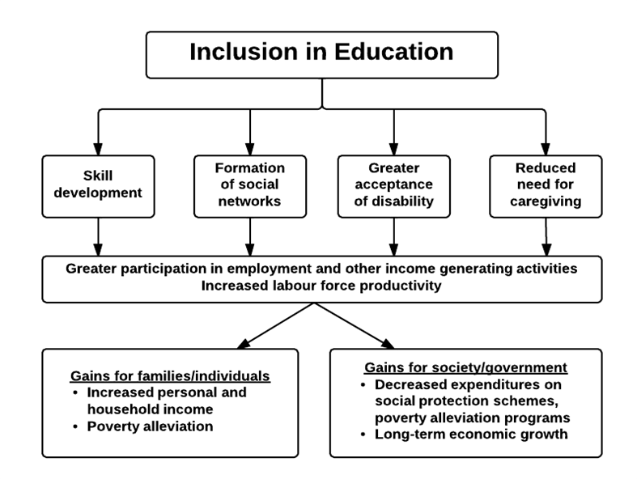
Pathway 1: Earnings and Labour Productivity
Figure 1. Education pathway 1: Earnings and Labour Productivity
The positive effect of schooling on future job opportunities and earnings is well documented.^{143, 144} It therefore follows that excluding people with disabilities from education can produce substantial monetary losses to both the individual and the societies in which they live. Through greater attainment of quality, inclusive education, people with disabilities stand to benefit from improved employment opportunities, higher incomes and an improved standard of living, contributing to both personal and national poverty alleviation and economic development.
There is clear evidence from general population studies that educational attainment is strongly linked to employment and income generation. Education supports skill development, which in turn can improve an individual’s competitiveness in the labour market. Additionally, schools are an important setting for developing social networks, which are influential in making linkages that can lead to job opportunities or promote entrepreneurship.¹⁴⁵ It is not surprising then that across countries, better educated individuals are more likely to be employed and have higher incomes.^{143, 146} In a multi-country study, each additional year of schooling led on average to a 10% increase in personal earnings; this figure was even higher in low-income countries, where low levels of schooling create a high demand for those with the requisite skills.^{143, 147}
On a national level, investments in education can foster economic growth.¹⁴³ In theory, education increases individuals’ capabilities, creating a more skilled labour force that is more efficient, better able to innovate and adapt to new technologies and more attractive to outside investors.¹⁴³ Additionally, employment decreases reliance on social protection schemes (where provided), leading to decreased government spending on these programs. Empirical evidence appears to back these assumptions: in an analysis of factors explaining the long-term growth in GDP/capita in 88 countries, primary school enrolment showed the greatest impact.¹⁴⁸ Another study found that for each additional year of schooling added to a country’s average, there was a 0.58% increase in long-term economic growth.¹⁴³ As with individual gains, returns appear greatest in low income settings.¹⁴³
The above findings focus on trends in the general population. There are relatively few studies in LMICs exploring the economic consequences of education specifically for children with disabilities. However, the studies that have been undertaken suggest similar financial implications exist for people with disabilities.
Firstly, in studies assessing the difference in poverty rates between people with and without disabilities, much (though not all) of this gap is reduced once education is controlled for.² For example, across 13 LMICs, households containing an adult with a disability were 5.0-14.5% more likely to belong to the poorest two quintiles.⁷⁹ However, for each additional year of schooling, this probability was reduced by 2-5%, turning the association between disability and poverty from consistently positive and significant to statistically insignificant in many countries.⁷⁹
Secondly, there is evidence from studies using modelling approaches, that wage returns to education for individuals with disabilities are substantial. In Nepal, the inclusion of people with sensory or physical impairments in schools was estimated to result in a rate of return of around 20%.⁵ In a similar study in the Philippines, increased schooling was associated with higher earnings among people with disabilities, generating an economic rate of return to education of more than 25%.¹⁴⁹ In China, estimates indicated that each additional year of schooling for people with disabilities leads to a wage increase of approximately 5% for rural areas and 8% for urban areas.⁶
Thirdly, there is some evidence that exclusion of people with disabilities in education generates costs to the state. In Bangladesh, the World Bank estimated that reductions in wage earnings attributed to lower levels of education among people with disabilities cost the economy US$26million per year.⁴ They estimate that a further US$28 million is lost from children who forgo schooling to care for a disabled person.⁴ This figure indicates the substantial economic losses at state level associated with exclusion from education, although it is unclear exactly how these estimates are derived.
Some care is needed in calculating and interpreting estimates of wage returns and earnings. Firstly, many individual level factors besides education can influence a person’s future earnings.^{6, 143} Some of these factors such as sex, marital status, area of residence are relatively easy to measure and adjust for in estimates of wage returns and were included in the above estimates from Nepal, Philippines and China. Others, such as scholastic abilities and personal motivation for learning are more challenging and require more complicated methodological approaches.^{6, 143} If these are not taken into account, the impact of education may be over or under-estimated.¹⁵⁰
Secondly, returns to education estimates for people with disabilities are subject to selection biases.^{143, 151} Given that people with disabilities currently tend to have low participation rates in both education and the labour force in LMICs, only a restricted sample of all people with disabilities will be contributing to the data used to determine the increase in wages associated with schooling.^{2, 29} The returns accrued by this select group may not be representative of potential gains should all individuals with disabilities be included in education. Not accounting for this may bias the estimates of returns to education.
There is some evidence that not accounting for these limitations actually underestimates returns to education for people with disabilities. In using the standard wage returns equation with added controls for sex, marital status and place of residence, Liao et al. found a rate of return between 5.3-7.6% for individuals with disabilities in China.⁶ Lamichhane et al. had a more extensive approach: when using an approach similar to Liao’s, returns to education were estimated at 5.9-6.5% in Nepal; however, after employing tools to account for selection bias and other potential limitations, gains jumped to 22.7-25.6%.²⁹

Jemimah’s Story

In Jemimah’s rural Massai community, being a woman and having a physical impairment prevented her from accessing local schools. However, as her parents were committed to ensuring their daughter received an education, they found a boarding school in another city for her to attend.
Despite the social exclusion she faced as the only student with a disability, Jemimah successfully completed primary and secondary school. Afterwards, Jemimah joined CBM’s partner the Association for the Physically Disabled of Kenya (APDK), where she initially received training in tailoring. Jemimah’s passion then led her to go to college to complete a full three year secretarial course. Returning to APDK after completion of her courses, Jemimah’s skills and motivation led to a series of progressive promotions from receptionist to an executive secretary to the executive officer. An online course in business training further propelled her career to personal assistant to the executive officer and a temporary acting coordinator for microfinance. In addition to her successful office career, Jemimah is active in her community, modelling in mainstream fashion competitions to showcase the work of designers with disabilities whilst advocating for the rights for persons with disabilities.
Jemimah’s story demonstrates that access to inclusive education can help individuals with disabilities develop the skills, experience and empowerment needed to follow their passions, develop rewarding careers and become financially independent. Additionally, Jemimah serves as a visible example that people with disabilities can be successful, which can go a long way towards changing long-held prejudices and fostering further social, economic and political inclusion.
Reproduced with permission from CBM (Original story can be found in:
CBM(2013). Resource Book Tanzania/Kenya. CBM Germany.)

A third area of consideration is that most of the studies presented above are concerned with years of schooling, with no reference to quality. Maximum economic gains will be present when individuals receive a quality education that boosts useful skills, leading to a more innovative, productive workforce.¹⁴³ Hanushek et al. found that the relationship between cognitive skills of the population were much more powerfully linked to individual earnings, distribution of income and national economic growth than simple years of schooling.¹⁴³ Simply boosting attendance rates will thus likely have minimal impact in decreasing inequalities between people with and without disabilities if efforts are not made simultaneously to ensure equality within schools as well.

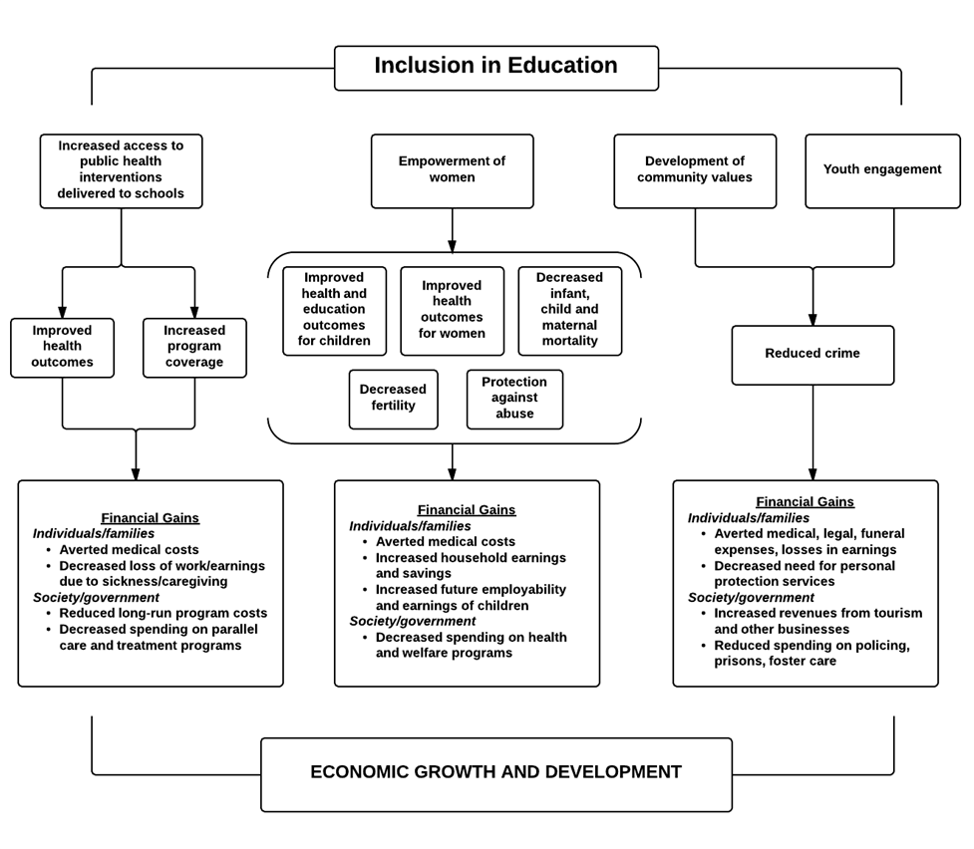
Pathway 2: Non-Employment Costs and Benefits
Figure 2. Education pathway 2: Non-employment costs and benefits
Education also has positive impacts in areas such as crime, population growth, health, citizen participation and gender empowerment, which in turn have financial and social consequences.¹⁴³ Empirical data on this for people with disabilities are lacking but some of the theoretical routes are highlighted below.
Many public health and development initiatives use schools as their point of delivery, particularly if children are the target population. Examples include mass drug treatments for diseases such as intestinal worms, nutritional supplementation programmes, bed-net provision for malaria prevention, and sexual and reproductive health education.^{152, 153} Exclusion from these valuable programs can result in worse health outcomes, including the development of secondary disabilities. Poor health in turn can lead to an array of costs, as highlighted in section 3, further trapping individuals with disabilities in the cycle of poverty.
Similarly, many social assistance and welfare programmes – notably cash transfers – are increasingly requiring recipients fulfil certain conditions to receive benefits. As conditionality is meant to address the drivers of poverty, enrolment of children in primary school is a particularly popular requirement for participation. However, if schools are inaccessible to children with disabilities, families may be excluded from programmes that have proven successful at reducing poverty and spurring development.¹³⁴
Education of women is well established to generate multiple benefits. These include: lower infant, child and maternal mortality, decreased transmission of HIV, increased autonomy, greater protection against abuse and improved health and educational outcomes for their children.¹⁵⁴ While the social benefits on their own merit investment in education for women, such advances would also bring high financial savings: for example, decreasing reproduction rates in low income countries has been linked to national economic growth and increased household savings, preventing HIV averts costs for care and treatment, and investment in children is instrumental for breaking the intergenerational cycle of poverty.^{154, 155} By excluding women with disabilities from education, they are less likely to share in and contribute to these gains.
The impact of exclusion from education may, in turn, contribute to lower educational attainment for the next generation. In a study in Vietnam, children of parents with disabilities were less likely to attend school compared to children of parents without disabilities. Lower education levels among the parents with disabilities was a possible explanatory factor in this association.¹⁵⁶
Finally, education is one of the most significant factors in preventing crime.¹⁵⁷ In addition to the losses in human life and suffering, crime is very costly for society: spending on legal and medical fees, policing, funerals, personal protection and prisons, reductions in revenues for tourism and other businesses and the losses in potential earnings and productivity of both the victims and perpetrators, cause significant declines in economic growth.^{157, 158} To reduce the burden of crime, increasing school attendance and fostering a sense of community within schools have been found to have the most impact on crime – reducing violent activity by 55-60% in one multi-country study.¹⁵⁸ Inclusive education, by providing avenues for more productive lifestyles as well as promoting community values, may therefore generate economic gains through crime reduction.

Non-Financial Impact
Exclusion of children with disabilities from education also has many non-financial associated costs. Schools are a primary place where children develop friendships; denial of this opportunity for social networking and community participation can lead to isolation, decreased autonomy, and lower quality of life. For caregivers, the increased dependency burden can heighten risk for depression and limits their own independence.¹⁵⁹ At a societal level, exclusion from mainstream education helps propagate discriminatory attitudes, creating further barriers to participation in other domains.¹⁶⁰ Further, efforts to increase the quality of education to ensure effective learning for those most in need (e.g. children with disabilities) arguably has the potential to improve teaching abilities overall. Finally, as education can provide individuals with the skills, experience and empowerment to vocalize their opinions, inclusion in education can be a first step towards increasing political participation and social justice for people with disabilities. Although education in segregated settings may teach children with disabilities the requisite academic material, it fails to provide many of these other non-financial gains, which in the future could translate into economic gains. Inclusive education for children with disabilities therefore can improve individual and family well-being while encouraging greater acceptance of diversity and the formation of more tolerant, equitable and cohesive societies.

