 | 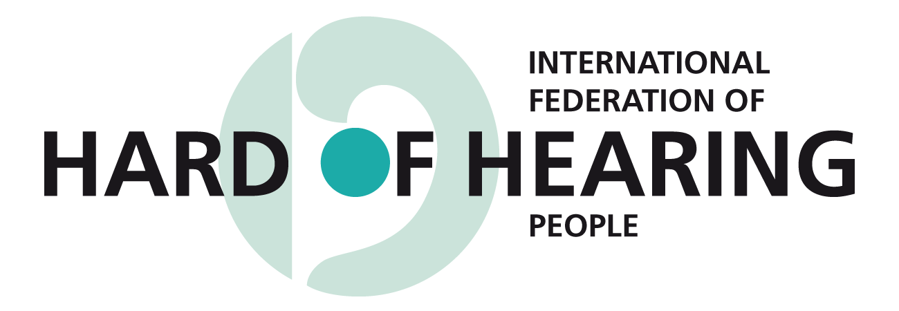 | info@ifhoh.org  http://www.ifhoh.org
Committed to worldwide hearing accessibility

Members of the CRPD Committee
United Nations, Geneva

Re: Day of General Discussion on the Right to Education
on April 15, 2015 in Palais des Nations, Geneva

Dear Committee Members,
I am pleased to provide a submission by the International Federation of Hard of Hearing People for your General Day of discussion on the topic of Right to Education. Please find enclosed the position paper of IFHOH on education in which we state: “In keeping with Article 24 (Education) of the Convention on the Rights of Persons with Disabilities, IFHOH believes persons who are hard of hearing have the right to an inclusive education and that all levels of education should be accessible.” We outline the specific accessibility requirements of persons with hearing loss, a category of disability that comprises over 360 million persons, representing 5 percent of the world's population.

IFHOH is an international, non-profit federation of hard of hearing people, which provides a platform for co-operation and information exchange among its members and interested parties. IFHOH works to promote a greater understanding of hearing loss issues and to improve access for hard of hearing people.

For more information, please contact me.
Sincerely,

Dr. Ruth Warick,
President,
International Federation of Hard of Hearing People
president@ifhoh.org

EDUCATION ISSUES

Learning is a treasure that will follow its owner everywhere – Chinese proverb.

Education is a basic human right that empowers people to develop their knowledge and skills to their fullest potential, which will benefit themselves and society as a whole. Three important historical developments impacted the development of an international legal and political framework on education:

Convention of the right of the child (1989)
The Convention recommends that all children with disabilities have “access to and receive education, training, health care services, rehabilitation services, preparation for employment and recreation opportunities” with the aim of providing them with opportunities for social integration and individual development, including cultural and spiritual development (Article 23).
The Salamanca Statement and framework for action on Special Needs Education (1994)
The Framework discusses a fundamental right to education for every child and that those with special educational needs should have access to supports within regular schools which accommodate them within a child-centred pedagogy.

Convention on the Rights of Persons with Disabilities (UN CRPD) (2006)
The UN CRPD encourages equal treatment of persons with disabilities in all aspects of employment, health, education, social, welfare, cultural and leisure needs. It encourages physical and communication access to education systems, public places, government programmes, and medical facilities. Article 24 speaks about inclusive and accessible education.

In keeping with Article 24 (Education) of the Convention on the Rights of Persons with Disabilities, IFHOH believes persons who are hard of hearing have the right to an inclusive education and that all levels of education should be accessible.

IFHOH strives for hard of hearing persons to have equal opportunities to participate in post-secondary and adult education programs. In this paper, IFHOH offers 9 key recommendations to achieve our goal of making education accessible to persons who are hard of hearing. These recommendations on how to make education inclusive and accessible to persons who are hard of hearing will help to make it possible for them to succeed to the same standards as for the population as a whole. In essence, our goal is equality of opportunity and equity of outcome.

1. Barrier-Free Environments

A barrier-free learning environment requires not only the absence of physical barriers, but also the provision of an optimum acoustical environment to maximize speech intelligibility in the classroom. This can be accomplished by reducing background noise and sound reverberations. Sound-absorbing materials such as window curtains, carpets, fabric on the furniture, ceilings and wall panels that absorb sound will help reduce echoes. Ideally, the environment should maximize the person's ability to hear and should not impair the effectiveness of the use of electronic listening devices.

A barrier-free environment should also include visual signals for fire alarms, doorbells, and telephones. Visual signals can usually be installed at little cost.

2. Captioning in the classroom

The use of captioning or speech-to-text technology should be available in the classroom so as to provide visual access to information. The student and/or his/her family should not be liable for the costs of these services as they are essential for educational accessibility.

3. Captioning of videotapes, films, DVDs, television programs, YouTube clips, etc.

All educational videotapes and films should have closed captioning or subtitles. Videos and films are not an extra, but are an essential component of education.

4. Language development

It is critical to maximize opportunities for language development as early as possible. All students should have access to support services for language development in order to maximize their learning potential. Support services for language development might include but are not exclusive to tutors, language learning classes, equipment and training for the use of alternative communication methods, and assistive listening devices.

It is also essential to promote the development of alternative communication methods, which might include but are not exclusive to sign language, gestures, drawings, images, pictographs, electronic communication aids, etc. The learning of sign language is an option being pursued by some countries in an approach that promotes both auditory and signing skills so that children can grow up to be bilingual.

Language skills and vocabulary development should be encouraged in the home. Parent-child programs are available to provide parents with information, methods, and encouragement to help their children develop communication skills. However, language development is a continuous process, therefore, services and support must remain in place throughout a hard of hearing person’s education.

5. Hearing aids and cochlear implants available

Hearing aids are often essential for students to learn. Funding programs should be set up to assist families with the cost of such devices and no child who requires a hearing aid should go without one. Furthermore, those who require cochlear implants should also be provided them.

6. Assistive listening devices available

Technical equipment such as induction loops, FM equipment and infrared systems often help students to maximize their hearing in the classroom. The provision of such systems should be considered an access issue just as ramps are for persons with mobility disabilities.

7. Support Services

Students should have regular access to support services, including and not exclusive to tutors, notetakers, itinerant teachers, interpreters, and assistive listening devices; the extent of which use depends upon the individual student. These systems should be available for both home and school, as a student needs to maximize his/her hearing at all times. The provision of such devices should continue throughout all levels of education, including post-secondary education.

It is also essential, once such devices are in place, that regular checks be made to ensure that the equipment is functioning properly. Furthermore, when replacements are required, those must be immediately available so there is no interruption in maximizing students’ education.

As with technological devices, the costs for these support services should not fall on the individual student and/or his/her family but should be recognized as an essential condition for educational accessibility.

8. Social Interaction

It should be recognized that social interaction is a vital component of the educational experience. Support for social activities may include but are not exclusive to interpreters, captioners, alternative communication methods, and assistive listening devices.

Community and voluntary organizations have a role to play in providing social opportunities, in cooperation with schools.

Parents and family members play an essential role in providing social and emotional support to hard of hearing children. Often the child's parents and family members play a critical role in the socialization and development of the child. They need to have an opportunity to learn about the nature of their child’s hearing loss and about communication strategies for the child, as well as to receive support for their own adjustment to the situation. Parents also need to be provided with opportunities to interact with hard of hearing adults in order to develop a positive image from such role models. Associations and service agencies should be encouraged to develop programs which would provide such experiences.

9. Teacher Training

Teacher training programs should include a specific orientation on working with students with hearing loss. Hard of hearing persons and professionals should be consulted in the design of course curriculums and should be involved as resource persons in the delivery of these programs. Also, educational institutions should make an effort to ensure that hard of hearing and late-deafened persons become part of the instructional staff.

Conclusion

An inclusive and accessible education, which empowers hard of hearing persons to develop to their fullest potential, is the first stepping stone to success. This paper presents the following recommendations for achieving this goal: the provision of a barrier-free environment optimized for maximal speech intelligibility, visual access to information through the use of captioning or speech-to-text technology, support services to maximize language development, the free provision of hearing aids and assistive listening devices, the provision of a variety of personal support services, support for social interaction, and specific training for teachers of the deaf and hard of hearing.

It should also be recognized that no individual educational program will be suitable for all persons with a hearing loss, and so there should be a variety of programs available for them. Those programs should have the common goal of providing an inclusive and accessible education that maximizes the ability of hard of hearing persons to grow and develop to their fullest potential.

IFHOH believes that persons who are hard of hearing have the right to an inclusive and accessible education system, and that hard of hearing persons should have equal opportunities to participate in post-secondary and adult education programs. The technological and human supports recommended in this paper are essential to creating the type of learning environment that will provide equality of opportunity and equity of outcomes for persons who are hard of hearing.

Prepared by Ruth Warick and Rosalind Ho.
Adopted by the IFHOH General Assembly, April 7, 2014

