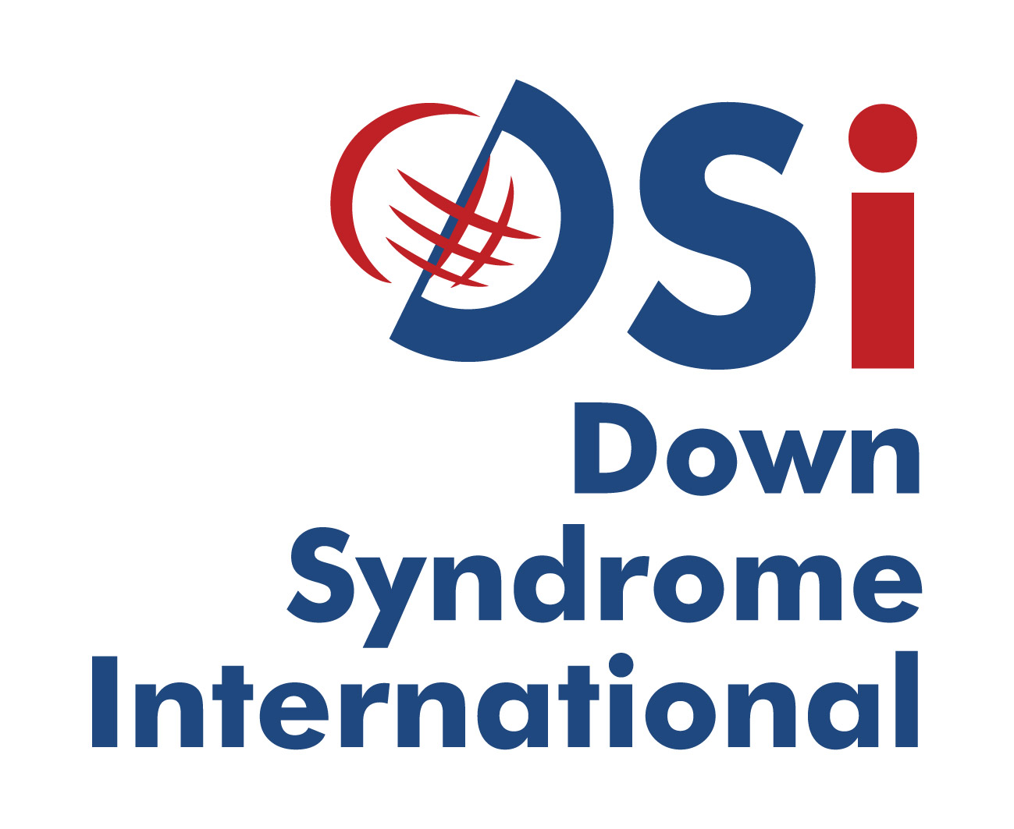
Langdon Down Centre
2A Langdon Park
Teddington TW11 9PS
United Kingdom

Down Syndrome International
Submission to the UNCRPD Committee on the
Right to Education for Persons with Disabilities

Summary
Down Syndrome International (DSi) affirms the rights of all people with disabilities to inclusive education as acknowledged in the UNCRPD. Our position is based on the clear research evidence for the benefits of inclusive education for people with Down syndrome. We accept the definition of inclusive education in the UNCRPD and extend this to acknowledge Inclusive Education as a philosophy and practice as well as a process . Down Syndrome International supports member organisations in their pursuit of inclusive education around the world. We do this through advocacy, the provision of access to research evidence and outreach of international experts to areas of need, as requested.

Down Syndrome International
Down Syndrome International (DSi) is a UK based international charity, comprising a membership of individuals with Down syndrome and their families, other interested persons and organisations from all over the world, committed to improving quality of life for people with Down syndrome worldwide and promoting their inherent right to be accepted and included as valued and equal members of their communities. Our mission is to improve quality of life for people with Down syndrome worldwide and promote their inherent right to be accepted and included as valued and equal members of their communities. This includes promoting the right to education.

Down syndrome and learning
Because of the naturally occurring chromosomal arrangement that causes Down syndrome, people with Down syndrome present with varying degrees of intellectual and physical disability and associated medical issues.
Children with Down syndrome are not just developmentally delayed but have a specific learning profile with certain characteristic, which have both strengths and weaknesses. Understanding these leaning styles and profiles is important in order for appropriate strategies to be introduced which helps to develop knowledge and learn new skills.

Reg Charity No. 1091843 T: +44 (0)20 8614 5124
Reg Company No. 4327941 E: contact@ds-int.org
W: www.ds-int.org

Introduction
Although we don’t have the exact data on how many children with Down syndrome are out of school we do know that the majority of those that do attend school are in special segregated schools. These schools do not offer a curriculum that is conducive to meaningful learning that leads to adults with Down syndrome achieving decent work. Segregation has a negative impact on the social standing of people with Down syndrome and this exclusion denies society from access to disability, which creates negatives stereotypes towards people with the condition.
Down Syndrome International (DSi) affirms the rights of all people with disabilities to inclusive education as acknowledged in the UNCRPD. Our position is based on the clear research evidence of the benefits of inclusive education for people with Down syndrome .

Challenges to education
Most people with Down syndrome still face many challenges when it comes to education. In developing countries (and still some developed) children with Down syndrome are being denied access to education. The belief is that children with Down syndrome cannot learn or be educated and therefore should not waste their time attending school. In addition, there is the belief that because children with Down syndrome are intellectually disabled they should attend special ‘segregated’ schools or placed in institutions. This form of exclusion is discriminatory and a violation of their basic human right to education.
Given the chance and support people with Down syndrome can respond positively to inclusive education which leads to them being recognised as people in their own right and being included in the community. Whilst some may need additional support they can go onto further education and meaningful employment.

Inclusive education
DSi recognises inclusive education as an approach that welcomes, values and supports the diverse learning needs of all students in shared general education environments . DSi accepts the definition of inclusive education in the UNCRPD as a process and extends this to understand inclusive education as a philosophy and a practice as well .
As a philosophy, inclusive education acknowledges and values human diversity.
As a process, inclusive education differs from other approaches such as segregation, or integration. Segregation is a process where students are educated apart from others; such as in a different school, or different classroom in a school for all or part of a day. Integration is a model of education where learners are physically located within the learning space of their age peers however, they may be undertaking work unrelated to the work of their classmates.
As a practice, inclusive education concerns the strategies, approaches and techniques employed by teaching teams.
Inclusive education is complex and research evidence support the view that positive attitudes of teachers and schools is more important than knowledge an skills as prerequisites for effective inclusive education practice . Some families opt for segregated education following bad experiences in inclusive schools. Poor inclusive practice is not a reason for segregated schooling. It is an imperative to make inclusive schooling the best it can be.

Role of Down Syndrome International
DSi is the peak body representing individuals with Down syndrome, their families, other persons and organisations with an interest in Down syndrome, around the world. DSi seeks to support the work of the UN in the promulgation of the CRPD, particularly with respect to education. We undertake to do this through three key strategies:
- Global advocacy and awareness;
- The provision of access to research evidence;
- Building capacity of our members including our Outreach programme.
DSi believes that people with Down syndrome should enjoy lifelong learning and be given the appropriate opportunities without prejudice. This can only be achieved through universal inclusive education practices.

Recommendations
DSi requests the Committee to call on State Parties to ensure:
- That people with Down syndrome have equal access to a quality education and adopt the model of Inclusive Education consistent with Article 24 of the UNCRPD;
- Laws, and policies include budgets to provide the necessary and adequate supports for learners with Down syndrome to be included in mainstream schools;
- Promote awareness and provide suitable training on inclusive education;

Note
DSi are members of the International Disability Alliance. In addition we have a close alliance with Inclusion International. DSi supports both organisations position on education and recommendations to the committee.

References
Buckley, S., Bird, G., Sacks, B., & Archer, T. (2006). A comparison of mainstream and special education for teenagers with Down syndrome: implications for parents and teachers. Down Syndrome Research and Practice, 9(3), 54-67.
Cologon, K. (2014). Preface. In K. Cologon (Ed.), Inclusive education in the early years. Right from the start. (pp. xviii - xix). South Melbourne, Vic: Oxford University Press.
de Graaf, G., van Hove, G., & Haveman, M. (2013). More academics in regular schools? The effect of regular versus special school placement on academic skills in Dutch primary school students with Down syndrome. Journal of Intellectual Disability Research, 57(1), 21-38. doi: 10.1111/j.1365-2788.2011.01512.x
Forlin, C., & Chambers, D. (2011). Teacher preparation for inclusive education: increasing knowledge but raising concerns. Asia-Pacific Journal of Teacher Education, 39(1), 17-32. doi: 10.1080/1359866X.2010.540850
Thousand, J., & Villa, R. A. (2000). Inclusion. Special Services in the Schools, 15(1-2), 73-108. doi: 10.1300/J008v15n01_05

