Submission to the CRPD Committee

Day of General Discussion on the Right to Education for Persons with Disabilities (art.24)
13th Session - 15th April 2015

From :
The Interfederal Centre for Equal Opportunities, Belgium
Contents
I. Introduction 2
A. Contents of the submission 2
B. Reminder : Belgium, federal State 2
C. Centre for Equal Opportunities 2
D. Convention on the Rights of Persons with Disabilities in Belgium 2
II. Description of education for students with disabilities in Belgium 3
A. Education for students with disabilities and the legal context 3
B. Education for students with disabilities : figures and recent legislative initiatives 3
Background information 3
Flemish Community 4
French Community 6
C. Education and discrimination reported to the Centre based on the criteria of disability 7
D. Inclusive education in Belgium according to the consultation organised by the Centre (2013- 2014) 8
E. Inclusive education in Belgium according to the Committee on the Rights of Persons with Disabilities (October 2014) 9
III. follow-up OF THE recommendations of the UN COMMITTEE by the Centre 10
IV. Points FOR ATTENTION FOR THE GENERAL COMMENT ON art. 24 CRPD 10

I. Introduction

A. Contents of the submission
The goal of this written contribution is to present the views of the Belgian Interfederal Centre for Equal Opportunities (referred to hereinafter as “the Centre”) on the implementation of the right to education for persons with disabilities in Belgium (art. 24 of the Convention on the Rights of Persons with Disabilities, referred to hereinafter as “CRPD”) and the points for attention for the General Comment.

B. Reminder : Belgium, federal State
As a reminder, Belgium has been a federal State with three communities (Flemish, French-speaking, German-speaking) and three regions (Flanders, Wallonia and Brussels) since 1993. Each level of government has competence in certain areas. Disability policy falls under the remit of a number of bodies. Education is the responsibility of the Communities. Areas such as transport (except railways) and assistance for persons with disabilities come within the remit of the Regions.

C. Centre for Equal Opportunities
The Belgian Interfederal Centre for Equal Opportunities is an interfederal public service, specialised in equal opportunities policy and non-discrimination, which is completely independent.
The Centre is responsible for assisting victims of discrimination based on the protected criteria (one of which is disability) by the anti-discrimination laws which are the transposition of the European directives 2000/43 and 2000/78. Since 2011, the Centre has also been responsible, as independent mechanism, for promoting, protecting and monitoring the implementation of the CRPD in Belgium.

D. Convention on the Rights of Persons with Disabilities in Belgium
Belgium signed the CRPD on 30 March 2007 and ratified it on 2 July 2009. It came into force at the national level on 1 August 2009.
Belgium submitted its first periodical report in compliance with article 35 of the CRPD in July 2011. Belgium's report was followed by the parallel report submitted by the Centre and the alternative reports from civil society organisations. These reports were intended to provide the Committee on the Rights of Persons with Disabilities with a critical view of the implementation of the rights protected by the CRPD in Belgium. The Committee issued its concluding observations on Belgium on 1 October 2014.

II. Description of education for students with disabilities in Belgium

A. Education for students with disabilities and the legal context
In Belgium, there are two types of compulsory education: mainstream education and specialist education. This is therefore a segregated education. Students with disabilities have two options:
- Specialist education (most of the time), a category made up of 8 different types of education based on the nature of the child's medical impairment, this will soon become 9 types in Flanders (“Type 9” for autistic children), as a result of the "M" Decree of 21 March 2014 ;

- Integrated education (extreme minority), which consists of integrating children from the specialist education system into the mainstream education system, with support provided by the specialist education system in the form of technical support and staff.

There are also cases of “ad hoc” integration of children into the mainstream educational system which are not based on a legal framework.
Furthermore, the antidiscrimination legislation (decrees by the Communities) provides for the right of all students with disabilities to reasonable accommodation. However, in practice, all too often, the school may not know how to implement reasonable accommodation, or may be opposed to it, which has led to many reports to the Centre (see below).

B. Education for students with disabilities: figures and recent legislative initiatives

Background information
The progression of integrations of students with disabilities is progressing slowly but steadily. Nevertheless, specialist education remains the leading approach and is extensively organised.
Yet in its initial periodical report submitted to the Committee on the Rights of Persons with Disabilities, Belgium claims: "The effect of the development of specialist education over the past 40 years has been that, to a large extent, students with disabilities are being educated in a noninclusive system: 0.78% (preschool), 6.79% (primary school) and 4.24% (secondary school)".

Flemish Community

- Distribution of the student population in the Flemish community (2013-2014)

 | Mainstream | Specialist | Total | % specialist
Preschool | 269,197 | 2,042 | 271,239 | 0.75%
Primary | 399,729 | 28,307 | 428,036 | 6.61%
Secondary | 417,469 | 20,495 | 437,964 | 4.68%

During the 2013-2014 academic year, 2,042 out of a total of 271,239 children were attending specialist preschool education in Flanders (which is 0.75%). In primary education, the proportion of pupils attending specialist education is much higher: 28,307 pupils out of a total of 428,036 (or 6.61%). Finally, in secondary education, 20,495 out of a total of 437,964 students were attending specialist education courses (or 4.68%). This still puts Flanders at the bottom of the European league table (the European average was already 3% in 2004).

- Integrated students in mainstream education

In Flanders, 15.000 students with disabilities are attending mainstream education as compared with nearly 51.000 in the specialist education.

- Evolution of the distribution of the student population in specialist education since 2010

In preschool education, the number of students is increasing year to year but the average of students guided towards specialist education is relatively stable:
  - 0.76% in 2010-2011
  - 0.75 % in 2013-2014

In primary education, the number of students is also increasing year to year but the average of students guided towards specialist education is falling:
  - 6.88% in 2010-2011
  - 6.61% in 2013-2014

However, in mainstream secondary education, although the number of students is falling from year to year, the number of students guided towards specialist education is increasing annually:
  - 4.38 % in 2010-2011
  - 4.68% in 2013 -2014

- Average cost of specialist education

For 2014, the average cost of a pupil in specialist basic education (preschool and primary combined) is 15,779 euros as compared with 4,763 euros in mainstream preschool and primary education. In specialist secondary education, the average cost of a student is 19,960 euros as compared with 8,731 euros in mainstream secondary education.

- Students outside the school system

In Flanders, according to the information provided to us by the Flemish Agency for Persons with Disabilities (VAPH), 812 students outside the school system who have disabilities attend boarding or partial boarding schools. These children consequently cannot appeal to the right to education. The Flemish Education Council had already called, in an opinion published in 2006, for the abolition of the label 'outside the school system' ('non scolarisé') and called for a right to education for all children and young people who have multiple severe impairments.

- Legislative initiatives

For the past several years, Flanders has been engaged in efforts to attempt to guarantee the access of students with disabilities to mainstream schools.
The latest initiative in this area is the decree of 21 March 2014 on measures for students with specific educational needs (known as the "M" decree ) which in principle will become effective on 1 September 2015. This decree contains a series of measures intended to promote the right to enrol in mainstream schools or to encourage inclusion (more stringent requirements for the justification of admitting a student to specialist education, involvement of the individuals concerned, monitoring with regard to diagnoses,…)
However, unfortunately, the ambitions of this "M" decree do not go far enough and are largely insufficient to meet the requirements of the CRPD. For example, the "M" Decree only guarantees the right to enrolment in mainstream education for those students who are able to follow the common curriculum: the conditions for accessing mainstream education are based on a concept of integration, rather than inclusion. Moreover, the ban on the refusal to provide reasonable accommodation is not sufficiently protected.
The Centre performed an analysis of the "M" Decree in light of the requirements of the CRPD through its own observations and in its capacity as impartial adviser which was submitted to the European committee on Social Rights in the context of the collective complaint n°109/2014 filed by the Mental Disability Advocacy Centre (MDAC) against Belgium.

French Community

- Distribution of the student population in the French Community (2012-2013)

 | Mainstream | Specialist | Total | % Specialist
Preschool | 186,783 | 1,375 | 188,158 | 0.73 %
Primary | 312,921 | 17,257 | 330,178 | 5.2%
Secondary | 338,510 | 16,789 | 355,299 | 4.5 %

- Integrated students in mainstream education

On the francophone side, despite a steady progression of individual integrations, the presence of children with disabilities in the mainstream education remains very marginal: only 2.400 students (6%) as compared with 35.421 students in the specialist education.

- Evolution of the distribution of the student population in specialist education

The proportion of pupils in specialist education is continuing to rise: since 2002-2003 the numbers in specialist primary education have risen by 14.7% (bearing in mind that the student population of mainstream primary schools has remained relatively stable) and those in specialist secondary education have risen by 23.7% (bearing in mind that the change in numbers is not as marked as this in mainstream secondary education).
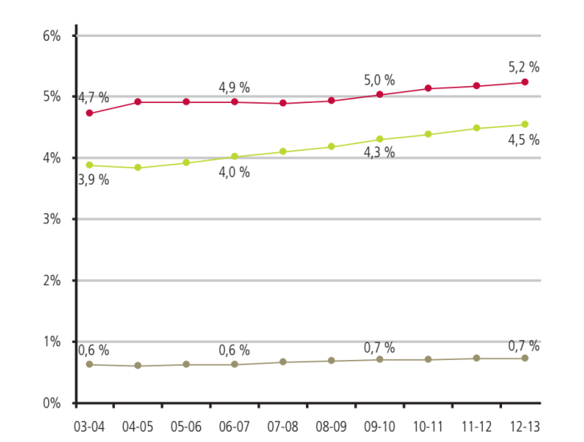
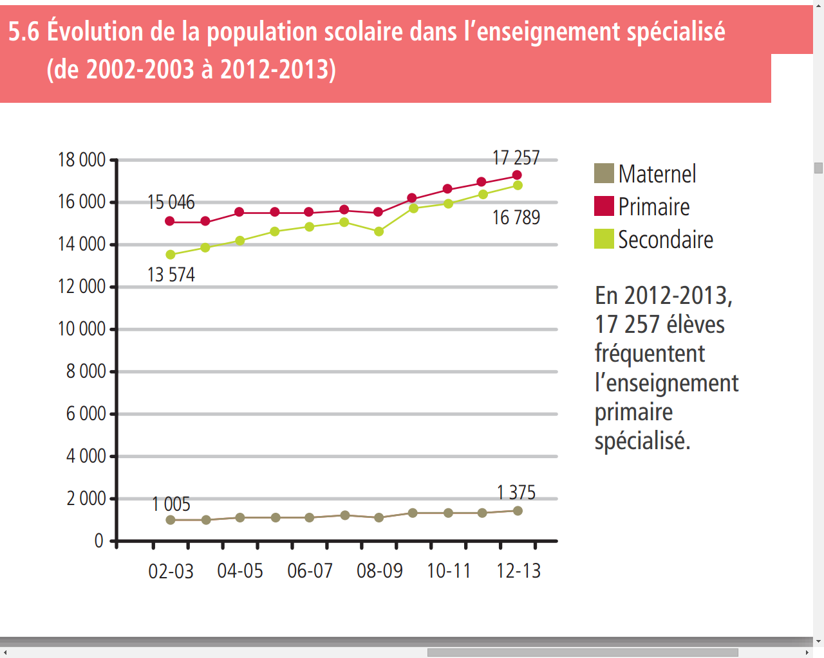 Preschool
Primary
Secondary

- Average cost of specialist education

For 2012-2013, the average cost of a pupil in specialist education is 15,110 euros as compared with 3,235 euros in mainstream preschool, 4,238 euros in primary education and 7,316 euros in secondary education.
- Legislative initiatives

In the French Community, there have been fewer recent initiatives.
One initiative was taken in the context of higher education by the Decree on inclusive higher education of 30 January 2014 aimed at promoting measures and resources to support the beneficiary students in order to address the difficulties associated with their disability that they may encounter in student life and in their efforts at socio-professional participation during and after their studies. However, the measures effectively taken remain minimal.

A "Pact for Excellence in Education" intended to reinforce the quality and equality of education in the French Community is currently in development. It is scheduled for implementation between 2015 and 2025. The preparatory note for the Pact states that the priority will be focused on the student and supports for students, including the aspect "of developing and building upon the individual capacities of each child with respect for difference and disability". Currently, no specific measures have been defined with regard to integration and inclusion of students with disabilities.

C. Education and discrimination reported to the Centre based on the criteria of disability
The Centre has been entrusted with the mission of protecting the fundamental rights of persons with disabilities (art.33.2 of the CRPD) and is qualified, in its capacity as independent interfederal public service responsible for promoting equal opportunity in combating discrimination, " to receive reports, process them and carry out any steps towards reconciliation or mediation that it deems necessary."
The Centre analysed the reports submitted over the past three years in the area of education based on the disability criterion. These break down as follows:
- 20% of the reports submitted in the area of disability have to do with education;
- these reports are increasing year by year: 31 reports filed in 2012, 62 in 2013, 87 in 2014 (this increase can be explained particularly by the distribution of the brochure created by the Centre entitled “A l’école de ton choix avec un handicap” (“Attending the school of your choice with a disability”);
- the distribution of the reports according to type of discrimination is as follows:
- 56.5% concern the refusal or absence of reasonable accommodation: the school refuses to provide support in the classroom, the school refuses to adapt the conditions under which exams are held (giving the students extra time…), the school refuses to provide a computer (with spell-check) to the student;
- 16% concern direct discrimination: the school refuses to enrol a student, the school refuses to allow a student to take part in a school trip;
- 11% concern indirect discrimination: the school is inaccessible or too far away, the cost is too high for the parents;
- 1% concern an insult or harassment but these incidents are reported in the majority of the cases processed.
- The majority of the complaints stem from a problem in primary school (30%) and secondary (32%) school. The other complaints concern higher education (17%), social advancement (10%) and specialist education (10%).
- The distribution of the victims of discrimination according to type of disability breaks down as follows:
- 26% of the victims had a physical disability
- 24% of the victims had a psychological disability
- 11 % of the victims had learning disabilities or a sensory disability
- 8% of the victims had multiple disabilities;
- 4% of the victims had intellectual deficiencies

D. Inclusive education in Belgium according to the consultation organised by the Centre (2013- 2014)

In the context of its role as monitor, the Centre commissioned a civil society consultation involving a consortium of universities, addressing seven major themes - including education - connected to the rights of persons with disabilities. Focus groups with eight to ten members have been meeting together with researchers all over Belgium. Persons with disabilities, advisory committees, parents of children with disabilities, representatives from the education sector and academia, trade unions, professional associations and specialist services were involved.
The final report, which offers an impression of the day-to-day experiences of persons with disabilities and offers a number of ideas for improvements contributed by the participants, is available on the Centre's website in French and Dutch . A summary is also available in English.
With regard to inclusive education, the obstacles highlighted by the participants are as follows: lack of clarity about the concept "inclusive education" and conflation of "integration" with "inclusion"; difficulty accessing the school of their choice (lack of accessible infrastructure at the school, lack of information about the school and the rights of parents); school guidance based on a medicalised approach to disability with a lack of consideration of the student's competencies; fear on the part of teachers that they will not know how to deal with a disabled child and fear that the school's reputation will be damaged; problems with the communication between professionals within the school, external professionals and parents,…

Among the proposals for ways to remove these obstacles, the participants specifically called for: clarification of the concepts of inclusion and reasonable accommodation in the initial and ongoing training, development of a "culture" of reasonable accommodation; better access to information for all members of the school community; thinking in terms of inclusive schools starting from preschool and in terms of a school curriculum with goals on the medium and long-term; reinforcement and continuation of the initial and ongoing training of teachers (confronting them with concrete situations, creating a repertoire of resources, providing coaching,…); accenting the competencies and needs of each student rather than the deficiencies and de-medicalising the process of orientation; promotion of the concept of the universal application of all tools in order to meet the needs of the greatest number of students; shifting material and human resources (teachers aides, therapists, nursing staff) from specialist education towards mainstream education; …

E. Inclusive education in Belgium according to the Committee on the Rights of Persons with Disabilities (October 2014)

In comments on the subject of article 24 of the CRPD, in its concluding observations on Belgium of 1 October 2014, the Committee stated that it was:
"concerned at reports that many students with disabilities are referred to and obliged to attend special schools because of the lack of reasonable accommodation in the mainstream education system. As inclusive education is not guaranteed, the special education system remains an all too frequent option for children with disabilities. The Committee is also concerned about poor accessibility in schools”.
Also, in terms of recommendations, the Committee:
“requests that the State party implement a coherent inclusive education strategy for children with disabilities in the mainstream system and ensure the provision of adequate financial, material and human resources. It recommends that the State party ensure that children with disabilities receive the educational support they need, in particular through the provision of accessible school environments, reasonable accommodation, individual learning plans, assistive technology in classrooms, and accessible and adapted materials and curricula, and guarantee that all teachers, including teachers with disabilities, receive comprehensive training on the use of Braille and sign language with a view to improving the education of all children with disabilities, including boys and girls who are blind, deaf-blind, deaf or hard of hearing. The Committee also recommends that inclusive education should form an integral part of teacher training at university and during continuing professional development”.

III. Follow-up of the recommendations of the UN Committee by the Centre
In its capacity as mechanism pursuant to article 33.2 CRPD, the Centre plans a number of steps in order to follow the recommendations of the UN Committee in the area of education, particularly:
- "Diversity Barometer- Education": after employment and housing, the Centre is initiating a research programme to assess the extent of discrimination in the educational sector in which the issue of disability will be analysed (statistical and qualitative data on discrimination and its mechanisms ), particularly the issue of orientation towards specialist education;
- Updating and continued distribution of the brochure "A l’école de ton choix avec un handicap "on reasonable accommodation in education; promotion of the concept of inclusion.
- Monitoring and critical assessment of existing and future legislation in light of the CRPD and the recommendations of the UN Committee;
- Recommendations to political actors to better take into account the need for support and interpretation for deaf and hard of hearing persons (including students).

IV. Points for attention for the General Comment on article 24 CRPD
The Centre would like to conclude these observations by emphasising the points which should ideally be developed by the General Comment on article 24:
- Clarification of the concepts of inclusion and integration and the distinction between the two;

- Confirmation that the system of segregated education (specialist education ) is in contradiction to the principles of inclusion;

- Process of implementation of art. 24:
  - immediate application in its dimension concerning discrimination,
  - need to establish a reasonable schedule for the changeover to inclusive education;
  - allocation of resources for the realisation of the fundamental right to inclusive education as a budgetary priority;

- Examples of good practices for the organisation of the changeover from a segregated system towards an inclusive system;

- Involvement of the student and his family in the school orientation and in the provision of reasonable accommodation;

- Importance of providing measures to support the educational staff in the shifting towards an inclusive school (information, initial and continuous training, promotion of inclusive methods,…).

Art. 33.2 CRPD
http://tbinternet.ohchr.org/_layouts/treatybodyexternal/Download.aspx?symbolno=CRPD%2fC%2fBEL%2f1&Lang=en
http://tbinternet.ohchr.org/_layouts/treatybodyexternal/Download.aspx?symbolno=INT%2fCRPD%2fNGO%2fBEL%2f17019&Lang=en
Concluding observations on the initial report of Belgium, CRPD/C/BEL/CO/1, see: http://tbinternet.ohchr.org/layouts/treatybodyexternal/Download.aspx?symbolno=CRPD%2fC%2fBEL%2fCO%2f1&Lang=en
type 1 : mild intellectual impairment, type 2 : moderate to severe intellectual impairment, type 3 : personality and/or behavioural disorders, type 4 : physical disabilities, type 5 : chronically ill children, type 6 : visual impairment, type 7 : hearing impairment, type 8 : severe learning disabilities
See below, p. 5 (Type 9 : autism spectrum disorders)
Decree of the Flemish Community of 10 July 2008 concerning a framework for the Flemish equal opportunity and equal treatment policy and the decree of the Federation Wallonia-Brussels of 12 December 2008 on combating certain forms of discrimination.
Initial periodical report of Belgium (http://socialsecurity.fgov.be/docs/fr/publicaties/uncrpd/uncrpd-rapport-be-fr.PDF), p.32
Department of Education and Training, Flemish Education in Figures 2013-2014, http://www.ond.vlaanderen.be/onderwijsstatistieken/2013-2014/VONC_13-14/VONC_2013_2014_Integraal.pdf
It is not compulsory to attend preschool education in Belgium.
Or 0.07% as mentioned in the state report (§ 106).
Flemish Education Council, 22 June 2006, Visietekst, Onderwijs en opvang voor kinderen en jongeren met ernstig meervoudige beperkingen: www.vlor.be/sites/www.vlor.be/files/tekst_visietekst.pdf
See especially: Law of 11 March 1986 on the organisation and subsidy of integrated specialist education; Decree of 12 December 2003 on the integration of students with moderate to severe intellectual disability in mainstream primary and secondary schools.
based on article 32A§1 of the regulation of the European Committee on Social Rights
http://www.coe.int/t/dghl/monitoring/socialcharter/Complaints/CC109CaseDoc4_fr.pdf
Enseignement et recherché scientifique, Les indicateurs de l’enseignement 2014, Fédération Wallonnie-Bruxelles,: http://enseignement.be/index.php?page=0&navi=2264
Enseignement et recherché scientifique, Les indicateurs de l’enseignement 2014, Fédération Wallonie-Bruxelles, http://www.enseignement.be/index.php?page=27187&navi=3682
See especially: the decree of 24 July 1997 defining the priority tasks of primary and secondary education and organising the necessary structures to realise them (conditions for enrolment), …
http://pactedexcellence.be/telechargez-le-pdf, p.23
Art. 6.§2 of the Cooperation Agreement of 12 June 2013 between the Federal Authority, the Regions and Communities for the creation of an Interfederal Centre for equal opportunities and opposition to racism and discrimination in the form of a joint institution, in the sense of article 92bis of the special law on institutional reform of 8 August 1980.
Interfederal centre for equal opportunities and opposition to racism and discrimination, "A l’école de ton choix avec un handicap", 2013 see http://www.diversite.be/lecole-de-ton-choix-avec-un-handicap, latest access on 16.03.2015.
The 7 themes are: equality and non-discrimination, accessibility; legal capacity (the ability to exercise rights), safety and freedom, independent living, education and work.
http://www.diversite.be/la-consultation-des-personnes-en-situation-de-handicap-sur-leurs-droits-fondamentaux-resultats-et
http://www.diversiteit.be/consultatie
http://www.diversitybelgium.be/consultation
Concluding observations on the initial report of Belgium, CRPD/C/BEL/CO/1, p.6 and 7, see: http://tbinternet.ohchr.org/_layouts/treatybodyexternal/Download.aspx?symbolno=CRPD%2fC%2fBEL%2fCO%2f1&Lang=en
Interfederal centre for equal opportunities and opposition to racism and discrimination, "A l’école de ton choix avec un handicap", 2013 see http://www.diversite.be/lecole-de-ton-choix-avec-un-handicap, latest access on 16.03.2015.

