COMMITTEE ON THE RIGHTS OF THE CHILD

Submission by:

ADF International
Chemin du Petit-Saconnex 28
1209 Geneva, Switzerland

Web: www.ADFinternational.org
Email: un@ADFinternational.org

ECOSOC Special Consultative Status (2010)

Draft Guidelines on the implementation of the Optional Protocol to the Convention on the Rights of the Child on the sale of children, child prostitution and child pornography
29 March 2019
Geneva, Switzerland

- Introduction
- ADF International is a faith-based legal advocacy organization that protects fundamental freedoms and promotes the inherent dignity of all people. As well as having ECOSOC consultative status with the United Nations (registered name ‘Alliance Defending Freedom’), ADF International has accreditation with the European Commission and Parliament, and the Organization of American States. ADF International is also a participant in the FRA Fundamental Rights Platform.
- ADF International welcomes the opportunity to provide comments to the Committee on the Rights of the Child (hereinafter “the Committee”) regarding its Draft Guidelines on the implementation of the Optional Protocol to the Convention on the Rights of the Child on the sale of children, child prostitution and child pornography (hereinafter the “Draft Guidelines.”)
- First, this written contribution addresses the Committee’s inclusion of the expression “gender/sex identities” in paragraph 15 of the Draft Guidelines concerning the participation of children in legislative, policy, and other decision-making processes [on all matters] affecting them. ADF International submits that neither the Convention on the Rights of the Child (CRC), nor any other provision of legally binding international human rights instruments identifies gender/sex identities as recognized categories of international law, and calls upon the Committee to refrain from introducing concepts that do not enjoy international consensus.
- Second, the submission stresses that, since the acts and activities relating to sale of children, child prostitution, and child pornography listed in Article 3, paragraph 1(a) of the Optional Protocol to the CRC on the Sale of Children, Child Prostitution and Child Pornography (OPSC) do not constitute a numerus clausus, the Committee’s encouragement to criminalize other, newly emerging conducts in paragraph 45 should not be limited to what it refers to as “sexual offences of children.”
- Finally, concerning paragraph 52 of the Draft Guidelines, the submission explains why the Committee should reconsider its position on surrogacy, namely that “while not all forms of surrogacy constitute the sale of children, the practice, in particular in its commercial form, may have this effect.”
- Accordingly, ADF International makes the following recommendations to the Committee:
- Eliminate the reference to “girls, boys and children of other gender/sex identities” in paragraph 15;
- Consistent with CRC Article 35 and OPSC Article 3, recognize that acts and activities that do not necessarily constitute sexual offences against children can nonetheless be equated to the sale of children, and recommend the prohibition of these broader acts and activities;
- Refrain from encouraging States to regulate surrogacy in paragraph 52, as this practice falls under the definition of “sale of children” under OPSC, even when it is said to be altruistically motivated; instead, encourage all States to reject and prohibit surrogacy in all its forms as an egregious violation of the human dignity of both women, and the children born through such arrangements.
- General measures of implementation
- In its Draft Guidelines, the Committee requires that children be informed of their rights in an a manner appropriate to their age, and states that children have the right to express their views freely in all matters affecting them, their views being given due weight in accordance with the age and maturity of the child. Accordingly, the Committee recommends in paragraph 15 that States parties ensure child participation in the drafting process of legislative and policy measures in order to duly consider the views of children “including girls, boys and children of other gender/sex identities, children with disabilities, and children in vulnerable or marginalised situations.”
- ADF International submits that the reference to “children of other gender/sex identities” is vague and misleading as such terminology is not codified by international human rights law, nor does it have a clear and agreed upon definition under any other existing international legal instrument.
- While recognizing that, due to a number of diverse factors, some children do live in situations of particular vulnerability or at greater risk of marginalization, ADF International calls on the Committee to avoid any unnecessary and inappropriate sorting of children into categories, especially when engaging in such an exercise would give rise to uncertainty in the law, challenge existing human rights norms, and further undermine the credibility of treaty monitoring bodies.
Recommendation: Revise paragraph 15 of the Draft Guidelines as follows:
“Hence, States parties should make efforts to include child participation in the drafting process of legislative and policy measures ensuring that the views of [all] children – including girls, boys and children of other gender/sex identities, children with disabilities, and children in vulnerable or marginalised situations – are considered, and that adults consulting with them have the necessary training and resources to carry out the consultations in an age-appropriate and gender-sensitive manner. Moreover, measures to implement the OPSC provisions should include a gender perspective.”

- Prevention of the sale of children, child prostitution and child pornography

Prohibition of the sale of children, child prostitution and child pornography
- Article 2(a) of the OPSC defines the sale of children as “any act or transaction whereby a child is transferred by any person or group of persons to another for remuneration or any other consideration.” Article 3 sets out a minimum range of conducts relating to sale of children, child prostitution, and child pornography, that should constitute offences under national criminal or penal laws. The chapeau of Article 3 indicates clearly that this list is not exhaustive, and that Sates can criminalize other, newly emerging means and modalities that constitute the sale of children, child prostitution, or child pornography.
- In paragraph 45 of Section V of the Draft Guidelines, the Committee encourages States to pursue the criminalization of other acts related to the crimes of child prostitution and pornography. However, the language of the draft limits this expansiveness only to crimes considered to be ‘sexual offences’. This umbrella covers child prostitution and child pornography; however, it does not necessarily include the sale of children, as this crime can be committed without sexual motives. This paragraph thus suggests that states should not seek to criminalize new and emerging forms of the sale of children; though no such exception is made within the OPSC. The equal significance of each of the three crimes and the imperative to prosecute them all therefore requires clarification.
- ADF International submits that to treat the sale of children in a more limited manner than the offences of child prostitution or child pornography not only constitutes a misinterpretation of the OPSC; it also conflicts with the obligations placed by the CRC upon state parties to “take all appropriate national, bilateral and multilateral measures to prevent the abduction of, the sale of or traffic in children for any purpose or in any form.” The non-consideration of forms of sale of children that do not constitute “sexual offences” is therefore legally unjustified. The CRC deems the intent of the crime to be null and void, sexual or otherwise; it is the act itself, not its intended purpose, which constitutes a violation against the rights of the child.
Recommendation: Revise paragraph 45 as follows:

“Article 3 requires States parties to ensure that all acts explicitly included in the provision, whether committed domestically or internationally, are fully covered under their criminal or penal law, as a minimum. This means that state parties can also criminalise other, newly emerging means and modalities to commit sexual offences of children [offences constituting the sale of children, child prostitution, and child pornography], and the Committee encourages States parties to do so.”
Surrogacy and the sale of children
- The Committee addresses the issue of surrogacy in paragraph 52 of the Draft Guidelines. Regrettably, the violation is only considered in a very limited manner. The Guidelines state that “while not all forms of surrogacy constitute the sale of children, the practice, in particular in its commercial form, may have this effect.”
- In so doing, the Committee places some forms of surrogacy outside of the scope of prohibition. However, according to the definition of “sale of children” offered in Article 2 of the OPSC, all forms of surrogacy fit the criteria of this human rights violation: this practice clearly constitutes “the transfer of a child from one party to another for remuneration or any other consideration.” Indeed, even the UN Special Rapporteur on the Sale of Children, Child Prostitution and Child Pornography does not support the limitation of the definition of the sale of children based on the element of purpose. In a report published in March 2018, the Special Rapporteur specifically linked surrogacy to CRC Article 35, claiming that “the phrase ‘for any purpose or in any form’ is significant, and surrogacy is no exception to the article’s prohibitions. Family formation should not be accomplished through 'the abduction of, the sale of or traffic in children’.”
- Regardless of the purposes and intentions of the transactional parties, the practice of surrogacy is harmful and fails to respect the best interests of the child, thus violating the guarantees of Article 3 of the CRC. An infant born by surrogacy is deliberately placed into a situation of planned abandonment and has not one set of parents, but rather up to six adults with no straightforward way to effectively know his or her true origins. Surrogacy practices lead therefore to legal uncertainty for the child and undermines a child’s rights to know and be cared for by their parents, develop a family identity, and aspire to family reunification. At one end of the spectrum of possibilities, all six adults vie for legal “possession” of the child. At the other end, the child is completely abandoned, unwanted, and left as a ward of the state. Ultimately, surrogacy subordinates the things most important to children to the desires of the adults forming the surrogacy agreement.
- Furthermore, the health risks posed to the surrogate-born child are well-documented. Studies show that separation from the gestational mother has proven to lead to anxiety issues and behavioral problems for children both in infancy and later in adolescence. Development of the brain’s response to stimuli is also affected when the baby is deprived of the scent and smell of the mother that the baby learned to know in utero, which is also known to assist with soothing for newborns. Indeed, the commodification of children into a product to be bartered over – for whatever reasons or intentions – violates their fundamental dignity as human beings. All these risks are overlooked for the sake of an alleged “right” of couples to have a child – a right that does not exist within international law.
- The statement in paragraph 52 of the Guidelines that “while not all forms of surrogacy constitute the sale of children, the practice, in particular in its commercial form, may have this effect” is misleading for several reasons. It has already been argued above that purpose is not a legally legitimate criterion to exclude surrogacy from the prohibition on the sale of the child; and yet, the purpose and motivation of profit is highlighted here as a pivotal factor.
- Additionally, the emphasis placed on the so-called commercial form of surrogacy suggests that in some cases, money does not change hands and the surrogate acts “altruistically” – simply sacrificing her claim to the child without expecting payment. However, this is an overly-simplistic filter to apply to the practice. Studies from the University of Kent show that in the United Kingdom, where only “altruistic” forms of surrogacy are permitted, the majority of commissioning couples still pay between £20,000-30,000 throughout the process in so-called “pregnancy expenses.” Even in situations where money is not transferred discretely, surrogacy still complies with the OPSC Article 2 definition of the sale of children because of the reference to “remuneration or any other consideration.” Such considerations may include payments in-kind, such as accommodation, payment of household or grocery bills, medical care and medication bills, etc; and more still, such gestures are often coupled with significant emotional pressures placed on the surrogate mother to make a sacrifice for a sister or friend. All forms of surrogacy, then – and not just those deemed to be ‘commercial’ – constitute the sale of children according to the CRC and OPSC.
Recommendation: Replace paragraph 52 with the following:
“The sale of children also occurs in the form of surrogacy, where a demand-driven system endangers the rights of children. The Committee underscores that all forms of surrogacy constitute a transaction, whether for the purpose of monetary gain or otherwise, consistent with Article 35 of the CRC, and shall therefore be prohibited by States parties.”

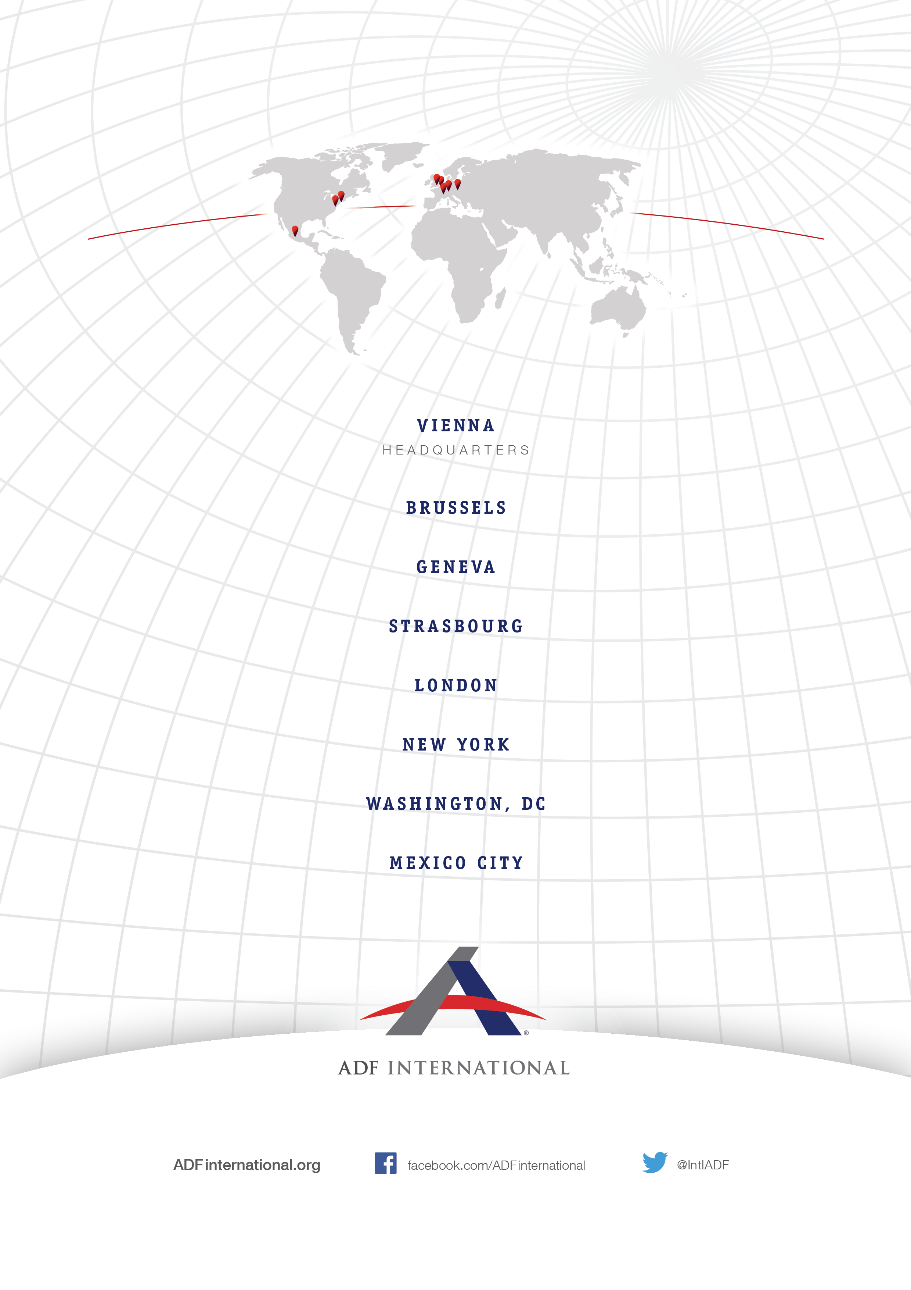
© 2017

Committee on the Rights of the Child (CRC Committee), Draft Guidelines on the implementation of the Optional Protocol to the Convention on the Rights of the Child on the sale of children, child prostitution and child pornography, INT/CRC/INF/8870/E, 5, https://tbinternet.ohchr.org/Treaties/CRC/Shared%20Documents/1_Global/INT_CRC_INF_8870_E.docx.
Ibid., 11.
Ibid., 12.
Ibid., 5.
Optional Protocol to the Convention on the Right of the Child on the Sale of Children, Child Prostitution and Child Pornography (adopted 25th May 2000, entered into force 18th January 2002) U.N. Doc. A/RES/54/263 Art 2(c) (OPSC).
Convention on the Rights of the Child (adopted 20 November 1989, entered into force 2 September 1990) 1577 UNTS 3 (CRC) Art 35.
CRC Committee, cited above §1, 12.
OPSC, cited above §5, Art 2.
United Nations Human Rights Council, ‘Report of the Special Rapporteur on the sale and sexual exploitation of children, including child prostitution, child pornography and other child sexual abuse material’ (15 January 2018) UN Doc A/HRC/37/60, 10.
CRC, cited above §2, Art 7, 8(1), 9, 10.
BBC News, Chinese baby born four years after parents' death, (12 April 2018), available at http://www.bbc.com/news/world-asia-china-43724395; Wang, Amy, The Independent, Surrogate mother forced to give away own child after surprise twin pregnancy, (3 November 2017), available at https://www.independent.co.uk/news/world/americas/surrogate-mother-pregnant-twins-own-baby-jessica-allen-omega-family-global-san-diego-a8034901.html.
BBC News, Australian couple abandon surrogate Down's Syndrome baby, (2 August 2014), available at https://www.bbc.com/news/world-asia-28617912.
Susan Golombok et al. ‘Children born through reproductive donation: a longitudinal study of psychological adjustment’ [2013] 54, 6 Journal of Child Psychology and Psychiatry 653.
Sullivan et.al., ‘Infant bonding and attachment to the caregiver: Insights from basic and clinical science’ [2011] 38, 4 Clinics in Perinatology 644.
Kirsty Horsey, ‘Surrogacy in the UK: further evidence for reform: Second Report of the Surrogacy UK Working Group on Surrogacy Law Reform’ (Surrogacy UK, December 2018).

