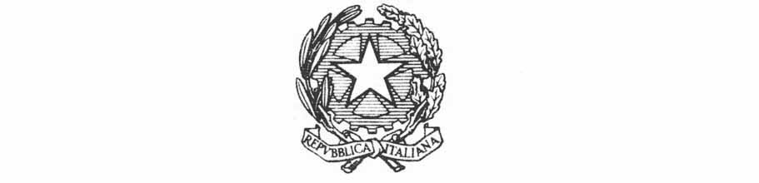
Ministry of Foreign Affairs and International Cooperation
Inter-ministerial Committee for Human Rights

Italy’s contribution on the
Draft General Comment No. 25 (202x)
Children’s rights in relation to the digital environment

August 2020

Italy’s contribution on the
Draft General Comment No. 25 (202x)
Children’s rights in relation to the digital environment

Following to the query for comments on the CRC Committee Draft General Comment No. 25, Italian Authorities are in a position to provide the following observations in relation to paragraphs and sections of the draft text.

23. Opportunities for the realization of children’s rights and their protection in the digital environment require a broad range of legislative, administrative and other measures, including precautionary ones. In the development of policies and practices that affect children’s rights regarding the digital environment, States should consult with children, their parents and caregivers.
Please include 'planning/programming' measures expressly, also by referring to the budgetary competences.

24. States should review and update national legislation to ensure the digital environment is compatible with the rights in the Convention and its Optional Protocols and that it remains relevant in the context of technological advances and emerging practices. States should mandate the use of child rights impact assessments to inform the development of legislation.10
Please add: 'adopt'.

C. Coordination
28. States should identify a government body that is mandated to coordinate policies and programmes related to children’s rights in the digital environment among central government departments and different levels of government.11 It should also cooperate with businesses, civil society and other organizations to realize children’s rights in relation to the digital environment at cross-sectoral, national, regional and local levels.12 Such a body should be able to draw on technological and other relevant expertise within and beyond government as needed. It should be independently evaluated for its effectiveness in meeting its obligations.
As for this section/paragraph, please consider that the coordination entails the drafting and adoption of soft laws and guidelines as well as monitoring & assessment functions.

34. Professionals working for and with children in all settings, including in health and mental health facilities, in social work, alternative care institutions, law enforcement, the justice system as a whole, and the business sector including the technology industry, should receive training that includes how the digital environment impacts the rights of the child in the multiple contexts and ways in which children access and use technologies. States should ensure that pre-service and in-service training relating to the digital environment is provided for educators working in nurseries, schools and other learning settings.
Please consider that the training also entails the compilation and adoption of manuals and guidelines addressed to professionals at large.

60. Any restrictions on children’s right to freedom of expression in the digital environment, such as filters and other barriers including safety measures, shall be provided by law, necessary and proportionate. States should provide children with information on how to effectively exercise this right, particularly how to create and share digital content, while respecting the rights and dignity of others and not violating legal rules, such as those related to incitement to hatred and violence.
Please include a reference to respect of freedom of expressions between and among peers.

113. States should ensure that schools teach digital literacy as part of the basic education curricula from the earliest years, and such teaching should be evaluated for its outcomes.53 This curricula should include the skills to handle a wide range of digital tools and resources and those related to content, creation, collaboration, participation and civic engagement. It should include the critical understanding needed to find trusted sources of information and to identify misinformation and other forms of biased or false content; sexual and reproductive health issues relevant to the digital environment; knowledge about human rights, including the rights of the child and of others in the digital environment, and available forms of support and remedy. Also, it should promote awareness of the risks of children’s exposure to potentially harmful content, contact and conduct, including cyberbullying and other forms of violence, and coping strategies to reduce harm and build children’s resilience.
The participation should also be reminded in informal settings, even if related to school and school curricula.

C. Protection of children in armed conflict, migration and other vulnerable situations
A reference to access to digitals from children deprived of liberty is not included in the draft GC: please take into consideration this vulnerable situation.

