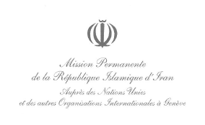

Comments by the Islamic Republic of Iran Pursuant to CRC Calls (REFERENCE: CRC/AF dated 12 August 2020) for Drafting a General Comment on the rights of children on children’s rights in relation to the digital environment
In response to calls made by the Committee on the Rights of the Child, with the purpose of drafting an advanced version of the General Comment on the rights of childrenin relation to the digital environment, comments made by the Government of the Islamic Republic of Iran are as hereunder:
- Providing comments on issues numerated herein shall, under no circumstances whatsoever, be interpreted as the Islamic Republic of Iran’s recognition of any commitments beyond responsibilities assigned thereto within the aforementioned Convention.
-It is necessary for governments and parents to acquaint children and juvenile with outstanding threats and harms posed bydigital environment.In order to reduce such menaces, they can take advantage of control tools to further monitor children and juvenile activities in digital environment. Uncontrolled virtual presence and excessive use of cyber-generated environment, in addition to potential physical injuries, can also lead to psychological damage. Therefore, it is imperative to add a paragraph in the introduction section to stress the need of establishing gradual monitoring mechanisms, with principles of respect for privacy taken into consideration.
- A paragraph should be added to the fifth part appertaining to governments’ obligations to educate general and specific target groups in order to lay emphasisupon observance of the rights of childrento access digital environment and operational strategies to protect them, while taking into consideration lifestyle and culture of countries.

