UN CRC General Comment 25 on children and the digital environment
Comment on first draft
Submitted jointly by the Consortium for Street Children and We Yone Child Foundation, Sierra Leone

This submission is made jointly by the Consortium for Street Children, and We Yone Child Foundation, Sierra Leone, to the Committee on the Rights of the Child as part of the development of their General Comment No. 25. Both organisations warmly welcome the opportunity to provide input into this process and wish to draw the Committee’s attention to some of the key issues for children in street situations with regards to the digital environment.

Methodology:
Please note that this submission was collated prior to the Committee’s launch of its child-friendly survey on General Comment No.25.

The Consortium for Street Children (CSC) circulated the draft General Comment with our global network of members, who were invited to comment on the draft and share it with the children they work with to gather their perspectives and insights. To facilitate this, CSC analysed the draft General Comment, and developed the following 6 questions to guide the input of children in street situations.
- How do you use technology/internet?
- What challenges do you face in accessing technology/internet? How does this make you feel?
- Have you ever felt unsafe while using technology/internet?
  - What would help you make use of technology / internet more safely?
- What is most important to you about the ‘digital environment’ or technology?
- Where the General Comment already mentions children in street situations, in paragraphs 68 and 94, does it describe your experiences well? Do you agree with the things the General Comment says about children in street situations, and what they want and need?
- If you could tell decision-makers anything else about how to make technology / internet accessible / safe, what do you want to say?

We Yone Child Foundation responded to this call for input and used their regular ‘Safe Space Sessions’ to discuss the questions with the children in street situations who they work with. These Safe Space Sessions take place once per week in two slums in Freetown, Sierra Leone: Kroo Bay Slum and George Brook Slum. 35 children regularly attend sessions in each location: the aim of the sessions is ‘to create an atmosphere of trust and confidence where the children can express their feelings and shared life experiences about their past and present life and how to cope with the present situation around them.’ Guidance counsellors also work with the children on issues including psychosocial counselling, growth and development, menstrual hygiene management, and career development. Children therefore have a strong, trusting relationship with the guidance counsellors who undertook this exercise with them.

The children participated in discussions and then provided their input in written format, as photographed and transcribed below. This input was analysed by CSC and linked to relevant paragraphs within the draft in order for it to be of most use to the Committee. The children’s full remarks are provided and transcribed in full to enable the Committee to hear directly from the children in their own words. Consent was obtained from all children to share the words and images included within this document.

We Yone Child Foundation consultation with children in street situations:
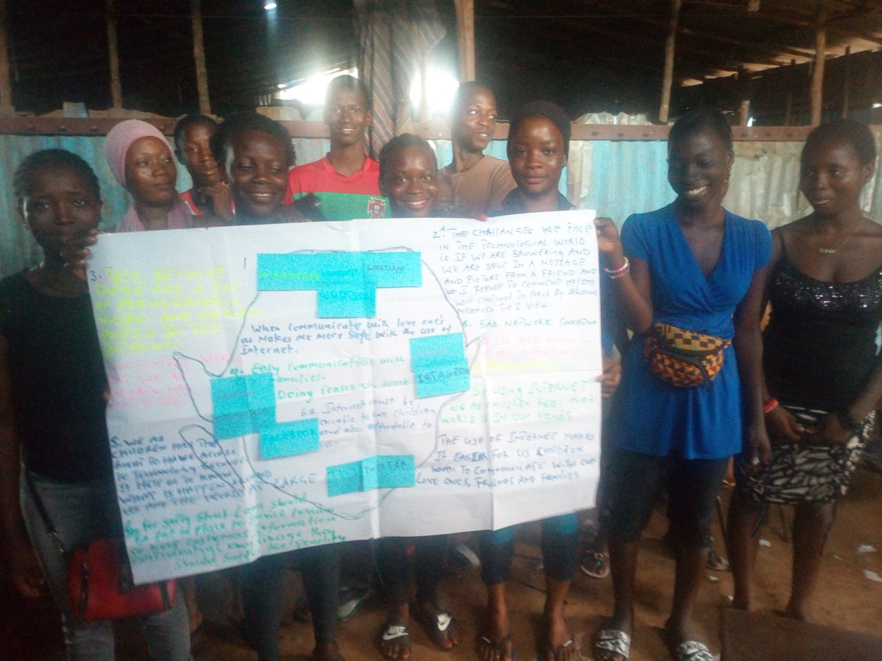
Children at the end of the session show the findings of their discussion.
(image included with permission from children)

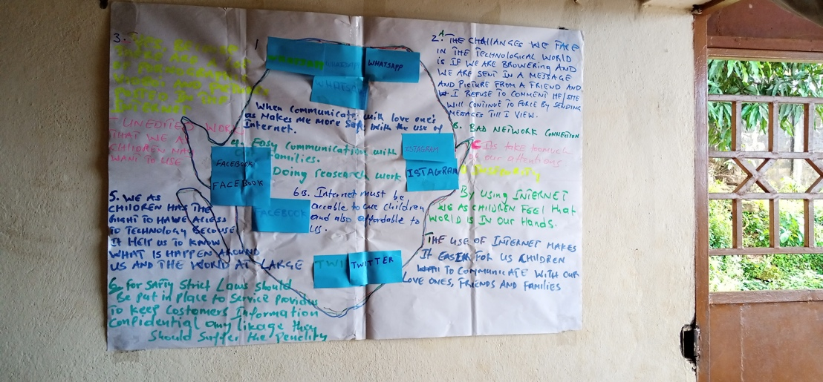
Mindmap of children’s discussion

Transcript of discussion findings (this work is shared unedited by either We Yone or CSC staff, questions have been added to aid the Committee’s understanding):

- How do you use technology/internet?
  - WhatsApp (x4)
  - Instagram (x2)
  - Twitter (x2)
  - Facebook (x3)
When communicating with loved ones it makes me more safe with the use of the internet.
By using internet, we as children feel that the world is in our hands.
The use of internet makes it easier for us children to communicate with our love ones, friends and families.
- What challenges do you face in accessing technology/internet? How does this make you feel?
The challenges we face in the technological world if we are browsing and we are sent a message or picture from a friend and I refuse to comment, he/she will continue to force by sending messages until I view.
Bad network connection.
It take too much of our attentions.
Insecurity.
- Have you ever felt unsafe while using technology/internet?
Yes, because there are a lot of pornographic videos and pictures posted in the internet.
- What is most important to you about the ‘digital environment’ or technology?
Easy communication with families.
Doing research work.
- Where the General Comment already mentions children in street situations, in paragraphs 68 and 94, does it describe your experiences well? Do you agree with the things the General Comment says about children in street situations, and what they want and need?
We as children has the right to have access to technology because it help us to know what is happen around us and the world at large.
- If you could tell decision-makers anything else about how to make technology / internet accessible / safe, what do you want to say?
For safety, strict laws should be put in place to service providers to keep customers’ information confidential. Any leakage they should suffer the penalty.
Internet must be accessible to we children and also affordable to us.

Key issues:
The following remarks have been developed by CSC in collaboration with We Yone Child Foundation, based upon both the outcome of the session held with children, and CSC’s expertise on the situation of street-connected children across our global network.

Paragraph Number | Relevant remarks
10 | Non-discrimination in access to the digital environment was a key concern for the children who participated in this submission. The children demonstrated a concern about the importance of equal access to technology, especially access to internet connection. They cited poor connectivity as one of the key issues that they have with accessing technology, demonstrating the unequal access they have to the digital environment, commonly as a result of their street situatedness.  Children were interested not only in accessibility to digital technologies, but also affordability.  Paragraph 10 could therefore be strengthened by explicit inclusion of ‘children in street situations’, who are also entitled to equal, non-discriminatory access to the digital environment, and who require tailored responses from governments in order to achieve this, given the specificities of their situation.
12 | In-line with comments made on paragraph 10, we recommend the additional inclusion of ‘children in street situations’ in paragraph 12, in order to underscore the unique opportunities and risks posed to children in street situations by the digital environment.
16 | We welcome paragraph 16 as currently drafted: the paragraph clearly and emphatically reflects the children’s concerns about online safety, particularly regarding abuse and exploitation. We urge the full inclusion of paragraph 16 as drafted.
53 | We appreciate the vital importance of diverse and accessible digital content to all children. We suggest the explicit inclusion of ‘children in street situations’ in the final sentence of paragraph 53, in order to reflect the specific position of children in street situations in terms of access, and lack thereof, to the digital environment.
55 | We recommend that the phrasing be changed to remove the word ‘terrorist’ ahead of armed groups. Children, particularly children in street situations, are vulnerable to exploitation and recruitment by all forms of non-state armed groups, including armed gangs, which do not necessarily constitute ‘terrorist’ groups. The language of paragraph 86 as drafted may be appropriate to duplicate here.
59 | We warmly welcome this paragraph as drafted, and the way that it reflects the vital role the digital technologies can play for children in street situations in connecting them with their peers, both locally, nationally and globally, to share their experiences and express themselves.
55  (83-85, 121) | We welcome the focus in the draft on children’s safety and security in accessing the digital environment. Children who participated in this submission expressed particular concern about the quantities of pornographic materials available on the internet. This was cited as a reason why children, particularly children in street situations, feel ‘unsafe’ on the internet.  It is important to acknowledge within the General Comment that children risk both being exploited sexually on digital platforms, but also that the proclivity of pornography of all kinds in itself makes children feel unsafe.  We therefore recommend the addition, in paragraph 55 or where the Committee deems it most appropriate, of language which reflects the fact that the proclivity of pornographic material on the internet makes some children feel unsafe, and that this should inform States’ responses in this area.
68 | We warmly welcome this paragraph as drafted and encourage its inclusion in full.
69-76 | Children expressed strongly their belief that data should be kept strictly confidential and that this should be enshrined in law: For safety, strict laws should be put in place to service providers to keep customers’ information confidential. Any leakage they should suffer the penalty.  Paragraphs 69-76, as currently drafted, are therefore most welcome.
80 | Birth registration is often a key issue for children in street situations, as the Committee recognised in its General Comment No. 21. We therefore suggest the explicit inclusion of ‘children in street situations’ in this paragraph, to make clear States’ obligations in this regard.
81 | We welcome the inclusion of paragraph 81 on statelessness, which is a key concern for many children in street situations, many of whom are also refugee children or children in situations of migration.  If possible, we suggest the explicit inclusion here of ‘children in street situations’ in order to highlight their particular vulnerability to statelessness and States’ responsibility towards them in this regard.
94 | Paragraph 94 was of crucial importance to the children who participated, and we welcome the explicit inclusion of children in street situations here.  Children noted in particular that ‘easy communication with families’ was one of the most important things to them about the digital environment and stated that (t)he use of internet makes it easier for us children to communicate with our love ones, friends and families.  To strengthen this paragraph, we recommend ‘children whose parents are incarcerated’ to be included in the list of groups of children separated from their families here, in order to reflect the specific needs of that group who often overlap with children in street situations.
106 | Children expressed concern that technology and the internet in particular can take up too much of their attention. We welcome this paragraph as drafted.
125 | We warmly welcome this paragraph as drafted. It clearly reflects several of the key concerns of the children involved in this submission. We encourage the inclusion of this full paragraph in the final Comment.

