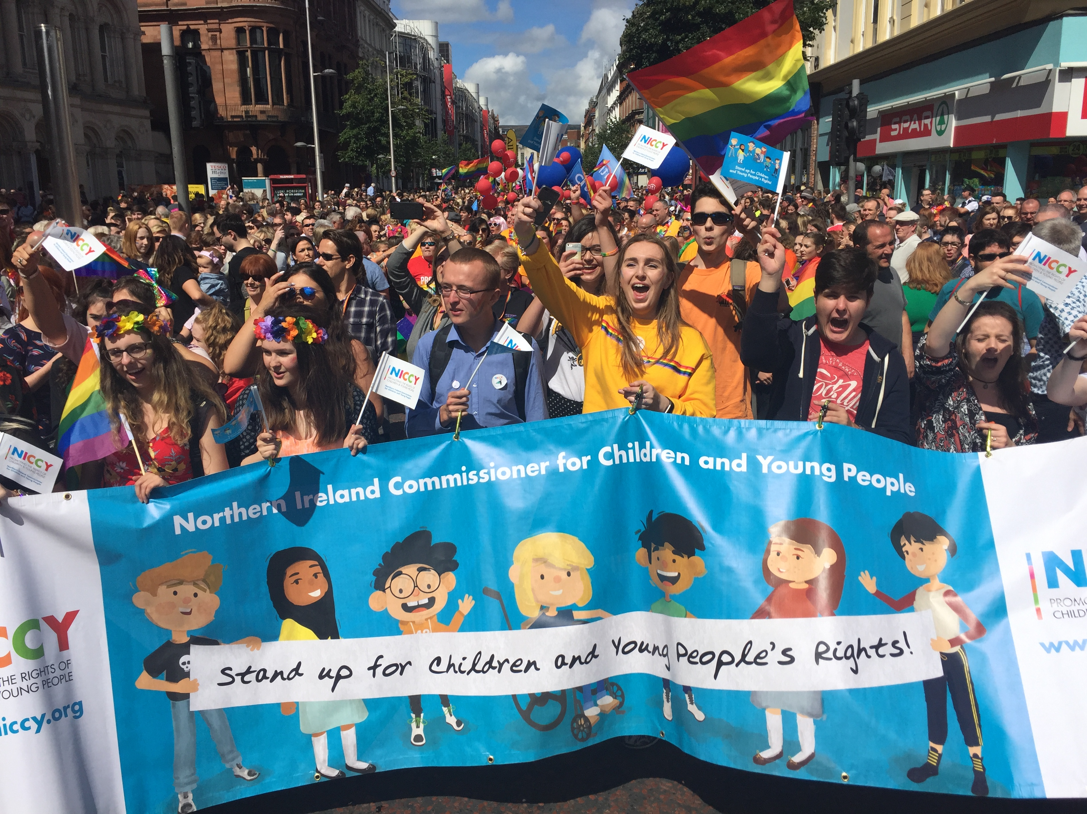

“Protecting and Empowering Children as Human Rights Defenders”

Young Person’s submission on behalf of the Northern Ireland Commissioner for Children and Young People.

Lead Author: Pearse Smith
Contributors: Caoilfhionn McKee McElkerney
El Savage
John Ewing
Madeline McKnight
Clare McCorry

Date: June ‘18

1.0 Preface

Koulla Yiasouma, the Northern Ireland Commissioner of Children and Young People (NICCY) is an independent holder of public office. The Commissioner’s statutory function centres upon the promotion and protection of the rights of children within her jurisdiction with regard to any relevant provisions of the United Nations Convention on the Rights of the Child.

The Commissioner may also make representations or recommendations to any body or person about any matter concerning the rights or best interests of children and young persons. Vitally, through the work of the NICCY’s Youth Panel (NYP) and ongoing engagement with children and young people throughout Northern Ireland, the views and experiences of children and young people inform the work of the Commissioner.

On hearing that the UN Committee on the Rights of the Child decided to devote its 2018 Day of General Discussion (DGD) to the theme “Protecting and Empowering Children as Human Rights Defenders”, the NYP agreed this provided an opportunity to develop a submission on behalf of the Commissioner. The Youth Panel’s voices where led by the thoughts and experiences of 17 year old student, Pearse Smith. Pearse has participated in a number of NICCY initiatives and during his time on a student work placement with NICCY, he was tasked to be the lead writer on this submission.

This is his story…

2.0 Introduction

My name is Pearse Smith, 17 years old from Belfast, Northern Ireland. I am a Human Rights Defender and wrote this report from my perspective as Human Rights Defender in a contested society.

I, and many others around me, have tried to assume this role of children as human rights defenders by:
- trying to create a safe space for all people through helping to secure funding to create a youth friendly space in my local area;
- being part of a funding application to attain money to put in place a personal and social development for local young people in order to try and protect local young people from exploitation, using dangerous drugs, etc.

I take part in, facilitate and promote cross community events that I believe are essential in contested societies such as Northern Ireland, to promote an attitude of tolerance and then co–operation between the two dominant communities.

The aim of this is to create a safe and stable place for all to enjoy whilst promoting people, on both sides, to enjoy and promote their culture. Beyond this, my work aims to eradicate any current infringements on human rights such as freedom of expression without fear of being targeted, the right not to be discriminated against and the right to assemble. All of these are not always respected in the current society of Northern Ireland.

I have also taken on the role on advising local politicians, campaigning for change and for the voice of young people to be heard. A recent example is when I helped organise and facilitate a conference on children and young people’s concerns and hopes with regards the Brexit negotiations, from both sides of the border. I then was part of a team that presented the views put forward by these 120 young people to key policy makers in Brussels.

Many people and young people actively defend human rights every day in Northern Ireland and need to be celebrated and acknowledged for the critical work they do. This report highlights the unique challenges children as human rights defenders face in a contested society. Similar issues undoubtedly occur in other ‘conflict to peace’ societies.

Structurally, the submission opens with ‘what helps young people become and fulfil the role as Human Rights Defenders’ and is followed by the ‘challenges a child or young person living in a contested society may face as a Human Rights Defender’.

Possible solutions to these challenges – from a young person’s perspective - are also offered.

Supplementing this content are additional comments from NICCY Youth Panel members both via the written word and through two videos: (https://youtu.be/BiMYOW2zF94)

Further shared experiences are provided by a young person, a youth worker and a Community Development Worker from the Colin area of Belfast.

2.0 WHAT HELPS CHILDREN TO ACT AS HUMAN RIGHTS DEFENDERS?

- A domestic incorporation of the UNCRC by the UK Government.

- Compulsory education of human rights and children’s rights; where to go if rights are violated and what to do when you know someone’s rights are being violated. Education is compulsory and school is where most children and young people are.

- Valuable and interactive classes to make it appropriate to younger children and young people (e.g. 8 – 13 year olds) as opposed to lectures and lengthy reports of little interest. Actively engaging young people through experiential learning can help to create an environment where children want to know more about these rights, equipping them with the knowledge to protect and promote such rights.

- Emphasise the value of these rights and contrast to a world without them. Highlighting how important these rights are making them want to participate in advocating for these rights and even further potentially to create a movement to develop these rights. An example that can be seen of this working to great effect is how the celebration of the suffrage movement is trying to be used to promote political participation, especially with women.

- Those not in education, employment or training (NEET) need to be reached as well and need to be aware of their rights also. Advertising specifically toward NEET people through social media, local media.

- This could perhaps be done through holding community events and inviting, encouraging and incentivising these NEET people to attend. Beyond that, NEET people could be encouraged to join youth clubs or other community groups. Through this, informal education of rights can occur with the same outcomes outlined above.

- There needs to be a trust from government and local level for children to be human rights defenders. This can be done through allowing children and young people to play an active role in campaigning for promotion and protection of human rights. The use of government funding to allow children to organise a campaign on rights awareness and conduct their own research. This research may highlight a weakness in the education of rights for example (Article 42, UNCRC). This research could be presented not only to policy makers but to other children so that this weakness can be tackled in an appropriate way in co-operation with children who are Human Rights Defenders.

- Creating a rights based society where all human rights are universally accepted and celebrated. This will allow children to feel safe and comfortable when discussing their rights and their views on such rights. Ideas for this could include, local Community events celebrating human rights with an emphasis on conserving rights, or maybe a fun day celebrating human rights. Further, to promote the cause of human rights, all political parties could say to their constituents very publically that they promote the advocacy of human rights. In addition, they can emphasise the critical role that children have to play through being CHRDs in educating each other personally on human rights and the UNCRC, or wider groups through community events.

- Encouraging the right to assemble and association can facilitate children as human rights defenders to organise campaigns or to organise events, visiting local youth groups, providing workshops and if necessary organising protests against human rights abuse. A network of local CHRDs could be beneficial, such as a Facebook group. These should all be encouraged at local and political level. Encouragement through political representatives meeting and working with these CHRD groups, local councils advertising the work of such groups, taking their views into serious consideration and consulting these groups in the legislative process if appropriate.

All of this work of CHRDs can only occur if they feel safe to do so. It must be of the upmost importance to the government to ensure that society and the culture ensures people can express their views without fear of harm or damage to their reputation.

3.0 Challenges to children as Human Rights Defenders (CHRDs) in a contested society

The Committee on the Rights of the Child, in its examination of the UK Government’s compliance with its obligations under the UNCRC, expressed its concern at the fact that in Northern Ireland, children face violence, including shootings, carried out by individuals / groups in paramilitary-style attacks, and recruitment by such people.

The Committee recommended that the Government,
“Take immediate and effective measures to protect children from violence by non-State actors involved in paramilitary-style attacks and from recruitment by such actors into violent activities, including through measures relating to transitional and criminal justice.”

The impact of the ‘Troubles’ and the divisions underlying it, continue to significantly impact on the lives of our children and young people, all of whom were born after the Good Friday Agreement (1998). The communities most deeply affected by the Northern Ireland conflict are also those in areas with the highest rates of mental ill health and child poverty, and the lowest levels of educational attainment.

3.1 A Sectarian Divide
In Northern Ireland, there are two traditional communities that dominate society, nationalists and unionists.

On a daily basis, the children living in these communities deal with the ongoing impacts of a conflict not of their making and which ended before they were born. Segregation continues to be a part of daily life for children and young people in Northern Ireland, in accessing services with segregated living significantly impacting on how they live their lives. In Belfast, 98% of public housing is segregated into Protestant or Catholic areas. Children are largely educated in separate schools, with only 7% of children attending integrated schools.

The legacy of the troubles as created a bitterness between these two communities and the violent past still poses fear of personal attack, verbal, physical or cyber if one was to express their views, revealing their beliefs. This has percolated further into people forming an opinion on you before you even speak or regardless of what you are actually saying simply because of where you live.

This is because areas may contain a predominant nationalist population for example, West Belfast, or a dominant unionist population, for example, Lagan Valley. Therefore people already form an opinion of your character and can lead to a complete dismissal of what you are expressing if they disagree with the political attitude of your community.

The very nature of the mistrust between the two dominant communities has caused implications for human rights, especially the right not to be discriminated against (Article 2 of the UNCRC) and the right to enjoy your own culture (Article 30). This is due to the fear of “one culture dominating the other”.

The current impasse over the Irish Language Act has come about partly due to the mistrust as to what the consequences of passing such legislation would hold. There have been claims from some stating that the Irish Language Act would cause the Catholic/Nationalist/Republican (CNR) community to dominate Northern Ireland’s culture and thus oppress the culture of the Protestant/Unionist/Loyalist (PUL) community. This is a current example of how legislation based on improving the rights of people in Northern Ireland has been shredded down to a “Green and Orange” issue when in reality it’s aimed at improving Article 30 UNCRC (the right to enjoy your own culture, use your own language and practice your own religion).

There is currently an attitude that this is the status quo and an acceptance that it is okay for these rights to implicated (not necessarily oppressed) on a daily basis. This acceptance percolates through to all generations challenging the willingness of children and young people to become CHRDs.

3.2 Paramilitaries
In some communities, paramilitaries are still active. Not to the extent as to what occurred during the Troubles, but they are undoubtedly still active.
They have major control and authority in communities which is illegitimate but poses a major threat to CHRDs. Seymour Hill is an, where the UDA dictate what occurs in the community and impose their own rule of law making them feared in the community and having unlawful authority.

For example, the story of joyrider Harry McCartan is still prominent 16 years later. McCartan was found nailed to wooden posts in a lane behind the Seymour Hill estate. Two rusty six-inch nails were driven though his hands and he had been beaten about the legs and face. The UDA claimed responsibility for this event. Personal friends who live in the area still speak of this case that happened before they were born. It scares them. There are countless examples of punishment beatings and scare mongering which leave a feared legacy.

There are examples on both sides of the divide with the presence of the Dissident Republicans in Republican communities carrying out punishment beatings as well. Progress with relation to protection of freedom of expression, and trying to encourage young people to speak up and speak out cannot happen with communities under the influence of these paramilitary groups, for fear of opposing these groups’ agenda.

A child’s development in these communities is essentially up to the paramilitaries with them having the power and examples of them telling community/youth workers to leave because they are doing “too much work”.

This is true for a personal friend of mine who was a youth worker in Seymour Hill and was asked to leave by the UDA because she was doing “too much” cross community work. This was a restriction on young people’s standard of living as they are being held back from positive progress and an attitude of intolerance to “the other side” is further sustained.

Oppression of progress, and the fear to freely speak will manifest among all people, especially children, as long as there is knowledge or speculation of a gun somewhere in the background.

Further, in many communities where paramilitaries are active, the image of paramilitaries appeal to some children and young people and who then want to be associated with such groups.
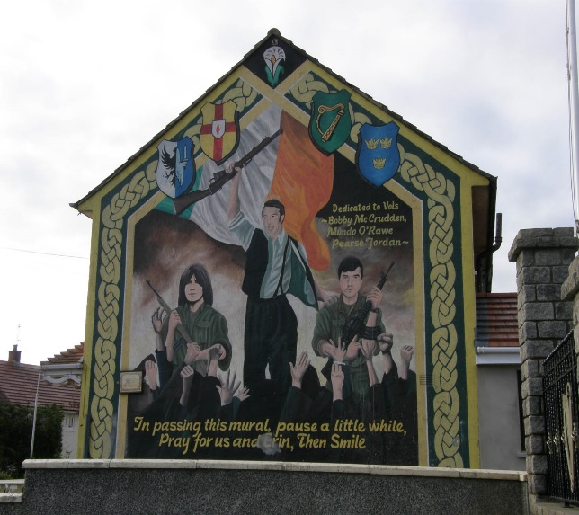
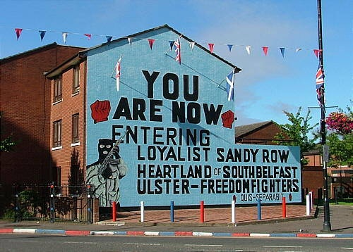

Loyalist and Republican murals - Belfast

These groups, who oppress human rights, are being idolised as role models in the community. This is, without doubt, a massive issue in hindering the development, recruitment and support available of CHRDs.

3.3 The Political System
The Northern Assembly has not been functioning for a year and 5 months (at the time of writing). How is it possible to pass any relevant legislation to protect Children as Human Rights Defenders? A complete change in the mind-set and attitudes towards human rights defenders, defending and promoting them must be stimulated and kick-started from politicians with the hope that these beneficial attitudes will trickle down towards people at grass-roots level. They have a duty and power to support and implement the ideas that can help young people become human rights defenders.

There is also a frustrating aspect of the mechanisms for queries into legislation or the expression of concerns within the institutions in Northern Ireland. It is understood that young people must be consulted and their views listened to whenever they have queries or wish to raise an issue with anything to do with legislation (as stated in article 12 UNCRC).

However, they do not have to be acted on and can be ignored and dismissed as long as there is a claim of giving the proposition “due weight”. Though, there is not as of yet a clear definition of “due weight”, leaving it up for interpretation and in a practical sense can mean that policy makers can dismiss what is being highlighted by CHRDs. This can stimulate negative attitudes and thinking with a “what’s the point”, “nothing changes anyway attitude” leaving CHRDs demoralised.

This does not encourage CHRDs to continue to pursue their work or inspire others to be like them.

Further, the UK have not ratified the relevant documents to allow for direct complaints for children’s rights violations to the UN Committee. This is meant to be a last resort after all local mechanisms have been exhausted.

Therefore, this has enormous implications on the protection of Human Rights and the effectiveness of local CHRDs, especially if the procedures at local level are inadequate.

3.4 Other General Challenges to CHRDs:

At the moment there is a negative stigma created around “social justice warriors”. Many young people would not want to be associated with this term due to the examples of hypocritical or illogical “social justice warriors”. This has caused many young people to be quiet on human rights issues/abuses online due to “online trolls” personally attacking them and not challenging their view or opinion.

This was seen very recently locally over the emotive debate on the 8th amendment in the Irish Constitution where many young people voiced their opinion on the issue and almost always getting personally attacked. This shows that the “online world” is not a safe place for people to express their concern and therefore poses a significant challenge to CHRDs as a large portion of their time being spent on social media with the majority of their information coming from this outlet.

It is a shame as this could be used very effectively to champion human rights due to so many people and especially young people being active on social media.

4.0 Possible solutions….

In my experience, not much can be changed in isolation. As Barack Obama said:
“Change will not come if we wait for some other person or some other time. We are the ones we've been waiting for. We are the change that we seek.”

4.1 For the presence of paramilitaries

Where you come from should not be a barrier to defending and championing rights neither should be hindered through fear of threats / punishments.

Communities need to “own” the change of the current situation getting rid of the authority these gangster groups have. They need to have the confidence and security to do so.

This must be ensured by the government however, the action to remove the authority of paramilitaries, I believe, must come from the community themselves. A neighbourhood partnership/community group can be set up to debate and discuss what is best for the community with everyone welcome.

Decisions from this forum must be made democratically.

There needs to be a community led “safe space” created where rights, essential development of children and young people and the benefits of co-operation are a fundamental part of the culture, engaging children in discussions on human rights and encouraging them to act as human rights defenders.

These groups cannot be allowed to dictate people’s rights and should definitely not prevent young people carrying out a bold and valuable role in being human rights defenders.

I would not try to disband paramilitaries who do not want to allow for human rights education in their communities or forcibly arresting their members. I believe this line of action will only breed more intolerance and hate towards human rights defenders as they can be seen as the catalyst that caused this attack on their organisation. This would make CHRDs even more of a target, threatening their safety and inhibiting them in their role of protecting and promoting human rights

End goal: Creating a culture centred on the knowledge and promotion of CHRDs, the benefits they bring to the community and eliminating the barrier the may face from local opposition.

4.2 For the stigma around where people come from

This in no way should be a barrier to the protection and promotion of human rights as human rights are for all in society. However, a persistent mistrust of “the other side” does exist in contested societies.

This social attitude is normally practiced in Northern Ireland through areas where people live. This can lead to resistance to human rights defenders’ cause simply because people do not want other people from the “other side” to seem reasonable, or are suspicious of their cause questioning the real motivation of Human Rights Defenders in general and thus CHRDs as well.

As previously mentioned, the current impasse over the Irish Language Act has come about partly due to the mistrust as to what the consequences of passing such legislation would hold.

An education of all generations on who human rights affect, what human rights are, who human rights defenders are, etc. A domestic incorporation of the UNCRC would support this. This can be done through a government programme, raising awareness of human rights. For example, a fun day celebrating the work of local CHRDS, local community meetings/events supporting CHRDs in their area.

Possibly a network of CHRDs in the city who go around local communities and community groups, e.g. old people’s groups, sports clubs, etc., advertising their work and the holistic benefits it’s had on their society and how their work could benefit the community groups. This would give CHRDs a positive image and encouraged and supported from local communities and hopefully all in the city/area. Citizens would know that the work is to benefit all in society and are seen as making a real benefit to society, taking on the role of role models.

End goal: An eagerness for young people to want to become CHRDs and for CHRDs to be idolised on both sides of the community.

4.3 For politicians/political institutions

Politicians should play a critical role in supporting and promoting the work of CHRDs in their constituency area and should publically support the protection and promotion of human rights. They must emphasise that human rights surpass any sort of cultural/sectarian division on local and political level. They should take the bold step into publically stating how important human rights are and that their role is to protect and promote them.

Further from simply listening to what CHRDs, the network for CHRDs should be consulted in appropriate and relevant legislation.

Mechanisms in the institutions to make sure that any queries into legislation about the affect they have on human rights should be widely available to CHRDs and free of cost. If a human right is breached, easy and child friendly procedures should be put in place and widely known so all people know what to do when this has occurred.

End Goal: A free, impartial service to aid young people in completing forms or whether to take legal action on human rights abuses must be available and known.

5.0 Lived Experiences

The following information supports the main report above and shares how other young people; a Youth Worker and a Community Development worker think about children as Human Rights Defenders.

5.1 NICCY Youth Panel Members Madeleine McKnight and John Ewing considered the guiding questions and their responses are noted below:

  - Who should be recognised as children human rights defenders (CHRD)?
- Young people
- Parents
- Teachers
- Workers at organisation’s

  - How can children use their capacities and experiences to act as a defender?
- They can witness to make change
- They can fill in NICCYs surveys
- Join a youth panel
- Educate others about rights

  - What is the role that children play as human rights defenders in society?
- An educating role
- First-hand experience
- To support and protect other young people
- To provide justice to those in need
- To be an example to others of a young person fighting for their rights
- To encourage others to learn their rights as young people and to stand up for them
- Provide evidence and explanation of issues being faced that adults might not identify

  - What does help children to act as human rights defenders?
- Support from adults
- Education about their rights
- Youth panels
- Student councils in schools
- Advertisement on social media
- Effort made via adults to engage young people

  - What are the barriers that children face at local, national and international level?
- Prejudice from those around them
- Lack of education
- Lack of awareness
- Misunderstanding of organisations in place
- Discrimination and judgement

  - How can children be supported by adults to act as human rights defenders?
- Parents, guardians and teachers can teach young people their rights
- Schools can set up youth\student councils
- Organisations can advertise participation
- Recruitment can be encouraged through schools
- Adults can act as children human rights defenders which sets an example
- They can teach children to care about how they are treated
- They can teach young people to practice their rights

How can children support adults in being children human rights defenders?
- Children can teach adults to be respectful of every age
- Children can teach adults to speak up for those who cannot speak up themselves (e.g. Children cannot vote)
- Children can teach adults of issues they may have been unaware of
- Young people can teach adults different ways to present issues through creativity
- Young people can encourage adults in their pursuit of justice
- Young people can stand by adults and provide them with evidence
- Young people and adults can both respect each other

How can CHRDs empower other children and receive support from them?
- Getting the word out – being vocal about defending children’s rights
- Keeping in touch with other CHRDs – Facebook group?
- Establish a network of CHRDs

What are the risks faced by CHRDs?
- Could lead to backlash (desire to maintain the status quo which may suppress the rights of children & young people) – children traditionally
- Defending children’s rights may be seen to conflict with other interests

How can CHRDs be protected?
- By an awareness of as many people as possible that children’s rights DO exist and are protected by law
- CHRDs having the confidence that they are protected by this
- Support from adults & relatives close to the relevant CHRDs

What mechanisms can CHRDs use to claim if their rights have been violated?
- Formal complaint against whoever has committed the violation – to the organisation itself
- Public organisations e.g. NICCY/Children’s Law Centre

What do you think your gov’t is doing to protect CHRDs?
- Promoting the 42 UNCRC articles
- Supporting organisations such as NICCY, who champion the cause of CHRDs, and are human rights defenders themselves

What else do you think your gov’t should be doing to protect them?
- Being more vocal in promoting the importance of children’s rights and subsequently defending those rights
- Practically e.g. introducing education on the UNCRC into the curriculum – in ‘Learning for Life and Work’ lessons?

Additional Question: During discussion, the question was raised about what children and young people can do to support adults to support children become human rights defenders.

How can children who are CHRDs support adults?
- Consistently emphasise the importance of having their own human rights protected as outlined in the UNCRC
- Make it clear that it is for the benefit of both adults and young people for adults to support the rights of children on a daily basis
- Show the benefit of having rights respected; that it increases the compliance of children as they will know that adults have their best interests at heart when making decisions for them
- Remind adults that, even though they are not directly affected by children’s rights, they can also champion the cause and defend the best interests of children and young people

5.2 Brendan McAteer is a Community Development worker in West Belfast supporting young people to realise their rights and having their voice heard. Brendan provided written answers to Pearse’s questions.

“What role do you think the government should have in promoting and protecting Children as Human Rights Defenders?”

"I believe that a government of any country has the morale duty to look after all its citizens no matter what their political views, religious beliefs or ethnic backgrounds maybe. Looking after the welfare of the most vulnerable in any society should be top of any government policy/ agenda and how to better the lifestyles of these citizens. In particular, the youth living with us today will be the generation who decides what happens in the future. Governments I believe are tokenistic when it comes to giving young people a voice in society and that goes in governmental decisions. Young people’s voices are not heard and that goes for Children’s voices and rights. As for their human rights, the UN should be doing more to force governments into using policies that protect children rights. Although I do believe that Young people get a better chance to voice their concerns/views than any other countries within the EU."

“Do you think that Paramilitary Groups in certain communities infringe on human rights?”

"Most definitely, the stage was set for arm groups to wind up after the GFA (Good Friday Agreement) was signed. Groups thereafter this were involved in drug dealing extortion and all sorts of criminality. If we are specifically talking about “infringing on the rights of young people in communities” Yes we see this more in PUL (Protestant/Unionist/Loyalist) areas were groups continue to sell drugs to young people and recently beatings have taking place to anyone speaking out against these activities by the PUL groupings. In CNR (Catholic/Nationalist/Republican) communities, we continue to see criminals portraying themselves as “defenders of the community” which is clear they are not as they openly order shootings and beatings to young people allegedly involved in ASB. So, this is a breach of human rights for these people on the receiving end of such acts. The police and the courts are the only ones who should be dealing with anyone involved in ASB (Anti-Social Behaviour)."

Do you believe that these groups (paramilitaries) limit the role of children and young people in bringing positive change in their communities?”

"Most people are afraid to speak out to groups infringing on anyone’s rights let alone young people and children. Young people who I have worked with in the Colin area are very passionate about “their area” and “their voice being heard”. Young people will shape and change the community that we live in now and will most certainly have positive changes for the future. I have great confidence that this will happen after all, they couldn’t do any worse in what has went on in the pass and with guidance from others young people can shape a better future."

5.3 Caoilfhionn McKee McElkerney, El Savage and Clare McCorry took time out from their busy exam schedule to share their thoughts on video about children and young people as human rights defenders.

5.4 As part of his research Pearse video interviewed one of his peers and a youth worker from his local community on their thoughts about young people, human rights defenders and the impact on this when living in a society emerging from conflict.

Lead Contributors:

Pearse Smith
Pearse is 17 years old and attends Rathmore Grammar School in Belfast. He enjoys getting involved with young people and to try to bring about positive change. He does this through being a Young Leader in the “Uniting Colin and Eastside: Through Creativity and Sport” which has given him invaluable experiences in engaging with young people, being a role model and to take on “taboo” and prominent issues in our society through delivering workshops on good relations to young people aged 11 – 15.

Caoilfhionn McKee McElkerney
Caoilfhionn is 18 years old, a member of the Northern Ireland Commissioner for Children and Young People’s (NICCY) Youth Panel (NYP) for over two years and attends St Louise's College in Belfast. She is passionate about children’s rights and especially passionate about the impact of mental health issues on children and young people’s ability to develop to their fullest potential.

El Savage
El is 14 years old, a member of the NICCY Youth Panel and attends Thornhill College in Derry. Although only a member of the Youth Panel since March ’18, El made a significant contribution to the development of the young person’s video and text version of NICCY’s ‘Statement on Children’s Right in Northern Ireland’ report which was launched in June ’18.

John Ewing
John is 17 years old, a member of the NICCY Youth Panel since March 2016 and attends Bangor Grammar School, Bangor. John is a keen protector of children’s rights and has recently been heavily involved in NICCY’s young person’s led initiative – in partnership with the Ombudsman for Children’s Office, Ireland – to explore how Brexit might affect children and young people in Northern Ireland and the Republic of Ireland, and provide key decision-makers in UK, Ireland and mainland Europe the opportunity of hearing directly from the young people of their concerns.

Madeline McKnight
Madeline is 15 years old, a member of the NICCY Youth Panel for over 2 years and attends Grosvenor Grammar School, Belfast. Like her peers, Madeline is a defender of children’s rights. She has been involved in producing a video to present to Northern Ireland’s civil servants to highlight the many issues that children and young people face as individuals and in their homes, schools and communities and is currently working on a campaign on negative body image among young people.

Clare McCorry
Clare is 17 years old, a member of the NICCY Youth Panel for 2 years and attends Lismore Comprehensive School, Craigavon. Clare is very active in the Youth Panel and is keenly involved in NICCY’s Mental Health Review NYP sub-committee. She advises on NICCY’s engagement plans with young people as it undertake a rights based review of emotional and mental health services for children and young people. The overall aim of the Review is to assess the adequacy and effectiveness of emotional wellbeing and mental health services for children and young people, highlight good practice and identify barriers that prevent them from fully realising their rights to the highest attainable standard of mental health.

June 2018

https://www.youtube.com/watch?v=BiMYOW2zF94
https://www.youtube.com/watch?v=8GcOqHv_2nI
Para 48(b), CRC/C/GBR/CO/5
Para 49(c), CRC/C/GBR/CO/5
O. Hargie, A. O’Donnell, and C. McMullan Constructions of Social Exclusion Among Young People From Interface Areas of Northern Ireland, Youth Society, (2011).
Ibid
www.deni.gov.uk/index/85-schools/10-types_of_school-nischools_pg/16-schools-integratedschools_pg.htm
https://www.youtube.com/watch?v=BiMYOW2zF94
https://www.youtube.com/watch?v=8GcOqHv_2nI
https://www.niccy.org/socrni

