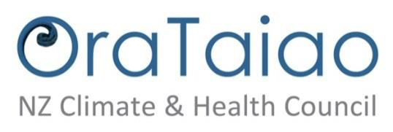

http://www.orataiao.org.nz

July 2016

Submission from
OraTaiao: The New Zealand Climate and Health Council
to the United Nations Committee on the Rights of the Child
2016 Day of Discussion
“Children’s Rights and the Environment

Introduction

OraTaiao www.orataiao.org.nz is part of the growing global movement of health professionals concerned with climate change’s impact on health. We are a New Zealand nongovernmental organization of over 500 health professionals and associates, committed to justice in global health and health equity and especially concerned with the effects of climate change on indigenous peoples and Pacific islands.

We are very appreciative of the leadership from United Nations Committee on the Rights of the Child and the opportunity to make a submission.

Our submission considers the serious and potentially catastrophic impact of climate change on the rights of children; how climate change disproportionately affects children; States’ legal obligations; the role of States in relation to the business sector including investment treaties; children as agents of change; and putting children’s rights at the heart of climate policy offers major opportunities to increase children’s enjoyment of their rights.

Our submission is informed by work we have done, including for the Action for Children and Youth Aotearoa alternative report on New Zealand to the United Nations Committee on the Rights of the Child.(1)(2)

Climate change: a serious and potentially catastrophic threat to children’s rights

Climate change threatens the enjoyment of all human rights. Children are among those who are especially vulnerable. The greater the increases in global warming, the worse will be the effects on children’s rights to life, survival and development, food, water and sanitation, health, education, housing, protection, self-determination, culture, and other rights.(3)(4)(5)

In addition to its direct effects, climate change aggravates underlying causes of serious child rights violations through violent conflict over reduced resources, worsening inequities, forced migration, and the effects of increases in severe storms, droughts and floods. Actions taken to mitigate or adapt to climate change can also impact on children’s rights.(3)(4)(6)(7)

The leading international medical journal The Lancet has described climate change as a medical emergency and the greatest threat to global health this century.(4) UNICEF says, “There may be no greater, growing threat facing the world’s children – and their children – than climate change.”(7) Unless we act with urgency, the effects on children’s rights will be catastrophic.

Climate injustice: the disproportionate effects on children

Climate justice requires that the rights of those most vulnerable are safeguarded and the burdens and benefits of climate change and climate action are shared equitably and fairly.(8)

Climate change has a disproportionate effect on children in many ways. Children’s growing bodies and minds are vulnerable to the effects of climate change through multiple pathways – for example, their higher skin to body mass ratio means they are more vulnerable than adults to dehydration in hot weather, their developing immune systems are at greater risk from vector borne infections, and their faster respiratory rate means they suffer more from air pollution.(7)(9)(7) Children bear the stress and mental health effects arising from disasters, displacement and conflict, directly and through effects on family or caregivers.(7)(10)

Because children (especially younger children) are reliant on adults and their wellbeing is interdependent with the wellbeing of others, they are additionally affected by impacts on their families, communities and societies via the direct and indirect effects of climate change and by mitigation and adaptation actions.

Climate justice issues include intergenerational equity. Climate change will affect today’s children now and during the rest of their lives. Without effective mitigation and adaption climate change will have a growing and increasingly damaging effect on the rights of future generations of children.(5)(11)

Some children will be – indeed some are already – especially badly affected. This includes the large numbers living in climate vulnerable situations, and those experiencing other disadvantage and discrimination.(5)(7)(12)

There are substantial differences between countries and within countries as to who bears the greatest burden of climate change. There is gross injustice in that the countries bearing the greatest impact are those who have done least to cause climate change – and yet these countries are the ones affected first and worst and have the least economic and infrastructure resources to adapt. Children, especially girls, in these countries will be especially affected, as will women, who are the dominant caregivers of children.(12) Figure 1 depicts visually these large disparities between those countries that are the big polluters and those countries where people suffer the most from climate change

Figure 1: The climate gap: those who have emitted most (upper map) and those impacted first and worst (lower map)(12)
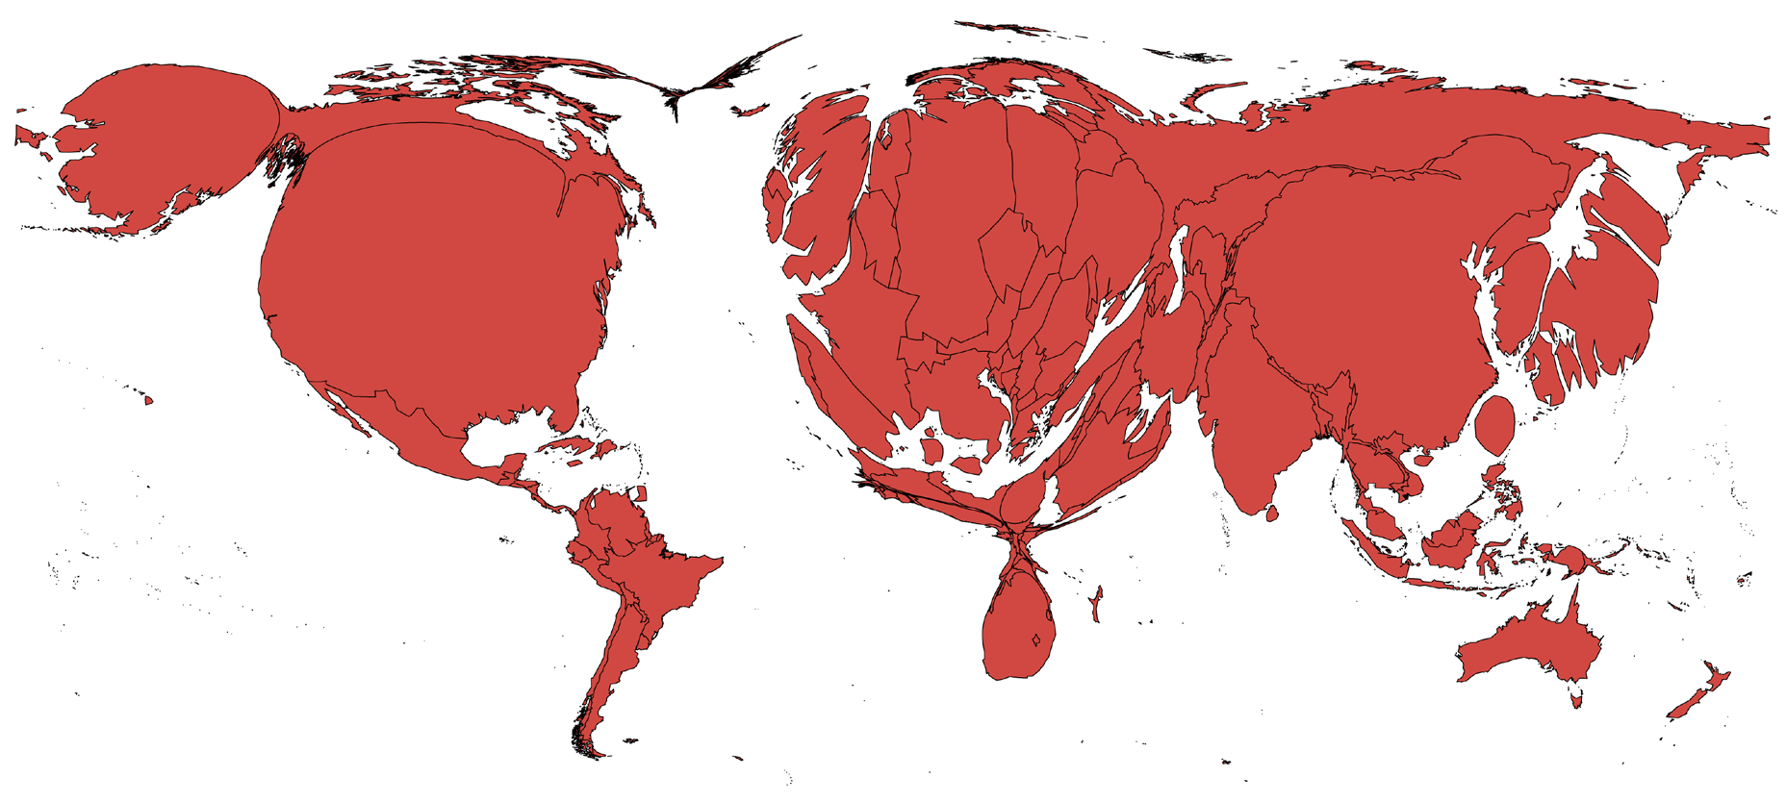
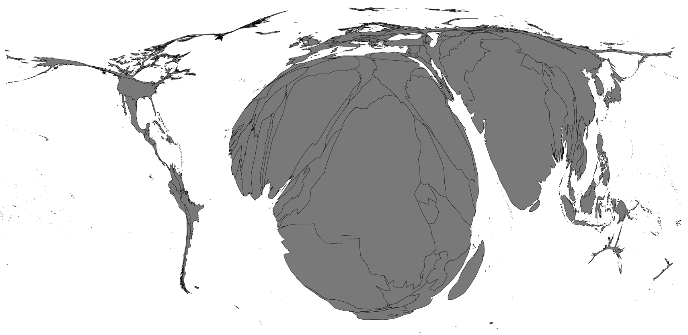Density-equalising cartograms(13) of countries’ cumulative fossil CO2 emissions 1950–2013 (upper map) comparing with additional deaths attributable to climate change from five climate-sensitive consequences (under-nutrition, malaria, dengue, diarrhoeal disease, heat) projected for 2030, all ages —excluding coastal flooding (lower map). source: Metcalfe NZ Med J 2015 (12), detailed in note 4 of its Appendix.

Thus children from poor countries who have done nothing to contribute to climate change are doubly impacted by severe climate injustice.

Last November all States pledged support for the Paris Agreement target of keeping the increase in global average temperature well below 2°C above pre-industrial levels and pursuing efforts to limit the increase to 1.5°C.(14) To fulfill this commitment, climate justice necessitates that that those States (including New Zealand) who are the greatest emitters of greenhouse gases must drastically reduce emissions.

New Zealand is a high emitter of greenhouse gases. But because New Zealand is buffered by surrounding oceans and outside the tropical regions, and a high-income country with relatively good infrastructure, it will be one of the countries least affected by climate change.(15)

Nevertheless, within New Zealand, children – especially some children – will be disproportionately impacted by climate change. Indigenous and Pacific children, and those already experiencing disadvantage and discrimination or living in climate vulnerable locations will carry a higher burden.(2)

For indigenous Māori children, climate change threatens displacement and dispossession from their traditional lands, heritage and resources; disruption of family relationships; loss of cultural identity and knowledge; increased poverty and marginalisation; worse health; and effects on their spiritual relationship with the natural environment.(2)

Tokelau is a non-self governing territory of New Zealand. As a small low-lying Pacific island country it is on the frontline of climate change, a problem it did not create and which will get worse. Tokelau is a leading advocate by example for climate action. Nevertheless, despite its people’s considerable mitigation and adaptation efforts, Tokelau may become uninhabitable. This has serious implications for all of the rights of Tokelauan children. Tokelauans would rather “fight and adapt” to climate change than leave their homeland and relocate elsewhere, and describe planned “migration with dignity” as a last resort.(2)(16)(17)

Pacific children living in New Zealand already experience considerable inequality and marginalisation, and are hence likely to be disproportionately affected. They will also be especially affected because they maintain historical, familial, cultural, language and economic connections with those living in the Pacific islands; countries that will be severely impacted by climate change.(2)(18)

States’ legal obligations

States have affirmative and binding obligations under the Convention on the Rights of the Child and other international human rights laws to protect children’s enjoyment of their rights from environmental harm caused by climate change and to ensure that adaptation and mitigation measures respect, protect and fulfill their rights.(3)(5)(19)

Climate change is a global crisis. It threatens the rights of all children and demands actions by all States. It thus necessitates States to act in accord with the obligations of international cooperation that are required by the Convention on the Rights of the Child, particularly articles 4 and 24. (20) International cooperation is also of course fundamental to the United Nations Charter (as in articles 55 and 56).(21)

Until recently, consideration of the views and rights of children has been frequently missing from international climate change agreements and negotiations.(5) However the Paris Agreement preamble refers to “human rights, the right to health, the rights of indigenous peoples, local communities, migrants, children, persons with disabilities and people in vulnerable situations and the right to development, as well as gender equality, empowerment of women and intergenerational equity.” These are obligations for Parties to “respect, promote and consider” (our emphasis) whereas States already have existing obligations under international human rights law, including the Convention on the Rights of the Child, to respect, protect and fulfill human rights. Climate justice and Mother Earth are also included in the preamble, described as being recognized by “some”.(14)

The Paris Agreement enters into force 30 days after 55 Parties representing 55 percent of total global emissions have ratified the Agreement. As of late July, only 20 countries representing less than half a percent of global emissions had ratified. However others have signaled their intention to ratify soon and there is hope that there will be sufficient ratifications for the Agreement to enter into force later this year or next.(22)

States must also report on their climate mitigation and adaptation actions under Sustainable Development Goal 13, “Take urgent action to combat climate change and its impacts.” Child rights-based approaches are essential for shaping implementation and accountability mechanisms if the Sustainable Development Goals are to achieve their agenda of “transforming our world”.(23)(24)

The role of States in relation to the business sector

States must consider the global impact of their own policies and domestic industries on children’s rights, including the right to health.(25)(26) An example of concern is the major contribution of breast-milk substitute production by the local dairy industry to New Zealand’s very high per capita level of greenhouse gas emissions. New Zealand export policies and agencies support investment in and expansion of production and export of this product that damages children’s right to health globally.(27)(28) Investment is promoted on government websites,(29) and includes descriptions of practices to market breast milk substitute brands (30)(p40) that may breach the World Health Organization International Code of Marketing of Breast-milk Substitutes.(31)

The Addis Ababa Action Agenda called for reorientation of international investment – and this will be essential to achieve the Paris Agreement and 2030 Agenda for Sustainable Development.(32) United Nations Special Procedures human rights experts have raised concerns that existing and future international investment agreements have adverse effects on human rights.(33)(34)(35) Many of these adverse effects on enjoyment of rights will be especially severe for children.

Analysis of one such investment agreement in New Zealand(36) indicates the retrogressive potential of investment agreements, including for children. The use of Investor-State Dispute Settlement mechanisms by investors to contest government policies is increasing, particularly in relation to renewable energy policies.(37)

The United Nations Conference on Trade and Development’s Investment Policy Framework and its Road Map for International Investment Agreement Reform offers an approach for States to manage international investment for sustainable development, human rights and a low carbon future.(38)

Hope for the future: children as agents of change, and opportunities to improve children’s rights

The power of children as climate advocates and role models is seen in a range of activities from actions in their own homes and communities to legal action to protect their rights and the rights of future generations.

Children in several countries are taking legal action, arguing that the State’s obligation to hold some resources in common for all extends to the atmosphere and requires climate action. Rabab Ali, a seven-year old Pakistani girl has recently filed a Constitutional Petition for the protection of her and the people of Pakistan’s fundamental rights.(39)(40) Children in the Philippines have been part of legal actions to protect the rights of themselves and carless people in the Philippines, asking for roads to be fairly shared, more bike lanes, and protection of the atmosphere.(41) Twenty-one children and young people aged from eight to 19 years are taking a climate change lawsuit against the United States government and the fossil fuel industry.(42)

Well-designed climate mitigation and adaptation actions that place children’s rights at their centre, bring great opportunities to improve opportunities to reduce disparities and for all children to enjoy their rights.

This is illustrated by children’s right to the highest attainable standard of health. For example, reducing emissions from fossil fuels will reduce air pollution and respiratory disease among children. Affordable clean renewable and energy efficient housing energy will have multiple benefits for the poorest families. Increasing travel by public transport, and safe provision for walking and cycling will reduce air pollution, road crashes and obesity as well improving children and their families’ access to education and other services, and work opportunities. Well-designed, food policies that address climate change could also reduce food insecurity and improve nutrition.(2)(4)(43)(44)

Conclusion

The Lancet Commission on Health and Climate Change said, “tackling climate change could be the greatest global health opportunity of the 21st century.”(4)

Well-designed, mitigation and adaptation actions on climate change could also be the greatest child rights opportunity of this century.

Annex 1: Recommendations

The United Nations Committee on the Rights of the Child urge States to:

- Urgently ratify the Paris Agreement and establish domestic legislation to rapidly reduce greenhouse gas emissions to levels that protect children’s rights;
- Place the rights of children, especially those most vulnerable, and intergeneration-al equity at the centre of domestic and international climate change action;
- Build children’s meaningful participation into climate change policy-making.

References

1. Action for Children and Youth Aotearoa. United Nations Convention on the Rights of the Child: Alternative Report by Action for Children and Youth Aotearoa. November 2015 [Internet]. Auckland; 2015. Available from: http://www.acya.org.nz
2. OraTaiao: The New Zealand Health and Climate. Child rights and climate change in New Zealand: A background paper. Written for Action for Children and Youth Aotearoa’s submissions to the United Nations Committee on the Rights of the Child. Auckland; 2016.
3. Knox J. Report of the Special Rapporteur on the issue of human rights obligations relating to the enjoyment of a safe, clean, healthy and sustainable environment. Human Rights Council, 1 February 2016, UN Doc. A/HRC/31/52. Geneva; 2016. Available from: http://www.ohchr.org/Documents/Issues/Environment/A.HRC.31.52_AEV.docx
4. Watts N, Adger WN, Agnolucci P, Blackstock J, Byass P, Cai W, et al. Health and climate change: policy responses to protect public health. Lancet [Internet]. 2015;6736(15):53. Available from: http://www.thelancet.com/commissions/climate-change-2015
5. Gibbons ED. Climate Change, Children’s Rights, and the Pursuit of Intergenerational Climate Justice. Heal Hum Rights J [Internet]. 2014;16(1):19–31. Available from: http://www.hhrjournal.org/2014/07/01/climate-change-childrens-rights-and-the-pursuit-of-intergenerational-climate-justice/
6. Levy BS, Sidel VW. Collective violence caused by climate change and how It threatens health and human rights. Heal Hum Rights J [Internet]. 2014;16(1):32–40. Available from: https://www.hhrjournal.org/2014/07/collective-violence-caused-by-climate-change-and-how-it-threatens-health-and-human-rights/
7. UNICEF. Unless we act now: The impact of climate change on children [Internet]. New York; 2015. Available from: http://www.unicef.org/publications/files/Unless_we_act_now_The_impact_of_climate_change_on_children.pdf
8. Mary Robinson Foundation – Climate Justice. Principles of Climate Justice [Internet]. 2016 [cited 2016 Jul 27]. Available from: http://www.mrfcj.org/principles-of-climate-justice/
9. Hosking J, Mudu P, Dora C. Health co-benefits of climate change mitigation - Transport sector. Health in the green economy [Internet]. Geneva; 2011. Available from: http://www.who.int/hia/green_economy/transport_sector_health_co-benefits_climate_change_mitigation/en/
10. Office of the Special Representative of the Secretary-General for Children and Armed Conflict in collaboration with UNICEF. Machel Study 10-Year Strategic Review: Children and conflict in a changing world [Internet]. New York; 2009. Available from: https://childrenandarmedconflict.un.org/publications/MachelStudy-10YearStrategicReview_en.pdf
11. Mary Robinson Foundation – Climate Justice. Meeting the needs of Future Generations: Applying the principle of intergenerational equity to the 2015 processes on climate change and sustainable development. Position paper [Internet]. Dublin; 2015. Available from: http://www.mrfcj.org/resources/meeting-the-needs-of-future-generations-applying-the-principle-of-intergenerational-equity-to-the-2015-processes-on-climate-change-and-sustainable-development/
12. Metcalfe S. Fast, fair climate action crucial for health and equity. N Z Med J [Internet]. 2015;128(1425):14–23. Available from: https://www.nzma.org.nz/journal/read-the-journal/all-issues/2010-2019/2015/vol-128-no-1425-20-november-2015/6741
13. Patz JA, Gibbs HK, Foley JA, Rogers J V., Smith KR. Climate change and global health: Quantifying a growing ethical crisis. Ecohealth [Internet]. 2007;4(4):397–405. Available from: http://citeseerx.ist.psu.edu/viewdoc/download?doi=10.1.1.564.6755&rep=rep1&type=pdf
14. United Nations / Framework Convention on Climate Change. Adoption of the Paris Agreement, 21st Conference of the Parties, 12 December 2015, UN Doc. FCCC/CP/2015/L.9/Rev.1 [Internet]. Paris; 2015. Available from: http://unfccc.int/documentation/documents/advanced_search/items/6911.php?priref=600008831
15. Howden-Chapman P, Chapman R, Hales S, Britton E, Wilson N. Climate change and human health: Impact and adaptation issues for New Zealand. In: Nottage R, Wratt D, Bornman J, Jones K, editors. Climate change adaptation in New Zealand: Future scenarios and some sectoral perspectives [Internet]. Wellington: New Zealand Climate Change Centre; 2010. p. 112–21. Available from: http://sustainablecities.org.nz/wp-content/uploads/Climate-Change-Adaptation-in-New-Zealand-NZCCC-high-8.pdf
16. Heads of State and Government and Representatives of the Coalition of Low Lying Atoll Nations on Climate Change. High Level Dialogue on Climate Change Induced Migration and Displacement Outcomes Document. Signed 10 October 2015 [Internet]. 2015. Available from: http://www.tokelau.org.nz/Bulletin/October+2015/Climate+induced+migration+outcomes+document.html
17. Faiva, P on behalf of Perez, S. Ulo O Tokelau Address to High-Level Event on Climate Induced Migration, 10 October 2015, Tarawa, Kiribati [Internet]. 2015 [cited 2015 Oct 17]. Available from: http://www.tokelau.org.nz/Bulletin/October+2015/Tokelauans+prior+relocation+highlighted+in+Kiribati.html
18. New Zealand College of Public Health Medicine. Pacific Peoples’ Health. New Zealand College of Public Health Medicine Policy Statement [Internet]. Wellington; 2015 [cited 2015 Oct 22]. Available from: http://www.nzcphm.org.nz/media/87942/2015_08_14_pacific_peoples__health_policy_statement.pdf
19. Office of the United Nations High Commissioner for Human Rights. Key Messages on Human Rights and Climate Change [Internet]. Geneva; 2015. Available from: http://www.ohchr.org/Documents/Issues/ClimateChange/KeyMessages_on_HR_CC.pdf
20. United Nations. Convention on the Rights of the Child (CRC), UN GA Resolution 44/25, 20 November 1989. New York: United Nations; 1989.
21. United Nations. Charter of the United Nations and Statute of the International Court of Justice. San Francisco: United Nations; 1945.
22. Climate Analytics. Paris Agreement Ratification Tracker. 2016. Available from: http://climateanalytics.org/hot-topics/ratification-tracker.html
23. United Nations General Assembly. “Transforming our world: the 2030 Agenda for Sustainable Development”. Resolution 70/1 adopted by the General Assembly on 25 September 2015. UN document A/RES/70/1 [Internet]. New York; 2015. Available from: https://sustainabledevelopment.un.org/post2015/summit
24. Williams C, Blaiklock A. With SDGs Now Adopted, Human Rights Must Inform Implementation and Accountability. SDG Series blog [Internet]. Boston: Health and Human Rights Journal; 2015. Available from: https://www.hhrjournal.org/2015/09/sdg-series-with-sdgs-now-adopted-human-rights-must-inform-implementation-and-accountability/
25. United Nations Committee on the Rights of the Child. General Comment No. 16 (2013) on State obligations regarding the impact of the business sector on children’s rights, 17 April 2013, UN Doc. CRC/C/GC/16. Geneva; 2013. Available from: www2.ohchr.org/english/bodies/crc/docs/GC/CRC-C-GC-16_en.doc
26. Mwatsama MK, Wong S, Ettehad D, Watt NF. Global health impacts of policies: lessons from the UK. Global Health [Internet]. Globalization and Health; 2014;10(1):13. Available from: http://www.pubmedcentral.nih.gov/articlerender.fcgi?artid=3977948&tool=pmcentrez&rendertype=abstract
27. Galtry JA. Improving the New Zealand dairy industry’s contribution to local and global wellbeing: the case of infant formula exports. N Z Med J [Internet]. 2013;126(1386):82–9. Available from: https://www.nzma.org.nz/journal/read-the-journal/all-issues/2010-2019/2013/vol-126-no-1386/galtry
28. The Royal Society of New Zealand. Transition to a Low-Carbon Economy for New Zealand [Internet]. Wellington; Available from: http://www.royalsociety.org.nz/media/2016/05/Report-Transition-to-Low-Carbon-Economy-for-NZ.pdf
29. New Zealand Ministry of Business Innovation and Employment. The Food and Beverage Information Project: Dairy [Internet]. [cited 2016 Jul 29]. Available from: http://www.med.govt.nz/sectors-industries/food-beverage/information-project/dairy
30. Coriolis. Infant Formula Value Chain: Part of the NZPECC dairy value chain project [Internet]. Auckland; 2014. Available from: http://www.mbie.govt.nz/info-services/sectors-industries/food-beverage/information-project/dairy
31. World Health Organization. International Code of Marketing of Breast-milk Substitutes. Geneva; 1981.
32. United Nations Conference on Trade and Development. World Investment Report 2016 - Investor Nationality: Policy Challenges [Internet]. 2016 [cited 2016 Jul 29]. Available from: http://unctad.org/en/pages/PublicationWebflyer.aspx?publicationid=1555
33. de Zayas A, Devandas Aguilar C, Puras D, Shaheed F, Knaul G, Helver H, et al. UN experts voice concern over adverse impact of free trade and investment agreements on human rights [Internet]. Geneva; 2015. Available from: http://www.ohchr.org/FR/NewsEvents/Pages/DisplayNews.aspx?NewsID=16031&LangID=E
34. de Zayas AM. Report of the Independent Expert on the promotion of a democratic and equitable international order on the impact of investor-State-dispute-settlement on a democratic and equitable international order, 5 August 2015, UN Doc. A/70/285. [Internet]. New York; 2015. Available from: http://www.un.org/en/ga/search/view_doc.asp?symbol=A/70/285
35. de Zayas AM. Thematic report to the Human Rights Council on the adverse impacts of free trade and investment agreements on a democratic and equitable international order, Human Rights Council, 14 July 2015, UN Doc. A/HRC/30/44 [Internet]. Geneva; 2015. Available from: http://www.ohchr.org/EN/HRBodies/HRC/RegularSessions/Session30/Documents/A_HRC_30_44_ENG.docx
36. Keating G, Jones R, Monasterio E, Freeman J. The Potential Impact of the Trans-Pacific Partnership Agreement on Health Equity, with Illustration From New Zealand. Appl Health Econ Health Policy [Internet]. 2016;14(4):397–400. Available from: http://dx.doi.org/10.1007/s40258-016-0252-3
37. United Nations Conference on Trade and Development. Investor-State Dispute Settlement: Review of Developments in 2015. IIA Issues Note, (2) [Internet]. Geneva; 2016. Available from: http://investmentpolicyhub.unctad.org/Upload/ISDS Issues Note 2016.pdf
38. United Nations Conference on Trade and Development. World Investment Report 2015: Reforming International Investment Governance [Internet]. Geneva; 2015. Available from: http://unctad.org/en/PublicationsLibrary/wir2015_en.pdf
39. Ali v. Federation of Pakistan Supreme Court of Pakistan, Constitutional Petition No. ___ / I of 2016, filed Apr. 2016 (Pak.) [Internet]. Available from: https://web.law.columbia.edu/sites/default/files/microsites/climate-change/files/Resources/Non-US-Climate-Change-Litigation-Chart/pakistanyouthclimatepetition.pdf
40. Gerrard MB, Chen J, Ciardullo J, Loubriel CS, Subramanian N, Chuffart S, et al. Welcome to the Database of Non-U.S. Climate Change Litigation. Date last updated: July 8, 2016. New York; 2016. Available from: http://web.law.columbia.edu/climate-change/non-us-climate-change-litigation-chart
41. Our Children’s Trust. Global Legal Actions: Philippines [Internet]. 2016 [cited 2016 Jul 27]. Available from: http://www.ourchildrenstrust.org/philippines
42. Our Children’s Trust. Landmark U.S. Federal Climate Lawsuit [Internet]. 2016 [cited 2016 Jul 27]. Available from: http://www.ourchildrenstrust.org/us/federal-lawsuit/
43. Jones R, Bennett H, Keating G, Blaiklock A. Climate Change and the Right to Health for Māori in Aotearoa/New Zealand. Heal Hum Rights J [Internet]. 2014;16(1):54–68. Available from: http://www.hhrjournal.org/2014/07/01/climate-change-and-the-right-to-health-for-maori-in-aotearoanew-zealand/
44. Hosking J, Jones R, Percival T, Turner N, Ameratunga S. Climate change: the implications for child health in Australasia. J Paediatr Child Health [Internet]. 2011;47(8):493–6. Available from: http://www.ncbi.nlm.nih.gov/pubmed/20367760

