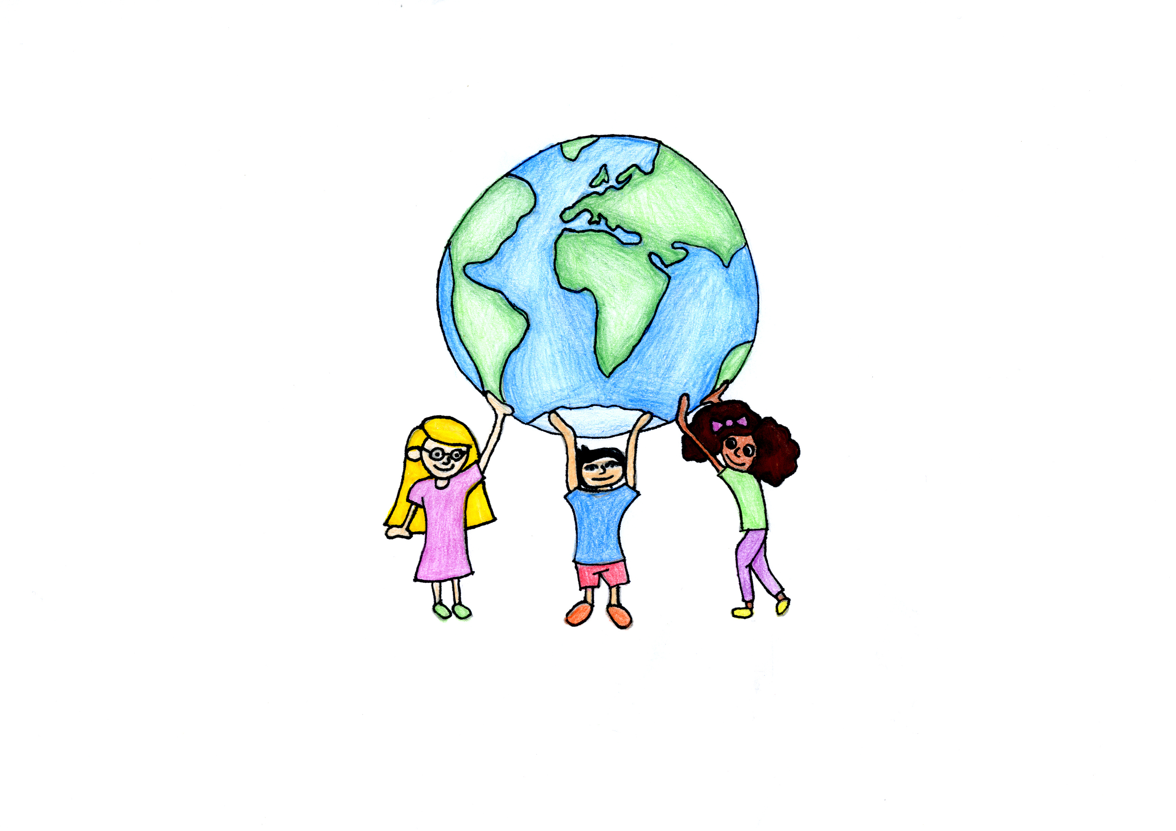
COMMITTEE ON THE RIGHTS OF THE CHILD
CHILDREN’S RIGHTS AND THE ENVIRONMENT
2016 DAY OF GENERAL DISCUSSION

PROGRAMME OF WORK
Room XIX, Palais des Nations

10.00-10.05 Opening remarks
Mr. Benyam Dawit Mezmur, Chairperson of the Committee on the Rights of the Child

10.05-10.50 Introductory statements
Dr. Maria Neira, WHO Director, Department of Public Health, Environmental and Social Determinants of Health
H.E. Cecilia B. Rebong, Ambassador of the Philippines, Mission to the UN in Geneva
Ms. Ritu, Mr. Caleb Mulenga, Ms. Gina Marcela Parra Chiquillo, (Child Representatives), and Mr. Ignacio Packer, Secretary General of Terre des Hommes
Prof. John Knox, UN Special Rapporteur on Human Rights and the Environment
11.00-13.00 Working groups
Working group 1 – Room XIX: Children’s exposure to environmental toxicants
Mr. Baskut Tuncak, UN Special Rapporteur on the Implications for Human Rights of the Environmentally Sound Management and Disposal of Hazardous Substances and Wastes
Dr. Lilian Corra, International Society of Doctors for the Environment
Ms. Juliane Kippenberg, Human Rights Watch
Working group 2 – Room XII: Children and the effects of environmental degradation - children’s rights and climate change
Ms. Joni Pegram, UNICEF UK
Ms. Brianna Fruean, Climate Youth Activist
Ms. Rekha Dhillon-Richardson, Climate Youth Activist and Ms. Kelly Matheson, Our Children’s Trust
13.00-15.00 Lunch break (with option to participate in lunchtime side events)

15.00-17.00 Working groups continued

Working group 1 – Room XIX: Children’s exposure to environmental toxicants
Ms Ritu, Child Representative, and Ms. Sharmila Bhagat, Ankur Society for Alternatives in Education
Mr. Nicholas Rees, UNICEF
Mr. Caleb Mulenga, Child Representative, and Mr Namo Chuma, Environment Africa
Dr. Daniel Limpitlaw, Mining Consultant
Working group 2 – Rooms XII: Children and the effects of environmental degradation - Children’s rights and the degradation of ecosystems, loss of biodiversity and lack of access to natural resources (nature)
Ms. Priscila Bribiesca-Rodriguez, Earth Defenders
Mr. Tom Weerachat, Mekong Youth Assembly
Ms. Gina Marcela Parra Chiquillo, Child Representative, and Ms. Maria Andrea Gomez Gomez, Pensamiento Y Acción Social
17.00-17.20 Coffee break

17.20-17.50 Presentation by rapporteurs to plenary of working groups’ conclusions

17.50-17.55 Concluding comments
Prof. Kirsten Sandberg, Rapporteur of the Committee on the Rights of the Child and Chair of the Committee’s Working Group on Children’s Rights and the Environment

17.55-18.00 Closing remarks
Mr. Benyam Dawit Mezmur, Chairperson of the Committee on the Rights of the Child

18.00-19.00 Closing reception and launch of the exhibition “children’s rights and the environment”
Palais des Nations, Mezzanine (Building E, 2nd floor – Door 40)

