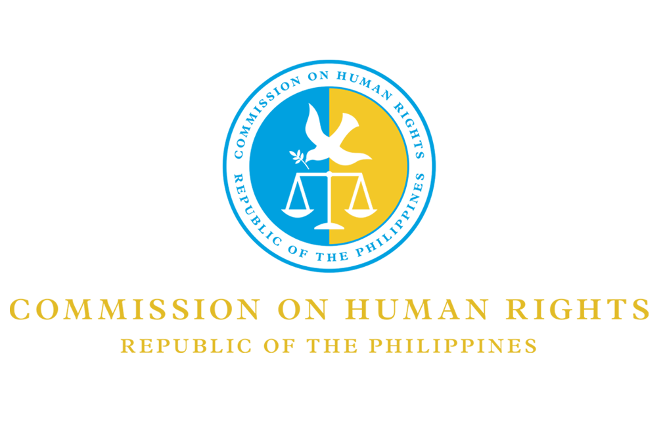

30 October 2020

Committee on Migrant Workers
Human Rights Treaties Division (HRTD)
Office of the United Nations High Commissioner for Human Rights (OHCHR)
Palais Wilson - 52, rue des Pâquis
Geneva, Switzerland

Dear Excellencies,

Greetings of good health and safety from the Commission on Human Rights of the Philippines (CHRP)!

The Commission is grateful to the Committee for providing us with the opportunity to comment on the draft General Comment No. 5 on migrants’ rights to liberty and freedom from arbitrary detention.

We acknowledge that the draft is comprehensive, integrates the Global Compact for Safe, Orderly and Regular Migration, and paves the way for more support and protection in favor of migrants and refugees.

The Commission requests the Committee to take this matter into account:

On par. 61, the Committee may consider making a distinction between private facilities operated for profit and alternatives to detention, or shelters run by faith-based groups and civil society.

In some countries, there are reports of private facilities being operated for profit that have no proper regulation and fail to meet health, safety, and human rights standards.

To help ensure that the work of for-profit actors do not harm migrants and refugees, the Committee may emphasize that states should seek private sector partners who have expressed a policy commitment to respect human rights. States should be more proactive in working with communities advocating for more humane policies such as non-custodial, community-based accommodations and sanctuary cities.

Should there be further questions, please do not hesitate to contact our Human Rights Policy Advisory Office through chrp.policy@gmail.com.

Thank you very much for your time.

Sincerely,

(Signed)

GWENDOLYN LL. PIMENTEL-GANA
Focal Commissioner
Migrants’ Rights

