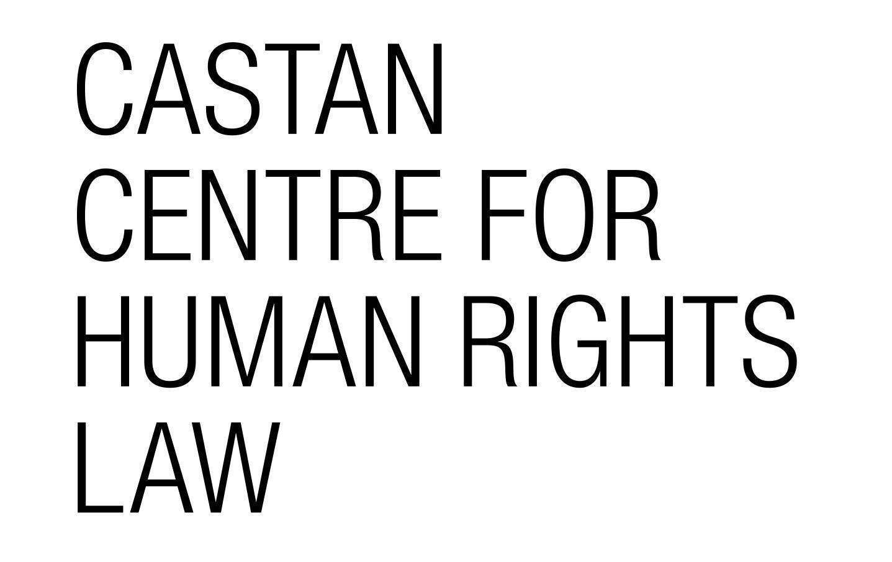

Draft General Comment No. 26 (2021) on Land and Economic, Social and Cultural Rights

Comment to the Committee on Economic, Social and Cultural Rights

Castan Centre for Human Rights Law
Professor the Hon. Kevin Bell AM QC - Director

Submission prepared by:
Andrea Olivares Jones - Policy Manager
Karin M. Frodé - Researcher
Dr Katie O’Bryan - Academic Member

August 2021

1. BACKGROUND
The Castan Centre for Human Rights Law (Castan Centre) is an academic research centre within the Faculty of Law at Monash University in Melbourne, Australia. We undertake research, policy work, student programs and public engagement to ensure that human rights are respected and protected.
We welcome the opportunity to comment on the Committee’s draft of General Comment No. 26. To keep within the page limit indicated by the Committee, our comments below focus on particular areas of concern. We would be very happy to elaborate further upon any of the comments should it be useful to the Committee.
2. RECOMMENDATIONS ON THE DRAFT
2.1 Part I: Introduction
Paragraph 1: Social, Cultural and Religious Significance of Land
The draft currently notes that land ‘constitutes a basis for various social, cultural and religious practices’, and that urbanization is taking place on land that is ‘used by’ various groups, including Indigenous communities.

We believe however that it would be important for the General Comment to underline that land is more than a practice and use for Indigenous peoples. As clearly stated in the UN Declaration on the Rights of Indigenous Peoples (‘UNDRIP’), Indigenous peoples have a ‘distinctive spiritual relationship’ with their traditionally owned lands, waters and other resources. Land is viewed as embodied and something that must be cared for the benefit of present and future generations.

While UNDRIP is mentioned briefly in a single footnote of the draft General Comment, it is solely referred to as one of several soft law instruments that signify obligations of duty-bearers in respect of the use of land. In our view, UNDRIP’s recognition of Indigenous peoples’ relationship with land, and the resulting rights and obligations, ought to be explicitly noted in one of the introductory paragraphs of the General Comment.

Further, while the Castan Centre recognises that the Committee has made some reference to the need for ‘free, prior and informed consent’ (FPIC) from Indigenous peoples in relation to land (paragraphs 18, 23, 55), we recommend that this be further elaborated on in the General Comment. Specific reference should be made to FPIC as it is expressed under UNDRIP, among other relevant documents. The link between FPIC and key rights such as self-determination, the rights to enjoy culture and take part in cultural life, and non-discrimination should also be made clear.

Recommendation 1: Include specific reference to the meaning of land for Indigenous peoples and reference to the relevant contribution of UNDRIP in this regard.
Recommendation 1I: Elaborate on the meaning of free, prior and informed consent for Indigenous Peoples in relation to land.
Paragraph 7: Environmental Considerations
We welcome the inclusion of paragraph 7 of the Introduction to underline the importance of sustainable land use and environmental impacts without a stewardship approach.

In addition, we believe that it would be useful for the Committee to refer in this regard to the importance of the principle of intergenerational equity and solidarity. In the context of land this requires a consideration of future generation in decisions and action relating to land management and use of resources.

Recommendation III: Include a reference in paragraph 7 to the benefit of sustainable land use, not just for present but also for future generations, noting the importance of the principle of intergenerational equity.
2.2. Part II: Relevant Rights
Paragraph 9: Right to Adequate Housing
Issues arising from climate change are intrinsically tied to land and housing. For example, rising sea levels are causing ‘the permanent disappearance of land’, while extreme weather and bushfires continue to destroy large areas of land. These events in turn can compromise existing housing, limit the availability and affordability of remaining housing, contribute to overcrowding, fuel conflict, and in some cases result in population displacement. This can disproportionately impact certain groups, including women, children, and Indigenous peoples.

In light of the above, several UN authorities have made clear that States should take steps to prevent and mitigate climate change and environmental degradation as part of their obligations in respect of the right to adequate housing. This includes the use of mitigation and adaptation measures to prevent the loss of homes and protect vulnerable groups from harm and displacement.

Recommendation IV: Include within paragraph 9 a recognition that the right to adequate housing is threatened by the effects of climate change and environmental degradation.
Recommendation V: Introduce into Part II on State Obligations a reference to the requirement for States to mitigate and adapt to the impacts of climate change with respect to land rights and the right to adequate housing.
Paragraph 11: Right to Water
Currently, paragraph 11 combines a discussion of both the rights to water and health. While we recognise that all rights are indivisible, interrelated, and interdependent, further clarification and emphasis to separate the discussion of each right (see below re right to health) is required.

The right to water is only briefly mentioned in the first sentence of paragraph 11. In our view, the importance of access to water as ‘indispensable for leading a life in human dignity’, and the inherent connection between land and water deserves further express elaboration in this General Comment. This includes an acknowledgement of water as a ‘limited natural resource’ that is crucial for land management and agricultural, residential, industrial, and commercial purposes, among others; and the potential impacts of land use on water supplies (i.e., pollution and contamination).

In addition, the unique relationship between Indigenous peoples and water ought to be recognised. As with land, Indigenous peoples have a ‘distinctive spiritual relationship’ with water, which they have a right to maintain and strengthen. Further, barriers to accessing water deprive Indigenous peoples of opportunities to ‘exercise self-determination, care for Country, and generate wealth from agricultural production’. Notwithstanding the above, in States such as Australia, Indigenous peoples’ rights to water remain ‘partial and constrained’. This considered, the Castan Centre suggests that any discussion of infringements of the right to water ought to reference disproportionate impacts that such infringements have on Indigenous peoples.

Recommendation VI: Elaborate upon the impact of land use upon the right to water in paragraph 11 and acknowledge the disproportionate impact that deprivation of access may have on particular groups, notably Indigenous peoples.
New Paragraph: Right to Health
As noted above, we suggest moving the discussion of the right to health in paragraph II to a new and separate paragraph. The current draft contains useful examples of the use of various land-related chemicals and other measures that impact on the right to health. Our view is that this paragraph could be strengthened by adding footnotes with reference to relevant jurisprudence from various human rights bodies and courts to illustrate these points. The 2017 report by the Special Rapporteur on the right to food (A/HRC/34/48) concerning the negative impacts and prevalence of the use of pesticides may also be a useful source to include in a footnote.

Recommendation VII: Add a new paragraph to discuss the right to health separately from the right to water.
Recommendation VIII: Consider adding footnotes with relevant jurisprudence and UN reports concerning the impact of land use (such as use of pesticides) on the right to health.
2.3 Part III: State Obligations
Section A: Non-discrimination and Equality
The Castan Centre welcomes the inclusion of a discussion of non-discrimination and equality in section A of Part III. However, we suggest that this discussion be aligned with the Committee’s General Comment No. 20, as well as the standards on equality and non-discrimination expressed in General Comment No. 6 (2018) by the Committee on the Rights of Persons with Disabilities.

For example, in paragraph 14, the draft lists ‘forms of discrimination’ as including ‘formal, substantive, direct, indirect and multiple’. As both General Comments 6 and 20 recognise, the four main forms of discrimination are: direct discrimination; indirect discrimination; denial of reasonable accommodation; and harassment. Multiple discrimination (which may be intersectional) is not a form of discrimination but rather is when discrimination takes place on more than one protected characteristic.

Paragraph 16 states that women and girls are vulnerable to intersectional discrimination in relation to land tenure. As noted above, intersectional discrimination is when discrimination happens on the basis of a combination of protected characteristics. The current wording does not indicate which grounds, in addition to gender, that renders women and girls at risk of intersectional discrimination. The Committee should clarify which combination of protected characteristics it has in mind when mentioning intersectional discrimination. In the Centre’s view, women at particular risk of intersectional discrimination include, for example, single women; older women; Indigenous women and women with disabilities.

Recommendation IX: Align the content of Section A with General Comments on the rights to equality and non-discrimination.

Recommendation X: Clarify in paragraph 16 which group(s) of women are at risk of intersectional discrimination (e.g., in addition to gender, which protected characteristic(s) expose a person to discrimination in relation to land tenure).
2.4 Part IV: Specific topics of relevance
New Section: Indigenous Peoples’ Rights and Land
The Castan Centre strongly supports the submission to the consultation on draft General Comment No. 26 by the Indigenous Peoples and Development Branch (Secretariat of the UN Permanent Forum on Indigenous Issues/Division for Inclusive Development/UN Department of Economic Affairs) which recommends the addition of a new section in Part IV concerning land and Indigenous peoples’ rights.

As emphasised throughout our submission above, there are significant and important considerations of the impact of land on Indigenous peoples. While this ought to be underlined throughout the General Comment as per our above recommendations, we also believe that it warrants a separate section in the part of the General Comment titled ‘Specific topics of relevance to the implementation of Covenant rights in land-related contexts’. Such a separate section will allow the Committee to engage in more detail with Indigenous peoples’ rights and land, which requires more than mention in passing throughout the submission. The UNDRIP provides important guidance in this regard.

Recommendation XI: Add a separate section in Part IV on Indigenous Peoples’ Rights and Land as recommended by the Indigenous Peoples and Development Branch (Secretariat of the UN Permanent Forum on Indigenous Issues/Division for Inclusive Development/UN Department of Economic Affairs).

United Nations Declaration on the Rights of Indigenous Peoples, GA Res 61/295, 61st sess, Agenda Item 68, UN Doc A/RES/61/295 (2 October 2007) art 25 (‘UNDRIP’).
Ibid.
Ibid arts 10, 11, 19, 28, 29, 32.
Committee on Economic, Social and Cultural Rights (CESCR), General Comment No 21, Right of everyone to take part in cultural life (art. 15, para. 1a of the Covenant on Economic, Social and Cultural Rights), 43rd sess, UN Doc E/C.12/GC/21 (21 December 2009) [7], [37], [55]. See also United Nations Office of the High Commissioner for Human Rights, Free, Prior and Informed Consent of Indigenous Peoples (September 2013) <https://www.ohchr.org/Documents/Issues/ipeoples/freepriorandinformedconsent.pdf>.
International Covenant on Civil and Political Rights, opened for signature 16 December 1966, 999 UNTS 171 (entered into force 23 March 1976) art 1 (‘ICCPR’); International Covenant on Economic, Social and Cultural Rights, opened for signature 16 December 1966, 993 UNTS 3 (entered into force 3 January 1976) art I (‘ICESCR’).
See ICCPR art 15; ICESCR art 27.
See eg, United Nations Committee on the Elimination of Racial Discrimination, General Recommendation 23 on the rights of Indigenous Peoples, 51st sess, UN Doc A/52/18 (1997) annex V, [4]-[5].
See eg, United Nations General Assembly, ‘Declaration of the United Nations Conference on the Human Environment (Stockholm Declaration)’ in Report of the United Nations Conference on the Human Environment, UN Doc A/CONF.48/14 (1973) principle 1; United Nations General Assembly, World Charter for Nature, GA Res 37/7, 37th sess, 48th plen mtg (28 October 1982); United Nations General Assembly, Rio Declaration on Environment and Development, GA Res A/CONF/151/26 (Vol 1) (12 August 1992) principle 3; United Nations Framework Convention on Climate Change (1992) principle 1; United Nations Educational, Scientific and Cultural Organisation (UNESCO), Declaration on the Responsibilities of the Present Generations Towards Future Generations, 29th sess, 27th plen mtg (12 November 1997) arts 1, 5; United Nations General Assembly, Intergenerational solidarity and the needs of future, UN DOC A/68/x.., 68th sess, Agenda Item 19 (5 August 2013) 22-25.
Robin Bronen, ‘Higher Ground: Protecting Human Rights as the Climate Crisis Forces Coastal Retreat’ (May 2021, vol 44, no 2) Human Rights Magazine <https://www.americanbar.org/groups/crsj/publications/human_rights_magazine_home/vol--44--no-2--housing/higher-ground--protecting-human-rights-as-the-climate-crisis-for/>.
See, eg, Climate Council Australia, ‘’This is Not Normal’: Climate change and escalating bushfire risk’ (Briefing paper, 12 November 2019) <https://www.climatecouncil.org.au/wp-content/uploads/2019/11/bushfire-briefing-paper_18-november.pdf>.
See, eg, ‘Rising sea levels on track to destroy the homes of 300 million people by 2050’, CBS News (online, 29 October 2019) <https://www.cbsnews.com/news/rising-sea-levels-on-track-to-destroy-homes-of-300-million-people-by-2050/>; ‘Australia fires: Almost 2,000 homes destroyed in marathon crisis’, BBC News (online, 7 January 2020) <https://www.bbc.com/news/world-australia-51015536>.
See eg, Maya K Buchanan, ‘Sea level rise and coastal flooding threaten affordable housing’ (2020) 15 Environmental Research Letters 1-14.
Caitlin E Werrell and Francesco Femia, ‘Climate change raises conflict concerns’, UNESCO Courier (2018-2) <https://en.unesco.org/courier/2018-2/climate-change-raises-conflict-concerns>.
Oxfam, Uprooted by Climate Change: Responding to the Growing Risk of Displacement (Report, 2019) 1, 5-6 <https://www.oxfam.org.au/wp-content/uploads/2017/11/bp-uprooted-climate-change-displacement-021117-summ-en.pdf>.
See eg, Leilani Farha, Report of the Special Rapporteur on adequate housing as a component of the right to an adequate standard of living, and on the right to non-discrimination in this context, UN Doc A/64/255 (6 August 2009) 13-16; See also Leilani Farha, Special Rapporteur, Guidelines for the Implementation of the Right to Adequate Housing, UN Doc A/HRC/43/43 (26 December 2019) [72]. See also Report of the United Nations High Commissioner for Human Rights, UN Doc E/2014/86 (11 July 2014) [4] <https://undocs.org/E/2014/86>.
Ibid.
World Conference on Human Rights, Vienna Declaration and Programme of Action, UN Doc A/CONF.157/23 (12 July 1993) [5].
CESCR, General Comment No. 15: The Right to Water (Arts. 11 and 12 of the Covenant), 29th sess, UN Doc E/C.12/2002/11 (20 January 2003) [1] (‘General Comment No 15’).
Ibid.
S Hodgson, Food and Agriculture Organisation of the United Nations, Land and Water: The Rights Interface (Report, 2004) 57.
See eg, Javier Mateo-Sagasta, Sara Marjani Zadeh and Hugh Turral, Water Pollution from Agriculture: a Global Review (Report, 2017); CESCR, General Comment No 15 (n 18) [1], [8], [10].
UNDRIP art 25.
Erin O’Donnell et al, ‘Returning Water Rights to Aboriginal People’, The Pursuit (Web Page, 6 April 2021) <https://pursuit.unimelb.edu.au/articles/returning-water-rights-to-aboriginal-people>. See also, Mike Foley, ‘‘It was our economy, now we are dirt poor’: First Nations people dispossessed of water’, The Sydney Morning Herald (online, 22 February 2021) <https://www.smh.com.au/politics/federal/it-was-our-economy-now-we-are-dirt-poor-first-nations-people-dispossessed-of-water-20210219-p5741i.html>.
Lee Godden, Sue Jackson and Katie O’Bryan, ‘Indigenous Water Rights and Water Law Reforms in Australia’ (2020) 37 Environmental Protection Law Journal 654, 655. See also Lana D. Hartwig, Natalie Osborne, Sue Jackson, ‘Australia has an ugly legacy of denying water rights to Aboriginal people. Not much has changed’, The Conversation (online, 24 June 2020) <https://theconversation.com/australia-has-an-ugly-legacy-of-denying-water-rights-to-aboriginal-people-not-much-has-changed-141743>.
For example, by referring to CESCR, General Comment No 15 (n 19).
For example, the Views of the Human Rights Committee in Portillo Cáceres and Others v Paraguay; Human Rights Committee, Views: Communication No. 2751/2016, 126th sess, UN Doc CCPR/C/126/D/2751/2016 (20 September 2019).
CESCR, General comment No. 20: Non-discrimination in economic, social and cultural rights (art. 2, para. 2, of the International Covenant on Economic, Social and Cultural Rights), UN Doc E/C.12/GC/20 (2 July 2009) (‘General Comment No 20’).
Committee on the Rights of Persons with Disabilities (‘CRPD’), General Comment No 6 (2018) on Equality and Non-discrimination, UN Doc CRPD/C/GC/6 (26 April 2018) (‘General Comment No 6’).
CESCR, General Comment No 20 (n 22) 3-4, 8-9; CRPD, General Comment No 6 (n 23) 4-5.
CESCR, General Comment No 20 (n 22) 8 [27]; CRPD, General Comment No 6 (n 23) 5[19].
See eg considerations detailed in section 2.1 of this submission, including on the need for free, prior and informed consent.

