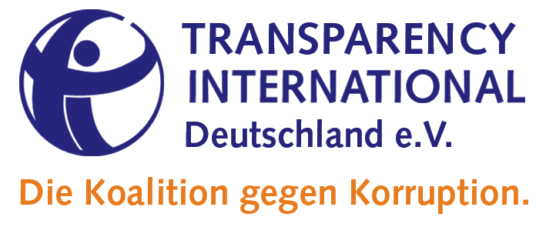

Contribution of Transparency International Deutschland e.V. to the draft
General comment No. 26 (2021) on land and economic, social and cultural rights

To approach goal 16.5 of the Agenda 2030 Sustainable Development “Substantially reduce corruption and bribery in all their forms“, anti-corruption should be addressed at all stages of development cooperation.

We appreciciate that the General comment No. 26 (GC) also addresses corruption, as lack of transparency and corruption are main obstacles to an effective development cooperation. However we think that the GC also should stress the special responsibilities of donors to meet corruption risks in bilateral or multilateral projects in effective ways.

Especially in jurisdictions with weak governance, donors should, before planning programs, conduct a country study/analysis on corruption structure and risks taking into account the specific country context and specific forms of corruption which enables them to take tailor made anti corruption measures. Donors should recommend local partners to establish compliance systems in order to insure anticorruption during the whole circle of the project, from plaaning, implementation, monitoring up to evaluation.

Recommendations

We propose to supplement the special obligations of donors, as mentioned above, by some amendments which may run as follows:.

- In No. 38 of the GC, the last sentence should followed by
This should include that States parties oblige private investors domiciling under their jurisdiction to comply with standards of the Global Reporting Initiative (GRI) relevant to responsible dealing with land governance issues.( GRI 205 Anti-corruption, GRI 411 Rights of Indigenous Peoples, GRI 413 Local Communities )

- No. 43 of the GC should be followed by a new No. 43a which may run as follows:

States and parties authorized by States which are engaged in bilateral or multilateral assistance programs to support capacity-building, for land administration, knowledge-sharing and developing national tenure policies should have mechanisms in place to prevent corruption in rolling out and performing such programs.. This includes a prior analysis of the corruption risks of the state in question at all levels of programs and to recommend local partners to establish compliance mechanisms to ensure integrity and transparency over the whole circle of the program (appraisal , planning, implementation, monitoring and evaluation). This also includes consultation and participation of people and communities affected by intended results of the assistance programs.

Since Joint responses to corruption will enhance the effectiveness of Anti-corruption efforts, donors should act in a coordinated manner in dealing with corruption in the partner country. Therefore, the issue of corruption should be regularly on the donors' agenda in order to develop common strategies in the fight against corruption.

We hope that our reflections and recommendations are a helpful input in the process of finalizing the draft General comment No. 26 prepared by Rodrigo Uprimny and Michael Windfuhr.

Sieglinde Gauer-Lietz Frank Janotta-Simons
Working Group Working Group
Governmental Development Cooperation Governmental Development Cooperation
Transparency International Deutschland e.V. Transparency International Deutschland e.V.
sgauerlietz@transparency.de janosim@gmail.com

