14 February 2020
Dear Honourable Committee Members,
Harm Reduction International applauds the Committee’s efforts in the draft General Comment, in particular in elaborating State obligations and articulating the link between the right to science and other economic, cultural and social rights (ESRCR).

Harm Reduction International is dedicated to reducing the negative health, social and legal impacts of drug use and drug policy. We promote the rights of people who use drugs and their communities through research and advocacy to help achieve a world where drug policies and laws contribute to healthier, safer societies. Harm Reduction International is an NGO in Special Consultative Status with the Economic and Social Council of the United Nations.

In the context of our work, the Draft General Comment’s elaboration on controlled substances and recognition of the vulnerability of particular groups in society, are particularly significant for the community of academics and human rights actors engaged in drug policy.

In respect of Part V Special Topics, E. Controlled Substances, Harm Reduction International makes the following recommendations in respect of the drafting of paragraphs 60-70:
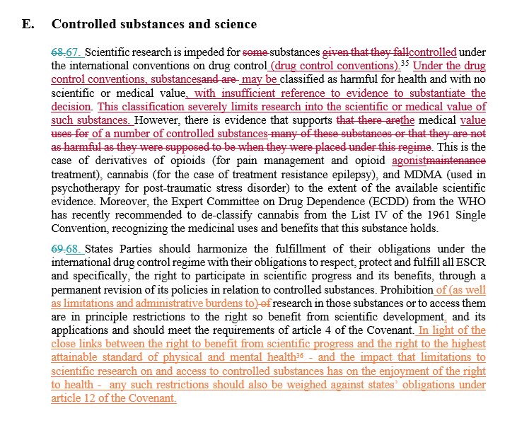

Harm Reduction International recommends the following additions to parts II, III and IV:

- At paragraph 18 (‘their possibility to contribute to the definition of the aims and objectives of the research’). In the context of drug control, researchers are extremely limited in defining the topic of their research and limited in their ability to conduct research on controlled substances, consider amending this paragraph to provide for scientific researchers to define/determine their research objectives. The emphasis on research methods which are ‘humanely, scientifically, socially and ecologically responsible’ is important.
- At paragraph 22 on accessibility, consider noting stigma (as well as discrimination) and noting marginalised and vulnerable groups.
- At paragraph 23 on accessibility, consider replacing ‘information’ with ‘evidence-based information’ in the sentence ‘Third, information concerning the risks and benefits of science and technology should be accessible.’ Consider elaborating on the need for States to be transparent in respect of their data collection processes for scientific research and data held.
- At paragraph 32, consider adding barriers to research as part of the list of examples of retrogressive measures.
- At paragraph 34, emphasise the participation of communities most affected.
- At paragraphs 36-44 and elsewhere, recognise people of colour as a specific group.
- At paragraph 38 consider adding the inverse example, where many actors in society believe a person should be forced to undergo treatment without consent (for example, the case of drug treatment, not always evidence-based).
- At paragraph 56, consider adding the example of eliminating laws and policies that hinder or obstruct research on specific topics (controlled substances), especially for political reasons.
- At paragraph 58, remove the words ‘as far as possible‘ in the sentence ‘A clear benefit of scientific progress is that scientific knowledge is used in decision-making and policies, which should, as far as possible, be evidence-based.’ Consider reflecting on the circumstances of treatment for drug dependence which is often not based on evidence.

Regards,
Naomi Burke-Shyne
Executive Director
Harm Reduction International

