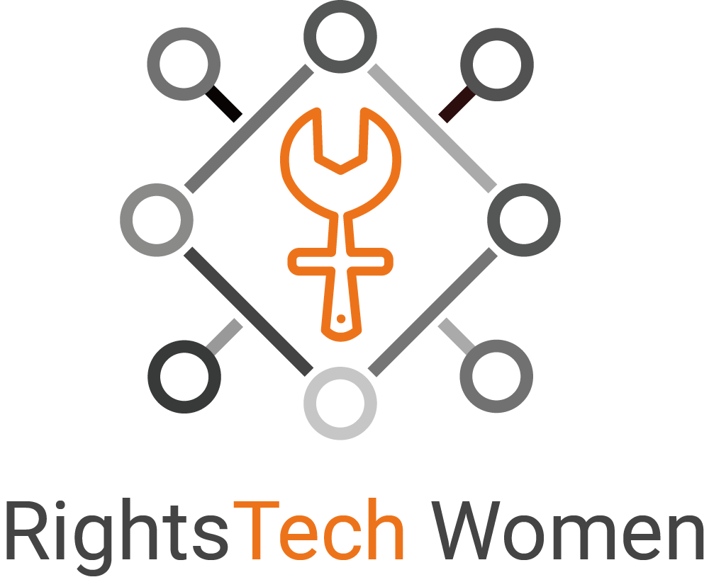

Written submission to the Committee on Economic, Social and Cultural Rights
CESCR Day of General Discussion on Article 15
9 October 2018
The right to enjoy the benefits of scientific progress and its applications
and other provisions of article 15 on the relationship between science
and economic, social and cultural rights

Connect with RightsTech Women:

Website: https://rightstech.org
Twitter: https://twitter.com/RightsTechWomen
Facebook: https://www.facebook.com/RightsTechWomen
LinkedIn: https://www.linkedin.com/company/rightstech-women/
Email: info@rightstech.org

RECOMMENDED ISSUES FOR INCLUSION IN THE GENERAL COMMENT
Implementing article 15, requires, inter alia, the elimination of institutional and legal obstacles as well as those based on negative practices that prevent women and girls from: participating fully in science education and employment; enjoying the benefits of scientific progress and its applications; and, from the development of science. Given the importance of article 15 on the lives and rights of women and girls, the General Comment should adequately include them and draw attention to the specific aspects of article 15 as regards them. Specifically, the following issues should be included.

Benefits of scientific progress and its application (see Discussion Paper paras. 13, 15, 17, and 18)
Benefits of scientific progress include both non-material and material elements. Women and girls must equally be able to benefit from (15(1)(b), 15(1)(c) and 15(4), and play an equal part in steering the direction of (art. 15 (2)), scientific progress. Research initiatives, including international collaborations, must equitably include women as researchers at all levels as well as women’s perspectives in research agendas. (art. 15 (2) and (4)).

Access to scientific knowledge, to the means of making science and to science education (see Discussion Paper paras. 13, 15, 17, 18, 20, 27, and 30)
Access to scientific knowledge, to the means of making science, and to science education are all aspects of science. Access to timely science information (art. 15(2) and (4)) is crucial to accessing the broader, comprehensive scientific knowledge (art. 15(b)). Women and girls must have equal access to - and be encouraged and able to choose to pursue and contribute to - scientific knowledge, education and research at all levels. (art (15)(1)(b) and (2)). Scientific progress and knowledge include: historical elements (i.e., the sum of what is known up until now, and how and by whom this information was found - including by women (art. 15(1)(c)); dynamic elements (i.e., the changing borders of knowledge to date, continual (re-)evaluation, measuring progress as a function of time); as well as scientific methods. Means for critical evaluation, scientific reasoning, and peer review form an important part of scientific knowledge. (Art. 15 (1)(b) and (4)). States Parties should implement measures to: ensure women and girls’ full access to all of these aspects; seek to raise girls’ interest and confidence in science where these are lacking and encourage them to pursue scientific education at all levels, including the highest (art. 15(1)(b)); and, recognize and promote the work of female scientists (art. 15(2)).

Addressing discrimination and under-representation in science- and technology-related employment, research and innovation, and in access to correlating resources (see para. 13 (‘professional promotion’) and 19 (employment discrimination)
As women are significantly underrepresented in most countries in science and technology employment, which fields are rapidly growing in significance, a comprehensive system of protection to eliminate gender discrimination and to ensure equal opportunities and treatment between men and women is needed. In particular, States Parties must study and remove women’s barriers to education and employment, as well as address cultural attitudes, stereotypes, and both direct and subtle forms of discrimination specific to science, which prevent women’s advancement.
Specifically, to ensure that all women can contribute at all levels in STEM, States Parties must identify and eliminate barriers to women, including women in different reproductive situations, in hiring, retention and promotion in STEM fields by eliminating discrimination and harassment, and by introducing positive action measures designed to target and eliminate inequalities at all levels.
Sharing good practices in promoting women’s equal enjoyment of article 15 (para. 28)
States Parties should share good practices in promoting article 15 implementation for women and seek international cooperation to do this. Stakeholders, including States Parties, donors and civil society, should cooperate to include women and girls in SDG and other initiatives to implement article 15.

DISCUSSION
The history of the study of science is replete with women who, against many odds, have achieved some of their field’s greatest accomplishments. Despite being denied entry into or professorships at schools and universities, ordered not to study science by their families, or having credit for their work taken by others, these brilliant scientists pursued and obtained their objectives. Today, there continue to be many obstacles for women not only to study science or to learn from existing scientific knowledge, but also to contribute to it, to direct its progress, or otherwise benefit from it.
Women must equally be able to benefit from, and play an equal part in steering the direction of, scientific progress. Ensuring this will not only help to implement article 15 but also a host of other rights such as the right to equality, adequate standard of living, education, work, just and favourable conditions of work, and health.

Benefits of scientific progress and its application
The benefits of scientific progress and its application include material and non-material benefits. The concept of science includes scientific processes, methodology, openness to public and rigorous scrutiny and debate, having means for critically evaluating results, and international collaboration. Scientific knowledge includes both the sum of historical knowledge, knowledge of what constitutes credible findings and how these are internationally accepted and (re-)evaluated, and timely access to information. Exclusion in education, employment, research and innovation denies many women from such non-material elements of the benefits of scientific progress and its application.
In addition, women are often precluded from benefiting from the promises of Article 15 with regard to material benefits of scientific progress, including in medical advancements. Despite the fact that, in some places, women consume more health services and prescription drugs than men, they tend to be significantly under-represented in clinical trials. Yet, valid reasons exist to include them. One study found that of 10 prescription drugs removed from the U.S. market, eight adversely affected women more than men. Finding ways safely to include all categories of women in clinical studies will work to identify and resolve such issues. Also around the world, there is a lack of access to medical advancements specific to women’s health, such as those addressing maternal mortality or basic reproductive health. Many women suffer from ‘period poverty’, missing sanitary products and water and sanitation engineering counting among the basic benefits of scientific progress.

Access to scientific knowledge, to the means of making science and to science education
Ensuring that women and girls have access to scientific knowledge has the potential to spark their interest in the field of science, necessary for equality. Scientific knowledge provides them with a scientific understanding of the world; tools critical for steering the development of their societies; and, practical information, such as about their bodies and survival. Access to scientific information is necessary to enjoy the benefits of scientific progress and to produce science. Some women have more difficulty accessing information, whether due to illiteracy, lack of access to libraries or to the internet, or social barriers that discourage women from seeking information.
Furthermore, in educational systems around the world, girls and women face many obstacles in obtaining a scientific education, including gender stereotypes, lack of support from family and teachers, and outright discrimination. As a result, while women represent a majority of university graduates, they are in the minority of STEM graduates in nearly all countries.
A recent study from the United Nations Educational, Scientific and Cultural Organization (UNESCO) found that one of the predominant reasons for girls to choose not to pursue STEM training is that they “often do not consider STEM professions to be compatible with their gender.” “Some studies have shown that girls appear to lose interest in STEM subjects with age, suggesting that early interventions are needed to sustain girls’ interest in these fields.” One study found that teachers gave girls in physics classes worse grades than boys, for the same answers. Or, professors sometimes prefer giving research assistantships to males, feeling somehow more ‘comfortable’. By working to combat such harmful stereotypes, to expose girls to the successes of other females in science, to increase support from those around them, and to share the fun and useful aspects and many benefits of scientific progress, stakeholders can help girls to feel confident in their equal abilities to contribute to science and ensure that the field of tomorrow is one of equality and prosperity for all people. Meanwhile, the economic impact of such harmful stereotypes should be studied, better understood, measured, and addressed through targeted measures.

Addressing discrimination and under-representation in science- and technology-related employment, research and innovation
It is also imperative that all stakeholders work to eliminate barriers that hinder women from obtaining employment and finding success in the field at all levels, including as technology start-up enterprise founders and equity-holders. The benefits of scientific progress also include the opportunity for employment in science. Given rapid developments in science, and their impact on employment, the world faces the bleak prospect of increasing gender inequalities. Women are often paid less than men for the same work. Science-focused jobs have the potential to help address the existing income inequality gap. Women are also significantly under-represented in science. Despite these challenges, RightsTech Women believes that stakeholders can reduce gender inequalities related to article 15 implementation. This is a ‘win-win’ prospect: in addition to, most importantly, respecting human rights, one study suggests that increasing the number of women in STEM “could increase aggregate productivity globally by as much as 16 percent.”
Women are significantly less likely than men to receive degrees in science at educational institutions in most countries. This, in turn, leads to women being underrepresented in research, and in many countries, men outnumber women in senior faculty positions 9:1. A recent study in the United States found that half of women in STEM fields reported gender discrimination in the
workplace. Separately, one study found that when all other variables were equal, both male and female faculty were less likely to choose a female candidate, and they were also more likely to offer a lower salary than would be offered to a male. Similarly, female scientists experience discrimination in essential tasks related to their job, including the review of manuscripts and grant funding. Macro- and micro-aggressions in the workplace and hostile work environments must be identified, corrected, and eliminated. For example, many studies have found “that resumes and journal articles were rated lower by male and female reviewers when they were told the author was a woman.”In particular, hate speech at work must not be tolerated.

RECOMMENDATIONS
To ensure women’s and girls’ equal article 15 rights, RightsTech Women asks the Committee to incorporate the following recommendations into the forthcoming General Comment or other documentation as appropriate.
- Call on States Parties to cooperate internationally, via relevant United Nations fora, to reduce gross inequalities among nations and peoples based on unequal enjoyment of the benefits of scientific progress and its applications. Such cooperation should include pro-actively sharing open-source technologies commonly used in – and forming a significant part of the GDP of – higher-income countries.
- Call on States Parties to cooperate internationally to achieve gender parity in all levels of STEM education and employment at all levels in all countries, including those countries currently classified by the UN as ‘least-developed countries’, in parallel with increased human rights education and human rights infrastructure-building in all countries.
- Call on States Parties to ensure that all women and girls have equal access with men and boys to – and are encouraged to pursue and contribute to – scientific knowledge (in all of its aspects), and that this right is reflected in national legislation, policies and practices. Ensure that women and girls can equally know about, contribute to, produce, steer, and enjoy the benefits of scientific progress (understood as a function of time, including the present time, thus including recent benefits and up-to-date knowledge).
- Call on States Parties and international scientific collaborations to ensure that women and girls have equal access to scientific knowledge about climate change and applying scientific progress to create green jobs and cheaper, more democratically owned energy sources, and peace and security solutions (local and international).
- Call on States Parties and international scientific collaborations to ensure that, to the greatest extent possible, scientific research is made publicly available at no cost, especially research that is publicly funded. Build on existing tools to increase translations.
- Call on States Parties to ensure that female scientists have equal access to join and lead national and international scientific advisory bodies, panels and councils, which set national and international research and innovation agendas and which distribute grants, including by actively encouraging female scientists to apply for leadership roles and company board positions.
- Call on States Parties to eliminate any restrictions based on sex in all fields of scientific employment, including those in civil service jobs, and to change relevant laws, policies, and job advertisements to remove limitations based on sex.
- Call on States Parties to ensure that research and clinical trials require an equal number of male and female participants on the basis of free, prior and informed consent, unless researchers present sufficient justification for not including women, while also developing, wherever possible, effective and gender-inclusive innovative trial methods not requiring human or animal testing.
- Call on States Parties and international scientific collaborations to implement measures to stimulate girls’ interest and confidence in science and encourage them to pursue scientific education, such as: through the establishment of role model programs; eliminating gender bias where it exists in learning materials, in testing or among science teachers; and, through expanding access to scholarships, bursaries, fellowships, and the like.
- Call on States Parties to collect and share, in consultation with relevant international bodies and civil society, sex-disaggregated statistics related to STEM educational pursuits and attainment to enable the study of STEM fields by women and girls to be accurately monitored and track trends. Participate in international cooperation to ensure the adoption of a universal set of terminology to allow easy data comparison.
- Call on States Parties to collect and share, in consultation with relevant international bodies and civil society, sex-disaggregated statistics related to STEM employment, such as average salary at different job levels, pay gap, and data related to field advancement (i.e., hiring, retention, tenure and promotions) to enable women’s participation in STEM to be accurately monitored and track trends.
- Call on States Parties who need this to seek international cooperation with relevant UN bodies, donors, private companies, and civil society, in order to build capacities in relevant data collection and analysis, and to encourage all countries to share the tools and methods for sex-disaggregated statistics, including free tools.
- Call on States Parties to identify and eliminate barriers to women, including women in different reproductive situations (for example, women of childbearing age, working women with children, or women returning to work after having children), in hiring, retention and promotion in STEM fields by eliminating discrimination and harassment, and by introducing positive action measures designed to target and eliminate inequalities (see CEDAW art. 4).
- Call on States Parties to increase attention to equal access to STEM education and employment by women and girls who experience multiple forms of discrimination, such as women and girls with disabilities, women and girls of indigenous heritage, minorities, gender minorities or migrants, so as to avoid exacerbating existing inequalities or creating new barriers.
- Call on States Parties to seek ways to promote, from the highest levels of government, the work of female scientists through the media, and through public national awareness campaigns; to publicize little-known female scientists from their countries, including, but not limited to featuring female scientists on coins, stamps, street names, public building names, libraries, means of public transportation, science museums, and public statues, to change public perceptions and those in scientific communities. These could be located near schools and businesses.
- Call on States Parties to share regularly, at CESCR and at the Human Rights Council, ITU, ILO and other relevant fora, good practices and achievements made in increasing women’s STEM education and employment at all levels, in adopting equitable maternal and paternal family leave policies and other policies conducive to life-work balance (relevant to those of all genders), and, in decreasing the gender pay gap at all levels.

RightsTech Women is an international, non-profit association based in Geneva dedicated to advancing the human rights of women and girls in the fields of science, technology, engineering and mathematics (STEM) around the world. We envision a world in which there is greater awareness of international human rights standards, and where STEM and human rights fields work together to ensure that women and girls can equally be part of the solutions to today’s global challenges.

National Institutes of Health, Opportunities for Research on Women's Health; Horton (ed.), The Women's Health Data Book, 1992. See also Redondo-Sendino, Áurea et al. “Gender Differences in the Utilization of Health-Care Services among the Older Adult Population of Spain.” BMC Public Health 6 (2006): 155.
Kim, Esther S.h., et al. “Enrollment of Women in National Heart, Lung, and Blood Institute-Funded Cardiovascular Randomized Controlled Trials Fails to Meet Current Federal Mandates for Inclusion.” Journal of the American College of Cardiology, vol. 52, no. 8, 2008, pp. 672–673, finding that “[t]he enrollment of women ranged from 10% to 47%” in an examination of 19 cardiovascular disease-focused studies.
Many diseases impact women disproportionately to men, lead to different symptoms, and respond in a different way to treatments. Liu, Katherine A., and Natalie A. Dipietro Mager. “Women’s Involvement in Clinical Trials: Historical Perspective and Future Implications.” Pharmacy Practice 14.1 (2016): 708. PMC. Web.
Heinrich, Janet, Director, Health Care – Public Health Issue, United States General Accounting Office. “Drug Safety: Most Drugs Withdrawn in Recent Years Had Greater Health Risks for Women.” Received by The Honorable Tom Harkin, et al., 19 Jan. 2001.
State of Inequality: Reproductive, Maternal, Newborn and Child Health. World Health Organization, 2015.
A 2017 study in the United Kingdom revealed that 10% of British girls had “been unable to afford sanitary wear” and 49% had “missed an entire day of school because of their period.” “Plan International UK's Research on Period Poverty and Stigma.” Plan International UK, 20 Dec. 2017, plan-uk.org/media-centre/plan-international-uks-research-on-period-poverty-and-stigma.
UNESCO Institute for Statistics global databases, 2018, https://data.unicef.org/topic/education/literacy, finding that male youths (15-24 years old) around the world have a literacy rate of 92.8% versus 89.9% for females.
Gender Review of the Global Education Monitoring Report Series: Meeting Our Commitments to Gender Equality in Education. United Nations Educational, Scientific and Cultural Organization, 2018, pp. 11-21.
Cracking the Code: Girls’ and Women’s Education in Science, Technology, Engineering and Mathematics (STEM). United Nations Educational, Scientific and Cultural Organization, 2017, p. 43.
Ibid. at 46.
Hofer, Sarah I., Studying Gender Bias in Physics Grading: The role of teaching experience and country, International Journal of Science Education, 37:17, 2879-2905 (2015).
Munoz-Boudet, Ana Maria, and Ana Revenga. “Breaking the STEM Ceiling for Girls.” Let's Talk Development, The World Bank, 9 Mar. 2017, blogs.worldbank.org/developmenttalk/breaking-stem-ceiling-girls.
UNESCO Institute for Statistics (UIS) database, http://data.uis.unesco.org, Sept. 2018.
Cracking the Code: Girls’ and Women’s Education in Science, Technology, Engineering and Mathematics (STEM), pp. 29-40.
Funk, Cary, and Kim Parker. “Women and Men in STEM Often at Odds Over Workplace Equity.” Pew Research Center's Social & Demographic Trends Project, Pew Research Center, 9 Jan. 2018, www.pewsocialtrends.org/2018/01/09/women-and-men-in-stem-often-at-odds-over-workplace-equity/.
Moss-Racusina, Corrine A., et al. “Science Faculty’s Subtle Gender Biases Favor Male Students.” Proceedings of the National Academy of Sciences, vol. 109, no. 41, 21 Aug. 2012, p. 16477.
Chesler, Naomi C., et al. “The Pipeline Still Leaks and More Than You Think: A Status Report on Gender Diversity in Biomedical Engineering.” Annals of Biomedical Engineering, vol. 38, 2010, p. 1933.
Council of Europe, Commissioner for Human Rights, Statement of 06/03/2017, https://www.coe.int/en/web/commissioner/-/hate-speech-against-women-should-be-specifically-tackl-1.
See, e.g., Lush Prize Short List: https://lushprize.org/.

