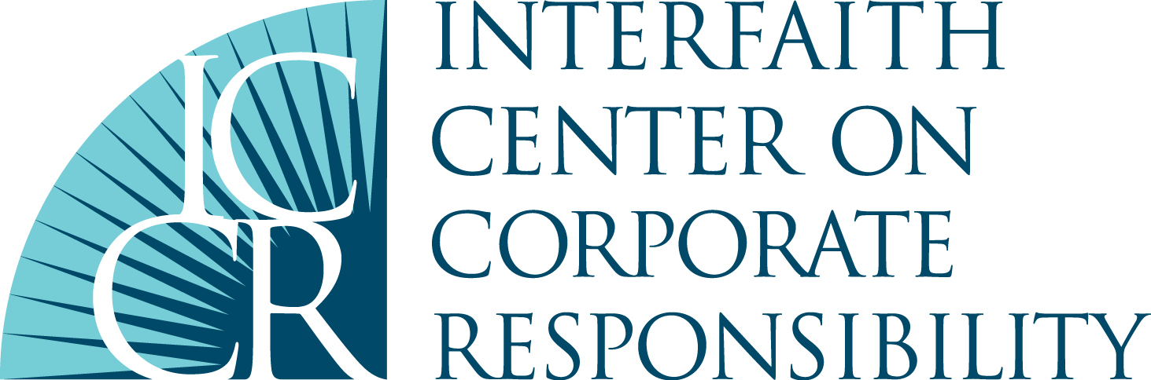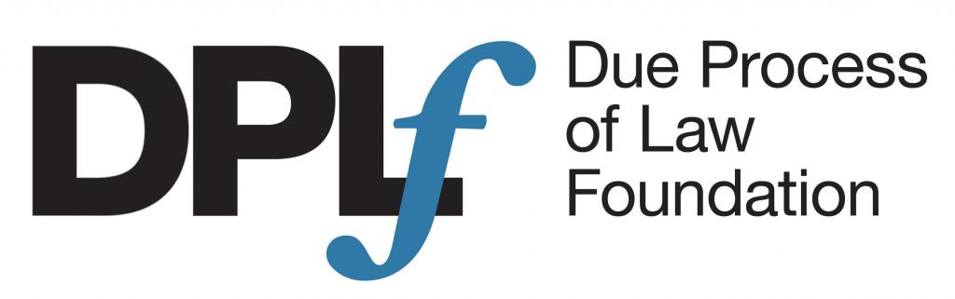

January 20, 2017

Submission on the draft General Comment No. 24 on State Obligations under the International Covenant on Economic, Social and Cultural Rights in the Context of Business Activities

1. The International Corporate Accountability Roundtable (ICAR), the Interfaith Center on Corporate Responsibility (ICCR), and the Due Process of Law Foundation (DPLF) welcomes the draft General Comment No. 24 (draft Comment) on the State Obligations under the International Covenant on Economic, Social, and Cultural Rights (ICESCR) in the Context of Business Activities. We applaud the Committee’s acknowledgement of the impact business activities can have on the enjoyment of economic, social, and cultural (ESC) rights, and the unique challenges faced in accessing remedy when these negative impacts occur. ICAR, ICCR, and DPLF appreciate the opportunity to provide input into the draft Comment and engage further with the Committee on Economic, Social and Cultural Rights to promote State compliance with their ICESCR obligations in the context of business activities.

Business and Economic, Social, and Cultural Rights

2. Business entities are capable of both supporting and undermining the realization of ESC rights. There are multitudes of ways in which businesses can both directly and indirectly undermine these rights. For example when they create unsafe working conditions, employ child or forced labor, place restrictions on trade union rights, and cause or contribute to harmful human rights impacts through their operations, such as negative health impacts, displacement, or environmental contamination.

3. ICAR, ICCR, and DPLF welcome the draft Comment as it provides clarity to the existing duties of the State to protect human rights under the ICESCR as recognized by the UN Guiding Principles on Business and Human Rights (UNGPs). The UNGPs were adopted by the UN Human Rights Council as a definitive restatement of “the implications of existing standards and practices for States and businesses; integrating them within a single, logically coherent and comprehensive template…” As a result, the draft Comment and its aim to “clarif[y] the duties of the State under the ICESCR to ensure that the activities of businesses contribute to and do not impede the realization of economic, social, and cultural rights,” does not undermine, but rather strengthens, the UNGPs.

States’ Obligations to Respect and Protect Economic, Social, and Cultural Rights

4. The draft Comment should make explicit that the scope and application of the ICESCR is not limited by territory or jurisdiction, unlike other human rights treaties. This should be clarified in paragraph 7, which currently does not sufficiently outline the scope of the ICESCR.

5. ICAR, ICCR, and DPLF welcome the draft Comment’s recognition of States’ positive duty to mandate that business entities exercise human rights due diligence. However, this recognition made in paragraph 18 should be strengthened, clarifying what is meant and required by due diligence. Specifically, it should highlight that human rights due diligence should be outcome-oriented; it should result in the identification of potential human rights risks and impacts, and aim to prevent such abuses. If such abuses or impacts are unavoidable, it should seek to mitigate and remediate harm.

6. Transparency and mandatory non-financial human rights reporting is an integral part of monitoring the impacts of business activities on the enjoyment of ESC rights, as it allows not only States, but also investors and interested stakeholder to monitor these impacts. As such, paragraph 18 of the draft Comment should also clarify the Committee’s expectations in relation to transparency and reporting requirements.

7. In discussing the State obligation to protect, ICAR, ICCR, and DPLF recommend that the draft Comment reflect the importance of the right to a living wage and its centrality to the realization of all ESC rights. When workers do not earn a living wage, they may be unable to feed, house, and educate themselves and their families, unable to access healthcare, and unable to participate in social and cultural life. Additionally, when wages are not high enough to meet even basic needs (let alone allow for discretionary spending), workers may be forced to work excessive hours, which can lead to physical and mental health problems. Paragraph 19 states that the obligation to protect entails that State Parties must “effectively prevent the infringements of economic, social, and cultural rights in the context of business activities,” including sometimes through more direct regulation such as “establishing minimum wage and fair remuneration practices to ensure adequate working conditions.” This language could be strengthened by clarifying that governments should establish a minimum wage that is in line with living wage standards. This guidance from the Committee on Economic, Social and Cultural Rights is urgently required as many countries set the minimum wage much lower than a living wage. For example, in India the minimum wage is 62% of a living wage, while in Cambodia it is 34%, in Sri Lanka it is 20%, and in Bangladesh it is 18%. A study released by the Clean Clothes Campaign focused on garment workers in Eastern Europe and Turkey found that in all but one of the countries surveyed, the legal minimum wage for garment workers is “set far below a subsistence minimum” and is even below the poverty line. Furthermore, in Haiti, garment workers often do not earn enough to afford three meals a day, let alone to pay for medical care or other necessities.
8. The draft Comment should be applauded for providing guidance and clarification on the relationship between obligations under the ICESCR and subsequent trade or investment agreements in paragraph 20. In particular, that trade and investment agreements must be designed in a manner that improves, not undermines, the ESC rights under the Covenant. However, the draft Comment should go further to clarify and address States’ obligations in relation to investor-state dispute settlement (ISDS) provisions. In June 2015, a group of ten UN experts voiced their concern over the adverse impacts of ISDS chapters in investment and trade agreements, noting that the “chilling effect” of ISDS awards against States for adopting regulations in relation to environmental protection, access to medicine, food security, or minimum wage “demonstrates that the regulatory function of many States and their ability to legislate in the public interest have been put at risk.” As the draft Comment recognizes in paragraph 19, the “obligation to protect at times necessitates more direct regulation and intervention,” such as restricting marketing and advertisement of certain goods, etc. The existence of ISDS provisions in trade and investment agreements threatens the State’s freedom to regulate in the public interest and undermines the ability to fulfill Covenant obligations.

9. ICAR, ICCR, and DPLF welcome the focus of national implementation through National Action Plans (NAPs) on business and human rights as they provide a potentially powerful vehicle to effectively address the negative impacts of business activities on ESC rights. However, ICAR’s analysis of existing NAPs on business and human rights reveals an overall weakness in the process and content of these plans. Much of the content is retrospective, outlining old or ongoing initiatives, and the forward-looking action points are weak and mainly geared towards voluntary corporate social responsibility-based initiatives. Furthermore, most NAPs have focused on addressing business conduct occurring abroad, largely ignoring domestic business practices, and fail to adequately address the issue of access to remedy. The ICESCR requires States to “take all appropriate steps, to the maximum of their available resources, in order to progress towards the full realization of the rights recognized in the Covenant.” The draft Comment should therefore elaborate on the utility and expectations of NAPs on business and human rights in paragraph 52. Specifically, it should highlight that to be effective NAPs must be forward looking, focus on business impacts at home and abroad, and ensure an adequate and appropriate access to remedy.

Extraterritorial Dimensions of State Obligations

10. ICAR, ICCR, and DPLF applaud the draft Comment’s overview of the extraterritorial dimensions of the duty to protect human rights. This position is consistent with a number of UN Treaty Bodies and the Maastricht Principles. In discussing the extraterritorial obligation to respect, paragraph 37 establishes that “Whereas State Parties would not normally be held internationally responsible for any violation of [ESC] rights which is caused directly by a private entity’s conduct, it would be a breach of its obligations under the Covenant if the violation reveals its failure to take reasonable measures that could have prevented the occurrence of the event.” In recognition of the current state of international law regarding extraterritorial obligations of States to protect human rights, and in line with the affirmation in paragraph 17 that the obligation to respect requires States to “ensure businesses conduct due diligence in order not to impede Covenant rights,” the language in paragraph 38 should be strengthened by confirming that States must, not may, require businesses conduct due diligence to ensure that related entities, such as subsidiaries, suppliers, franchisees, or investors, comply with the requirements under the Covenant.

11. Governments procure goods and services via supply chains in which serious human rights abuses are widespread, and in recent years the implication of public buyers in such abuses has been frequently documented. The UNGPs make clear that the State duty to protect extends to situations where there is a commercial “nexus” between public actors and business. Such a nexus exists when government bodies purchase goods and services through public procurement and in connection with “contracting-out” and privatization. ICAR, ICCR, and DPLF therefore call for the draft Comment to include stronger language around the State obligation to protect human rights in its own supply chains. This could be achieved by confirming that the State duty to protect requires States to take human rights into consideration when making purchasing decisions, including by requiring contractors, operating domestically and abroad, to conduct human rights due diligence and to disclose their supply chains.

Access to Remedy

12. The draft Comment rightly focuses on the “particular challenges that victims of transnational abuses committed by business face in accessing available and effective remedy.” In 2014, ICAR, together with the CORE Coalition and the European Coalition for Corporate Justice (ECCJ) conducted an analysis of the major barriers to accessing remedy for transnational violations of human rights. The Third Pillar Report found that States are generally not fulfilling their obligations to ensure access to effective judicial remedies. A number of barriers to effective remedy identified in the report include: the doctrine of limited liability for corporations and forum non conveniens; time limitations on bringing claims; immunities and non-justiciability doctrines; evidentiary burdens on claimants, particularly in relation to transnational litigation; discovery rules; and limitations on collective redress mechanisms.

13. ICAR, ICCR, and DPLF commend the draft Comment for recognizing a number of the major procedural, practical and substantive barriers to remedy, particularly in the context of cross-border cases. ICAR, ICCR, and DPLF call for the language around accessing remedy to be strengthened further by encouraging States to identify the specific barriers to remedy that exist in their respective jurisdiction and consider the range of actions they can take to alleviate these barriers. Furthermore, the draft Comment should note and build on the recommendations of the UN High Commissioner for Human Rights on improving accountability and access to remedy for victims of business-related human rights abuse.

14. State-based judicial mechanisms are at the core of access to remedy. In paragraph 48, the draft Comment should clarify that victims of violations of Covenant rights must have access to effective judicial remedies, including civil remedies and through criminal prosecution where applicable, regardless of the presence or efficacy of non-judicial mechanisms.

15. Additionally, in paragraph 48, the draft Comment should further elaborate upon the role and importance of prosecuting authorities in upholding Covenant rights. In 2014, ICAR and Amnesty International launched the Commerce, Crime, and Human Rights project, which focused on the lack of prosecutions against corporations for their involvement in human rights abuses. The project team undertook interviews with over a hundred prosecutors and government officials in the Americas, Asia, Africa, and Europe to identify the main factors behind this lack of State action. The Corporate Crimes Principles establish ten basic principles to increase prosecutions for corporate human rights abuses. ICAR encourages the Committee on Economic, Social and Cultural Rights to include specific language encouraging States to enhance investigation and prosecutions against corporations for crimes involving violations of ESC rights by enforcing existing criminal laws, and where such laws don’t exist, by adopting new laws that allow for corporate criminal prosecutions. Specifically, States should (1) fight impunity for corporate crimes by investigating and prosecuting offences; (2) fight impunity for cross-border corporate crimes by choosing to assert jurisdiction; (3) guarantee accountability and transparency in the justice process when pursuing corporate crimes; (4) identify the legal standards and secure the evidence needed to establish liability for corporate crimes in your jurisdiction (5) collaborate widely to ensure accountability for corporate crimes, particularly in cross-border cases; (6) pursue charges that reflect the gravity of the crime; (7) investigate and prosecute those corporate actors most responsible for the wrongdoing; (8) use all available legal tools to collect evidence, build cases and obtain the cooperation of critical witnesses in corporate crimes; (9) ensure that victims of corporate crimes are able to obtain effective remedies; and (10) put in place appropriate measures and incentives to protect victims, informants, whistle-blowers, witnesses and experts in corporate crimes cases. Furthermore, the draft Comment should also clarify that States must create an environment that is conducive to pursuing corporate crimes, by ensuring investigators and prosecutors have the necessary skills, resources, expertise, and discretion to pursue such cases.

16. ICAR, ICCR, and DPLF value the opportunity to provide input on the draft Comment and appreciates further opportunities to engage with the Committee on Economic, Social, and Cultural Rights during the Day of General Discussion on draft General Comment No. 24.

The International Corporate Accountability Roundtable is a civil society organization working to ensure that governments create, implement, and enforce laws and policies to protect against business-related human rights abuse. More information can be found at www.icar.ngo.

The Interfaith Center on Corporate Responsibility is a coalition of faith and value-driven organizations who view the management of their investments as a powerful catalyst for social change. ICCR members and staff engage hundreds of multinational corporations annually to promote more sustainable and just practices because we believe in doing so they will secure a better future for their employees, their customers and their shareholders. More information can be found at http://www.iccr.org/.

The Due Process of Law Foundation DPLF is a 501(c)(3) nonprofit, nongovernmental organization based in Washington, D.C., working to strengthen the rule of law and promote respect for human rights in Latin America through applied research, strategic alliances with actors in the region, advocacy activities and the effective communication of our message. More information can be found at http://www.dplf.org/en.

Human Rights Council, Report of the Special Representative of the Secretary-General on the issue of human rights and transnational corporations and other business enterprises, John Ruggie, Guiding Principles on Business and Human Rights: Implementing the United Nations “Protect, Respect and Remedy” Framework, UN Doc. A/HRC/17/31 (Mar. 21, 2011).
See, e.g., Fons Coomans, Application of the International Covenant on Economic, Social, and Cultural Rights in the Framework of International Organizations, Max Planck Yearbook of United Nations Law, Vol II (2007) 362.
The right to a living wage is well established in international law. UDHR Article 23(3); ICESCR Article 7 states that everyone has a right “to the enjoyment of just and favourable conditions of work which ensure, in particular: (a) Remuneration which provides all workers, as a minimum, with: (i) Fair wages and equal remuneration for work of equal value without distinction of any kind, in particular women being guaranteed conditions of work not inferior to those enjoyed by men, with equal pay for equal work; (ii) a decent living for themselves and their families…”
Relevant rights under the ICESCR include: the right to an adequate standard of living (Article 11); the right to just and favorable conditions of work (Article 7); The right to education (Article 13); the right to the highest attainable standard of physical and mental health (Article 12); and the Right to participate in cultural life (Article 15(1)(a)).
Labor Behind the Label, Asia Floor Wage Figures for 2015, http://labourbehindthelabel.org/campaigns/living-wage/ (last visited Nov. 3 2016).
The one country not included in this figure does not have a legal minimum wage.
Clean Clothes Campaign, Stitched Up: Poverty Wages for Garment Workers in Eastern Europe and Turkey (2014), available at https://cleanclothes.org/livingwage/stitched-up.
International Labor Rights Forum, Living Wage, http://www.laborrights.org/issues/living-wage (last visited Nov. 3 2016).
UN Office of the High Commissioner for Human Rights, UN Experts Voice Concern over Adverse Impact of Free Trade and Investment Agreements on Human Rights (June 2, 2015), http://www.ohchr.org/EN/NewsEvents/Pages/DisplayNews.aspx?NewsID=16031&LangID=E@
International Corporate Accountability Roundtable & European Coalition for Corporate Justice, Assessments of Existing National Action Plans (NAPs) on Business and Human Rights (2015); International Corporate Accountability Roundtable & Dejusticia, Assessment of the Colombian National Action Plan on Business and Human Rights 10 (2016).
See, e.g., Danish Institute for Human Rights & International Corporate Accountability Roundtable, National Action Plans on Business and Human Rights: A Toolkit for the Development, Implementation, and Review of State Commitments to Business and Human Rights Frameworks (2014).
See, e.g., ESCR-Net & FIDH, Ten Key Proposals for the Treaty: A Legal Resource for Advocates and Diplomats Engaging with the UN Intergovernmental Working Group on Transnational Corporations and Other Business Enterprises (2016), Chap. 7, 65-68.
Claire Methven O’Brien, Human Rights: A New Frontier for Public Procurement, Danish Institute for Human Rights.
International Corporate Accountability Roundtable, European Coalition for Corporate Justice, & Corporate Responsibility UK (CORE), The Third Pillar: Access to Judicial Remedies for Human Rights Violations by Transnational Business (2013).
U.N. Human Rights Council, Improving Accountability and Access to Remedy for Victims of Business-Related Human Rights Abuses: Report of the United Nations High Commissioner for Human Rights, U.N. Doc. A/HRC/32/19 (2016).
Amnesty International & International Corporate Accountability Roundtable, The Corporate Crimes Principles: Advancing Investigations and Prosecutions in Human Rights Cases (2016), http://www.commercecrimehumanrights.org/wp-content/uploads/2016/10/CCHR-0929-Final.pdf.

