Oxford OX2 6PN
Tel (01865) 612000
Fax (01865) 612001
patricia.sellersviseur@conted.ox.ac.uk

May 6, 2020

Dear CEDAW Committee,
Thank you for the opportunity to contribute comments to the draft General Recommendation on trafficking in women and girls in the context of global migration.
Our comments are premised upon the recognition that the slave trade exists as an international crime, a humanitarian prohibition and as a human rights violation. International law’s prohibition of slavery and of the slave trade, in all their forms, has obtained jus cogens status. Frequently, trafficking as a human rights violation or transnational crime is confused or conflated with prohibitions of slave trading and slavery. Protection from trafficking exists concurrently, yet distinctively, from slave trade and slavery prohibitions. The draft General Recommendation on trafficking in women and girls in the context of global migration rightly acknowledge that violations of trafficking are situated within and alongside other norms of international law. The suggested modifications aim to clarify and underscore that women and girls are afforded protection from acts of the slave trade as well as human trafficking rights violations.
To further understand the overlapping, yet distinct, safeguards that the prohibitions of the slave trade and trafficking offer, we refer you to our article entitled, “Missing in Action: The International Crime of the Slave Trade,” forthcoming in the Journal of International Criminal Justice (2020), and currently available at: https://papers.ssrn.com/sol3/papers.cfm?abstract_id=3583564.
Please extend attentive and kind consideration to the text highlighted in italics below that comprise the suggested modifications.
1. To paragraph 10, please consider adding the following sentence:
10. … Noting the distinctions between the international crime and human rights violation of the slave trade and that of trafficking in persons, the Committee recognizes that women and girls retain concurrent protections from all crimes and violations.

2. To footnote 13, please consider adding the following text:
¹³ Article 1(2) of the 1926 Convention to Suppress the Slave Trade and Slavery, defines the slave trade as: “. . . all acts involved in the capture, acquisition or disposal of a person with intent to reduce him [or her] to slavery; all acts involved in the acquisition of a slave with a view to selling or exchanging him [or her]; all acts of disposal by sale or exchange of a slave acquired with a view to being sold or exchanged, and, in general, every act of trade or transport in slaves.” The 1956 Supplementary Convention on the Abolition of Slavery, the Slave Trade and Institutions and Practices similar to Slavery updated the definition of the prohibition of the slave trade by outlawing the act of conveyance or attempting to convey by “whatever means of transport,” including aircraft. Article 8 of the International Covenant on Civil and Political Right states that, “slavery and the slave trade shall be prohibited in all their forms.”
3. In paragraph 11, please consider including the below wording:
11. Moreover, combating the crime of trafficking in women and girls requires engagement of the larger protection framework stemming from international humanitarian law, refugee law, international criminal law, labour and international private law, the statelessness conventions as well as instruments in international human rights law…

4. To footnote 14, please consider adding the following citations:
¹⁴ Geneva Conventions (I, II, III and IV), 1949, and the Additional Protocols I and II, 1977, relating to the protection of victims of international and non-international armed conflict respectively; International Committee of the Red Cross (ICRC), Study of Customary Law: Slavery and the Slave Trade, Rule 94. Rome Statute of the International Criminal Court, 1998; … ILO Convention No. 189 Concerning Decent Work for Domestic Workers, 2011, and Domestic Workers Recommendation (No. 201), 2011; International Covenant on Civil and Political Rights; Convention for the Rights of the Child; Optional Protocol on the Sale of Children, Child Prostitution and Child Pornography.

5. In footnote 17, please consider concluding with the following sentence:
¹⁷ This includes: child marriage of girls fleeing humanitarian crises . . . . These acts also could be characterized as slave trading and slavery under international humanitarian law, international criminal law and international human rights law.

6. In paragraph 15, please note that, to date, there does not exist any jurisprudence from the international courts or tribunals based on violations of trafficking. The reference to jurisprudence, therefore, should be removed. Moreover, under the Rome Statute, trafficking could be pursued as the crime against humanity of enslavement whenever an exercise of powers of ownership over the trafficked person is proved (in addition to the chapeaux elements). Nonetheless, acts of trafficking might constitute proof of other international crimes. The suggested modifications below accord with that understanding.
15. Trafficking in women and girls may amount to slavery, the slave trade, torture or cruel, inhuman or degrading treatment.4[1] The direct obligation of non-State actors to respect the prohibitions of slavery, slave trade and torture, as peremptory (jus cogens) norms is set out in both international humanitarian law and human rights law. 5[2] States parties’ obligation to exercise due diligence to prevent, investigate, prosecute and punish acts of trafficking is reinforced by international criminal law. including jurisprudence of the international and mixed criminal tribunals and the The Rome Statute of the International Criminal Court recognizes that whenever trafficking entails the exercise of any or all the powers of ownership in the context of a widespread attack against a civilian population, pursuant to which enslavement as in the course of trafficking in women and girls may constitute a war crime, a crime against humanity may be pursued. Moreover, under customary international criminal law, acts of trafficking might also be pursued as constitutive elements of war crimes, other crimes against humanity, and/or genocide.

7. To footnote 26, please consider adding the following citations:
²⁶ General Recommendation No. 35 (2017) (CEDAW/C/GC/35), para. 25; International Committee of the Red Cross (ICRC), Study of Customary Law: Torture, Rule 90 and Slavery and the Slave Trade, Rule 94 are non-derogable prohibitions; UN Human Rights Committee (HRC), ICCPR General Comment No. 29: Article 4: Derogations during a State of Emergency, 31 August 2001, CCPR/C/21/Rev.1/Add.11, para. 7 prescribes derogation, inter alia, from Article 7 (torture or cruel, inhuman or degrading punishment) and Article 8 (prohibition of slavery, slave trade and servitude) during states of emergency.

8. In footnote 27, please consider the following modifications:
²⁷ General recommendations: No. 30 (2013) (CEDAW/C/GC/30), para. 23; No. 35 (2017) (CEDAW/C/GC/35), para. 16: ref. articles 7 (1) (g), 8 (2) (b) (xxii) and 8 (2) (e) (vi) of the Rome Statute of the International Criminal Court provides that trafficking can constitute enslavement whenever any or all of the powers of ownership are exercised over the trafficked persons. Also see …

9. To paragraph 35, please consider adding the phrase “slave trading”:
35. … Forcibly displaced women are often subjected to gross human rights violations, including risks relating to trafficking for purposes of sexual or labour exploitation, slavery, slave trading and servitude, including the abduction or recruitment of women and girls into armed forces and groups.

Thank you, once again, for the opportunity extended to international law experts, civil society, practitioners and policy makers to submit comments to the drafting committee. The CEDAW General Recommendation on trafficking in women and girls in the context of global migration will be a pivotal, interpretative instrument that will serve to ensure the enjoyment and enforcement of the human rights of women and girls. It is within that spirit that we forward the above modifications concerning the related protection from prohibitions concerning the slave trade. We remain available to offer any additional legal sources, clarifications, jurisprudence, analysis or other clarification to the drafting committee.
Sincerely yours,
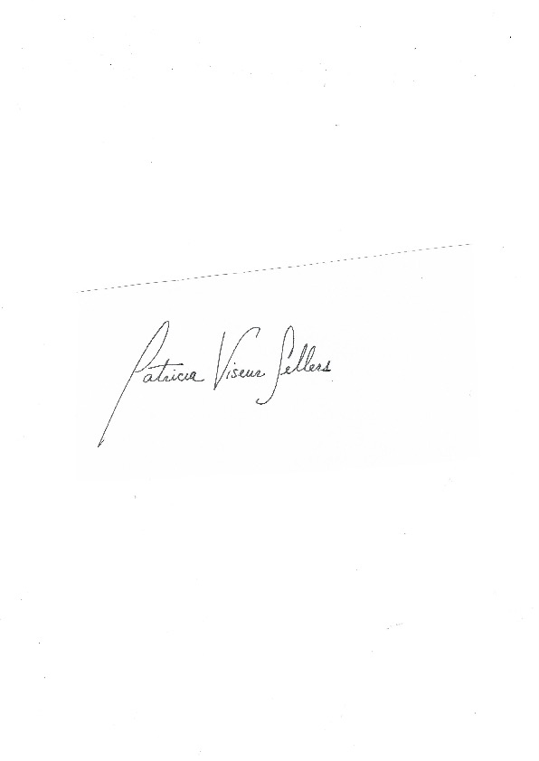
Dr. Patricia Viseur Sellers
Visiting Fellow Kellogg College, Oxford University
Special Advisor for Gender, International Criminal Court
Former Legal Advisor for Gender, International Criminal Tribunal for the former Yugoslavia

Jocelyn Getgen Kestenbaum
Associate Professor of Clinical Law, Benjamin N. Cardozo School of Law
Director, Benjamin B. Ferencz Human Rights and Atrocity Prevention Clinic
Faculty Director, Cardozo Law Institute in Holocaust and Human Rights

