
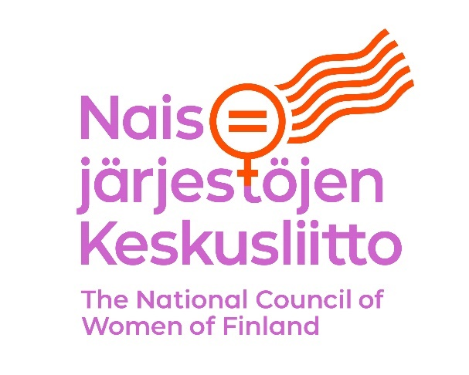

Draft General Recommendation on trafficking in women and girls in the context of global migration (Draft General Recommendation on TWGCGM)

Submission by National Council of Women of Finland and Monika – Multicultural Women’s Association Finland
We thank the Committee on the Elimination of Discrimination against Women for the possibility to comment on the Draft General Recommendation on Trafficking in women and girls in the context of global migration based on Article 6 of the Convention to Eliminate All Forms of Discrimination Against Women.
Side 0, the headline of the Draft: The article 6 of the Convention to Eliminate All Forms of Discrimination Against Women includes both trafficking in women and exploitation of prostitution of women: States Parties shall take all appropriate measures, including legislation, to suppress all forms of traffic in women and exploitation of prostitution of women. The General Recommendation should thus follow the Conventions choice of words and carry the name “General Recommendation on Trafficking in Women and Girls and Exploitation of Prostitution in the Context of Global Migration” (cursive added). This is also consistent with the Convention for the Suppression of the Traffic in Persons and of the Exploitation of the Prostitution of Others (1949). The exploitation of prostitution should be involved in the headlines of relevant paragraphs as well.
Section I, paragraph 3: In the line with the notice of the headline, the mention of exploitation of prostitution in article 6 should be visible here too: It affirms States parties’ obligation of due diligence to prevent, investigate, prosecute and punish trafficking in women and girls and exploitation of prostitution to protect victims as well as to provide reparations.
II, 3, paragraph 9 or additional paragraph: The 1949 Convention and its Article 1:The Parties to the present Convention agree to punish any person who, to gratify the passions of another: (1) Procures, entices or leads away, for purposes of prostitution, another person, even with the consent of that person; (2) Exploits the prostitution of another person, even with the consent of that person and Article 2: The Parties to the present Convention further agree to punish any person who: (1) Keeps or manages, or knowingly finances or takes part in the financing of a brothel; (2) Knowingly lets or rents a building or other place or any part thereof for the purpose of the prostitution of others. All exploitation in prostitution does not fall under the international definition of trafficking, but it can nevertheless be punishable under national offences such as pandering/pimping. The aim should be to widely prevent sexual exploitation. It is not only a question of direct violence or deprivation of liberty; it is about exploiting vulnerability and exerting a position of power.
IV.a, 12: Discouraging the demand is essential for the abolition of trafficking in women and girls and exploitation of prostitution, and we applaud that it has been particularly pointed out. Noticing the importance of intersectionality of women and girls is also positive, although we want to emphasize in particular the double risk of violence and exploitation women with disabilities are facing.
IV.b, 14: The Committees acknowledgement that trafficking and exploitation of prostitution constitutes gender-based violence against women is crucial and we commend its placing in the Draft.
IV.b, 15: The reference of state parties’ obligation to exercise due diligence to prevent, investigate, prosecute, and punish acts of trafficking is highly relevant. To date, only a handful of countries have enacted specific legislation on corporate responsibility of forced and child labour.
IV.c, 16 & 17: Including private persons and intimate partners to the States parties’ obligation of due diligence is welcomed. Often the victims of trafficking, especially when refugees or migrants, do not recognize their status as victims, and thus their rights.
IV, d., 18: The mention of diverse forms of discrimination is again, essential. We would again like to remind that there are various causes of discrimination of women and girls, such as: age, disability, religion, and gender identity.
IV, e., 20: Sexually exploited trafficking victims have often been victims of various other forms of violence against women before becoming victims of human trafficking. These other forms of violence include domestic violence and sexual violence, forced marriages or FGM. Human trafficking is a part of the continuum of experienced violence in the life of trafficking victims. Female minors, women migrants, racialised women, and women in difficult life situations are particularly vulnerable to exploitation and violence. For many women in prostitution, violence is part of their everyday life, and violence is often one of the underlying reasons for women to become involved in prostitution. There is strong evidence that trafficking, prostitution and exploitation of women and girls in vulnerable situations are linked to other forms of violence against women. On average, countries where prostitution is legal experience larger reported human trafficking inflows. According to Europol, in countries where prostitution is legal or regulated, the legal environment makes it easier to exploit the cheaper labour provided by migrant women and other vulnerable persons. Even when prostitution is regulated, persons in prostitution face significant problems earning enough money after brothel keepers have taken their portion – and in many cases they avoid the employer responsibilities by functioning as landlords. The majority of persons in prostitution in Europe are from Eastern Europe and outside of Europe. Compared to their customers, they are in much more vulnerable position. Without questioning women’s agency, the image of women and girls as agents who make independent choices in prostitution is problematic. The choice to be educated, to have a decent job, and a salary to feed one’s family should not have to be achieved through exploitation. Women in prostitution are in danger of violence and trafficking. A person’s right to physical integrity and protection should always overrule someone else’s preference to use the body of another human being for personal satisfaction.

IV, e., 22: It is important to stress the significance of the impunity enjoyed by perpetrators and what causes it. The exploitation of prostitution should be added here since most of the victims detected globally are trafficked for sexual exploitation.
IV, e., 23: Monika - Multicultural Women’s Association Finland and National Council of Women of Finland have long worked for abolishing child and forced marriages. In the case of children, we consider them to be the same thing; a child can never truly give her consent to arrangement made by and for adults. There is a significant risk for exploitation and violation of human rights in child marriages. Encouraging of annulment of them in every state is a step towards a world free from human trafficking, especially when most of the children in underage marriages are girls.
IV, e, 24: Women and girls living in rural and remote areas, indigenous women and girls, women in prostitution, those with an irregular migration status, as well as stateless women and girls and those at risk of statelessness who experience social, political and economic exclusion face specific risks of being trafficked. Prostitution increases the risk significantly.
IV, f, ii: Including in design those affected is highly relevant.
IV, 30, a, ii) (…) and civil society organizations, engaged in combatting trafficking in women and girls and exploitation of prostitution.
IV, 31, d) or IV, 44: The responsibility of the countries that receive victims of trafficking is essential; for instance, the countries covered by the Dublin procedure (The Dublin Regulation (EU) No.604/2013) should assess the risk of re-exploitation when following the Dublin Regulation. The State that is about to repatriate should together with the receiving country take care of the necessarily services needed by the victim and grant residence permit, if necessarily.
IV, 29, g) This should include an emphasis on victims’ right to unconditional assistance; victims have right to assistance regardless of possible investigation or court judgement.
IV, 46: The notion of revictimization is essential: The State parties should do all in their power to prevent revictimization and make sure that the law enforcement officials are trained in a victim-centered approach and are sensitive throughout the procedure especially when speaking with minor victims.
IV, 61, c&d) Highly relevant points and we are delighted that removing migrant women’s dependency is included here.
IV, 62, a) It is important to address the supply chain. More laws like the Dutch Child Labour Due Diligence Law (2020) (the purpose of the law is to advance the identification of the use of child labour in subcontracting chain) should be encouraged at the national level, as well as obliging organizations to implement human rights due diligence.
IV, 62, c) sexual exploitation of prostitution as well. Zero tolerance as a term is problematic; it focuses on rejecting the wrong doings when reforming the system should aim to abolish discriminatory structures.
V, 68, a) We applaud including gender-sensitive, victim-centered, age-, gender-sensitive and trauma-informed approach here, and taking gender-sensitive approach throughout the Draft. Identification of victims should not be linked to criminal procedure; other professionals such as social and health care workers could identify as well. To do so, services should be sufficiently financed, as it takes time to create a trustful relationship to victims. The headline should include “Early identification and protection of presumed victims of human trafficking and exploitation of prostitution”.
V, 68, g) “Encourage reporting of trafficking by intensifying nationwide education and awareness-raising campaigns about the risks and criminal nature of trafficking and exploitation of prostitution…”A child perspective is highly relevant as some nations do not sufficiently recognize the (national) trafficking in children.

V, 70: Again, victim of trafficking but also of exploitation of prostitution

V, 72, the headline: Strengthen the unconditional assistance and protection provided to victims of trafficking and exploitation of prostitution

VI, 78: Impunity is one of the main challenges in exploitation of prostitution as well. So, of trafficking and of exploitation of prostitution

VI, 84: (…) and victims of exploitation of prostitution

VI, 92, b) Remedies for victims of trafficking and exploitation of prostitution. It is important to include those who are mainly affected by trafficking to protect women’s right and prevent exploitation as broadly as possible.
Sincerely yours,
Eva Biaudet, President of the National Council of Women of Finland
Bahar Mozaffari, President of MONIKA – Multicultural Women’s Association, Finland

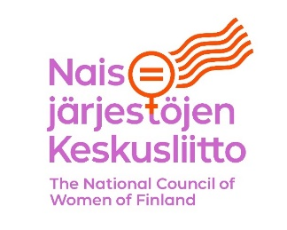
The National Council of Women of Finland (founded 1911) is an umbrella organization and co-operation forum for Finnish women’s organizations that promote gender equality. Currently, the Council consists of 64 member organizations and over 400,000 women. The Council focuses on advancing and promoting women’s rights and gender equality. It coordinates a constantly growing network of women’s organization as well as takes initiatives, gives statements, and consults in legislation.
MONIKA – Multicultural Women’s Association, Finland, is a nationwide multicultural women’s NGO operating in the field of social affairs. It promotes the equality and inclusion of immigrant women in Finland and prevents violence against women. The Association acts as an expert and does advocacy to improve the status of women, as well as supports immigrant women’s activities through its member organizations.

For more information:
Secretary General of the National Council of Women of Finland, Terhi Heinilä, email: terhi.heinila@naisjarjestot.fi
Managing Director of MONIKA – Multicultural Women’s Association, Finland, Jenni Tuominen, email: jenni.tuominen@monikanaiset.fi

Cho, Seo-Young and Dreher, Axel and Neumayer, Eric (2013) Does legalized prostitution increase human trafficking? World development, 41 pp. 67-82. ISSN 0305-750X

