**Written Comments of FIZ on the Draft General Recommendation on trafficking in women and girls in the context of global migration of the CEDAW Committee**

Since 35 years, the Swiss NGO *FIZ Advocacy and Support for Migrant Women and Victims of Trafficking (FIZ)* advocates for the protection and rights of migrant women who are victims of violence and exploitation. FIZ runs the Counseling Center for Migrant Women (sex workers, domestic workers, cleaners, employees of nail studios or gastronomy and other jobs in precarious, informal and unregulated economic sectors) and the specialized Makasi – Counseling and Support Services for Victims of Trafficking. Furthermore, FIZ does advocacy, trainings and public information. FIZ applies a human rights and victim-oriented approach.

[](https://csp.ch/geneve/)[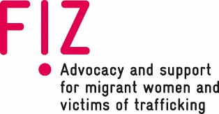](http://www.fiz-info.ch)These Swiss organizations support the following comments:[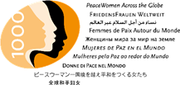](https://www.1000peacewomen.org/en/who-we-are-1.html)[](http://www.sexwork.ch)

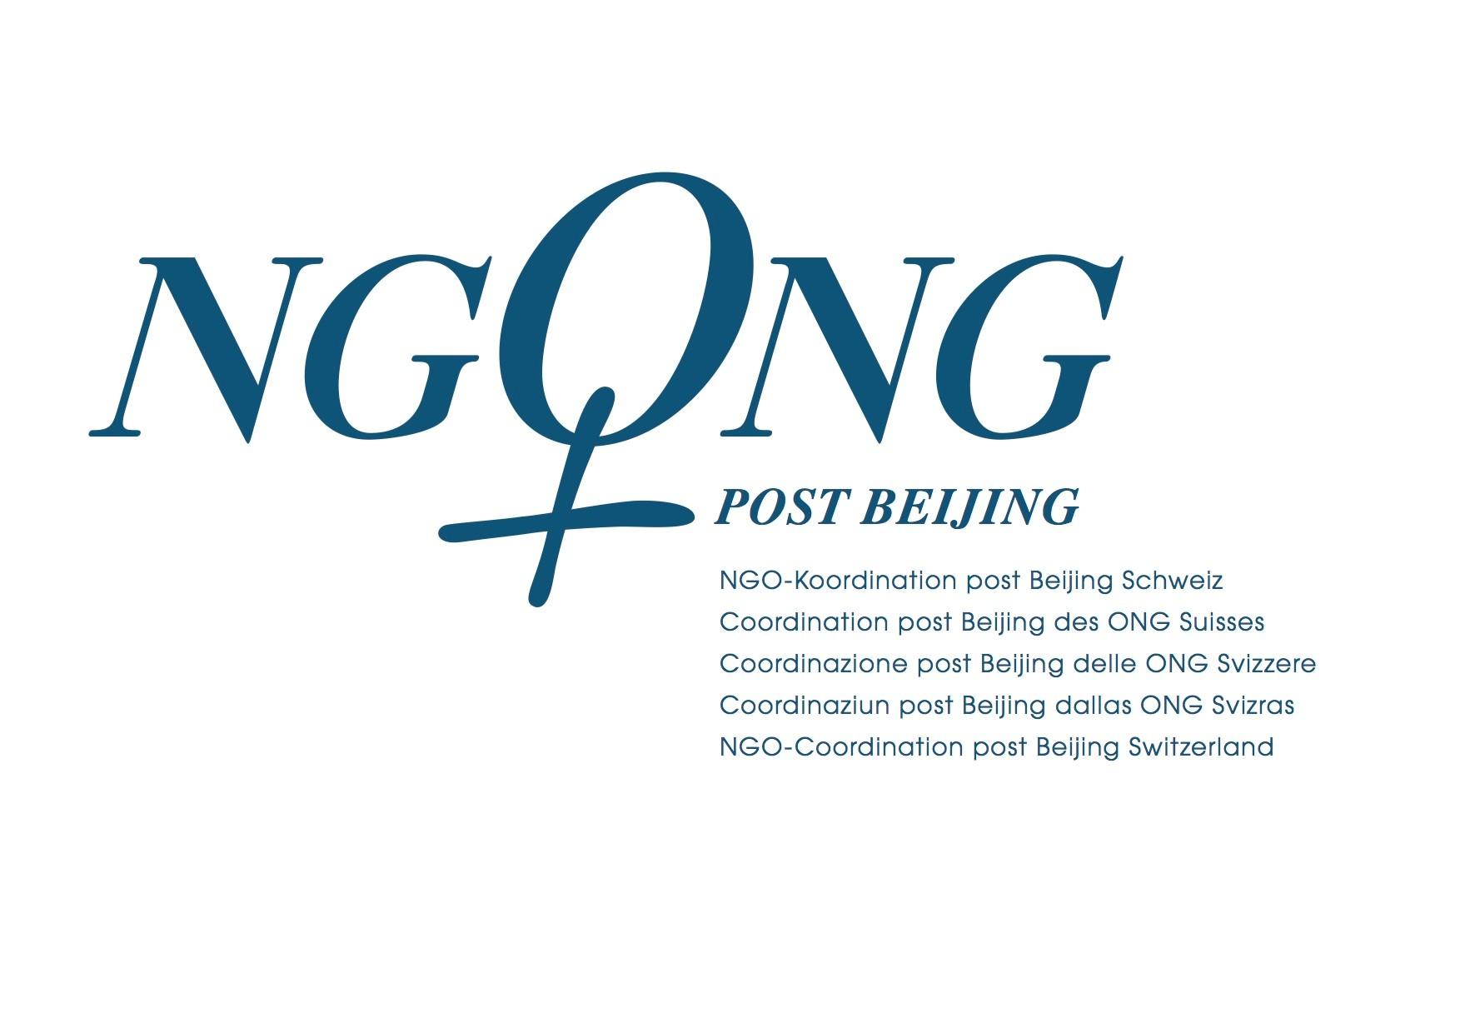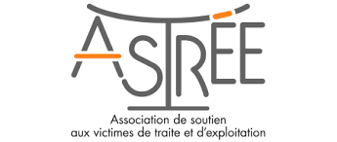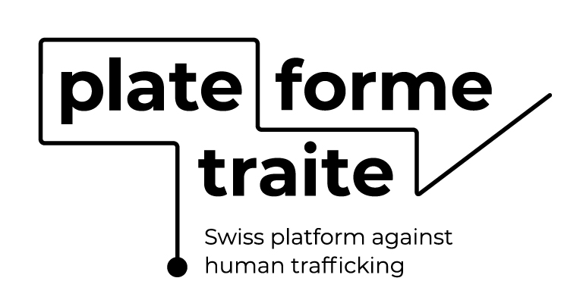

**[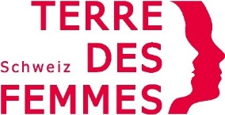](https://www.terre-des-femmes.ch/de/)**

[](https://www.refugeecouncil.ch/)**[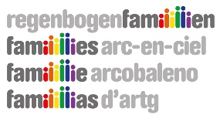](https://www.regenbogenfamilien.ch/)**[](http://www.feminism.ch)

Remark: Swiss Refugee Council OSAR supports FIZ’s comments concerning the asylum field.

**ACKNOWLEDGEMENT**

FIZ thanks the CEDAW committee for the current draft and for the consultation. FIZ welcomes all references made to States’ policies and responsibilities to ensure access to secure and protected employment and decent working conditions, especially in informal or unmonitored economic sectors. FIZ also appreciates that the General Recommendation calls upon all States to apply their obligations without discrimination both citizens and non-citizens, including refugees, asylum seekers, migrant workers, migrants with irregular status and stateless persons. We particularly emphasize that these demographic are especially vulnerable to human trafficking and other forms of serious exploitation. Therefore, it is also essential in the current draft to refer to ensuring more regular and systematic migration pathways, while eliminating any gender discriminatory restrictions on migration in practice, policy or law that limit opportunities for women’s migration. Furthermore, FIZ is very pleased that the current draft re-affirms the States’ parties obligation to identify, assist and protect victims and provide access to justice and support, as well as to prevent, investigate, prosecute and punish trafficking in human beings.

**KEY CONCERNS AND RECOMMENDATIONS**

Part IV, chapeau: Root causes ~~and discouraging the demand that fosters exploitation through trafficking~~

*Reason: Here as well as e.g. in Para 19, 20, 22, 25 (f-i), 27 and 34 the demand-side is named, and often as part of the causes of trafficking. However, the main root causes – as the General Recommendations makes clear in other sections and paragraphs – are inequality, poverty, gender discrimination, lack of education, lack of decent employment opportunities, poor or unimplemented labour and social laws and protections, marginalization, austerity measures and/or low budgets for the domains that would most support women’s lives in dignity, overburden of care work and GBVAW including domestic violence, etc.*

*However, the term ‘demand’ in relation to human trafficking remains a vague and artificial term which needs to be specifically defined. The term ‘demand’ lacks a common understanding of the form of demand and how it fosters human trafficking. There is no clear connection between the exploitation and the services and products the demand are related to. It should be noted that in principle anyone can unknowingly be a potential user of goods and services produced with exploitative labour. We would suggest to address employers or companies through prosecution who ultimately profit or benefit financially from exploitative labour – because of the lack of labour protection, inspections, labour law, access to justice etc. We would welcome the deletion of all references to demand. It has been scientifically confirmed, that in particular economic factors, social norms and discrimination, as well as policies and regulations play a major role in the exploitation, regardless on the sector or services.[1] In case the term is used, it should be further explained and CEDAW should avoid any suggestions that demand only play a role in the sex industry.*

Para 12: […] 94% of those trafficked for sexual exploitation […]

*Reason: These percentages and ratios between the various forms of exploitation need to be explained. On the one hand, they are a question of the focus of the investigation: Where there is an investigation, victims are often found. According to our experience, due to the more in-depth investigative work undertaken by the police in the sex industry, more victims can be identified. And it is a question of training and awareness to individual forms of exploitation. The awareness of labour exploitation is not (yet) sufficient and the number of unreported cases is supposed to be huge. This lack of awareness results in the small number of reported victims in other sectors such as care, gastronomy, agriculture etc.*

Part IV e), chapeau and Para 19: Root causes of trafficking in women and girls ~~and discouraging the demand that fosters exploitation through trafficking~~

*Reason: See reason above.*

Para 19-21: **Move** the Paragraphs 19, 20 and 21 from **IV.e)** **to Part III. Legal Framework.**

*Reason: These paragraphs refer to the important role and responsibility of States parties’ in combatting and foremost preventing human trafficking. Therefore, it is more appropriate in Part III (or after Paragraph 11), which highlights the connection between legal and political levels of governance.*

Para 22: […] more likely to be impoverished, uneducated, unemployed and/or disempowered by wars and political conflict or other political issues, ~~political,~~ economic, societal and family structures […”]

*Reason: War and conflicts must be mentioned explicitly because they also harmfully affect women’s life conditions and vulnerability, which can lead to exploitation and trafficking.*

Para 25: + g) Securing high standards for the protection of personal data and collection according to ethically reasonable criteria (no information on ethnicity, impairment).

*Reason: Often, personal data of trafficked persons is collected without their informed consent and without the possibility to withdraw their data. Personal data must be handled protectively and in the interests of the people concerned, and that e.g. data on ethnicity or disability should not be recorded because it could harm people. In addition, data is often collected that is not necessarily ensuring rights protection or prosecution of the crime.*

Para 27, chapeau: ~~Discourage the demand that fosters~~ Combat all forms of exploitation of persons, especially women and children, that lead to human trafficking.

*Reason: See explanation comment to Part IV, chapeau. Especially in Paragraph 27 it appears that much of what is meant by the term “demand” relates to the demand for sexual services or the punishment of customers of sexual services.*

Para 27 a): Adopting or strengthening legislative and other measures to implement prevention techniques through educational, social or cultural measures, ~~including in particular those targeted toward potential users of trafficked goods or services;~~

*Reason: See explanation comment to Part IV, chapeau. And: The important content in this Paragraph is better formulated in Paragraph 62 g).*

Para 27 b): ~~Where applicable, instituting penal legislation to sanction the users of goods and services that result from trafficking in persons.~~

Para 27 d): Investigating, prosecuting and convicting all perpetrators involved in the trafficking of persons, ~~including those on the demand side.~~

*Reason: It is a misleading focus on client criminalization while sanctioning products or clients is totally impractical. However, the framework “discouraging the demand that fosters exploitation” fosters higher risks at the working place, e.g. for sex workers; they will be one of a few women deprived of agency to decide which job they hold, due to “moral” considerations and to the conflation between trafficking and sex work. It is essential to understand sex work as work and human trafficking as a serious crime and not to mix the two terms. This differentiation is particularly important in investigative work and in the process of identifying victims of human trafficking.* *Similarly, the criminalization of clients avoids reporting on alleged cases of human trafficking, because clients fear punishment or repression. FIZ's experience is that clients are important informants to identify victims.*

Para 42 e): Adopt comprehensive gender-sensitive and human-rights-based migration and refugee policy that takes into consideration the vulnerability of displaced women to trafficking and that puts the needs and security of those (potentially) affected by human trafficking first, especially by ensuring that right provisions in place to protect trafficked persons have priority over regulations based on international migration law such as e.g. the Dublin III regulation; the Dublin claims of presumed trafficked persons should be lifted.

*Reason: In its daily work with victims of human trafficking in the area of asylum, FIZ is repeatedly confronted with the fact that the alleged victims have to return to their country of origin or to a Dublin country before the clarification of the victim’s status or even after identification as victims. As a result, many of those affected are unable to exercise their victim rights. This is also particularly problematic because the exploitation usually took place in the country of origin or the other Dublin country, and therefore fled to Switzerland (to avoid further exploitation). The danger of re-trafficking is therefore also particularly high since they might have no social network, knowledge of the local language or their rights.*

Para 42 f): […] about all forms of trafficking and refer them to adequate information and support offered by specialized victim support services or other support structures.

*Reason: As a victim, it is one thing to understand human trafficking. More crucial is, that victims know their rights and can receive support and assistance in their difficult situation. Therefore, it is also important to raise awareness on support structures and the legal framework.*

Para 43: […] services by reflecting gender and trauma sensitivity […]

*Reason: Forcibly displaced women in particular need close support and assistance at arrivals at land, air and sea borders. In order to carry this out according to the needs of the victim, the danger of retraumatisation and therefore a trauma-sensitive guiding must be taken into account, depending on the context and destination.*

Para 58: **Move** the whole Paragraph 58, which is devoted to Employment and labour framework **to Part IV.**

*Reason: labour and employment conditions are often root causes of exploitation and parts of trafficking. Therefore it is important to put the explanations in Part IV about root causes.*

Para 58: **+** g) Increase and secure access to safe and protected formal employment opportunities for women and improve the informal labour market, e.g. by delinking social protection from employment or the introduction of a universal basic income.

*Reason: It is crucial to strengthen the position of mostly female workers in the informal working sector universally by improving their general position in society, ensure access to health, justice and work – independent of the residency permit status. This is a crucial root cause to tackle.*

Para 62: **Move** the whole Paragraph 62, with the title “Trafficking in corporate chains” **to Part IV as Letter c).**

*Reason: FIZ welcomes the strong focus of the General Recommendation on ensuring decent work possibilities and appropriate working conditions, especially for female (migrant) workers, as a central basic prerequisite for combatting human trafficking. Labour exploitation still happens far too often and is far too rarely detected in various, but especially in the informal, predominantly female labour sectors. A shift to Part IV would support this importance.*

Para 62 c): Recognize in law the care sectors as legitimate areas of paid work ~~by addressing gender segregated labour markets and human trafficking into the care economy~~

*Reason: It is not clear how addressing trafficking in human beings in the care economy will lead to recognition of the care sector or how states address gender-segregated markets*

Para 63: Adequately resource, increase the number, and strengthen the capacity […] including private households. The mission and responsibility of inspectors focus on control of labour conditions and providing adequate information to workers including labour their right to claim justice and compensation/back wages instead of controlling migration status of workers.

*Reason: According to the recommended standards of ILO, States’ parties should increase their number of inspectors. Further, labour inspection should have the main responsibility to control labour conditions, instead of controlling the migration status of workers, to allow safe reporting and complaint mechanisms for all workers.*

Para 68 e): […] proactive inspections and criminal investigations for the identification of […]

*Reason: Besides inspections (at workplaces) also the criminal investigations (by other ways and locations) are crucial to get in contact with potential victims. Other stakeholders, like street workers or counselling centers are very important to build up trust and to identify victims, but also to catch and to prosecute against the perpetrators.*

Para 68 j): […] anti-trafficking efforts, including sex workers organizations, ~~including faith-based actors~~, who could provide […]

*Reason: Especially in the field of (combatting) human trafficking, faith-based organizations have a very controversial approach and reputation. Some of them have been involved in “rescue” raids, illegal detention and forced labour of women in sex work[2]. Working with vulnerable, traumatized people requires high professional standards. The many abuse stories that have surfaced in recent years around faith-based organizations worldwide show that great caution is required. We would therefore recommend, to support organizations with a human rights based approach and to strengthen the rights and negotiating position of directly affected people and workers who organize themselves, such as sex workers as a particularly vulnerable group.*

Para 72 c): Adopt a gender-sensitive and trauma-informed policy and procedures manual […]

*Reason: For comprehensive victim protection, it is crucial that employees are sensitized to trauma and post-traumatic disorders. Particularly in criminal prosecution and criminal proceedings, victims are repeatedly confronted with their experience of exploitation, often having to recount it several times. In order to be able to understand the reaction and the state of mind of those affected under these circumstances and to be able to react to it correctly, trauma-sensitive training or awareness of the people involved is required.*

Para 72 c): Provide linguistic and culturally appropriate gender-sensitive and trauma-sensitive emergency and longer-term medical, psychological and social services […] and on their immigration status and regardless on where the crime scene is located without fear of arrest or deportation.

*Reason: FIZ’s and other organizations’ (e.g. ASTREE) experience with asylum-seeking victims of human trafficking is that they often flee to Switzerland to escape exploitation and human trafficking (reason for flight: human trafficking) or have become victims of human trafficking on their escape route, i.e. the crime scene is not always in Switzerland. In these cases, victims are not entitled to victim protection and victim assistance in Switzerland, although they are highly endangered and traumatized and in need of close support and counselling. In addition, the crime scene is often not clearly identifiable because it is sometimes impossible for victims to orient themselves geographically in the exploitation situation or to remember it because of the traumatising experiences. It is therefore all the more important for victims that victim protection and assistance can also be guaranteed unconditionally by geographical factors of exploitation.*

Para 72 l): Commit providing individualised support and assistance […] in which they are identified that is respectful of the cultural identity, their individual social and economic needs and interests.

*Reason: We appreciate the pronunciation of the individuality of the needs and therefore different support and assistance for each person. Besides the influence of the cultural background of the victim, it is also important to meet the needs of an individual independent on the cultural background.*

Para 96 a): […] status, obtain comprehensive and effective […] redress including ~~rehabilitation and compensation~~ social inclusion as well as compensation and back wages and other remedies.

*Reason: A comprehensive protection is crucial for a repeatedly traumatized person while social inclusion is – in the long run – the most effective durable method to (re-)start an autonomous life.*

Para 103: +f) Convention C189 on Decent Work for Domestic Workers

*Reason: An additional important convention regarding labour exploitation of (migrant) women.*

Para 103: +g) Convention C190 pm Ending Violence and Harassment in the World of Work

*Reason: An additional important convention regarding labour exploitation.*

1. See also „COLLATERAL DAMAGE The Impact of Anti-Trafficking Measures on Human Rights around the World“,2007 Global Alliance Against Traffic in Women (GAATW). Link: <http://www.gaatw.org/Collateral%20Damage_Final/singlefile_CollateralDamagefinal.pdf>
2. <https://www.thenation.com/article/archive/crusade-against-sex-trafficking/>; <https://www.denverpost.com/2014/02/06/column-take-a-closer-look-at-the-pros-and-cons-of-prostitution/>