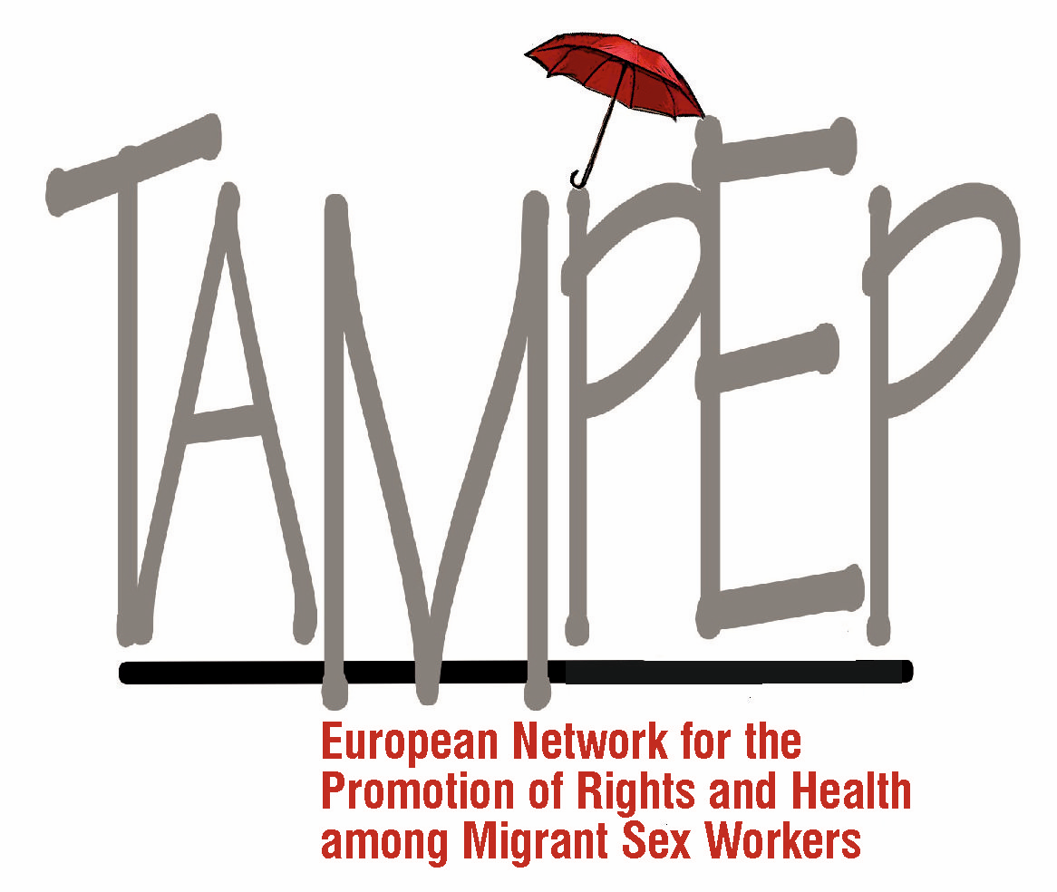

TAMPEP | European Network for the Promotion of Rights and Health among Migrant Sex Workers
Oral Intervention
CEDAW | February 2019

The TAMPEP Network has 25 years of experience in assessing the intersection of migration and sex work in Europe, in implementing programmes and services that support the human rights of migrant people in the sex industry, including trafficked women.
We appreciate an opportunity to contribute to the Committee’s efforts to provide clarity to CEDAW’s Article 6, and we offer the following recommendations:

Victims of trafficking must not be further exploited as witnesses. States should acknowledge their responsibility to assist and protect victims of trafficking – regardless of their ability or willingness to co-operate or testify in court proceedings. States' obligation for assistance to women who have been trafficked should extend to providing realistic opportunities for a safe environment, instead of being deported after they testify against their traffickers.

Governments should address women's poverty, education for girls and the protection of women's rights as a global anti-trafficking strategy.

Consider sex work and forced labour as two separate phenomena. Anti-trafficking laws must not be used to target sex workers - in particular migrant sex workers - and curtail their rights.

Acknowledge the global reality of migration, including for sex work. Abolish laws and policies that criminalise migration and sex work, and provide the possibility for migrant sex workers to obtain residence and work permits in order to increase their independence, and to prevent exploitation.

Encourage the respect and protection of migrant sex workers’ human rights, including their right:
- to equal protection under the law
- to freedom of movement and residence
- to work
- to free choice of employment
- to just and favourable working conditions
- to the highest attainable standards of physical and mental health

Encourage a clear separation between immigration enforcement and the provision of essential services. Putting the enforcement of immigration rules ahead of people’s fundamental rights prevents migrant sex workers without regular status from accessing services, reporting crimes and receiving justice.

State bodies should recognise restrictive immigration legislation, and anti-prostitution policies as contributing factors to human trafficking and related abuses.

