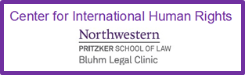
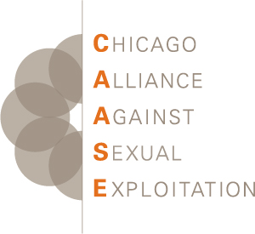

Oral Statement of the Chicago Alliance Against Sexual Exploitation (CAASE) and
the Center for International Human Rights (CIHR) of Northwestern Pritzker School of Law on Trafficking of Women and Girls in the Context of Global Migration

22 February 2019

Our comments are from the perspective of NGOs in the U.S., a destination country both for the trafficking of women and girls and for asylum-seekers. Our first area of concern is the criminalization of sex trafficking victims. The United States prosecutes sex trafficking victims for prostitution and other crimes that result from being trafficked, including immigrant-related offenses. This allows traffickers to continue operating with impunity, while perpetuating victimization of women and girls who were trafficked.

We recommend States:

  - Institute laws to ensure juveniles engaged in prostitution are seen as trafficking victims, not criminals, and offered age-appropriate, trauma-informed, and survivor-centered services
  - Create alternatives to the traditional criminal justice system to address crimes with which trafficked women and girls are regularly charged
  - Provide remedies to clear criminal records that cover the many crimes with which victims have been charged; and
  - Provide legal immigration options that give trafficking victims safety and security for their immigration status and encourage participation in the prosecution of traffickers.

Our second area of concern involves State policies at border crossings. Policies that make it difficult or impossible for migrants to enter a country to apply for asylum are incompatible with the right to asylum.

Since this past October, over 7,000 immigrants have reached the U.S.-Mexico border. Although many want to seek asylum, U.S. policies have interfered with their ability to enter the U.S. to do so, leaving women and girls languishing in intolerable conditions. The new U.S. policy of “metering” artificially limits the number of people who may cross the border. Despite the thousands waiting to enter, fewer than one hundred people are allowed to enter on an average day; often the number is from 40 to 60. Lack of food and water, the threat of organized crime, and the presence of men luring women and children away with promises of a warm bed have contributed to increased vulnerability, creating the perfect circumstances for traffickers to prey on women and girls.

Borders around the world are experiencing increased migration flows.

We recommend that States:

- End border policies such as “metering” that block refugees from entering a country to apply for asylum;
- Provide enough staffing at borders to allow asylum seekers to enter without delay, to and avoid the massive buildups of people that foster human trafficking; and
- Educate border control personnel to the various signs of human trafficking so they will intervene to protect trafficking victims.

Thank you.

