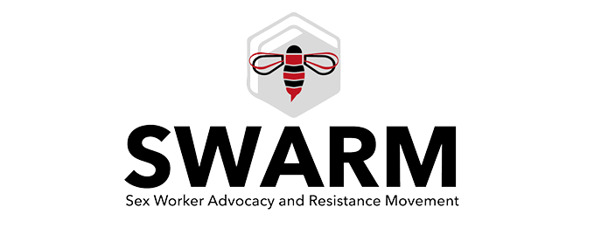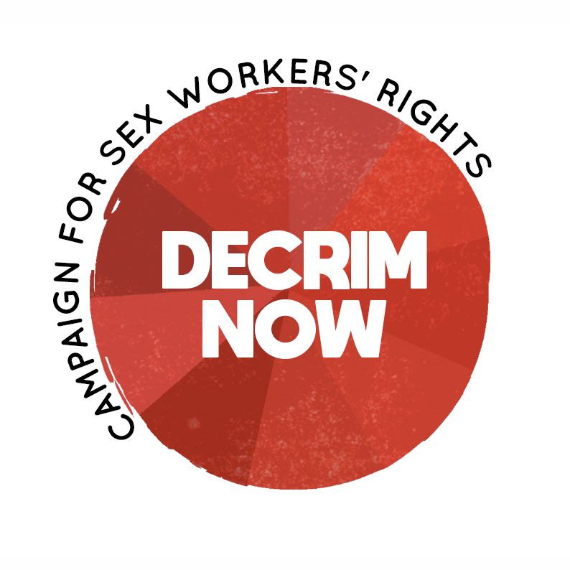

For the Attention of: Committee on the Elimination of Discrimination against Women
OHCHR - Palais Wilson 52,
rue des Pâquis
CH-1201 Geneva
10 Switzerland
cedaw@ohchr.org

Subject: Written submission for CEDAW discussion on the General Recommendation on Trafficking in Women and Girls in the Context of Global Migration (General discussion on TWGCGM)

Date: 18th February 2019

SWARM is a collective founded and led by sex workers who believe in self-determination, solidarity and cooperation. We campaign for the rights and safety of everyone who sells sexual services. Together we organise skill-shares and support for sex workers, as well as public events. We are UK based and part of the global sex worker led movement advocating the full decriminalisation of sex work. Decrim Now is an alliance of sex workers, sex worker rights organisations, feminists, trade unionists and human rights organisations campaigning for the decriminalisation of sex work in the United Kingdom. As sex worker rights organisations concerned with labour rights and the end of exploitation and violence against sex workers, the topic of the proposed GR is of huge importance for SWARM and Decrim Now.

“Human trafficking” or “sex trafficking” and “modern slavery” are terms that have been increasingly picked up in recent years by the media, the NGO sector and governments worldwide. These terms, and the laws and policies associated with them,are often used vaguely, conflating a wide range of different situations. While trafficking, forced labour and sexual exploitation are human rights violations worthy of attention, media coverage and policy discussions about these topics often play into anti-migrant narratives and ‘moral panic’.

A highly problematic discourse has built up around ‘trafficking’ in the sex industry which has been used to justify legislation that puts all sex workers, including both those who are subject to coercion by third parties and those who are not, at greater risk. Essentially, this is reflective of discourse which considers sex work itself to be the ‘root cause’ of trafficking, and that legislative models which attempt to disrupt sex work through criminalisation will result in a reduction of trafficking. The alternative viewpoint held by SWARM, Decrim Now and other sex worker led organisations worldwide is that sex work is a strategy for seeking livelihood that - like other marginalised or informal forms of work, is too often done under exploitative conditions. In our view, the pathway to an improvement in the lives of people selling sex is through decriminalisation, collective organising to improve labour conditions, and efforts to remove the factors which drive exploitation in the industry: restrictive migration policies, stigma and criminalisation of sex work, police violence, homelessness, and poverty.

FOSTA/SESTA and crackdowns on online advertising

Combating trafficking has been used as the justification for some of the most catastrophic recent legislation affecting sex work. In the US, Donald Trump signed the Stop Enabling Sex Traffickers Act (SESTA) and Allow States and Victims to Fight Online Sex Trafficking Act (FOSTA) into law in April 2018. These laws make websites legally liable for any content hosted relating to prostitution, and their owners liable for lengthy prison sentences if found guilty. The enactment of FOSTA/SESTA has led to awave of shutdowns and censorship - of sites sex workers used to find and screen clients, but also online sex worker support forums and “blacklist” sites used to share information among sex workers about dangerous clients.

The shutdown of online sex work platforms has been devastating to US sex workers, both among those who were working in already highly exploitative conditions and those who previously felt relatively safe in their work. There have been wide scale reports of sex workers facing an impossible choice between destitution through loss of their income and riskier working practices: looking for clients on the street instead of working indoors, having to accept clients they haven’t screened or who don’t seem safe, being forced to overstep their own boundaries by offering services they didn’t offer before. There have been reports of exploitative third parties (‘pimps’) using this confusion and desperation to their advantage.

Kristin Diangelo – a trafficking survivor and the the Executive Director of the Sacramento chapter of the Sex Workers Outreach Project – reported that her organization saw an 18 percent increase in street-based sex work, and that 50 percent of people who had begun working on the street had experienced violence – often in the form of rape – since their migration from indoor to outdoor work. Working on the street carries a higher risk of violence both from individual perpetrators and from police.

In the UK, some MPs are pushing for legislation banning websites which host sex workers ads to be passed by Parliament, directly inspired by FOSTA/SESTA.

The Nordic Model: Criminalising clients as “anti-trafficking”

In some jurisdictions, the aim of stopping trafficking has been used as a primary justification for introducing so-called “Nordic Model” or “End Demand” legal frameworks which criminalise sex buyers.

In Northern Ireland, the “Nordic Model” was introduced as part of the Human Trafficking and Exploitation (Criminal Justice and Support for Victims) Act (Northern Ireland) 2015. It was included in the law following lobbying from prohibitionist feminist and conservative Christian groups, despite a Department of Justice commissioned survey finding that 98% of sex workers opposed the law and felt it threatened their safety.

Unsuccessful attempts have been made to introduce the Nordic Model into English and Welsh law under the guise of anti-trafficking. There is no credible international research which shows that the criminalisation of sex work decreases trafficking. In fact, criminalisation exacerbates exploitation, including trafficking, by driving the industry underground and creating strong disincentives for people who witness or experience exploitation to come forward to report it. If sex workers did not fear prosecution or deportation themselves, they could more easily report to authorities if they find out another worker is underage or being exploited by a third party. The same goes for clients - they are less likely to report signs of trafficking or exploitation if they fear arrest themselves.

As clarified in the American Medical Association AMA Journal of Ethics by academics Erin Albright, JD, and Kate D’Adamo (herself a former sex worker and trafficking survivor):

“Criminalisation increases opportunities for violence that’s de facto unreportable; that is, because the work they do is regarded as criminal activity, sex workers are easy targets for abuse and exploitation, including trafficking.”

Nordic Model advocates claim that it reduces trafficking into sex work, but there is no reputable, international evidence to support this claim. In a paper evaluating the Swedish government’s 2010 report on the Swedish Model, Ann Jordan points out that by defining trafficking as any sex work in conjunction with a third party (in a brothel, with a manager, at a club), trafficking statistics are artificially inflated: 400-600 trafficking victims are reported but this includes any number of sex workers voluntarily working in conjunction with a third party.

The reality of raids

Sex workers frequently experience police raids which are claimed to rescue them as traumatic, terrifying experiences. Referring to them as “rescue operations” is bitterly ironic. Sex workers have phones and earnings seized, face sudden loss of their income; and migrant sex workers are subject to being taken into immigration detention and deported against their will.

Raids on sex workers’ flats are a heavy-handed, counter-productive measure that run in direct contradiction to the UK National Police Chiefs’ Council (NPCC) Policing Sex Work Guidance, which stress that the safety of people engaged in sex work must be paramount. The guidelines state that “brothel closures and ‘raids’ create a mistrust of all external agencies including outreach services. It is difficult to rebuild trust and ultimately reduces the amount of intelligence submitted to the police and puts sex workers at greater risk.”

There is no clear separation between raids supposedly intended to identify victims of human trafficking and regular “hostile environment” immigration raids.

In addition, raids do not work as a strategy to identify victims of trafficking and apprehend perpetrators. In the UK, trafficking crackdowns have not been a success. Operations ‘Pentameter’ and ‘Pentameter 2’, the biggest ever of such operations, involved 822 raids involving all police forces in the country. However, data in the report from the ‘UK Human Trafficking Centre’ (now known as the Modern Slavery Human Trafficking Unit) revealed that:

• 10 of the 55 police forces found no-one to arrest.
• 122 of the 528 arrests announced by police never happened.
• Among the 406 actual arrests, more than half of those arrested (230) were women, and most were never implicated in trafficking at all.
• Most of the remaining 253 were not accused of trafficking: 73 were charged with immigration breaches; 76 were eventually convicted of non-trafficking offences involving drugs, driving or management of a brothel; others died, absconded or disappeared off police records.
• They found only 96 people to arrest for trafficking, of whom 67 were charged. 47 of those never made it to court. Only 22 people were finally prosecuted for trafficking, including 2 women who had originally been "rescued" as supposed victims. 7 of those were acquitted.

Similar occurred around the 2012 Olympics, when an expensive police crackdown again yielded no trafficking victims but did manage to displace sex workers from the area, taking them away from both established safety networks and outreach services.

Between 2007 and 2009, the Economic Social Research Council funded the Migrants in the UK Sex Industry research project. The team interviewed 100 migrant sex workers in London. While 13% of female interviewees felt they had been subject to varying levels of exploitation, only 6% felt that they had been deceived and forced into selling sex. A subsequent analysis of sex trafficking rhetoric by a journalist in the Guardian describes how commonly touted figures are essentially plucked from thin air.

If not criminalisation, what?

Trafficking is a highly complex, global issue that will not end without long-term, systemic and radical change. However, there are changes UK policy makers could introduce immediately that would make a difference to improve the lives of victims of exploitation in the sex industry. Many of these would also benefit victims of trafficking in other industries (e.g. construction, domestic service, farm work).

- Decriminalise consensual adult sex work by removing laws prohibiting soliciting, brothel keeping, kerb crawling. Coercing a person into any sexual act, commercial or not, through intimidation, grooming or violence should remain remain illegal.
- Introduce a strict principle of non-prosecution of victims for any offence when they come forward to report exploitation and training for police to ensure this is adhered to.
- Create a ‘firewall’ between immigration enforcement and support for victims of trafficking or exploitation in prostitution, so they can feel safe to come forward to authorities.
- End data-sharing between NHS services and police and immigration operations -- this practice deters people in the sex industry from accessing vital healthcare for fear of negative repercussions.
- Ensure fast-tracked pathways to permanent residence and citizenship if victims of trafficking wish to remain in the UK, and assistance to claim asylum if they will be at risk of re-trafficking or other violence if deported to their country of origin.
- Provide secure and appropriate housing for victims of trafficking when they come forward for support or are identified by authorities, and access to welfare benefits at a level to allow for decent quality of life.
- Fund the other support victims of trafficking need: employment support, language and education support, free medical treatment and trauma-informed counselling. Victims should be consulted and centered throughout the support offered to them in recovery and re-integration. None of this support should be conditional on co-operation with a criminal investigation.
- Fund access to legal aid and advice for victims of trafficking, enshrined in law.
- Remove barriers to claiming compensation faced by recognised victims of trafficking.
- Abolish the cruel and inhumane practice of immigration detention. Holding survivors of trafficking and exploitation in detention centres is traumatising. It is state violence.

Pimps Are Preying on Sex Workers Pushed Off the Web Because of FOSTA-SESTA (Motherboard, April 30 2018) https://motherboard.vice.com/en_us/article/bjpqvz/fosta-sesta-sex-work-and-trafficking
The War on Sex Workers Needs to Stop Now (Rolling Stone, April 13 2018) https://www.rollingstone.com/politics/news/sesta-fosta-war-sex-workers-needs-to-stop-w519076
https://www.theguardian.com/society/2018/jun/30/ban-prostitution-websites-stamp-out-trafficking-sexual-exploitation
https://www.justice-ni.gov.uk/sites/default/files/publications/doj/prostitution-report-nov-update.pdf
https://journalofethics.ama-assn.org/article/decreasing-human-trafficking-through-sex-work-decriminalization/2017-01
Jordan, ‘The Swedish Law to Criminalise Clients: A failed experiment in social engineering’, (2012); http://www.nswp.org/sites/nswp.org/files/Issue-Paper-4%5B1%5D.pdf
https://www.libertyhumanrights.org.uk/sites/default/files/HE%20web.pdf
United Kingdom Human Trafficking Centre, “United Kingdom Pentameter 2 statistical assessment of victims recovered and suspects arrested during the operational phase’ draft report’, (2009); http://scot-pep.org.uk/sites/default/files/reports/briefing_paper_-_the_trafficking_debate__sex_work.pdf
The Trafficking Research Project, ‘Sex work and the London 2012 Olympics – How was it for you?’ (2012); https://thetraffickingresearchproject.wordpress.com/2012/09/14/sex-work-and-the-london-2012-olympics-how-was-it-for-you/
Brook, Cassell, Mercer et al.’P3.341 Sex and the London Olympics 2012 Part 1. Impact on Community Sexual Health Service Provision in London’ (2013); http://sti.bmj.com/content/89/Suppl_1/A255.3
Mai, ‘ESRC Project: Migrant Workers in the UK Sex Industry’ (London Metropolitan University n.d); https://archive.londonmet.ac.uk/iset/research-units/iset/projects/esrc-migrant-workers.html
Davies, ‘Prostitution and trafficking – the anatomy of a moral panic’ (The Guardian, 2009); https://www.theguardian.com/uk/2009/oct/20/trafficking-numbers-women-exaggerated

