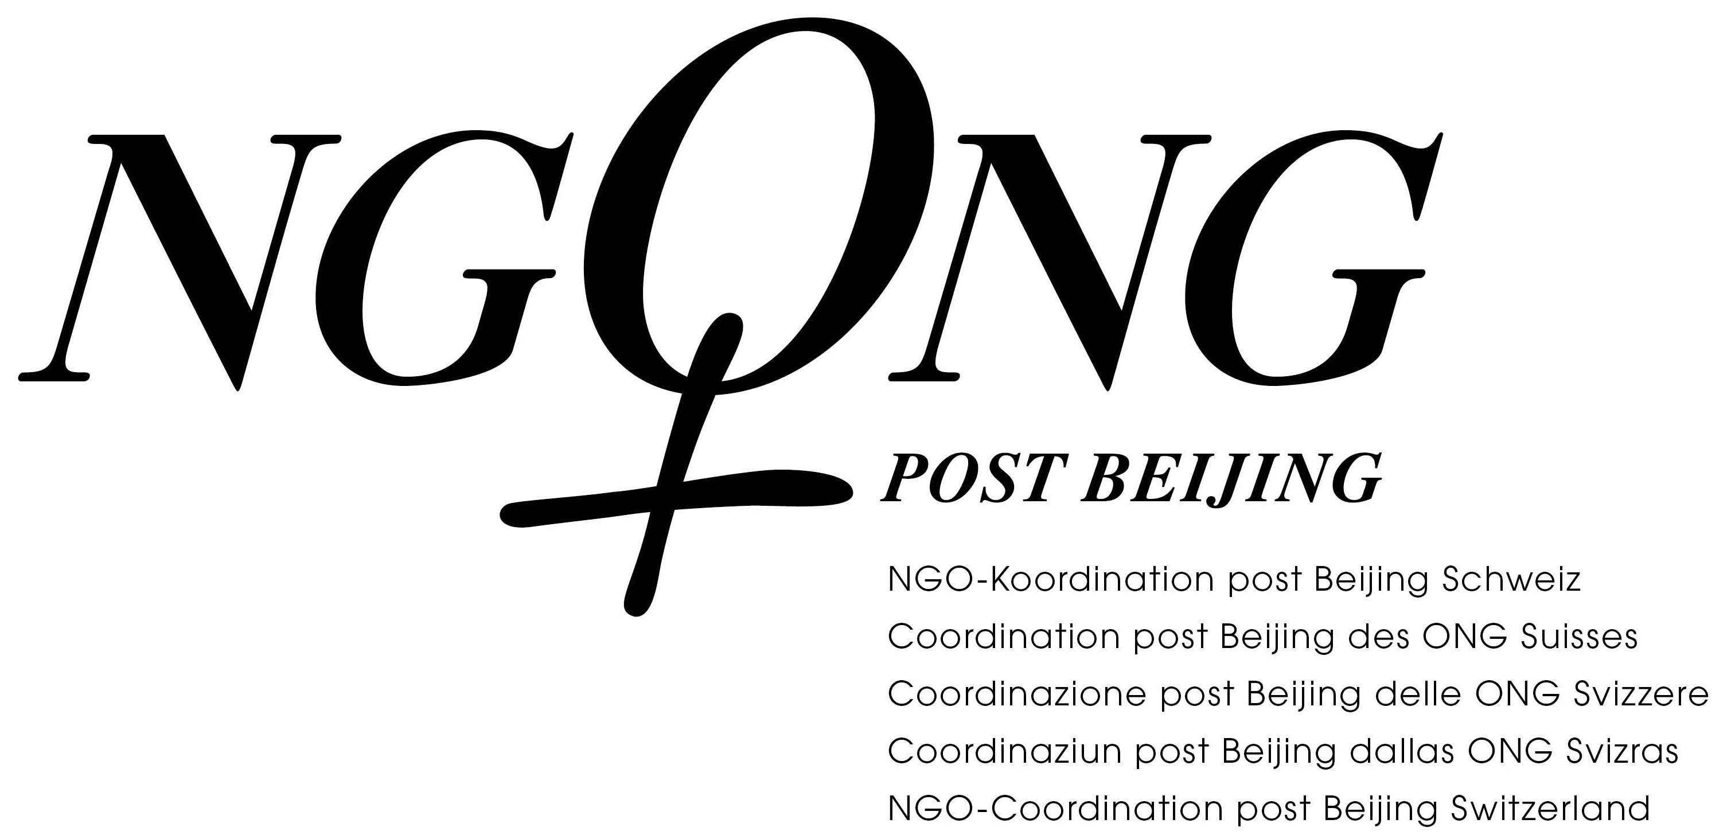

Submission of the NGO-Coordination post Beijing Switzerland for the general discussion on “Trafficking in Women and Girls in the Context of Global Migration“

Trafficking in women for sexual exploitation is a key topic in Switzerland. Trafficked women frequently continue to fight for recognition, have uncertain residence status or no rights of residence at all and barely any avenues open to them to demand their rights. Victims can only exercise their rights if Switzerland grants them protections afforded by resident status, meaning that they are permitted to legally reside in Switzerland and thus have access to support and protection. A further weak point in victim protection is the lack of adequate accommodation facilities for victims.
Switzerland has not followed recommendation no. 30 proposed by the CEDAW Committee, which involved not only tracking down and punishing human traffickers, but also ensuring protection of victims and subsequently considering the option of extending temporary residence permits and other measures. The way in which the Swiss legal system is designed still places a clear emphasis on criminal law. This also continues to be standard practice in the administration, the judiciary and the police, thus impeding the implementation of the CEDAW recommendation.
Laws to combat undeclared labour cannot be viewed as effective instruments to tackle human trafficking for labour exploitation. In its current form, the ongoing amendment to the law also misses the opportunity to improve protection for workers and help identify victims of human trafficking. It fails to make it the express legal duty of workplace inspectors to check for and report violations of article 182 of the Swiss Criminal Code.
Neither the federal or cantonal constitutions nor legislation make explicit references to trans people and the topic of “gender identity”. This lack of protection is in striking contrast to the reality of their lives which are marked by discrimination, stigmatisation and violence, particularly in the area of trafficking in human beings. What is lacking is a comprehensive and coordinated approach.

Recommendations
Switzerland must introduce binding standards for all cantons to ensure that identification and protection of victims is not handled differently from canton to canton.
Switzerland must provide long-term funding to support the work of specialised victim-protection centres for victims of human trafficking.
Switzerland must place greater importance on victim protection and increase the protections afforded by resident status, in particular by granting residence permits to enable victims to take part in protective and rehabilitation measures, by granting and interpreting the recovery and reflection period with the benefit of the victim in mind, and by granting residence permits to all victims regardless of criminal proceedings and their level of cooperation.
Switzerland must provide funding for a victim protection programme that offers a full spectrum of services, such as adequate accommodation facilities and suitable integration measures. The reality of trans people must be taken into account.
International guidelines concerning victim protection and human trafficking must also be integrated into and applied to Swiss asylum law. If cases fall under the Dublin regulation, the jurisdiction of Switzerland is responsible for substantiating its suspicion of human trafficking.
Switzerland focuses mainly on combating human trafficking for the purposes of sexual exploitation. Very few victims of human trafficking for the purposes of exploitation of labour are identified. We have knowledge merely about FOUR convictions for human trafficking for the purposes of exploitation of labour in Switzerland. Switzerland should urgently promote involving and training new players and NGOs such as labour inspectors, employees and trade unions; inspectors must have an explicit remit for their controls regarding human trafficking.

NGO-Coordination post Beijing Switzerland, 2019-02-11

