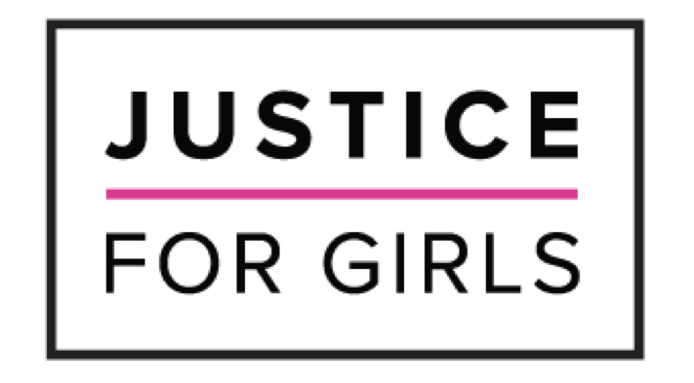

JUNE 18, 2021

Joint Submission of Justice for Girls & Just Planet
for consideration by
the Committee on the Elimination of Discrimination Against Women
during the Day of General Discussion on "the Rights of indigenous Women and Girls" at its 79th session
June 24th, 2021

Oral submission by:

Zoe Craig-Sparrow
Master of Arts (with Distinction) in Human Rights (University of London)
Justice for Girls, Director of Indigenous Rights and Environmental Justice
Just Planet, Expert in Women & Children's Rights/Indigenous Peoples/Ecocide

- My name is Zoe Craig-Sparrow and I’m here on behalf of Justice for Girls and Just Planet.
- I am an Indigenous young woman whose community and family, the Musqueam people, have lived and learned in modern day Vancouver, Canada for thousands of years. I have been advocating for Indigenous women and girls’ rights, particularly in the context of the environment, since I was 12 years old and am intimately familiar with many of the issues discussed today.
- I know first hand that, as children, Indigenous girls face barriers associated not only with their indigeneity and gender, but also their age.
- I am here to urge you to specifically emphasize and analyse the rights and experiences of Indigenous girls in developing a general recommendation.
- I urge you to go beyond simply tacking “and girls” onto an adult women’s human rights framework, instead prioritizing girls rights and perspectives with the accuracy and specificity needed to capture their agency, intersectional experiences and vulnerabilities as both rights holders and human rights defenders.
- The right to self-determination is central to the full realization of the rights of Indigenous girls, and moreover ending the extreme violence and poverty they experience globally.
- I remind this Committee of the consensus amongst world scientists that climate change is an imminent and existential threat to humanity and future generations. Indigenous girls are at the frontline of that threat.
- Extractive industries --as drivers of climate change and environmental contamination-- cause profound ecological damage and are also linked to violence, forced migration, sexually transmitted infections, human trafficking, sexual exploitation, sexual harassment, and sexual assault against Indigenous women and girls..
- I echo the concerns of many Indigenous women and girls worldwide when I state that violence against the earth and violence against indigenous women and girls go hand in hand; the ecocidal impacts of extractive industries are closely linked to genocide of Indigenous women and girls.
- My country, Canada, is currently home to both the largest and most destructive oil operations in the world and a genocide of Indigenous women and girls where I, as an Indigenous woman, am 12 times more likely to go missing or be murdered.
- In developing a general recommendation, I urge the Committee to emphasize both the specific human rights violations and intersectional vulnerabilities Indigenous girls face as well as the importance of their resistance, leadership and voices.
- On a more personal note, I want to express that, as an Indigenous young woman from a colonial country who is facing many of the challenges discussed here today, I appreciate the Committee’s discussion on this general recommendation and am hopeful that it will serve to advance and improve not only my ability to enjoy the full spectrum of rights that I am entitled to, but also safeguard and improve the lives of my teenage sisters, and future daughters and granddaughters in the generations to come.
- Thank you for your time.

