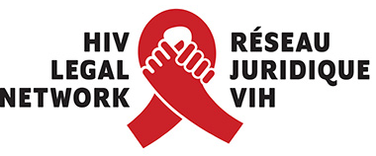
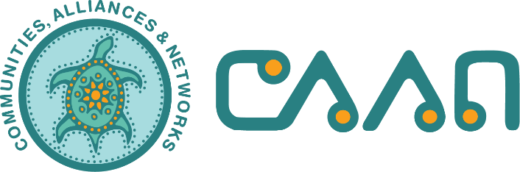

Oral Submission to the UN Committee on the
Elimination of Discrimination against Women:

Equality and Non-discrimination with a Focus on Indigenous Women and Girls
and Intersecting Forms of Discrimination

June 2021

HIV Legal Network
schu@hivlegalnetwork.ca
www.hivlegalnetwork.ca

CAAN
margaret@caan.ca
www.caan.ca

Speaker: Margaret Kisikaw Piyesis, CEO of CAAN

My name is Margaret Kisikaw Piyesis, Kind Hearted Warrior Woman. I am joining today from Treaty 4 Territory and the traditional homeland of the Métis Nation, in this land now called Canada. On behalf of CAAN and the Canadian Legal Network, I will speak about solutions and the way forward for some of the discrimination that Indigenous women face regarding HIV, sex work, and drug use.

HIV
Canada is known internationally for its severity in criminalizing people living with HIV. Fear of these punitive measures means that people are afraid to disclose their status, seek testing, or access support. This fear drives stigma, which in turn drives HIV transmission. We know that HIV+ Indigenous women face multiple forms of stigma, and we know that stigma kills. Instead of draconian laws, we need investment in supports that reduce HIV risk, such as housing, harm reduction, and culturally safe services for Indigenous women.
SEX WORK
As the National Inquiry into Missing and Murdered Indigenous Women and Girls concluded, Indigenous women involved in sex work who have experienced violence cannot reach out to police. They run the risk of being implicated, arrested, and charged for violence themselves. Laws that criminalize sex work result in isolating women, particularly Indigenous women, from support and safety mechanisms that could save their life. In addition to decriminalizing sex work, we must also fund and support culturally appropriate programs and services that are developed by people who have lived experience.
DRUG USE
The overdose crisis experienced by Indigenous people in Canada is an outcome of colonialism, including the intergenerational legacy of residential schools and displacement from our traditional lands. The overdose crisis will not be solved by punishing people who use drugs. We must decriminalize the possession of all drugs for personal use and develop appropriate models for the legalization, regulation, and supply of currently criminalized substances. We must scale up and ensure access to culturally appropriate harm reduction services for Indigenous women, including supervised consumption services and drug treatment support services, particularly in remote and rural communities, and in prisons.

Colonialism may have created these dis-eases, but we as Indigenous People have the solutions to address them. I have described a few legal reform and policy improvements. For these to be effective, they must be grounded in the meaningful engagement of Indigenous women, be culturally appropriate, and be gender specific. Thank you for the opportunity to speak to you about some of the solutions for eliminating discrimination against Indigenous women and girls.

