Rights of indigenous women
Submission for the Committee on the Elimination of Discrimination Against Women
79th session, June 21st to July 1st, 2021
- Introduction
The Information Group on Reproductive Choice (GIRE, by its initials in Spanish) is a feminist non-governmental organization that works for the advancement of reproductive justice in Mexico via six priority issues: access to safe and legal abortion, maternal mortality, obstetric violence, access to contraception, assisted reproduction techniques and work-life balance. GIRE writes this contribution, regarding reproductive rights of indigenous women, for the day of general discussion on the rights of indigenous women and girls, and for the Committee's next General Recommendation on this issue, to be held in the Committee’s 79th session.
- Contraception

According to the 2014 National Survey on Demographic Dynamics (ENADID), 54% of indigenous women of reproductive age became mothers during their adolescence, a higher percentage than among those who do not speak an indigenous language (45.9%). Regarding the use of contraceptives by sexually active adolescents, it was found that six out of ten speakers of an indigenous language do not use contraceptives.

Likewise, the 2016 National Survey on the Dynamics of Household Relationships (ENDIREH) reported that 20.08% of adolescents who identify as indigenous claim to have had at least one pregnancy, as opposed to the 16.15% of their peers who do not identify themselves as such. This differentiation on the reproductive life of indigenous and non-indigenous adolescents might be related, among others reasons, to the lack of accessibility on the access to contraception in public institutions, as GIRE’s research have found.

The information obtained by GIRE through requests for access to government information demonstrates that, at the federal level, no health institution reported having trained personnel to provide consultation on reproductive health and contraceptive methods in any language other than Spanish.
One response provided by the Women’s Hospital was notable, reporting that, given the lack of personnel who speak indigenous languages or trained interpreters, the hospital requests that the women come accompanied by a family member who speaks Spanish, to whom the information is given. Similarly, the Mexican Social Security Institute (IMSS) reported that family planning counseling in primary care health centers is conducted in Spanish, and on a state level, they rely on those who accompany the patients for interpretation or translation.

At the state level, 16 Mexican states reported not having interpreters to provide contraceptive counseling and information in indigenous languages. It is alarming that the Zacatecas health authorities responded that they do not require interpreters since there are no indigenous groups in the state, despite the fact that, according to the National Institute of Statistics and Geography (INEGI), 7.61% of its population identifies as such. Other cases that stand out are the states of Guerrero and Oaxaca, both of which have significant indigenous populations: the first does not have trained personnel to interpret for patients in languages other than Spanish, and the second does not report the requested information.

In addition, the 15 states that claimed to have interpreters in their health centers did not provide information about the number available, their training or the languages they speak, so it is impossible to infer whether they are sufficient to meet the demand of people, especially women, who could require these services.

This evidence demonstrates a serious problem in public health services that, as part of the State’s obligation to guarantee reproductive health for indigenous women, should have interpreters available, as well as enough public information to measure the effectiveness of interpreters or to hold the State accountable in case they are not enough. The current situation of reproductive health services available only in Spanish transfers the responsibility to the patients and their families and denies the right to intimacy in the access to these services.

INTERPRETERS FOR CONTRACEPTIVE COUNSELING IN INDIGENOUS LANGUAGES
STATE-LEVEL MINISTRIES OF HEALTH

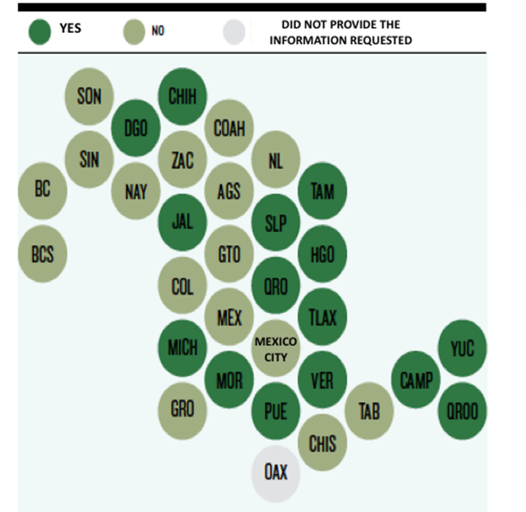
Source: Developed by GIRE based on requests to public information.

- Obstetric violence and maternal mortality
From October 2011 to October 2016, a total of 8.7 million women in Mexico gave birth at least once. During the same period of time, 33.4% of these women suffered some type of mistreatment by medical professionals. Of the women who suffered some type of abuse during childbirth, 26% spoke an indigenous language or identified as indigenous. The most frequent types of abuse reported involved yelling at or scolding the woman, delaying treatment because the woman “was complaining or screaming a lot,” withholding information about the birth, or pressuring the woman to accept a contraceptive method or sterilization.
Sometimes, the presence of obstetric violence ends in maternal mortality, which affects disproportionately on indigenous women. Of the total number of maternal deaths in recent years in Mexico, the percentage of those women who speak indigenous languages has remained practically static. In 2013, the death of indigenous-speaking women represented 11.3% of all maternal deaths; for 2014, they were 9.9% and in 2015, 11.2%. The figure contrasts with the last census in Mexico, which reports that the indigenous population represents 6% of the overall population.
There are states where the maternal death of indigenous women is especially high, such as Chiapas. With indigenous people making up 27% of the state’s population, 41.9% of the total maternal deaths in 2013 were women who spoke an indigenous language. Although the number decreased slightly in 2014, in 2015 it increased again to 40.3% of the total number of maternal deaths. These figures represent the inequality that indigenous women face in accessing reproductive health care.
Another case were indigenous population and maternal mortality are related is the case of Yucatán: half of the population is indigenous and is the state with the highest percentage of indigenous population in the whole country, 49% of Yucatán’s population are mayan speakers. According to the Health Information General Direction (DGIS by its initials in Spanish), in 2018 the maternal mortality ratio in Yucatán was the highest fourth nationally. Even though it decreased to 19.5 deaths per 100 thousand births in 2019, it increased again to 51 deaths per 100 thousand births in 2020.

Maternal mortality ratio in Yucatán 1990-2018
Yucatán National
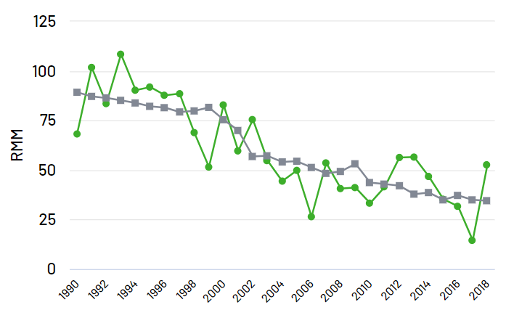
Source: Data from the National Indicators on the maternal mortality ratio of the Information System of the Ministry of Health, updated to 2018. Available http://sinaiscap.salud.gob.mx:8080/DGIS/
Historical and structural failures in the health system have a particular impact on women in indigenous communities, who have to travel long distances to health centers that are in poor condition, without basic medical personnel or interpreters of languages other than Spanish, and who encounter discriminatory attitudes from the staff.
Despite Mexican policies, health sector practices still place women’s lives at risk during pregnancy, childbirth and puerperium. These practices include the absence of quality prenatal care; a decline in the quality of primary-level care for deliveries without complications -attended in hospitals generating significant overload-; an increase of unjustified cesareans; and a lack of quality treatment and compliance with evidence-based norms, guidelines and protocols.
Also, currently there are no conditions for indigenous women and adolescents to choose freely to give birth at home with a traditional midwife when they have a low-risk pregnancy, because of the lack of
- Conclusions and recommendations
Indigenous women and girls face a differentiated impact on the recognition and exercise of their reproductive rights because of their identity, language and, in some cases, geographic residence. GIRE asks the Committee to address reproductive rights on indigenous women and adolescents in its General Recommendation on the issue, by recommending the States parties to:
- Guarantee the availability of an interpreter in health services, at all levels of care.
- Guarantee the free decision of indigenous women to wether give birth at home or at hospitals
- Consolidate the attention provided at the primary level by strengthening low-risk delivery care to reduce the saturation of secondary and tertiary level services and ensure timely referral to these services for the resolution of obstetric emergencies.
- Strengthen the training and accreditation actions of obstetric midwives and nurses to incorporate them progressively into health services.
- Modify the professional training of medical and nursing staff in the care of women during pregnancy, childbirth and postpartum to include a gender and intercultural perspective.

The publication of this document on the CEDAW’s web page is authorized
GIRE, The Missing Piece: Reproductive Justice, 2018, p. 31, available at: https://justiciareproductiva.gire.org.mx/assets/pdf/JusticiaReproductiva.pdf
GIRE, The Missing Piece, Reproductive Justice, op. cit., p. 31.
GIRE, The Missing Piece: Reproductive Justice, op. cit., p. 32.
National Institute of Statistics and Geography, Op cit., 2016
Indigenous Development National Comission, Socioeconomic indicators of the indigenous peoples of Mexico, 2015, México https://www.gob.mx/cms/uploads/attachment/file/239921/01-presentacion-indicadores-socioeconomicos-2015.pdf
Census data from National Institute of Statistics and Geography from 2015 and from the Atlas of Indigenous Peoples of Mexico the same year
GIRE, The Missing Piece: Reproductive Justice, op. cit., p. 117.

