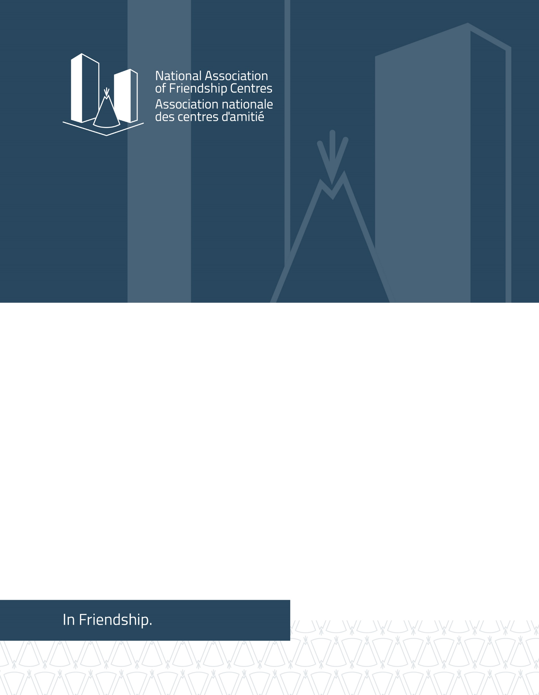
CANADA: Submission to the United Nations Committee on the Elimination of Discrimination Against Women (CEDAW) in advance of its preparation of the Day of General Discussion on the Rights of Indigenous women and girls

Contact:
Jocelyn Formsma, H.B.Soc.Sci, J.D.
Executive Director. National Association of Friendship Centres
275 MacLaren Street, Ottawa, Ontario K2P 0L9 CANADA
1 (613) 563-4844 ext. 318
www.nafc.ca
jwformsma@nafc.ca
June 2021

About NAFC
The National Association of Friendship Centres (NAFC) is a national network of Indigenous owned and operated civil society, not for profit, and service delivery organizations across Canada. Collectively, we refer to our network of over 100-member local Friendship Centres (FCs) and Provincial/Territorial Associations as the Friendship Centre Movement (FCM). The FCM is the most significant urban Indigenous service delivery infrastructure in Canada. For over half a century, FCs have been developed and advanced by Indigenous peoples living in urban environments and helped individuals access the vital culturally appropriate services they need to succeed in urban settings across Canada.

Introduction
The NAFC submits this written statement to the United Nations (UN) Committee on the Elimination of Discrimination Against Women (CEDAW) in advance of its preparation of the Day of General Discussion on the Rights of Indigenous women and girls on June 24, 2021. This submission is intended to provide perspectives based on urban Indigenous realities in Canada.
Due to their residency and other intersecting forms of discrimination, many Indigenous women, girls and 2SLGTBQQIA+ who are urban based do not have the same opportunity for participation in political and public life through existing mechanisms in Canada. Further, resources for Indigenous peoples living in urban settings in Canada are limited and not in line with the population or full experiences of urban-based Indigenous peoples.
Friendship Centres are a mechanism by which Indigenous peoples have been able to meet their human rights and express themselves within a civil society network. As Canada’s largest Indigenous civil society network, FCs deliver critical programs and services that directly contribute to Indigenous community wellbeing and safety. Their work helps urban Indigenous communities prevent, intervene in, and heal from acts of violence. Our programming takes an inclusive, wraparound approach. FCs do work integral to the continuum of anti-violence, even when this programming is not typically recognized as addressing violence directly. Examples of such programming includes employment programs, children’s programs, men’s sharing/peace circles, play-based programs for youth, and seniors’ advocacy groups. Ultimately, we share that Friendship Centre programming is rooted in rich and diverse Indigenous cultures and our work is essential to upholding the articles and rights affirmed in UNDRIP.
In 2013, the UN Special Rapporteur on the Rights of Indigenous People observed that Canada has an “epidemic” of murdered and missing Indigenous women. As later noted by the National Inquiry on Missing and Murdered Indigenous Women and Girls (NIMMIWG), “Indigenous women and girls are 12 times more likely to be murdered or missing than any other women in Canada, and 16 times more likely than Caucasian women.”
The Government of Canada launched the NIMMIWG in August 2016 with a mandate to investigate the systemic causes of violence against Indigenous women and girls. The inquiry’s scope expanded to include two-spirited, lesbian, gay, bisexual, transgendered, queer, questioning, intersex, asexual and non-binary people (2SLGBTQQIA+). The final report stated that the national tragedy of murdered and missing Indigenous women and girls amounts to a genocide, sparking significant domestic and international attention and equally significant debate.
The NIMMIWG final report proposed 231 Calls for Justice (CFJs), a set of imperatives rooted in international and domestic Indigenous and human rights law. These imperatives provide a pathway “to end the genocide and to transform systemic and societal values that have worked to maintain colonial violence.” The NIMMIWG final report did not contain much reference to urban Indigenous women, girls and 2SLGBTQQIA+.
National Action Plan- Urban Path to Reclaiming Power and Place, Regardless of Residency
The NIMMIWG’s CFJs requested that the Canadian government establish a National Action Plan (NAP) on Violence Against Women, Girls, and 2SLGBTQQIA+. The NAP was published on June 3, 2021. This NAP was released along with 9 sub-working group plans (Urban, Families and Survivors, First Nations, Inuit, Métis, Data, federal, provincial/territorial, and 2SLGTBQQIA+). A federal government implementation plan is forthcoming.
The NAP defines urban Indigenous people as “First Nation, Inuit and Métis people living in small, medium and large communities, including rural, isolated and remote communities, which are: off-reserve; outside of their home community, community of origin or settlement; or outside of Inuit Nunangat (Inuit Homelands).” The majority of Indigenous people in Canada live in urban areas. The reasons for the increasingly urban reality for Indigenous people vary, including being born and raised in the city. Other factors for moving to urban centres include employment opportunities, marriage, colonial approaches to removal of Indigenous children through the residential school systems, the Sixties Scoop, escaping intimate partner violence, bullying, structural violence, or homophobia. While the reasons for Indigenous people living in urban settings are many, there remains a gap between the availability of services and the accessibility of those services for urban Indigenous community members.
The Urban Sub Working Group chapter, Urban Path to Reclaiming Power and Place, Regardless of Residency, includes a call to recognize urban Indigenous legitimacy, outlines urban realities and discusses urban perspectives on the baskets of rights: Culture, Health and Wellness, Safety and Human Security, and Justice. Understanding urban Indigenous realities is vital to effective public policy, program and funding decisions and should inform legislative development and changes in Canada.
The urban framework upholds the need for a National Urban Indigenous Strategy that addresses children’s rights, anti-racism, sexism, homophobia and transphobia, violence prevention programs and a national Indigenous housing program regardless of residency. The strategy would support grassroots programming, decolonized and trauma informed approaches that focus on the needs of survivors and families. The framework asserts that urban Indigenous women, girls and 2SLGBTQQIA+ should be given decision making power to ensure adequate resources for urban communities and Indigenous-led organizations.
Urban Indigenous organizations are leaders in facilitating programming to eradicate violence in their own communities. Urban Indigenous organizations wield an advantage over non-Indigenous service providers in urban environments because they recognize the whole of a person, holistic wrap around supports, alongside broader kinship and community needs. FCs are the most significant urban Indigenous service delivery infrastructure and are the primary providers of culturally enhanced programs and services to urban Indigenous people in Canada. Furthermore, they contextualize care from the vantage point of a shared history and understanding. FCs are born from community and kinship lines and have created inclusive spaces to share, learn, and support urban Indigenous women, girls and 2SLGBTQQIA+. However, our ability to express the experiences of urban Indigenous peoples has not been fully recognized or acknowledged.
There is currently a lack of data and research dedicated to the needs of urban Indigenous women, girls and 2SLGBTQQIA+. The National Action Plan’s urban framework calls for “A mapping exercise of programs and services providing a direct focus on anti-violence; establish self identification data collection standards which include urban and 2SLGBTQQIA+ as categories; establish an oversight/monitoring body with the full participation of urban Indigenous people”. All levels of government must work collaboratively with urban Indigenous partners on policy, programs, research and gathering data. There must be more of a focus on “client-centred and culture-based” programming to support “urban land-based activities for healing, ceremonies, social and community events; and breaking down binary gender stereotypes”.
The Government of Canada has adopted a “distinctions-based approach” to its federal policy and decision making. Distinctions-based means the three constitutionally recognized Indigenous groups in Canada: First Nations, Métis, and Inuit. The distinctions-based approach was intended to remedy the previous “pan-Aboriginal” or “one size fits all” approach to Indigenous policy and decision making. While recognizing and supporting the need for unique approaches, the NAFC has been critical of the distinctions-based approach with respect to federal funding for Indigenous peoples because of the risk that policy, programming, and funds are solely divided along these distinctions. As unpacked in the Urban Path, First Nations, Métis, and Inuit peoples also have multiple and intersecting identities and approaches to their support, must also be reflective and inclusive of those layered identities. Under a distinctions-based approach that cannot recognize the unique challenges of Indigenous women, girls and 2SLGBTQQIA+ who are urban based and urban Indigenous civil society organizations, the federal government of Canada will not make available the same mechanisms available to Indigenous peoples who are urban based to influence public policy, participate in decision making, or even have their realities considered. Rights are held by Indigenous peoples, as individuals and collectives.
In keeping with the findings of Canada’s NIMMIWG, NAFC holds that distinctions ought to be defined with an intersectional lens, not just including First Nations, Métis, and Inuit, but also considering the residence of Indigenous people, the province or territory that they are in, whether they are remote or northern residents, their physical and mental abilities, and their sex, gender identity and sexual orientation. The National Action Plan’s Urban Framework asserts that an intersectional lens to distinctions will better position the Government of Canada to provide urban Indigenous community members with the support they require.
The federal government of Canada announced funding to implement the National Action Plan, but no timeline has been outlined. It is still unclear how urban Indigenous people and organizations will be able to access funds.
National Action Plan - 2SLGBTQQIA+ Chapter
The MMIWG 2SLGBTQQIA+ National Action Plan: Final Report advocates to “ensure Two Spirit, and Indigequeer kin can return to family/ community/ ceremonial circles to be embraced for the sacredness carried in our spirits and to take our rightful place in our respective Nations”. The 2SLGBTQQIA+ Sub Working Group (2SLGBTQQIA+SWG) came together to address the level of violence, exclusion and erasure that community members experience.
The 2SLGBTQQIA+SWG asserts that “the absence of an intersectional lens has excluded the 2SLGBTQQIA+ community members from national inquiries and commissions such as the National Inquiry on Missing and Murdered Indigenous Women and Girls (NIMMIWG) and the Truth and Reconciliation Commission of Canada (TRC)”. In response, the 2SLGBTQQIA+SWG“identified a need to develop a Two-Spirit specific gender-based analysis tool to ensure that the realities of our Two-Spirit and Indigequeer relatives are reflected and fully incorporated into this action plan and to address the exclusion as a missed opportunity to describe the imposition of binary gender identities onto Indigenous people.” These calls to action are “to hold the recommendations which will bring change to the lives of our 2SLGBTQQIA+ people.”
The first call to action the Report makes is to establish a NAP specific to 2SLGBTQQIA+, that is incorporated as a companion to the MMIWG2S National Action Plan. Ideally the report noted the Action Plan will address systematic erasure as a group. The report asserts the need for federal legislation that protects, promotes, enhances, and ensures the direct involvement of the 2SLGBTQQIA+ community. The report argues for the restoration of the “2SLGBTQQIA+ people to historical roles” in order to help “mitigate” violence.
The 2SLGBTQQIA+SWG specifically wants to see the “Recognition, reaffirmation, and expansion of UNDRIP provisions to include 2SLGBTQQIA+ individuals so they are entitled, without discrimination, to all human rights recognized in international law.” As well as, “Re-affirmation and expansion of Article 3 and 7. 2.” The report notes that, “2SLGBTQQIA+ have the right to autonomous self determination of identity to live, work, raise their families, practice culture and ceremony, and thrive in healthy, safe, secure, peaceful, nurturing environments and shall not be subjected to any act of violence, genocide, harm, harassment, forced assimilation, unlawful detainment, surveillance, or arrest.”
The 2SLGBTQQIA+SWG wants to see an “expansion of 2SLGBTQQIA+ programs and services including Indigenous-specific funding allocations.” As well as, “establish a 2SLGBTQQIA+ National Committee.” More specifically, the report outlines that the committee must be “explicitly engaged in the review and expansion of UNDRIP enabling/confirming legislation to include 2SLGBTQQIA+ rights and the design and implementation of the NAP to mitigate violence.”
The 2SLGBTQQIA+SWG Final Report for the NAP focuses on four areas of rights including culture, health and wellness, safety and security and justice. They assert that measures to support these 4 areas apply to 2SLGBTQQIA+” Indigenous people in “rural/on reserve contexts, and urban” and must also consider “healing and cultural reclamation strategies for First Nations, Métis and Inuit Two-Spirit, Indigequeer identified People and their family members”.
The 2SLGBTQQIA+ NAP Final Report calls for inclusion of disabled 2SLGBTQQIA+ people and more support for sex workers who identify as 2SLGBTQQIA+. They argue that more needs to be done to address intersecting forms of violence and discrimination based on race, class, sex, gender, residency, geography, ability, and age.
The 2SLGBTQQIA+SWGoutlines the “right to culture” includes full participation in traditional teachings, ceremony, land-based activities, and cultural activities regardless of residency. The working group asserts that “2SLGBTQQIA+ people have the right to practice culture and ceremony anywhere in the territory they live in or travel to, for the purpose of ceremony”. 2SLGBTQQIA+ people should be equally included in pow wows, gatherings and ceremonies and pageants.
The final report outlines the need for a National Healing Strategy that is encapsulated under the right to health and wellness. The strategy would foster holistic support including “healing and wellness” program funding for 2SLGBTQQIA+ organizations. The program funding would be made available to Board of Directors, staff, in addition to Indigenous community members.

A Friendship Centre Approach - Honouring Our Ways: Missing and Murdered Indigenous Women and Girls (MMIWG) 2SLGBTQQIA+
There exists a unique need in Indigenous communities for advocacy and national collaboration for Indigenous women, girls, and 2SLGTBQQIA+ wellbeing and safety, that is inclusive of their layered and diverse identities, regardless of residency and geographic location. These unique considerations go to both equality and non-discrimination with a focus on intersecting forms of discrimination and effective participation of Indigenous women, girls and 2SLGTBQQIA+ in political and public life.
The right to self-determination is connected to the practice of self-governance and recognition of collective interests to allow individuals and communities to chart their own course. The NAFC submits that there is a robust role for Indigenous civil society organizations, especially those in urban settings, such as FCs in Canada, to be fully engaged in any action planning and implementation, sharing best practices, and creating broader support systems to advance and uphold the principles of self-determination and are essential ending violence against Indigenous women, girls, and 2SLGBTQQIA+.
To respond to the needs from the communities that we serve and to develop our own approach and anti-violence/violence prevention implementation plan, the NAFC convened members of the FCM that are engaged in violence prevention work to accomplish the following:
- highlight and amplify the critical work that FCs, as urban Indigenous civil society organizations, are already doing to address violence,
- identify opportunities for governments, policymakers, and funders to effectively augment their support, and
- establish tangible next steps to resource FCs’ ability to foster healthy, safe communities in a just and sustainable way.
Practicing culture, tradition, and ceremony is an act of self-determination, and is enshrined within Indigenous rights that are recognized in domestic and international law. Both UNDRIP and the NIMMIWG support the need for culture and ceremony within Indigenous communities and call for greater acknowledgement of this work—and in doing so, the greater acknowledgement of the FCM across Canada leading this work in urban Indigenous contexts to end violence against Indigenous women, girls and 2SLGBTQQIA+. This work was inspired by our obligations and responsibilities to each other and our communities and affirms the ways in which our work will continue to secure wellbeing and safety for our communities.
Two articles within UNDRIP contain precise mention of the role of culture, tradition, custom, and ceremony. Article 11 states, “Indigenous peoples have the right to practice and revitalize their cultural traditions … [and] this includes the right to maintain, protect, and develop the past, present, and future manifestations of their culture.” Article 12 states “Indigenous peoples have the right to manifest, practice, develop and teach their spiritual and religious traditions, customs, and ceremonies.”
Indigenous peoples, as collectives and individuals, have the right to self-determination, and governments must directly acknowledge those community-driven entities that are best positioned to help guide their communities along this path. This principle is supported by Article 23 of UNDRIP, which states that “Indigenous peoples have the right to determine and develop priorities and strategies for exercising their right to development,” and more fundamentally, reifies the freedom to “pursue their economic, social and cultural developments” that Article 3 puts forward.
FCs, as Indigenous expressions of self organizing in urban environments, defined what “anti-violence” means in their own contexts. In our view, anti-violence is more than the lack of violence—it is active work to advance a positive, productive commitment to safety and an environment that enables communities to thrive. Anti-violence requires ongoing and continued support. Support may come in the form of programs, resources, services, or community connections that exist at local, regional, and national levels. Anti-violence work is also directive and preventative—it is a positive force that when enabled, provides pathways and opportunities to channel energy, intention, and potential into healthy endeavours that better individuals and communities.
In recognizing FCs’ capability to support the holistic wellbeing and safety of urban Indigenous communities, there are also necessary next steps governments, policymakers, and funders must pursue to enable them to sustainably deliver these services with dignity and amplified success. These steps include:
- Providing resources for capacity building and program design, delivery, data collection, and evaluation,
- Recognizing diversity within urban Indigenous communities, urban Indigenous contexts, and the portability of Indigenous peoples’ rights, and
- Acting to effectively address systemic causes of violence.
Conclusion
We share this submission to help inform the ways in which we view the work that lies ahead to ensure the equality and non-discrimination of all Indigenous women, girls, and 2SLGTBQQIA+, regardless of residency, and inclusive of their layered and intersectional identities. We will continue to work to ensure that there are mechanisms available for Indigenous peoples who are urban based to have effective participation in the matters that affect them in public and political life.

The term “Indigenous” will be used to include peoples in Canada who are First Nations, Métis and Inuit, regardless of their legal status with the government of Canada.
The term “urban” encompasses Indigenous peoples who are living in large metropolitan cities, rural, remote and northern communities. Specifically, First Nations who are living off-reserve, Métis living outside of Métis homelands, and Inuit living outside of Inuit Nunangat (Inuit homelands).
Missing and Murdered Indigenous Women, Girls and 2SLGBTQQIA+ National Action Plan: Urban Path to Reclaiming Power and Place, Regardless of Residency. 2021.pg 34. https://4c3tru4erdnui9g3ggftji1d-wpengine.netdna-ssl.com/wp-content/uploads/2021/06/NAP-Urban-Framework_EN.pdf
MMIWG AND 2SLGBTQQIA+ Urban Sub Working Group Summary. 2021. Pg. 1. https://4c3tru4erdnui9g3ggftji1d-wpengine.netdna-ssl.com/wp-content/uploads/2021/06/Urban_EN.pdf
Truth and Reconciliation Commission of Canada. http://www.trc.ca/
About the Sixties Scoop. https://www.cbc.ca/cbcdocspov/features/the-sixties-scoop-explained; Sixties Scoop Class Action. https://sixtiesscoopsettlement.info/
Missing and Murdered Indigenous Women, Girls and 2SLGBTQQIA+ National Action Plan: Urban Path to Reclaiming Power and Place, Regardless of Residency. 2021.pg 14. https://4c3tru4erdnui9g3ggftji1d-wpengine.netdna-ssl.com/wp-content/uploads/2021/06/NAP-Urban-Framework_EN.pdf
Ibid., 49
Ibid., 9
Ibid., 52
Missing and Murdered Indigenous Women, Girls and 2SLGBTQQIA+ National Action Plan: Urban Path to Reclaiming Power and Place, Regardless of Residency. 2021.pg 79. https://4c3tru4erdnui9g3ggftji1d-wpengine.netdna-ssl.com/wp-content/uploads/2021/06/NAP-Urban-Framework_EN.pdf
See MMIWG 2SLGBTQQIA+ National Action Plan: Final Report Pg. 74
Missing and Murdered Indigenous Women, Girls and 2SLGBTQQIA+ National Action Plan: Urban Path to Reclaiming Power and Place, Regardless of Residency. 2021.pg 6. https://4c3tru4erdnui9g3ggftji1d-wpengine.netdna-ssl.com/wp-content/uploads/2021/06/NAP-Urban-Framework_EN.pdf
Ibid., 24
Ibid., 35
Ibid., 36
Ibid., 37
Ibid., 37
Ibid., 37
Ibid., 38
Ibid., 39
Missing and Murdered Indigenous Women, Girls and 2SLGBTQQIA+ National Action Plan: Urban Path to Reclaiming Power and Place, Regardless of Residency. 2021.pg 73. https://4c3tru4erdnui9g3ggftji1d-wpengine.netdna-ssl.com/wp-content/uploads/2021/06/NAP-Urban-Framework_EN.pdf
Ibid., 23
Ibid., 41
Ibid., 42
Ibid., 65
Ibid., 44

