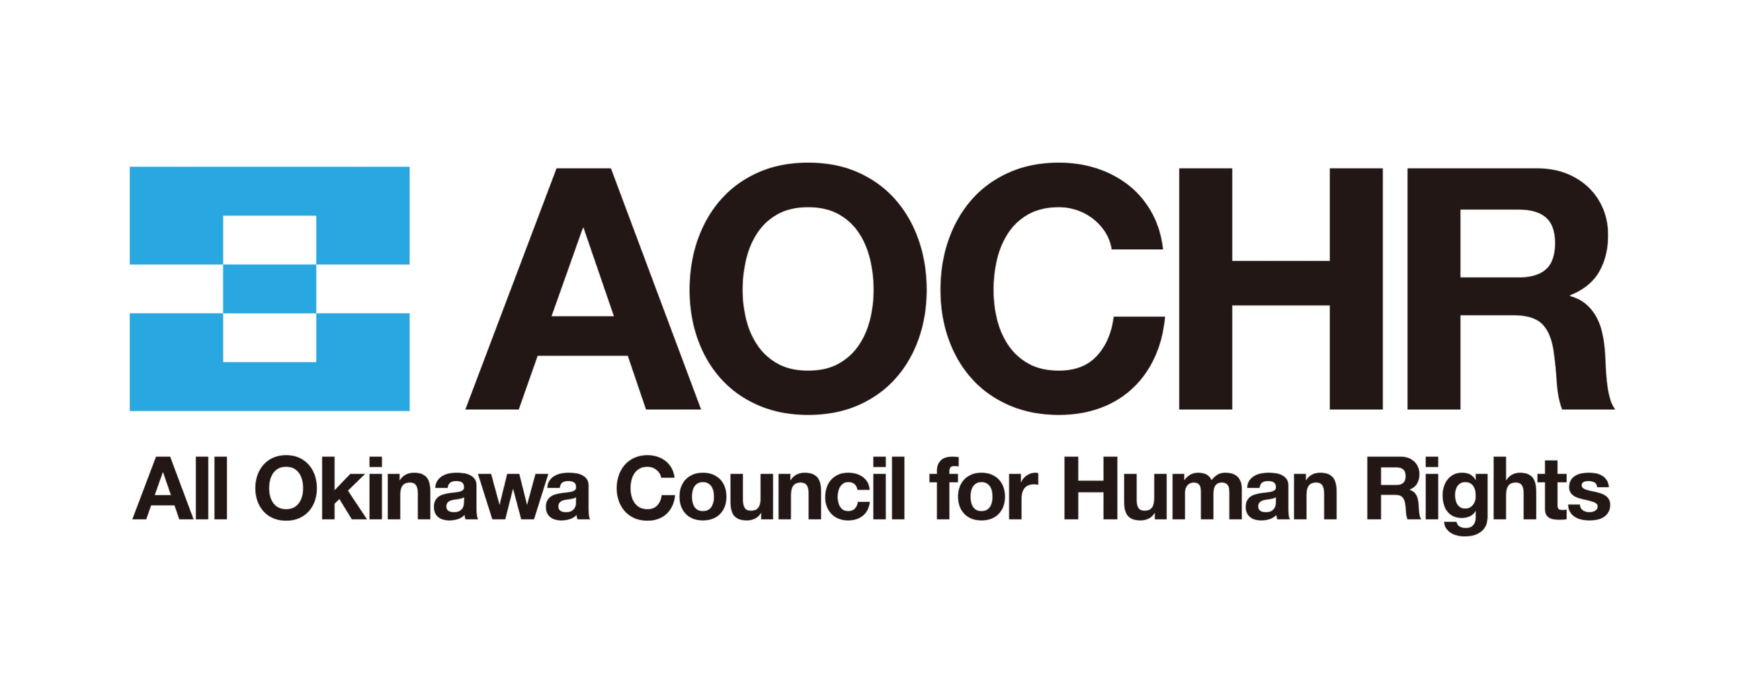
Inputs for the Day of General Discussion
on the Rights of Indigenous Women and Girls

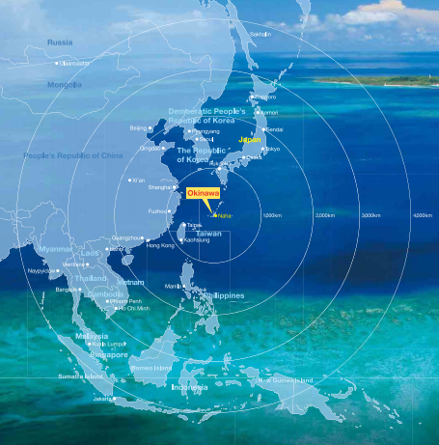
Copyright @ Okinawa prefecture

Background
This submission addresses three major issues faced by Ryukyuan/Okinawan women. Okinawa, now one of the 47 prefectures (administrative regions) in Japan, was once a country called the Kingdom of Ryukyu which was annexed by Japan in 1879 (Ryukyu Disposition). Following the annexation, its languages and culture were banned by the Imperialisation policy of the Government of Japan. Its land was taken and its environment was damaged by Japan’s militarisation policy. At the end of the Pacific War, the islands of Okinawa became the battle fields between the Japanese and U.S. forces. The islands had been occupied and put under U.S. military control until it was returned to Japan in 1972. During the U.S. military occupation, much of its land was seized to construct U.S. military bases. Even after the reversion to Japan, the burden of U.S. military bases has not decreased, and currently about 70% of the U.S. military facilities in Japan are concentrated in Okinawa Prefecture, the small islands prefecture that accounts for only about 0.6% of Japan's land area. In recent years, the deployment of Japan's Self-Defense Forces (SDF) to Okinawa has also expanded rapidly, intensifying a discriminatory situation that has continued for 75 years since the end of World War II, in which numerous problems stemming from militarisation have been disproportionately imposed on Okinawa.
Civil society organisations in Ryukyu/Okinawa appealed to the Government of Japan through the United Nations Human Rights Bodies to recognise the peoples of Ryukyu/Okinawa as indigenous peoples and to respect and protect their rights as indigenous peoples. The UN treaty bodies have repeatedly recommended the Government of Japan to consider recognising them as indigenous peoples. However, the Government of Japan has failed to do so.
This submission provides information on three major human rights problems faced by indigenous Ryukyuan/Okinawan women in Japan.
- Sexual violence: Sexual violence related to the U.S. military presence in Okinawa
- Health hazards: health hazards to mothers and children from military
training by U.S. forces in Okinawa
- Water pollution caused by militarization

1. Sexual violence: Sexual violence related to the U.S. military presence in Okinawa
About a half of all U.S. military personnel in Japan reside in Okinawa (55,026 U.S. military personnel in Japan and 25,843 U.S. military personnel in Okinawa, accounting for 47%).
There have been many incidents and accidents involving U.S. military personnel in Okinawa. In particular, sexual violence against women has been rampant since 1945, the year U.S. forces landed on Ryukyu/Okinawa. It threatens the safety of Ryukyuan/Okinawan women.
During the postwar period of the U.S. military occupation of Okinawa until 1972, rape by U.S. soldiers was rampant. Even after the reversion of Okinawa to Japan in 1972, according to the statistics of the Okinawa Prefectural Police, the total number of criminal offenses committed by U.S. servicemen, servicewomen and their families until September 2020 counted 6,052, of which 581 were heinous crimes such as murder, robbery, rape and arson, and 129 were rape cases. This is only the number of arrests made, and the actual number of incidents is believed to be much higher. Even today, half a century after the reversion of Okinawa to Japan, there is no end to the incidents of sexual violence committed by U.S. personnel in Ryukyu/Okinawa which hosts the largest military base in the Far East.

Due to the Japan-U.S. Status of Forces Agreement, Japan does not have primary jurisdiction over cases involving U.S. military personnel on official duties, and even in cases where an incident occurred outside of official duties, the Okinawa Prefectural Police cannot take the suspect into custody before prosecution and therefore cannot conduct the full investigation. In addition, if the suspect flees to the base, the extradition of the suspect requires the consent of the US military. Since the U.S. military is not obligated to extradite, it is possible for the U.S. military to repatriate suspects so that they will not be tried for their alleged crimes. In fact, according to data from the period of 2001-18, the prosecution rate for criminal offenses committed by U.S. military personnel was 13.17%, which is about one-third of the national over-all prosecution rate of 43.85%. The crimes committed by U.S. military personnel have gone largely unaddressed. In addition, there is a Japan-U.S. Joint Commission agreement that, in principle, Japan will not exercise primary jurisdiction except in important cases, making it difficult for Japan to prosecute even if a case is filed.
In other words, Ryukyuan/Okinawan women suffer from a situation in which not only the sexual violence is rampant, but also the damage is not legally redressed.

The United Nations Declaration of the Rights of Indigenous Peoples (UNDRIP), paragraph 12 of the preamble emphasises the importance of demilitarisation of indigenous peoples' lands and territories, and Article 30, paragraph 1 stipulates the prohibition of military activities on their lands and territories.
CEDAW states in its General Recommendation No. 19 on violence against women (11th session, 1992) that "Wars, armed conflicts and the occupation of territories often lead to increased prostitution, trafficking in women and sexual assault of women, which require specific protective and punitive measures.” The situation in which the U.S. military has been stationed for nearly 80 years since the end of World War II is not a war or under armed conflict, but the prevalence of violence against women by military personnel makes the General Recommendation significantly relevant.
CEDAW also recommends States parties in its General Recommendation No. 30 on women in conflict prevention, conflict and post-conflict situations (2013, 56th session) to " (a) [p]rohibit all forms of gender-based violence by State and non-State actors, including through legislation, policies and protocols; (b) [p]revent, investigate and punish all forms of gender-based violence, in particular sexual violence perpetrated by State and non-State actors; and implement a policy of zero tolerance”. This means that sexual violence committed by the military, a State actor, must be prohibited, prevented, investigated and punished, and a zero-tolerance policy must be implemented.

The Government of Japan promotes disproportionate militarisation on the land of Ryukyu/Okinawa, which not only violates the UNDRIP but also constitutes discriminatory treatment of the indigenous peoples of Ryukyu/Okinawa. In addition, Ryukyuan/Okinawan women continue to suffer from widespread sexual violence and the lack of legal redress under the prolonged military presence. These constitute intersectional discrimination against indigenous women, and the Government of Japan has not taken effective measures to address this intersecting form of discrimination.

The General Recommendation on the Rights of Indigenous Women and Girls should clearly acknowledge that indigenous women and girls are particularly vulnerable to the effects of militarisation, including prolonged military presence, and state the obligation of States parties to develop laws and provide with financial resources to prohibit, prevent, investigate and punish all forms of gender-based violence against indigenous women and girls committed by State and non-State actors, and to implement a zero-tolerance policy.

2. Health hazards: health hazards to mothers and children from military training by U.S. forces in Okinawa
In the vicinity of U.S. military bases in Ryukyu/Okinawa, health hazards, especially to mothers and infants, have arisen due to the effects of noise pollution over the years.
Okinawa Prefecture conducted a four-year survey on the health effects of aircraft noise on residents living near the Futenma and Kadena Air bases from 1995 to 1998. It revealed the adverse effects of aircraft noise pollution on the residents, such as loss of hearing due to years of exposure to noise, an increase in the birth rate of low-birth-weight (LBW) babies, and a large number of infants requiring physical and mental observation.
According to another survey conducted by Okinawa Prefecture, the percentage of LBW babies in Okinawa Prefecture is the highest in Japan at 11%, compared to the national average of 9.4%, while the number of LBW babies is highest in the Okinawa’s Chubu area where the U.S. military bases are concentrated. It has been pointed out that LBW babies often require medical care after birth, and are at high risk for delayed growth and development, disability, and health problems, including in adult life.
Residents living near the Futenma and Kadena Air bases filed lawsuits against the Government of Japan, seeking an injunction order against night-time flights of U.S. military aircrafts and compensation for damages, but in each case, the lawsuit was dismissed on the basis of the "third party act theory”, which stated that the Government of Japan does not have the authority to restrict the actions of U.S. forces.
In addition, in the decision on the appeal of the second Futenma explosive sound lawsuit, the Naha Branch of the Fukuoka High Court acknowledged the health hazards caused by the noise, such as psychological burden, mental anguish, sleep disturbance, and increase in blood pressure due to stress, but it denied the increased risk of ischemic heart disease, increase in LBW babies, decrease in long-term memory of school children, and damage caused by infrasound, stating "no evidence sufficient to admit the facts".
Under Article 24 of the Convention on the Rights of the Child, States parties are required to strive for "the enjoyment of the highest attainable standard of health and [the right] to facilities for the treatment of illness and rehabilitation of health” for children. Considering the impact on maternal health and other specific harms to women’s health, the Government of Japan shall promptly investigate the impact of noise pollution from nighttime military aircraft on the health of mothers and children, and to make the results known.
In its recommendation to the Government of Japan in March 2016, CEDAW expressed concern that indigenous and minority women in Japan are experiencing intersecting and multiple forms of discrimination and urged the State party to make active efforts aimed at eradicating multiple and intersecting forms of discrimination in health, education, employment and public activities and in health and education services.
In addition, CEDAW General Recommendation No. 9 on statistical data concerning the situation of women (8th session, 1989) calls for data that can be “disaggregated according to gender, with regard to both absolute numbers and percentages, so that interested users can easily obtain information on the situation of women in the particular sector in which they are interested.”
The General Recommendation on the Rights of Indigenous Women and Girls should clarify the obligation of States parties to collect disaggregated medical and socio-economic data of indigenous women and girls, and to take necessary measures to ensure that indigenous women and girls enjoy the highest attainable standard of health, based on research into factors that impede health.

3. Water Pollution Caused by Militarization
Organofluorine compounds and other toxic substances used in foam fire extinguishing agents and other products at U.S. military bases have frequently been detected in high concentrations in rivers and wells in the vicinity of Kadena Air Base and Kadena Airfield on the main island of Okinawa. These substances have been pointed out to pose risks such as carcinogenicity, to the health of mothers and children, and to the development of children. Since the high concentrations are found around the U.S. military bases, these bases have been considered as the source of the contamination.
In an April 2019 a research team lead by Akio Koizumi, professor of Kyoto University, conducted a survey of blood levels of organofluorine compounds among residents of Ginowan City, Okinawa Prefecture, where Kadena Air Base is located. The results showed that the levels of PFOS were four times higher than the national average. The blood levels of PFHxS, a toxic organofluorine compound for which international discussions are underway to regulate its manufacture and use, were 53 times higher than the national average.
In April 2020, a massive leak of fire extinguishing foam containing PFOS occurred from the Futenma Air Station. In June of the same year, PFAS was detected in rivers and other areas within the U.S. Kadena Air Base in Okinawa Prefecture at levels up to several hundred times higher than the government's provisional target values.
Although Okinawa Prefectural Government and local municipalities around the U.S. bases have requested the U.S. military and the Japanese government to allow investigations of soil and water quality on the bases, to take measures against soil and groundwater contamination, and to provide the record of the use of fire extinguishing foam agents at Kadena Air Base and Futenma Air Base, the investigations have not been conducted. The rivers and wells around the U.S. bases that have been found to be contaminated by toxic substances are the source of drinking and daily life water for local residents, but sufficient investigation, verification, and information disclosure on the causes of the contamination are left to the discretion of the U.S. military.
Water contamination does not only originate from US military bases. In April of this year, a firefighting foam leaked from the Japan’s Air Self-Defense Force's Naha base on the island of Okinawa. At first, the Air Self-Defense Force (SDF) explained that the leaked foam did not contain organofluorine compounds. However, it later apologized and said that it would correct its initial explanation after it detected the compounds at a maximum of about 128 times the government's provisional guideline value in the fire extinguishing foam recovered at the base.
PFAS has been found to be associated with reduced birth weight, and studies have shown that children born between 1974 and 1993 in areas of Okinawa with PFAS contamination of drinking water tended to have lower birth weights than children born in other areas (Naha and Ginowan cities, where the contamination is found, has a PFAS level of 7.3 %, where 6.4% in other areas).

In addition, the construction and deployment of Japan’s SDF bases is proceeding at a rapid pace on the remote islands of Miyakojima and Ishigakijima in Ryukyu/Okinawa.
Miyako Island has a total area of about 160 square kilometers and a population of about 50,000 people. There is no river on Miyako Island, and the residents solely rely on groundwater for their water needs, including drinking water. For the deployment of the Ground Self-Defense Force in Miyakojima, the Academic Committee of the City Groundwater Council, an advisory body to the Miyakojima Mayor consisted of geology experts, concluded in 2016 that "the construction and operation of the facility is not allowed" in light of the impact of the deployment of the garrison on groundwater sources. However, the base was built without an environmental assessment required by laws and regulations, and 700 personnel, including surface-to-air missile troops, have been deployed there since April 2020.
Ishigaki Island has an area of about 222 square kilometers and a population of about 48,000. In March 2019, construction work began on a garrison for the deployment of Ground SDF missile units on the island. The area around the proposed deployment site is a tributary of the Miyara River, which is a water source for the islanders, but no environmental assessment has been conducted for this construction.

General Comment No.15 (2002) of the Committee on Economic, Social and Cultural Rights sets out three criteria for water: availability; quality; and accessibility. Availability means that the supply of water is continuous for individuals and households; quality means that the water is free of chemicals and does not pose a threat to human health; and accessibility means that the water is physically and economically accessible to all people. It also states that the State must provide resources to indigenous peoples to enable them to manage their access to water. CWDAW General Recommendation No.24 stipulates that the State party is obliged to take appropriate measures to ensure adequate living conditions, including water supply.
Despite serious risks to their health and children, Ryukyuan/Okinawan women are prevented from accessing quality water that is free of chemicals, as well as from accessing information on water safety, and urgent action is needed.

The General Recommendation on the Rights of Indigenous Women and Girls should also acknowledge the responsibility of States parties to ensure that indigenous women, mothers and girls have access to safe and quality water and information on its safety.

E/CN.4/2006/16/Add.2, para 6
CERD/C/JPN/CO/7-9, para 21, CERD/C/JPN/CO/10-11 para 17, CCPR/C/JPN/CO/5, para 32, CCPR/C/JPN/CO/6, para 26.
Please note these are reference figures. The number of U.S. troops stationed in Japan is as of March 31, 2018, and that in Okinawa is as of June 30, 2011, which is a different time point. These are the latest officially released figures.
Interview s with women have revealed that incidents of rape and sexual violence against women by U.S. servicemen have been occurring since the U.S. military landed on Ryukyu/Okinawa in 1945 during World War II (Battle of Okinawa). See also NGO report. 2016. Okinawa Beihei ni yoru josei heno seihanzai 沖縄・米兵による女性への性犯罪. Okinawa
Okinawa Times (21 Oct 2020), In Okinawa heinous crimes by US military personnel counts 581, case detected counts 6052 - since reversion to Japan, available at: https://www.okinawatimes.co.jp/articles/-/650949
In 1955, an Okinawan girl of elementary school age was assaulted and killed by a US soldier and her body was dumped; in 1995, three US soldiers sexually assaulted an Okinawan girl; and in 2016, a 20-year-old Okinawan woman was assaulted, killed, and dumped by a former US military man.
Okinawa Times (10 Feb 2020), Low Prosecution Rate for Criminal Offenses Related to U.S. Military: Expert Says Japan's Secret Agreement to Give Up Jurisdiction is Alive, available at: https://www.okinawatimes.co.jp/articles/-/532799
A/47/38, para16
CEDAW/C/GC/30, para 38.
Okinawa prefectural Government (2018), U.S. Bases in Okinawa, available at: https://www.pref.okinawa.jp/site/chijiko/kichitai/documents/3syou1.pdf .
Okinawa prefectural Government (2008), Maternal and Child Health in Okinawa Prefecture (2008) 3. Maternal and Child Statistics in Okinawa Prefecture from a National Perspective (2008), available at: https://www.pref.okinawa.jp/site/hoken/chiikihoken/boshi/documents/syunaru.pdf
Okinawa Times (17 Apr 2019) Editorial: Ruling on Futenma explosive sound lawsuit: Relief for residents' a big step backward, available at: https://www.okinawatimes.co.jp/articles/-/409867
CEDAW/C/JPN/CO/7-8
A/44/38.
Perfluorooctane sulfonate
Perfluorohexane sulfonate
Mitchell, J et al., ジョン・ミッチェル. 2020 Eien no kagaku busshitsu mizu no PFAS osen永遠の化学物質 水のPFAS汚染. Tokyo: Iwanami Shoten. p 61.
Okinawa Times (8 Apr 2021), PFOS detected in foam spilled from Air Self-Defense Force base in Naha, also detected in nursery school, available at https://www.okinawatimes.co.jp/articles/-/734543
Supra note 17, p 68.
E/C.12/2002/11, para 12.
Ibid. para16
A/54/38/Rev.1, chap. I, Para 28

