Sixty-Third session of the Commission on the Status of Women

SIDE EVENT
Co-organised by CEDAW and UNWOMEN

“Women’s Rights and the 2030 Agenda:
40 Years of Empowering Women with a View of Sustainable development
UNHQ, New York, 18 mars 2019

Statement by Ms. Cristina LUNGHI
President Arborus NGO

Gender international certification « GEEIS » become « GEEIS-SDGs »

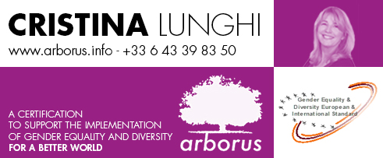

I would like to thank the United Nations for giving me the opportunity to present the launch of a new tool that brings together gender equality and sustainable development goals.

I am pleased to present our initiative which is a way of cooperation with the private sector not only to ensure sustainable economic growth but also to integrate women’s rights !

I want, we want with companies, more!

We want to make gender equality as the pillar of the change and of the SDGs.

To start a better world for us and for our children.

Our philosophy has been since the creation of Arborus in 1995, to make equality between women and men the driving force behind the change in organizational systems that are driven by the principle of male domination.

It is only through this transformation of systems that we can transform behaviours.

My organisation, Arborus, has launched in 2010 an international gender equality certification, which is called GEEIS (Gender Equality European & International Standard).

Very big companies, such as DANONE, as well as very small ones, like for instance a small company in Turkey, CAMFIL, are certified in 37 countries.

We have almost 200 entities certified worldwide. They have all signed the global compact and the WEPS in particular. They of course respect international regulation on equality.

With the GEEIS certification, companies are in progress, with specific process, to implement gender equality in all fields, at all levels.

Arborus, has a very strong philosophy about the issue of gender equality. We are convinced, that we need to change paradigm: to change the old world of male domination to have a more balanced society.

We are convinced that without gender equality, nothing right is possible. Therefore, gender equality is the first step for any progress.

But at the same time, we are very aware that our planet is in danger.

The GEEIS is not only a tool that guides companies in their equal opportunities policy, but it conveys a positive, forward-looking message, to build together a better world respectful of women and men, as well as the earth, and to prepare a world of peace for future generations.

This standard carries the image and the fundamental values ​​from which they come, and also the SDGs, which are an integral part of today's business thinking.

So GEEIS, which is in line with Goal 5 of the SDGs, will integrate some of the SDGs objectives, in particular objectives 1, 8 and 10.

This action is very important because, it goes beyond the Human Resources and Business Management processes. It is part of a partnership with countries where our companies are located.

Therefore, we are very proud to announce today, a new challenge for companies, which is the GEEIS-SDGs trophy, which will be deliver in September for companies that are committed to goal 5 of course, with the GEEIS certification, and to the SDGs.

A way to collect best practices.

To show and share.

A way to start a network in the US of companies to work together, with the United Nations.

I would like to welcome the presence of Diana Gutierrez, from UNDP, who is one of the members of our jury.

Ms. Anne Claire Berg, from DANONE will illustrate all this in a very pragmatical way.

