Human Rights Committee General Comment No. 37 on the right of peaceful assembly, article 21 of the ICCPR

Frequently asked questions

The Human Rights Committee adopted General Comment 37 on the right of peaceful assembly under article 21 of the ICCPR on 23 July 2020. The General Comment is available here. The press release is here. This note prepares some frequently asked questions concerning the General Comment and its elaboration of the right of peaceful assembly.
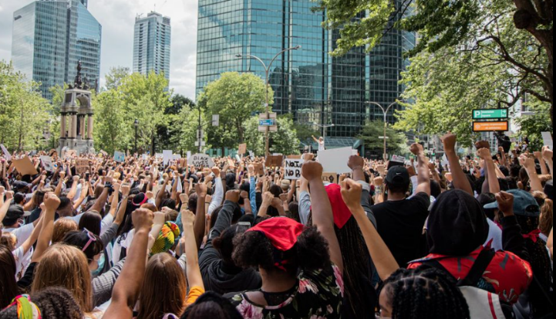
Why protect the right of peaceful assembly?

The rationale for protecting the right of peaceful assembly is that, along with other key rights, it constitutes the very foundation of a system of participatory governance based on democracy, human rights, the rule of law and pluralism. Indeed, a failure to respect and ensure the right of peaceful assembly is typically a marker of repression.

What kind of activities does the right of peaceful assembly protect?
The right of peaceful assembly protects the non-violent gathering by persons for specific purposes, principally expressive ones. The right protects assemblies wherever they take place: outdoors and indoors, offline and online; in public and private spaces; or a combination of any of these.

For participation in a peaceful assembly to fall within the scope of the right, two elements must be present:

- Assembly - there must be more than one person gathered for a specific purpose for participation to be protected. Standing in line at a bus stop is not covered by the right, but having lunch with others is. The purpose of the gathering will often be expressive, but that is not a requirement. On-line assemblies (remote participation) and assemblies in private spaces are also protected.
- Peaceful – only peaceful participation in an assembly is protected. An assembly is presumed to be peaceful. An assembly can still be peaceful even if there are isolated acts of violence by some participants. However, an assembly is no longer ‘peaceful’ if there is widespread and serious violence. In the absence of actual violence, the assembly might be ‘deemed violent’ when there is credible evidence that participants 1) have the ‘intention’ to be violent, 2) where they ‘incite’ violence, or 3) where violence is ‘imminent’.

What do States have to do regarding peaceful assembly?

States must respect and ensure peaceful assemblies. This has a negative component – the authorities must not ‘unduly interfere’ with such assemblies. In some instances it may also have a positive component – the authorities must ‘facilitate’ assemblies (in other words, make them possible, for example by blocking off the traffic on streets where a march as held) and ‘protect’ participants (including against potentially violent counter-assemblies). These obligations must be undertaken without discrimination.

When do these obligations apply?

States have to respect and ensure peaceful assemblies during the actual assembly, but also before and after the event. For example, protections cover the organising and advertising of an assembly, including through social media.

Can State authorities restrict the right of peaceful assembly?

Yes. The authorities can restrict peaceful assemblies through measures that are provided for by law, if such measures are also necessary and proportionate, and are taken in pursuit of one of a limited number of accepted grounds, such as the protection of the rights of others. Importantly, the onus of justifying any restrictions is on the authorities, not on the participants in the assembly.

Some important factors to bear in mind:

- Any restriction must be content-neutral – in other words, the authorities should not treat assemblies differently simply because of what participants are saying or because of the relationship between the organisers and the authorities;
- Any restrictions on the time, place or manner of assemblies should give due consideration to the sight and sound principle – in other words, participants should as far as possible be allowed to convey any message they wish to convey to their target audience.
- The mere fact that an assembly might be unpopular, or cause some disruption, are not grounds to restrict it.

Does the right of peaceful assembly protect assemblies in private spaces?

Yes, the right to peaceful assembly protects assemblies in private spaces. However, the rights of others in the private space - such as the owners of shopping malls, or of the land where assemblies are held - must also be given due weight. A number of considerations should be taken into account to balance these competing interests. This includes whether the spaces are normally accessible, whether participants have been given permission to conduct assemblies there, and whether the purpose of the assembly is to contest the rights claimed over the space.
Can participants in peaceful assemblies be anonymous?

Yes. For example, the wearing of face-masks is possible. An exception is where the conduct of a person participating anonymously would be a reasonable grounds for arrest or where there may be other compelling reasons to ban a particular kind of face covering. An example would be the wearing of Ku Klux Klan hoods as the hood is a symbol of hate. Increasingly important is the fact that on-line anonymity is also protected.

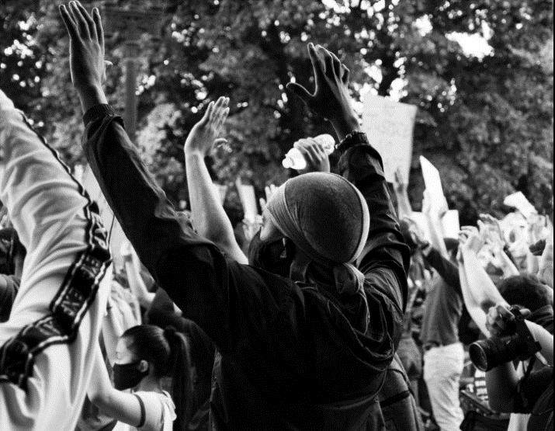
Do participants in peaceful assemblies maintain their right to privacy?

Yes. The mere fact that a particular assembly takes place in public does not mean that participants have forfeited their right to privacy. For example, facial recognition and other technologies used to identify participants in a crowd might infringe the participants’ right to privacy.

Are the organizers and participants of assemblies accountable for injuries or damage caused during the assembly?

In general, organisers and participants may be held accountable only for injuries of damage caused by their own unlawful conduct. In exceptional cases, organizers might be held accountable for injuries or damages that they did not cause where they could reasonably have foreseen and prevented it.

Do organizers have to ask for permission or notify the authorities of peaceful assemblies?

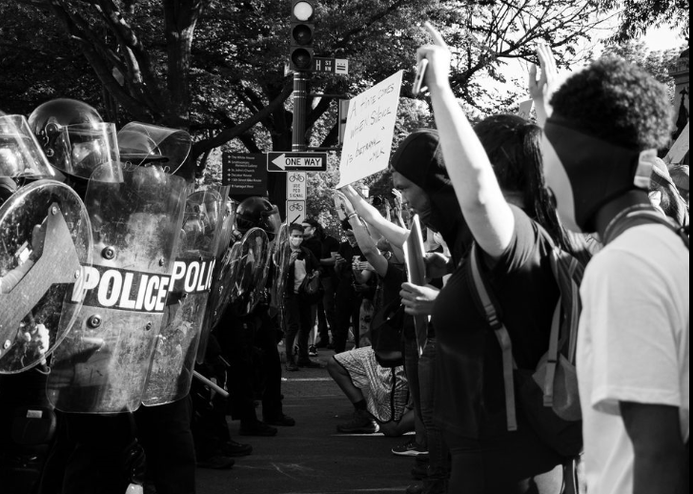
In general, a requirement to apply for permission from the authorities undercuts the idea that peaceful assembly is a basic right and is not permissible. However, in some instances the authorities may require notification of pre-planned assemblies, for example to help the authorities facilitate the smooth conduct of the assembly. Notification should not be required as a rule, and any notification must be free of charge.

How must law enforcement officials approach assemblies?

Law enforcement officials involved in policing assemblies should aim to facilitate peaceful assemblies where necessary. Law enforcement officials should plan operations with the aim of enabling the assembly to take place as intended while minimizing the potential for injury or damage.

Can law enforcement officials use force during an assembly?

Yes, the use of force is possible if a legitimate law enforcement purpose justifies it. However, even then, the use of force must be only the minimum force necessary in order to de-escalate the situation. Once the need for any use of force has passed, such as when a violent individual is safely apprehended, no further resort to force is permissible. Law enforcement officials may not use greater force than is proportionate under the circumstances to disperse an assembly, prevent a crime or to pursue the lawful arrest of offenders.

Which law enforcement officials can police assemblies?

Only law enforcement officials trained in the policing of assemblies, including on the relevant human rights standards, should be deployed for that purpose. The military should in general not be used to police assemblies. All law enforcement officials responsible for policing assemblies must be suitably equipped, including where needed with appropriate and fit-for-purpose less-lethal weapons and protective equipment.

Can law enforcement officials take preventive measures in the context of assemblies?

Law enforcement officials may use preventive detention only in the most exceptional cases, for no longer than is absolutely necessary, and only where the authorities have proof of the intention of the individuals involved to engage in or incite acts of violence.

Law enforcement officials may stop and search participants only if they have a reasonable suspicion of the commission or threat of a serious offence. They must apply stop and search powers without discrimination.

They may also rely on containment – the encirclement of a group of participants – when it is necessary and proportionate to do so, in order to address actual violence or an imminent threat of violence from that group.

Can law enforcement officials disperse assemblies?

Law enforcement officials may disperse an assembly only as an extreme measure where the assembly is no longer peaceful, or where an imminent threat of serious violence cannot be reasonably addressed less intrusive measures such as targeted arrests. Domestic law must set out the conditions for dispersing assemblies and only a duly authorised official may order a dispersal.

Can law enforcement officials use firearms to police assemblies?

Firearms are not an appropriate tool for the policing of assemblies, and must never be used simply to disperse an assembly.

May plainclothes law enforcement officials police assemblies?

Any deployment of plainclothes officers in assemblies must be strictly necessary in the circumstances. Before conducting a search, making an arrest, or resorting to any use of force, plainclothes officers must identify themselves to the persons concerned.

Does the right of peaceful assembly apply during states of emergency and armed conflict?

The State may derogate from the right of peaceful assembly during a properly declared state of emergency. However, the ordinary restrictions on the right of peaceful assembly referred to above should usually be sufficient to allow people to continue to enjoy the right.

During an armed conflict, the use of force related to participants in assemblies remains regulated by the rules of law enforcement. Civilians in an assembly are protected from being targeted under the rules of international humanitarian law unless and only for such time as they take a direct part in hostilities.

*******

