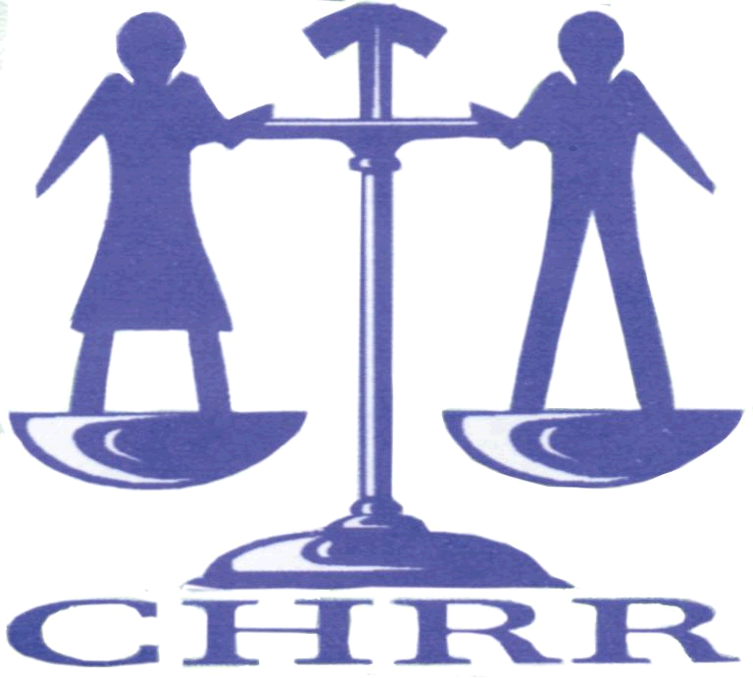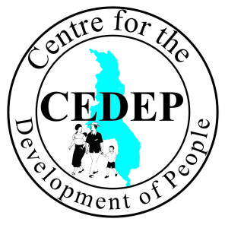
25/06/2015
General discussion on article 6
Introduction
The Centre for the Development of People (CEDEP) is a registered human rights HIV/AIDS organisation under the Trustees Incorporation Act of 1962 in Malawi.The organisation was established in November 2006 in order to address the needs and challenges of minority groups in Malawi in the context of human rights, health and social development. Such minority groups include Lesbian, Gay, Bisexual and Transgender (LGBT), Prisoners and Sex workers whose rights are often neglected.
The Centre for Human Rights and Rehabilitation (CHRR) is one of Malawi’s leading human rights non-governmental organizations. It was founded in 1995 as a non-partisan non-profit making organization registered under the Trustees Incorporation Act of 1962. CHRR’s vision is of a Malawi with a vibrant culture, which embraces the values of democracy, human rights and gender equality.
CHRR and CEDEP would like to contribute to the discussion on the topic above regarding Article 6 of the International Convention on Civil and Political Rights (ICCPR). Article 6 (1) states that: Every human being has the inherent right to life. This right shall be protected by law. No one shall be arbitrarily deprived of his life. CEDEP and CHRR express grave concern about the abuse and violations perpetrated against LGBTI persons in Malawi. Much as the government of Malawi has included key population in the National HIV strategic plan for 2015 to 2020 and accepting the 2 recommendations on the LGBTI persons at the UPR May session. CEDEP and CHRR expresses concern in the public health service. The public health service providers use language that encourages violations among LGBTI persons when accessing health services. This discourages LGBTI persons from accessing services. For example in Malawi a young gay man lived with a Sexual Transmitted Infection (STI) which later turned cancelers and the person died, this was amid times when another gay man got arrested when he attempted to seek medical care due to an STI that he had. As a result of this incident, the health seeking behavior of many gay men was reduced.
The General Comment should affirm the link between right to life and Article 6 recognizing the obligation under Article 6 to realize the right to health, the right to equality and non-discrimination with special attention to sexual orientation and gender identity and expression (SOGIE).
Emma Kalea –Gender Coordinator (CEDEP)
Dunker Kamba –Programmes Officers (CEDEP)
Michael Kaiyatsa –Research and Training Coordinator (CHRR)

Honduras Recommendation: Guarantee that people of the LGBTI communities have effective access to health services including treatment for HIV/AIDS. Austria Recommendation : Take effective measures to protect LGBI persons from violence and prosecute the perpetrators of violent attacks.

