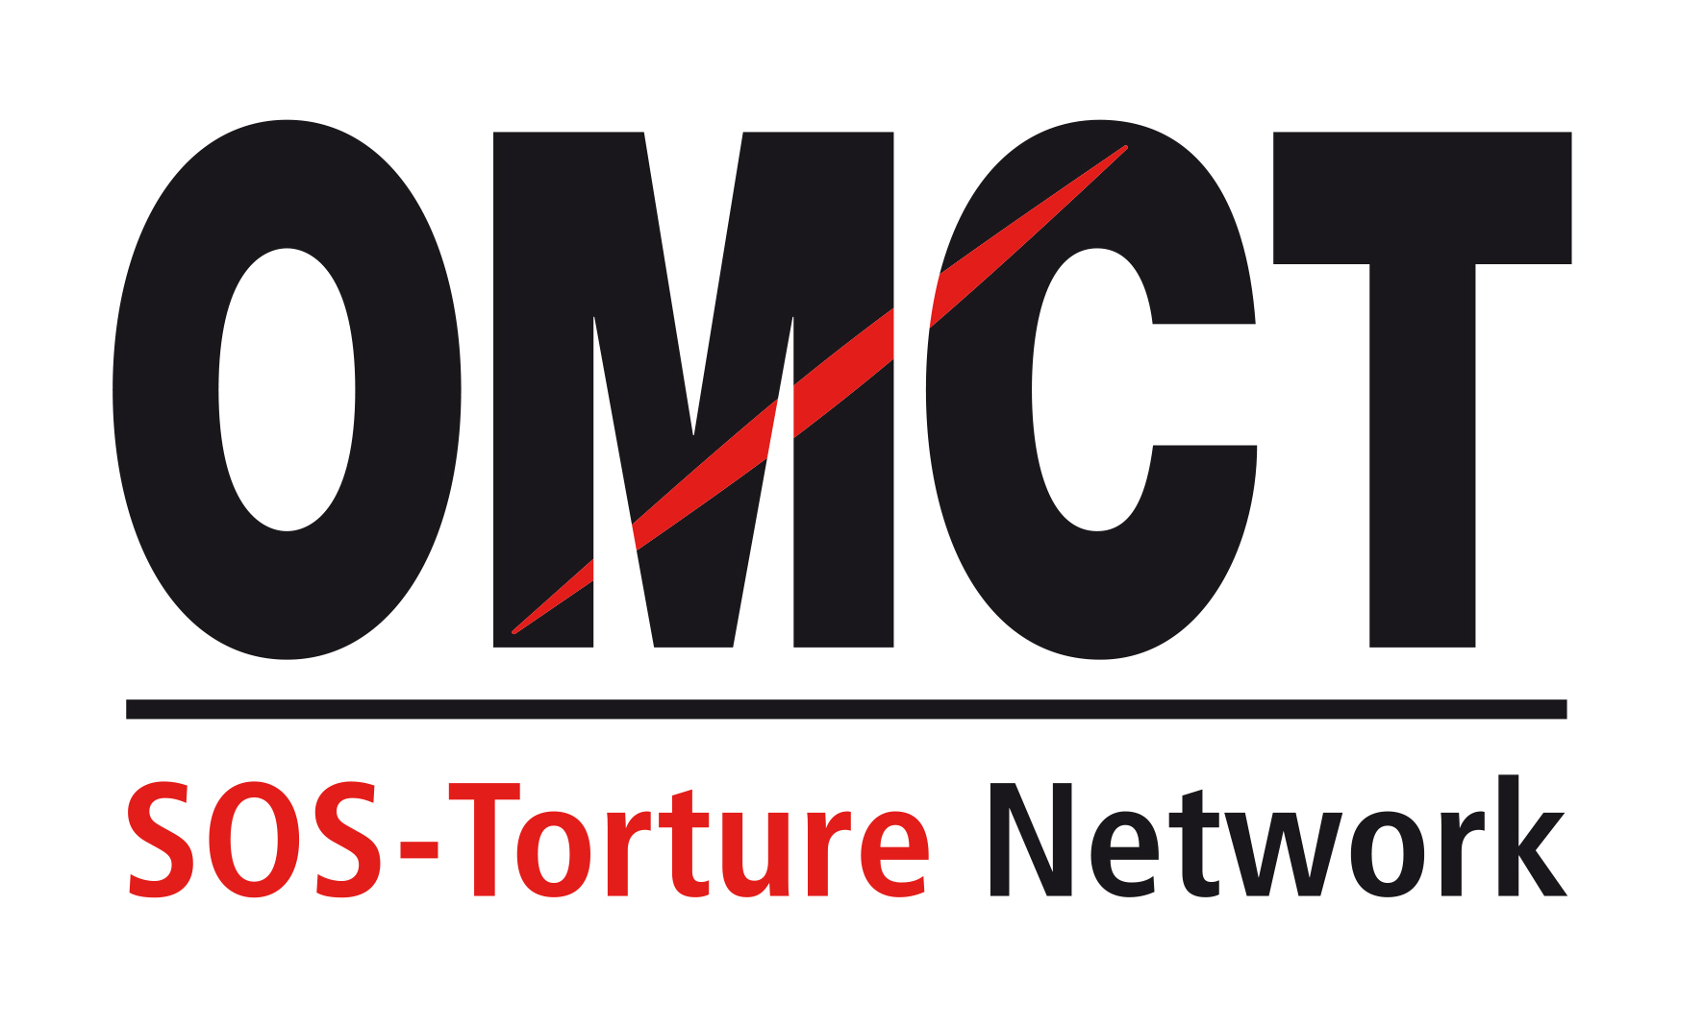

73rd CAT session

19 April – 13 May 2022
Confirmation of attendance for in-session NGO briefing

Please return this form to the OMCT at cat@omct.org before 5 April 2022.

State concerned

Name of State

Alternative report
Title
Author(s)
Short summary
(50 to 100 words)

NGO presenting the report
Name of NGO
Address
Country
Telephone / fax
Email

Person(s) attending
Surname /Name
Email
Telephone/Mobile
Surname /Name
Email
Telephone / Mobile

Principal issues of concern to be raised before the Committee against Torture
Principal issue 1
Principal issue 2

Your recommendation(s) for the follow up procedure

