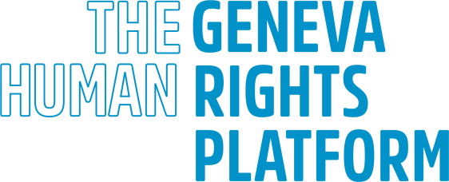

Submission by the Geneva Human Rights Platform to the 33rd Annual Meeting of Chairpersons of Human Rights Treaty Bodies

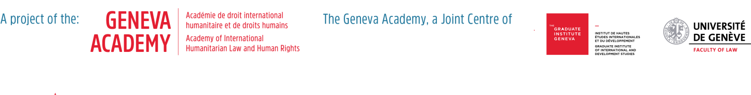
Distinguished Treaty Body Chairpersons,

We are grateful for this opportunity to present our considerations in light of the recently concluded 2020 Treaty Body Review, a process that we have carefully followed since its inception in 2014. The Academic Platform on Treaty Body Review 2020 has represented a great example of linking academia to the different Committees as well as the useful resource that independent academic thinking can bring to the strengthening and consolidation of the Treaty Body system’s work.

2020-2021 has not been an easy year and regardless of the many obstacles the different Committees have faced, creative solutions were found by the actors within the TB System. We wish to congratulate all treaty body members, as well as the OHCHR Secretariat, for having been able to keep up the work and achieve even some improvements towards a more aligned set of working methods and experimenting the benefits and limits of a digital shift in their working methods.

More specifically, the GHRP wishes to congratulate the Chairs of the treaty bodies on the following beginning improvements made to the system and encourage them to reinforce them:

- Firstly, introducing a coordinated schedule of country reviews, with Covenant Committees reviewing review countries on an 8-year cycle as well as synchronizing the timing of their reviews and the Convention Committees planning to reviewing countries on a 4-year cycle, or as provided by each Convention. The decision to have each review take place as scheduled irrespective of whether a report has been submitted represents an important step towards ensuring the regularity of reviews as provided for in the treaties. Further substantive coordination in LOIPRs and back-to-back reviews could be additional benefits of such a fixed calendar.

- Secondly, aligning as much as possible their interaction with national stakeholders, including national human rights institutions, national preventive mechanisms, non-governmental organizations and others;

- Thirdly, aligning the follow-up procedure according to the process previously endorsed by the Chairs in the procedures of the human rights treaty bodies for following up on concluding observations, decisions and views (see HRC/MC/2018/4).

Such improvements, as stated in the Vision paper, “aim to focus, coordinate and streamline the reporting process and the dialogue [and] will facilitate enhanced interaction between States parties and other stakeholders and the treaty bodies”.

One additional improvement to the TB system has been proposed by different constellations of stakeholders of the review process, namely the review in regions. This has been a concept that dates back to at least 20 years, when our very much-missed Professor Christof Heyns published the first edition of his book on the Impact of the Treaty Body System in 2001. Since then, the idea to get the TB system closer to the people resurfaced numerous times.. The most recent TB-specific development - the Committee on the Rights of the Child’s extraordinary meeting in the Pacific island state of Samoa in March 2020 - has shown the many benefits of engaging on regional level.

The 2020 Review process has in essence confirmed the trend, with more than 40 between State and national stakeholders submitting their input to the co-facilitators report being in favour of conducting treaty body sessions at regional or national level (12 States, 31 stakeholder submissions). Among these is the Submission concerning the process of the consideration of the state of the UN human rights treaty bodies system: Opportunity of reviews in countries or in regions (6 July 2020) co-signed by 22 sitting Treaty Body members. The Position paper of the Chairs of the human rights treaty bodies on the future of the treaty body system also included one specific paragraph to this regard:

All treaty bodies agree that there are considerable benefits in conducting dialogues with States parties concerning their reports at a regional level, and that this option should be offered to States on a pilot basis by those Committees wishing to do so, with a view to permanent implementation. Such dialogues may be conducted by a delegation of the treaty body, with concluding observations being adopted by the Committee as a whole.

The co-facilitators of the 2020 Review (Morocco and Switzerland) included in their final report a whole section on Reviews in Region, acknowledging

69. the positive value of introducing reviews in the region as an important step towards increased domestic stakeholder accessibility, enhanced visibility of the treaty body system and closer interaction with national and regional human rights system. Therefore, the co-facilitators encourage treaty bodies’ engagement with UN Member States at regional level.

In short, the possibility that the treaty bodies will on occasion act outside the UN headquarters presents an opportunity to give the treaty system greater visibility and to foster a stronger sense of universal ownership of the system over time, also in the South, and as such to strengthen the system and to contribute towards its long-term sustainability and impact.

The above-mentioned 22 Treaty Body members submission stated one year ago that the time was not ripe to endorse a specific approach, but rather to recognize the positive role that such meetings can play, leaving the exact modalities of such a system open to evolution over time. The current global situation is certainly not conducive to any system that entails global travelling, but in a year the situation may be very different. A flexible approach is thus required, which allows for some experimentation and piloting. And the time is now certainly ripe for this.

To conclude, the GHRP commends the Chairpersons for their great efforts during this challenging year and remains ready to collaborate and engage further on all the above issues, such as piloting Focused Reviews that may be of help towards a stronger and more interconnected TB system, including with its many different national stakeholders.

Annex: Overview Focused Review Project

We have developed a comprehensive concept note on a project for piloting the Focused Review. In a nutshell this would include the steps outlined below. While waiting for it to become part of the official review cycle, we hope that an informal piloting, in collaboration with the Treaty Body Chairs and Members, could yield useful insights and examples.

Practical Steps

- Identification of recommendations under the focused review: based on the latest recommendations issued by the participating TBs, a limited number of recommendations will be chosen for the focused review (e.g. recommendations for follow-up, other specific COBs identified by State, other specific COBs identified by TB members delegation). To avoid thematic repetition, recommendations from the different TBs will be coordinated;
- Development and submission of the focused review questionnaire: based on the identified recommendations, the pilot organizers will develop a questionnaire aimed at identifying the steps taken by the State concerned towards their implementation as well as the needs/capacity necessary towards their implementation. Such questionnaire will be submitted to the State, as well as to all other national stakeholders, inviting them to report on the status of implementation of the recommendations;
- Preparation of the focused review session: based on the written input/reply to the questionnaire by both the State and other national stakeholders, the TB members delegation, supported by the pilot organizers, will prepare the focused review session;
- The focused review session: based on the input/reply to the questionnaire, the one/two day hybrid dialogue with the State (taking place in the national capital, in Geneva or online) will last for 3 hours per session and be preceded by a 2 hour session with civil society actors and national stakeholders;
- Preparation of recommendations / report: based on the information received during the focused review session, the TB members delegation will draft a report on the current status of implementation of the selected recommendations, with the identification of concrete steps to fully implement the selected recommendations in a timely manner. This informal report will be made available to the plenary of each TB concerned to inform the drafting of the subsequent LOIPR. From a State perspective, this informal report will feed into the replies to follow-up recommendations and the subsequent review cycle of the TB concerned. Once the focused review would be part of the official reporting cycle, this outcome would take the shape of concluding observations.

