Report of a Mission of the United Nations High Commissioner for Human Rights – accounts of Congolese fleeing the crisis in the Kasai region, in the Democratic Republic of the Congo

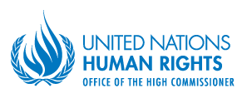Contents

*Page*

1. Executive summary 3
2. Methodology 4
3. Context 5
4. Main findings.... 7

A. Human rights violations by State security forces 8

*Extra-judicial killings* 8

*Violations of the right to physical integrity/rape* 9

*Arbitrary arrests, illegal detentions and other violations to the liberty and security  
 of the person* 9

*Destruction of property* 9

1. Human rights abuses by the Bana Mura militia 10

*Summary killings* 10

*Mutilation and other injuries* 12

*Sexual and gender-based violence* 14

*Destruction of property* 14

1. Human rights abuses by the Kamuina Nsapu militia 14

*Summary killings* 15

*Use and recruitment of children* 16

*Destruction of property* 16

1. Conclusion and recommendations 16

Annexes

1. Map - Kamonia territory and the rest of the Kasai region 19
2. Map of satellite detected fires and destruction within Kamonia territory during the period  
   under review 20

I. Executive summary

1. From 13 to 23 June 2017, the High Commissioner for Human Rights deployed a team of human rights officers to Angola to interview refugees who had fled violent attacks launched between 12 March and 19 June 2017, on different villages of Kamonia territory, Kasai province, in the context of the ongoing crisis in the Greater Kasai region, in the Democratic Republic of the Congo (DRC). The United Nations Human Rights Office (OHCHR) is grateful to the Government of Angola for access and all cooperation provided to the team.

2. The crisis currently affects the provinces of Kasai, Kasai Central, Kasai Oriental, Lomami, Kwilu and Sankuru. Human rights violations and abuses were committed against civilians by DRC Government armed forces and pro-Government militia – the Bana Mura – and by an anti-Government militia – the Kamuina Nsapu - during attacks on villages, that were often launched along ethnic lines. The violence has caused thousands of victims since August 2016 and MONUSCO identified at least 80 mass graves as of July 2017. According to the office of the United Nations High Commissioner for Human Rights (UNHCR), approximately 30,000 people fled the Kasai to Angola between April and 22 June 2017 while 1.3 million people were internally displaced.

3. Based on its interviews with 96 refugees in Angola, the OHCHR team confirmed that human rights abuses and violations had been committed against at least 282 victims, including 113 women and 68 children, by parties involved in the ongoing crisis in the Kasai, including the Kamuina Nsapu and the Bana Mura militia, as well as state agents, mainly FARDC soldiers, in the context of operations to fight the Kamuina Nsapu insurrection. Human rights violations and abuses included 251 victims of summary or extra-judicial killings, 17 victims of mutilations and other injuries, nine victims of abductions, four victims of rape and one victim of arbitrary arrest. Of the 68 children affected, 62 were killed, including 30 who were less than eight years old. OHCHR also received reports of incidents of widespread looting and destruction or burning of property and parts of villages. The Bana Mura militia were responsible for 171 victims (150 killed), the Kamuina Nsapu militia for 86 victims (79 killed) and FARDC soldiers, in collaboration with other State agents, for 25 victims (22 killed).

4. A crisis that had started in August 2016 as a dispute over chieftaincy and traditional rights between the Kamuina Nsapu militia and the Government of the DRC has evolved, as of April 2017, taking on a more pronounced ethnic dimension, with attacks that were well planned and systematic and targeted the population of several villages of Kamonia territory, in Kasai province. Local State security and defence agents, as well as traditional leaders, supported and, on occasions, led the Bana Mura militia in fighting the Kamuina Nsapu insurrection, acting outside the framework of their functions and mandated roles. Interviewees indicated that local security forces and other officials started organizing and using Tchokwe, Pende and Tetela members of the population to conduct targeted and well-planned attacks against the Kamuina Nsapu – mainly composed of individuals of Luba and Lulua ethnicity - as well as against Luba and Lulua communities living in villages which the militia had occupied or threatened to occupy. The Kamuina Nsapu militia were responsible for launching attacks on State symbols and officials, as well as on individuals suspected of practicing sorcery, and for the recruitment of a large number of children into their ranks.

5. The human rights violations and abuses presented in this report constitute criminal offences under DRC criminal law and may amount to crimes under international law. The nature and scope of some of the violations and abuses presented in this report may amount to crimes against humanity if brought before a competent tribunal.

6. The report also raises several recommendations to the Government of the DRC, including on the need to conduct prompt, transparent and independent investigations to establish responsibility for the serious crimes committed in the Kasai region; to ensure that all militia are promptly disbanded; and to ensure that State security and defence forces deployed in the region are duly trained and equipped to protect the civilian population and have not been involved in human rights violations. The report could also provide a basis for upcoming investigations in the Kasai region, including by the team of International Experts mandated by the Human Rights Council, in its Resolution 35/33 of 22 June 2017.

7. The crisis in the Kasai region is unfolding within the context of an increasingly unstable political environment at the national level, which may lead to the indefinite postponement of the presidential elections, based on security grounds. In this context, the declaration by the President of the National Independent Electoral Commission (CENI), on 7 July, that national elections will not occur before the end of the year due to the insecurity in the Kasai region, and the call of the youth league of the ruling party - *Parti du peuple pour la reconstruction et la démocratie* (PPRD) - on 15 July 2017, for President Kabila to impose a state of emergency, are worrisome developments. Urgent actions aimed at preventing a further outbreak of violence are deemed critical in this context.

II. Methodology

8. The team gathered accounts of incidents that allegedly took place from 12 March to 19 June 2017. Given the ongoing violence and difficult access to areas and victims affected by the crisis in the DRC - mostly due to security concerns - the interviews were carried out with individuals who fled the country to Angola from mid-March 2017. Dates in the report are sometimes approximations, since many refugees provided vague time references and their perception of time was often affected by their traumatic experience. The team interviewed a total of 96 refugees living in two registration centres of Lunda Norte, namely Cacanda and Mussungue centres, or staying with host families in the Lunda Norte capital of Dundo. The OHCHR team also interviewed all refugees being treated in the hospital “Centralidade David Bernardino”, in the outskirts of Dundo, and in the “Josina Machel” hospital in Luanda.

9. Of the 96 refugees interviewed, 66 were men and 30 were women. The majority of those interviewed were of the Luba and Lulua ethnic group. These communities were most affected by the violence in Kamonia territory in the period under analysis. OHCHR also interviewed Tchokwe and Pende refugees, who lived mostly in host communities among fellow Tchokwe and Pende of Angolan nationality. All the refugees fled from different villages of the Kamonia territory, in Kasai province, close to the Angolan border.

10. The interviews were conducted in secluded areas so as to guarantee the confidentiality of the identity of the sources. Gender-sensitive investigation methods were used including by giving the option to female victims of sexual violence of being interviewed by female members of the team. Most refugees were eager to be interviewed, and in some case pleaded to be heard so that the violations and abuses committed against them and their families could be documented and those responsible held accountable. There were no reports of protection concerns amongst the refugees partly because the different ethnic groups were in different locations (the Lulua and Luba had chosen to stay in the registration centres while the Tchokwe and Pende mostly stayed with host communities) and therefore the two groups had little interaction.

11. Photographic evidence was taken of mutilations and wounds including injuries from firearms, machetes, knives and burns. Some of the photographs are inserted in this report. UNITAR-UNOSAT[1] satellite imagery of some areas where the alleged destruction by fire took place were used to design the maps in the annexes that provide visual evidence of the level of systematic destruction of property that followed some of the attacks. The actual number of violations and abuses may be much higher than those documented in the report since the team was unable to corroborate some serious allegations given the time limits for the investigation and the inability to visit areas where the violations and abuses had occurred. For example, several witnesses reported having seen corpses piled up and/or buried in graves, which the OHCHR team was not able to corroborate.

III. Context

12. The situation in the Kasai region deteriorated significantly during 2016 following a conflict over chieftaincy between the central Government of Kinshasa and supporters of the traditional leadership system[2]. In April 2016, the refusal of the central authorities to recognize Jean-Pierre Mpandi – *alias* Kamuina Nsapu - as hereditary chief of the Bajila Kasanga chieftaincy in Kasai Central, and the decision to replace him with a Government-appointed chief, provoked the Kamuina Nsapu insurrection. Kamuina Nsapu had then instructed other traditional rulers to join him in the revolt against all symbols of the State, and ordered that every village send him groups of young people to be initiated and trained to form a militia that would take actions aimed at destabilizing the Government. Many young people and some traditional leaders in his region, including leaders from Kayasampi, Mindula and Kabundi villages, responded favourably to his instruction. The killing of Kamuina Nsapu on 12 August 2016, by soldiers of the *Forces armées de la République démocratique du Congo* (FARDC) during operations against the insurgency reportedly marked a turning point in the crisis.

13. The United Nations Joint Human Rights Office (UNJHRO) reported serious abuses by the Kamuina Nsapu militia, in the context of the rebellion, as well as serious human rights violations by State agents, mainly FARDC soldiers on operation against the militia. Since August 2016, the conflict has caused thousands of victims and at least 80 mass graves were identified by MONUSCO as of July 2017. Two United Nations experts were summarily executed in Kasai Central province while investigating the violations in March 2017.

14. As of April 2017, the crisis in the Kasai took a more pronounced ethnic dimension: members of the Luba and Lulua communities started being accused of being accomplices and supporters of the Kamuina Nsapu militia and Tchokwe, Pende and Tetela communities became progressively associated with the Congolese security and defence forces. The OHCHR team was able to confirm that during the early months of 2017, individuals from the Tshokwe, Pende and Tetela ethnic groups created a militia, the Bana Mura, which committed serious and large-scale human rights abuses against the Luba and Lulua. This militia was allegedly armed and supported in operations by local traditional and security officials. The violence reportedly became systematic and reached its peak when the above officials decided to combat the Kamuina Nsapu militia through operations conducted outside the framework of their institutional mandate, using populations as proxies.

15. The Luba people are of Bantu origins and mostly live in the eastern part of the DRC and in different provinces of the Greater Kasai region and Katanga. The Luba, who form the majority of the population in the province of Kasai, consist of many sub-groups that include the Lulua. Despite a major conflict between the Luba and Lulua during the independence period from 1959 to 1961, both communities are generally perceived as belonging to the same ethnic group by the three other main ethnic groups living in the province of Kasai, on account of both groups speaking the Tchiluba language. The Tchokwe, the Pende and the Tetela, who speak distinct languages, form a minority of the population in the Greater Kasai region. All five major ethnic communities of the Kasai province are also present in the Angolan province of Lunda Norte, which borders the Kasai province to the south. However, the demographics are distinct in Lunda Norte where the Tchokwe make up the largest number of inhabitants, whilst the Luba and Lulua constitute a small minority of the population.

16. The Kamuina Nsapu is almost exclusively composed of members of the Luba ethnic group. It is primarily an anti-government militia, which initially aimed at eliminating State authorities in the Kasai provinces, including police officers, military, intelligence agents and public officials, as well as symbols of the State, mainly administrative buildings. As an example, the OHCHR team interviewed Luba refugees in the Mussungue registration centre, in Dundo, who fled the Kamuina Nsapu attacks in the Kasai because they had family members in the FARDC. Later on, the militia also started targeting men and women accused of witchcraft, irrespective of their ethnic identity.

17. According to Tchokwe and Pende refugees interviewed by the OHCHR team, the Kamuina Nsapu began conducting targeted attacks on individuals due to their ethnic identity from March 2017. These attacks included the killing of Tchokwe and Pende inhabitants in the villages of Lupemba, Mayanda and Mwaango. During attacks, the Kamuina Nsapu combatants were also reported to have picked up earth from the ground and thrown it in the air while shouting “this land is ours”, which was interpreted by Tchokwe and Pende refugees interviewed as an affirmation that the Kasai was a Luba territory.

18. The Luba and Lulua refugees interviewed by the OHCHR team stated that members of the Tchokwe, Pende and Tetela communities formed armed groups from early April 2017 onwards, reportedly aimed at eliminating the Luba-speaking population of the Kasai province, and who referred to themselves as the Bana Mura. All refugees (including several children) who had visible injuries from gunshot, machete cuts, mutilations, or burns, interviewed by the OHCHR team in the hospitals or registration centers, were Luba and Lulua victims of the Bana Mura. Individuals from the three other ethnic groups interviewed by the OHCHR team, however, claimed that the armed group was a self-defence group composed of members of the Tchokwe, Pende and Tetela communities, which was established to protect villages from the Kamuina Nsapu. Some Luba and Lulua refugees claimed to recognize inhabitants from their own villages among the Bana Mura. Other Luba and Lulua witnesses described militia members as originating from a different village from their own and having attacked the village following direct orders and careful planning by some local officials.

19. While the Kamuina Nsapu are reported to have conducted targeted killings – mostly of State agents and individuals suspected of practicing sorcery - since April 2017, the Bana Mura allegedly undertook a campaign aimed at eliminating the entire Luba and Lulua populations in the villages they attacked. The OHCHR team collected reports of five mass killings by the Bana Mura from 15 April to 9 May, where large numbers of the Luba and Lulua population were massacred. During attacks, militia members reportedly shouted that the Luba should leave for Kasai Oriental province (to the east of Kasai province) and let the Kasai and Kasai Central provinces to the other ethnic groups. During attacks on Luba and Lulua communities, men, women and children were killed indiscriminately on the spot, on the streets or during house to house searches, never being given the option to leave.

20. Information collected by the team indicated that the attacks by the Bana Mura appeared to be premediated, with the active involvement of identified local officials, namely members of security and defence forces as well as traditional leaders. In the village of Cinq (sometimes written Singe), for example, the non-Luba inhabitants were told to leave certain areas by local officials before an attack, leaving only Tchiluba-speakers in the villages. Barriers were reportedly erected on roads by the Bana Mura to prevent any Luba and Lulua who had survived the massacres in the villages from escaping. A number of Luba and Lulua witnesses stated that during some attacks on villages, the Tchokwe members of Bana Mura called out “Katchokwe” – you the Tchokwe - and if a potential victim was unable to answer correctly “Laula” (wake up! in the Tchokwe language), he or she was killed. Interviewees alleged this was a clear sign proving an orchestrated plan to eliminate a specific group. Luba refugees claimed that the FARDC had also begun ethnic-based killings during the period under review.

21. Some refugees reported that due to a FARDC military operation against the Kamuina Nsapu in Kasai province during the month of June 2017, allegedly named “*Opération éclair*”, many Kamuina Nsapu elements had switched to wearing conventional clothes, without the usual red bandages on the head and arms, and were therefore indistinguishable from the Luba population in general. The FARDC allegedly responded by making no distinction between the militia and the wider Tchiluba-speaking population during military operations.

22. Many interviewees from all ethnic groups claimed there were no problems between the different communities in the Kasai province before the crisis erupted in 2016. However, few believed the ethnic groups would be able to live together in the immediate future given the prevalent animosity. The OHCHR team heard extremist discriminatory discourse by the Tchokwe and Pende members against the Luba during interviews. Many Tchiluba-speakers interviewed also expressed fear and hostility vis-à-vis the other three ethnic groups. Most interviewees claimed that disputes over ownership of land and resources were at the origin of the conflict.

23. According to some Luba interviewed, the tension between the ethnic groups did not dissipate once the refugees reached Angola. In the Cacanda registration centre the ethnic groups allegedly gravitated towards each other, possibly for protection. Most of the Luba refugees lived in the Cacanda registration centre, whilst most Tchokwe and Pende lived in the Mussungue registration centre or among the Angolan Tchokwe and Pende host communities, in or around the city of Dundo, where many of the Angolans live in established mono-ethnic neighbourhoods. A few incidents of ethnic discrimination were reported outside the camps: it was reported for example that Luba children were prevented from collecting water by Tchokwe individuals. However, at the time of the visit by the OHCHR team, no inter-ethnic violence in Angola was reported.

IV. Main findings

24. The OHCHR team was able to confirm that between 12 March and 19 June 2017, serious human rights violations and abuses were perpetrated by different parties against 282 victims, including 113 women and 68 children, in different villages of Kamonia territory, Kasai province. The Bana Mura militia were responsible for 171 victims (150 killed), the Kamuina Nsapu militia for 86 victims (79 killed) and FARDC soldiers for 25 victims (22 killed).

A. Human rights violations by State security forces

25. Soldiers of the FARDC, at times accompanied by other State agents, such as of the *Police nationale congolaise* (PNC), the *Agence nationale de renseignements* (ANR), the *Direction générale de migration* (DGM) and traditional chiefs were allegedly involved in serious human rights violations during the period covered by this report. The violations were all perpetrated in the context of the operations against the Kamuina Nsapu militia. From 12 March to 19 June 2017, in at least five villages of Kamonia territory FARDC soldiers were responsible for human rights violations against 25 victims, including at least 22 victims of extra-judicial killings (including four women and five children), four victims of violations of the right to physical integrity - including the wounding of two children who then died in hospital, and the rape of two women. Extensive looting, destruction and burning of houses were also reported, mainly as soldiers retreated from villages after operations.

26. The victims were mostly targeted for their perceived affiliation with the Kamuina Nsapu militia, having allegedly provided transport for them, and for allowing the recruitment and use of children from their communities. Whilst initially (towards the end of March 2017), human rights violations were mostly committed against those perceived as having a role in facilitating the occupation of villages by the Kamuina Nsapu militia, the security forces operations appeared to increasingly target the Luba and Lulua groups at large, as they started progressively associating the group in general with the militia and its claims. In some villages, including the village of Kamako, FARDC soldiers reportedly asked the population to dig graves where the individuals they had executed were then buried.

27. In many of the incidents reported to the OHCHR team, FARDC soldiers, accompanied by other local officials identified by interviewees, were seen leading groups of Bana Mura militia during attacks on villages targeting Luba and Lulua communities.

*Extra-judicial killings*

28. Whilst excessive use of force and extra-judicial killings by FARDC soldiers had been reported since August 2016, the alleged deployment of additional units from Kinshasa to Kamako from 5 April 2017, marked the beginning of major operations against the Kamuina Nsapu militia as well as of a harsh repression of the population perceived to have supported the Kamuina Nsapu’s occupation of Kamako. As they entered the village in early May, the FARDC allegedly identified and killed 12 bicycle and motorcycle owners accused of having transported Kamuina Nsapu militia. The 12 were accused of having facilitated the entrance of the militia in Kamako.

29. In another emblematic incident, in the village of Tshitundu, on 9 May, an attack began with the public execution of the Luba representative “*chef du Grand Kasai*” by a FARDC commander who entered the village accompanied by other security forces and approximately 100 members of the Bana Mura militia. After shooting the leader, the Bana Mura militia allegedly decapitated him and took the head away. The operation was reportedly led and coordinated by an identified FARDC Major and an identified PNC agent, both based in Kamako.

30. The most recent incident reported to the OHCHR team, and corroborated by three separate witnesses, was the firing of what were described as rockets into a Pentecostal church in the village of Djiboko, on 10 June, in which between 60 and 90 men, women and children who were gathered for a religious service were killed - some whom were burnt alive. The victims included several family members of one of the witnesses interviewed by the OHCHR team.

*Violations of the right to physical integrity/rape*

31. In Kamako, a medical source indicated having received 10 patients, including four children, all seriously injured by firearms in connection with a FARDC operation on 24 April. In addition, cases of rape of women were reported to have occurred in Mudiadia village on 14 May, with one victim indicating that she and several other women were raped by several FARDC soldiers as they went from house to house, usually armed and late at night (between 22h and 24h), searching for Kamuina Nsapu elements. On 10 June, in Djiboko, a girl was allegedly raped by FARDC soldiers, who also killed the father when he tried to intervene.

*Arbitrary arrests, illegal detentions and other violations to the liberty and security of the person*

32. Interviewees alleged that at least 30 individuals were arrested around 13 April 2017 and taken to the local joint FARDC/PNC position in Kamako upon the orders of a FARDC soldier and the local PNC Commander. The soldiers reportedly tied red bandages around the heads of some young boys they had arrested, with the aim of accusing them of being members of the Kamuina Nsapu, before publically presenting them to the population as presumed members of the militia. Accounts from witnesses indicate that FARDC soldiers arrested local inhabitants and forced them to dig graves close to a FARDC/PNC military location. Some of those arrested are believed to have been executed at the location and buried in the graves. Other bodies are believed to have been transported to a well (or water conduit according to others) located by the Kamako airstrip. Rumours that soldiers were killing detainees led the Kamuina Nsapu militia to organize a counter attack on Kamako towards the end of April which allegedly resulted in the killing of many elements of the security forces, including the local PNC Commander, as well as members of the population. The Kamuina Nsapu reportedly facilitated the escape of all those remaining in a detention cell at the location, including one person who was interviewed by the OHCHR team who corroborated the allegations.

33. In April 2017, in the villages of Muyeji and Tshitundu, FARDC soldiers, in collaboration with other State agents, reportedly set up barriers to prevent people from fleeing the villages where operations against the Kamuina Nsapu and their perceived collaborators were taking place. OHCHR was able to corroborate that, at the end of April, in Muyeji, several people fleeing Cinq were stopped at the barrier and executed by FARDC soldiers and the Bana Mura militia. An undetermined number of women was reportedly raped at these barriers and then let go by the perpetrators.

*Destruction of property*

34. Witnesses who had fled Mudiadia, Kamako and Cinq told the OHCHR team that when returning to the villages after the FARDC operations against the Kamuina Nsapu, they found their houses burnt down. Satellite imagery confirmed that at least five villages had been partially burnt following military operations. In Djiboko, according to witnesses, the FARDC burnt down the Pentecostal church on 10 June (see para 28).

B. Human rights abuses by the Bana Mura militia

35. A militia, named Bana Mura, composed of members of the Tchokwe, Pende and Tetela ethnic groups was identified by many Luba and Lulua victims and witnesses as the perpetrators of the attacks on the villages of Cinq, Kanpotopoto, Kasandje, Mwakaanga, and Tshitundu[3], all located in the Kamonia territory of Kasai province, throughout April and May 2017. According to witnesses interviewed by OHCHR, the Bana Mura militia is reportedly organized by traditional chiefs and local security forces (FARDC, ANR, PNC, DGM) and conducted what appeared to be well planned attacks on villages, either to fight the Kamuina Nsapu militia, or to track and kill Luba and Lulua perceived to be supporting them.

36. The victims and witnesses interviewed identified 171 victims of violent crimes and human rights abuses committed by Bana Mura militia in at least five villages in Kamonia territory (see above list) during the reporting period. These included 150 victims of killings, three victims of abduction, 16 victims wounded by firearm or machete, including mutilation; and two women who were victims of sexual and gender based violence, including rape. Extensive looting, destruction and burning of houses was also reported by all witnesses and victims interviewed by the OHCHR team.

37. Many refugees interviewed described a similar modus operandi used by the Bana Mura militia in carrying out attacks. Reportedly, the militia would hold meetings several days before their attacks on villages in order to plan them. The members of the militia were described as mostly speaking Tchokwe or Lingala and wearing bandanas made of white mosquito nets around their heads and bracelets made of leaves. Witnesses stated that they attacked the Luba and Lulua inhabitants of the villages, killing and beheading their victims, mutilating many with machetes, shooting them with hunting rifles, or burning them alive in their homes. There were also reported cases of sexual and gender-based violence.

*Summary killings*

38. According to accounts received by the OHCHR team, of the 150 persons killed by the Bana Mura militia during five separate attacks on five villages during the period under review, 68 were women and 30 were children. The victims were killed mainly with machetes or knives, and a small number with a traditional hunting rifle known as Calibre 12. At least 18 victims were allegedly burnt alive in their homes. The actual number of killings is likely to be much higher since witnesses reported numerous other killings but the information was too imprecise to be corroborated with other sources. One of the main attacks resulting in major loss of life took place in the village of Cinq on 24 April. According to 28 witnesses interviewed, including 15 survivors of physical attacks, hundreds were killed in Cinq. The team compiled and corroborated a list of 132 names of victims from Cinq, including 116 killed, two abducted and 13 wounded.

39. Inhabitants of the village of Cinq reported hearing rumours in early April that the Chief of the *groupement* Muyeji, of the Tchokwe ethnic group, had ordered that barriers be erected in Muyeji to prevent the inhabitants from Cinq fleeing to Tshikapa, the capital city of the Kasai province. Shortly after that, the traditional chiefs of the Tchokwe, Pende and Tetela communities reportedly held a meeting in the village of Chambwanda where weapons and money were allegedly distributed, and specific tasks were assigned to those present. Many women and children who were neither Luba nor Lulua left the village in the days following the meeting. Due to rumours of a potential attack, a small group of the Kamuina Nsapu militia arrived in the village allegedly to protect the Luba and Lulua communities. On 24 April, at around 11h, between 200 and 500 people dressed in civilian clothes, with white bandanas tied around their head, armed with machetes, knives, hunting rifles, and carrying containers of fuel, entered the village. The group was reportedly composed of Tchokwe, Pende and Tetela inhabitants of the villages of Muyeji, Thonji, Shambwanda, Shuhuwa and Ngombea. Witnesses stated that they recognized local civilian and military authorities among the attackers.

40. Witnesses interviewed by the team reported that the Bana Mura militia attacked the Luba and Lulua population in their homes, in the streets, in the nearby forest, in the village health centre and in a pharmacy. Thirteen victims identified by name were reportedly burnt alive, either in their homes, or killed at the health centre. Two staff members from the health centre who survived the attack reported that 90 patients, as well as several medical staff members and villagers who had sought refuge in the health centre, were either shot dead, chopped up or burnt alive by the militia. The surgery room was set on fire with patients inside, many of whom had just undergone surgery, and who were subsequently burnt alive. Victims were hacked with machetes, and many were reportedly beheaded. At least two pregnant women with well-formed foetuses were disembowelled and the foetuses were allegedly chopped into pieces. A baby was reportedly shot twice in the head by Calibre 12 rifle four hours after birth, but managed to survive (see photos below). The mother was injured by Calibre 12 and then raped by introducing a rifle barrel in her vagina, still bleeding from childbirth. “*I did not end up like the others because I lied on the ground pretending to be death …and hid my baby under my body […]*”. The few members of the Kamuina Nsapu who had been present in the village fled. The Bana Mura also reportedly attacked other villages in the vicinity during the following three days.

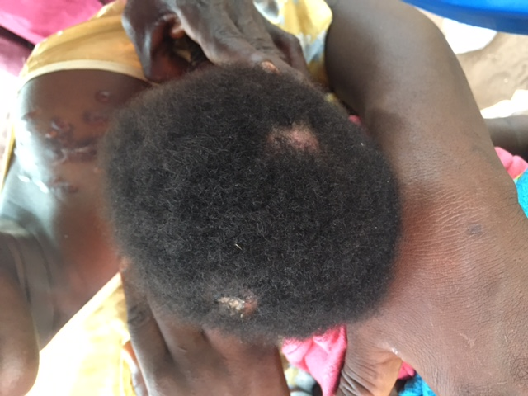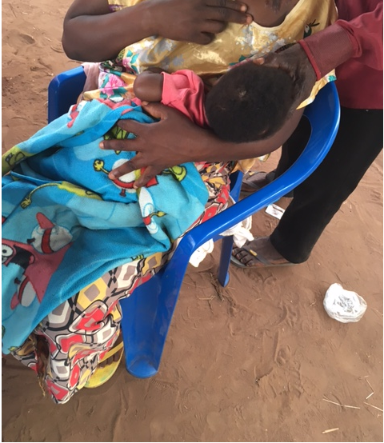

Baby shot twice in the head by Bana Mura militia four hours after birth at the hospital of the village of Cinq on 24 April 2017 (Photos taken by OHCHR on 17 June 2017)

41. The Bana Mura militia also killed unarmed Luba and Lulua inhabitants from the villages of Kasandje, Tschitundu, Mwakaanga and Kanpotopoto, using similar methods. On 15 April, Kasandjewas reportedly attacked by the Bana Mura who remained in the village for three days. Some of the Tchokwe, Pende and Tetela inhabitants of the village allegedly joined the militia to eliminate the Luba and Lulua population. The organizer of the attack was reportedly a high-ranking local Pende leader. A woman interviewed by the OHCHR team reported having lost eight members of her family. She reported that when she returned to the village of Kasandje after the attack to bury them, she saw numerous bodies, some of which were beheaded or cut into pieces. Witnesses provided the names of 10 victims of killings from Kasandje, including two children.

42. The village of Tshitunduwas reportedly attackedby the Bana Mura militia on 9 May. Witnesses described seeing approximatively 100 attackers armed with sticks, machetes and hunting rifles, together with a FARDC Major and some police officers who were allegedly leading the operation. The OHCHR team compiled a list of eight names of victims of killings. One witness claimed to have buried 45 decapitated bodies following the attack.

43. The village of Mwakapenga was reportedly attacked by the Bana Mura in mid-May. One woman reported that the militia had killed her entire family. ” *Two attackers entered my house, shot dead my husband, my 13-year old daughter and my 17-year old son. My youngest daughter was hacked by machete …she was only three-year old*” she told OHCHR. She also stated that whilst hiding in the forest, she had witnessed the killing of 11 persons burnt alive in their home, and described how she heard them screaming and crying upon realizing they had been locked into their burning home. She affirmed that a total of 17 Luba and Lulua individuals were killed during the attack.

*Mutilation and other injuries*

44. The Bana Mura militia reportedly mutilated and wounded hundreds of unarmed Luba and Lulua villagers with hunting rifles, knives and machetes. The Centralidade David Bernardino hospital in Dundo received 72 wounded or mutilated victims. The team interviewed 18 patients (two in Luanda hospital), including five children, reportedly mutilated by machete or wounded with machetes or rifles by the Bana Mura. Two of the patients interviewed died shortly after from their injuries, one from burns and the other from machete wounds. Fifteen victims were reportedly from the village of Cinq, two from Tchitundu, and one from Muyage. Refugees reported that a large number of victims who had been wounded or mutilated died whilst fleeing, either in the forest, crossing a river, or on the road to the Angolan border.

45. The team interviewed a mother with her seven-year old son who had been caught by a traditional leader in Cinq as he was trying to escape from the village on 24 April. The local leader chopped some of his fingers off (see photo below) while other attackers sliced open his face and arm. The face of the boy was totally disfigured.

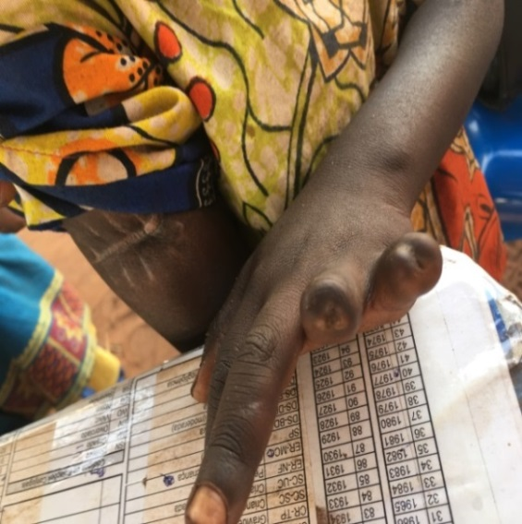

Child from the village of Cinq whose fingers were chopped off by machete by a local leader on 24 April 2017 (Photo taken by OHCHR on 18 June 2017)

46. Another survivor interviewed was hiding in her home in Cinq on 24 April when militia elements entered and attacked her with a machete. Her left arm was sliced off (see Photo below). She was able to flee despite her wound, hid in the forest for several days before reaching the Angolan border, and was airlifted by an Angolan Government helicopter to the hospital in Dundo.

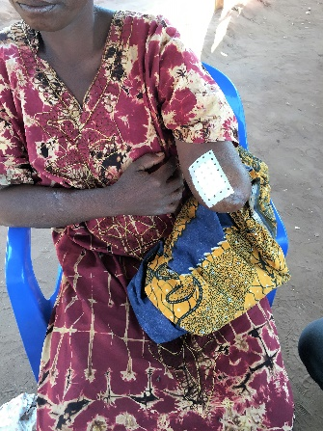

A female survivor of the attack on Cinq by the Bana Mura militia on 24 April. She had her arm amputated in an Angolan hospital after she fled the DRC (Photo taken by OHCHR on 18 June 2017)

47. A female patient interviewed, said to the team that “*the Bana Mura militia broke into our home in Cinq and killed my husband. They then shot me in the leg, my son of one year and 10 months was also shot in the left leg, and my daughter had machete blows to her back*” (see photos below). The victim reported that she had walked for one week to reach the border, from where she was airlifted by helicopter to the hospital in Dundo. Due to injuries, her son had one leg amputated at the hospital (see picture below).

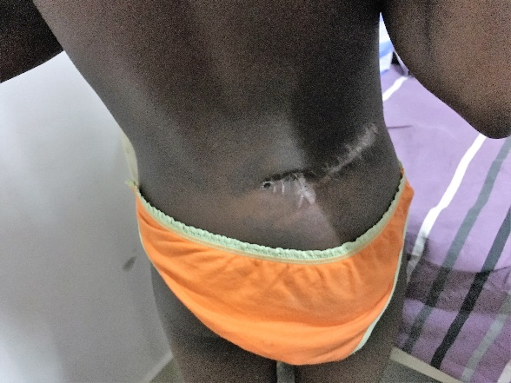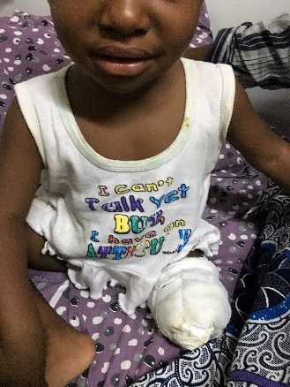

A girl and her one year and 10 months old brother both victims of Bana Mura violence on 24 April, in Cinq village. The boy had one leg amputated in an Angolan hospital due to the gravity of the bullet wounds (Photos taken by OHCHR on 16 June 2017)

48. One woman and one man of the Luba ethnic group, interviewed at the Hospital in Dundo, reported how they were attacked and mutilated by the Bana Mura militia in Tschitundu, at the beginning of May. The woman reported that she was attacked at home by a Tchokwe and a Pende from her village whom she recognized. The attackers sliced open her right arm with a machete. The woman died shortly after the interview. The man reported that he was attacked in his house by six Bana Mura members, who cut off some of his fingers and gave a machete blow to his head. The attackers escaped with his 10-year-old daughter who has since not been heard of.

*Sexual and gender-based violence*

49. The witnesses reported that during the attacks on their respective villages, the Bana Mura militia committed sexual violence against women, in particular rape. One woman interviewed was too weak to explain what had happened but a doctor subsequently informed the OHCHR team that she had been raped. A second woman, a Luba from Cinq, reported that Bana Mura members inserted a rifle barrel into her vagina before hacking at her with a machete on the arm, the neck, the buttocks and the head. Several witnesses from the village of Cinq confirmed that Bana Mura elements introduced objects in the vagina of several Luba and Lulua women in front of other inhabitants of the village. Staff of the health centre of Cinq reported that amongst the survivors who were transferred to the hospital in Dundo, several women had suffered rape by sticks inserted in their vaginas.

*Destruction of property*

50. Almost all Luba and Lulua victims and witnesses interviewed by the team had lost all their possessions. Most reached Angola without any belongings. The houses belonging to Luba and Lulua families in the villages of Cinq, Kasandje, Mwakaanga, Kanpotopoto and Tshitundu, were reportedly identified by members of the Tchokwe, Pende and Tetala communities living in the same villages, before being looted and set on fire by the militia, at times with residents inside their homes. The destruction of their property may have been a strategy to prevent Luba and Lulua from returning to their villages, since there are reports that the Bana Mura militia would order members of these ethnic groups to go back to Kasai Central.

C. Human rights abuses by the Kamuina Nsapu militia

51. According to refugees interviewed by the OHCHR team, the Kamuina Nsapu militia were responsible for human rights abuses, in particular for killings targeting the military, police officers, public officials, and men and women accused of witchcraft. A great majority of the Kamuina Nsapu elements are children (girls and boys), some as young as seven. From 12 March to 19 June, Kamuina Nsapu elements were allegedly responsible for human rights abuses against 86 victims: 79 were killed (including 17 women and six children), six were abducted (including two women and one child), and one was wounded. Some refugees alleged that Kamuina Nsapu targeted men and women due to their ethnicity, but there are no corroborated cases of large-scale killings based on ethnic identity by this militia.

52. Interviewees stated that the Kamuina Nsapu would attack villages in groups ranging from 15 to 60 individuals. However there are also reports of small groups of three to five members carrying out guerrilla-style attacks such as freeing prisoners from a police station. The Kamuina Nsapu members are reported to be primarily armed with machetes, sticks and hunting rifles and, to a lesser extent, semi-automatic weapons which, interviewees claimed, were stolen from the FARDC and PNC.

53. Witchcraft is reported by interviewees as being a fundamental element of the attacks by Kamuina Nsapu. The men, women and children recruited by the Kamuina Nsapu militia are reportedly convinced that their magic rituals prevent them from being killed in battle. When the Kamuina Nsapu execute someone, usually in public, they reportedly frequently decapitate the body, taking the heads away allegedly to expose them in the *Tshota*, meaning “the sacred fire” in Tchiluba. The refugees interviewed by the team, stated that they were convinced that the Kamuina Nsapu had magical powers.

54. This generalized belief about the powers of Kamuina Nsapu and the fear it triggers among segments of the population in the Kasais may partly explain why a poorly-armed militia, composed to a large extent of children, has been able to resist offensives by a trained national army for over a year.

*Summary killings*

55. The OHCHR team confirmed that Kamuina Nsapu militiamen summarily killed at least 79 individuals. Many witnesses described targeted killings across several villages in Kamonia territory, mainly between 12 March and 23 April. According to witnesses, a characteristic attack by Kamuina Nsapu would involve several dozen men, women and children who would initially search the village for members of the FARDC, PNC or public officials. If discovered, the members of security forces and State employees would be publically executed and subsequently decapitated and their heads taken away. Kamuina Nsapu would also hunt down any person involved in witchcraft which they feared could be used against them, and would publicly execute them.

56. On 20 March, the Kamuina Nsapu reportedly attacked the village of Nsumbula. The militia was heavily armed and arrived in large numbers from Djoboko, North of Nsumbula, reportedly in pursuit of State agents, their collaborators and individuals suspected of practicing sorcery. The militia reportedly killed at least five PNC agents, all of whom allegedly had their throat slit. The Head of the DGM in Nsumbula was also killed by cutting his throat and his body was then burnt.

57. The head of groupement, Francois Ntambue Kabongo, was also allegedly killed on 10 April in Muzamba, together with his four brothers. The heads of the victims were allegedly taken to the village of Kabundimbu, the stronghold of Kamuina Nsapu. On 23 March, in the village of Kanyola, Kamuina Nsapu allegedly killed with a machete a male nurse who was assisting the injured; shot dead a motorcycle taxi driver; killed another person for having hidden police officers from the militia; and killed a border official before beheading him. On 13 April, the Kamuina Nsapu reportedly entered the village of Kamako, but retreated after soldiers allegedly killed four of their members. On 23 April, the Kamuina Nsapu is reported to have arrived back to the village in greater numbers causing the military to flee. After 10 days of relative peace in the village, the Kamuina Nsapu began threatening members of the Tchokwe, Pende and Tetela communities, and numerous witnesses reported that a public official from the Ministry of transport, a police officer and a border official were decapitated. A woman accused of witchcraft and a thief were also allegedly killed by Kamuina Nsapu elements on that day.

58. On 18 April, 24 members of Kamuina Nsapu entered the village of Mayanda, assisted by three Lulua from the village, looking for individuals they suspected of practicing witchcraft. According to witnesses interviewed by OHCHR, two women were beheaded, accused of being witches. Before being killed, one of them reportedly had a machete inserted in her vagina after being heated over a fire. A third woman accused of witchcraft also reportedly had a hot machete inserted in her vagina and subsequently died of her injuries. In Mujanda, during the month of April, Kamuina Nsapu members reportedly executed five men and women for various reasons, including for witchcraft, refusing to leave a home which was requisitioned by the militia, and being a member of a political party.

*Use and recruitment of children*

59. In all incidents documented by the OHCHR team, the Kamuina Nsapu militia used children. Many of the interviewees stated that a large number of the Kamuina Nsapu were boys and girls, some as young as seven. Tchokwe and Pende refugees interviewed reported that Luba families would often offer their children to fight for the militia. In one village, Lubamimanga, dozens of Luba children were allegedly recruited by Kamuina Nsapu. Groups of girls called “Lamama”, often wearing skirts made out of straw and red bandages tied around their heads and arms, reportedly accompanied the militia. The Lamana reportedly practiced rituals considered as magic, such as shaking their skirts to repel bullets and drink the blood of victims which is believed to render the group invincible. An example of the involvement of children in combat roles occurred on 15 May 2017, during an attack on Mudiadia village. During heavy fighting between FARDC soldiers and the Kamuina Nsapu militia - many of whom were allegedly young boys and girls - witnesses who fled the village reported to the OHCHR team that they heard FARDC soldiers shouting in Lingala “don’t kill the youngest ones”.

60. Survivors of the Kamuina Nsapu attack on Shamudisu village, in late March (exact date unknown), indicated having seen from their hideouts an ANR agent, the chief of Shamudisu village, and an alleged sorcerer who were targeted by the militia. The victims were reportedly asked to lie on the ground and the Lamama (aged approximately 13) sat on their chest. A militiaman would then decapitate them. The Lamama reportedly drank the blood of the victims while the other assailants inserted a stick into the heads before placing them in a fire. Other witnesses described to the OHCHR team how they had to walk over bodies of child members of Kamuina Nsapu who had fallen in clashes with the FARDC and were wearing red bandages on their heads and arms.

61. Witnesses indicated that one of the first requests of the Kamuina Nsapu as they entered a village, was for the inhabitants to hand over their children to be “baptized” and join the group. Some of the chiefs and other individuals killed by Kamuina Nsapu, were targeted for resisting the recruitment of children by the militia.

*Destruction of property*

62. According to witnesses, the Kamuina Nsapu burnt down the houses of any person linked either to security forces or to the State in general, and people accused of practicing witchcraft. Some refugees interviewed claimed the militia would also systematically burn down houses that belonged to the Tchokwe, Pende and Tetela individuals. For examples, on 23 March, Kamuina Nsapu elements allegedly burned 200 houses in Kanyola, reportedly in retaliation for the alleged killing of 16 of its members by the FARDC. Also, at the end of March, approximately 40 Kamuina Nsapu members attacked Shamudusi and reportedly burned down the houses of several Tchokwe, Pende and Tetela. During the month of April, witnesses reported that the villages of Shakombe and Shamukungo were burnt by the Kamuina Nsapu.

V. Conclusion and recommendations

**63. On the basis of accounts of victims and witnesses who had fled several villages of Kamonia territory, Kasai province, in the DRC, OHCHR team deployed to Angola from 13 to 23 June 2017, was able to confirm that between 12 March and 19 June 2017, serious human rights violations and abuses were committed by State agents and militias against 282 people in the context of the ongoing violence in the Kasai region.**

**64. Since all the refugees interviewed by OHCHR had fled different villages of the Kamonia territory, close to the Angolan border, the violations and abuses documented in this report reflect the violence and dynamics of Kamonia territory only, which may differ from the situation in other parts of the region. The violations and abuses documented by the team include the summary or extra-judicial killing of 251 people, the mutilation and other injuries affecting 17 people, the abduction of nine individuals, the rape of four women and one arbitrary arrest. There were also reports of extensive looting and destruction or burning of property. Some of the survivors of attacks who spoke to the OHCHR team presented life-changing scars and wounds and will be disabled for life. Most had fled their villages, lost everything they owned and, in many cases, were separated from members of their family as they fled the violence. The numerous children recruited in the ranks of the Kamuina Nsapu militia will face serious trauma and risk stigmatization and difficult reintegration in their communities.**

**65. Local security and defence agents are alleged to have supported and, on occasions, led the Bana Mura militia in fighting the Kamuina Nsapu insurrection, acting outside the framework of their functions and mandated roles. Interviewees also indicated to the OHCHR team that local traditional officials participated in the planning of some of the operations. It is important to underline that mysticism is an integral part of the collective belief system in the Kasai region, and its influence on the dynamics of the crisis should not be underestimated. The Kamuina Nsapu militia and the inhabitants of the villages under attack are convinced that sorcery plays a major role in explaining their resistance against the well-equipped national army. Local security forces and other officials reportedly started organizing and using Tchokwe, Pende and Tetela members of the population to conduct targeted and well-planned attacks against the Kamuina Nsapu, as well as against Luba and Lulua communities living in villages which the militia had occupied or threatened to occupy. Some elements of the Bana Mura militia were reportedly chosen and used by State agents for their alleged magical powers in order to neutralize the sorcery used by the Kamuina Nsapu.**

**66. OHCHR documented a large number of accounts that the Bana Mura had the objective of separating the Luba and Lulua communities from the rest of the population, in order to facilitate the targeting of victims and to eliminate a specific group from the area.**

**67. The human rights violations and abuses documented by the OHCHR team constitute criminal offences under DRC criminal law and may amount to crimes under international law. The large scale and mass killings that have been perpetrated as part of attacks against peaceful villagers by the Bana Mura, with the support of local security forces, may for instance amount to crimes against humanity. In this regard, it should be recalled that the DRC has ratified the Rome Statute and integrated its provisions in its national legal system. The perpetrators of such crimes, as well as their accomplices, and those having had a commanding role, must be held accountable. The findings of the present report will be put at the disposal of the team of International Experts on the Kasai mandated by the Human Rights Council, as well as any judicial institution addressing the situation in the Kasai, in an effort to advance accountability efforts in this regard.**

**68. OHCHR urges the Government of the DRC to:**

**• Conduct a prompt, transparent and independent investigation to establish the facts and circumstances of the alleged human rights violations and abuses perpetrated by State agents and militias throughout the Kasai province; establish disciplinary and vetting processes for agents of the State accused of involvement in serious violations;**

**• Provide accurate and updated information on administrative, traditional, defence and security officials deployed in Kamonia territory between March and June 2017, and ensure that those allegedly responsible for organizing, recruiting and arming the Bana Mura are identified and prosecuted;**

**• Take prompt and immediate action to disband and disarm the militias active in the Kasai region and discourage all initiatives of self-defence;**

**• Ensure that elements of the defence and security forces deployed in the Kasai region are duly trained and equipped to carry out their paramount duty to protect the population, and that those presumed to have been involved in serious human rights violations are sanctioned and removed from the areas of operations so as to reduce the risk of recurrence of violations;**

**• Promptly replace FARDC units accused of involvement in serious violations while ensuring that a clear record is kept of the locations to which they have been transferred in order to avoid that such transfers are used to escape prosecution;**

**• Ensure safe and unrestrained access to information, sites and individuals deemed necessary for the work of the team of International Experts on the situation in the Kasai;**

**• Take all necessary measures to fulfil, in collaboration with partners, including MONUSCO, its primary role to protect the population of all ethnic backgrounds in the greater Kasai area;**

**• Take prompt and appropriate action to promote community reconciliation initiatives, including through inclusive and consensual dialogue on traditional chieftaincy and hereditary rights.**

**69. OHCHR also urges all armed militia active in the Kasai region to:**

**• Promptly disarm and ensure all pressure exercised on the local population ceases immediately, including pressure to hand over children to join their ranks.**

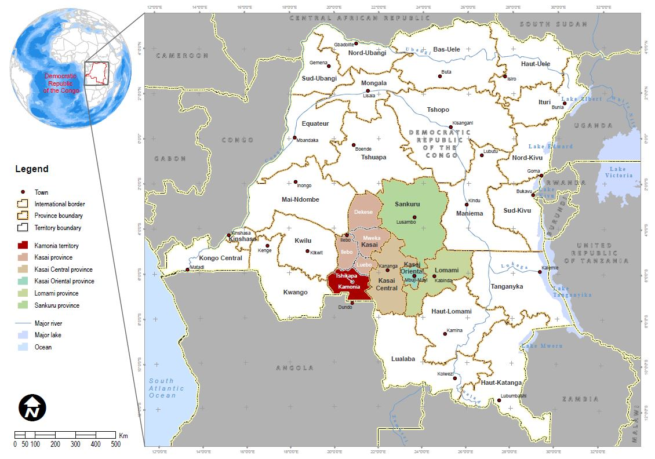

**19**

Annex I – Map of Kamonia territory and the rest of the Kasai region



DEMOCRATIC REPUBLIC OF THE CONGO

**20**

Annex II - Map of satellite detected fires and destruction within Kamonia territory during the period under review

1. UNOSAT is the Operational Satellite Applications Programme of the UNITAR (United Nations Institute for Training and Research)
2. In the DRC, traditional chiefs are integral to public administration. They administer villages and many perform important spiritual functions. Chiefs are appointed per local traditions and on a hereditary basis, and are then recognized by the State. In principle, traditional chiefs are apolitical, but they are often pressured by the State for political allegiance, which in turn helps them to secure their position.
3. Many other villages were reportedly attacked, but the OHCHR team was not able to interview witnesses from these villages. They include the villages of Kakondo, Mvula Milenge, Milomba, Camp Kuilu, Kamabonza, Mulundu, Mayanda, Liselela, Malemba, Shamungolo, Tshawemba and Kanana.